Bug 1

Title:

Incorect price

Severity: 2

Priority: 1

Description:

The price is not calculated well.

Reproducing steps:

1. Open the Badabum website.
2. Search the product which you want to buy.
3. Add it to cart.
4. You will see a wrong calculated price (sum not multiplication of nr of units and unit price).

Actual Result:

The website calculate the sum of: nr of units and unit price. (**see screenshot**)

Expected Result:

The website calculate the multiplication of: nr of units and unit price.

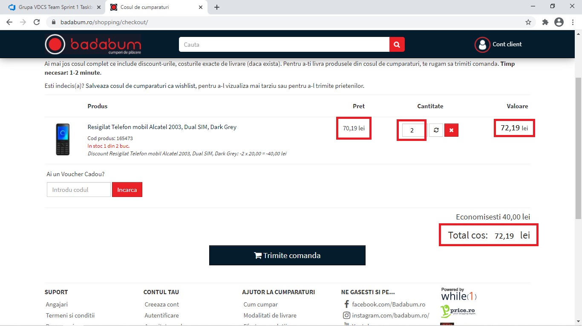

Bug 2

Title:

Cancel order button is missing.

Severity: 3

Priority: 3

Description:

After giving an order, the customer does not have a Cancel Order Button.

Reproducing steps:

1. Open the Badabum website.
2. Search the product which you want to buy.
3. Add it to cart.
4. Finish the order.
5. In orders history click on View Details button at the order which you want to cancel.
6. A page with details about order is displayed but there is not a Cancel order button to have the posibility to cancel the order.

Actual Result:

No Cancel order button is displayed.(**see screenshot**, in the indicated space at first order of this account was displayed a cancel order button)

Expected Result:

In the indicated space in screenshot must be a Cancel order button.

