|  |  |
| --- | --- |
|  | 🞂Computer Vision 1  Practical Assignment 1  Selene Baez Santamaria (2572529)  Andrea Jemmett () |

**1. Photometric Stereo**

The goal of this assignment is to use Matlab to implement the photometric stereo algorithm, which aims to recover a patch of surface from multiple pictures under different light sources.

For this implementation we assume five light sources are involved, all of them distant. They are positioned facing the front, left-above, right-above, left-below and right-below corners of the surface showed in the images.

We created a function that is called without arguments and produces three figures, one for the surface albedo, one for the surface normals and one for the reconstructed shape.

**Step 1**: Read the given images for a sphere under different light sources and store them together in a three dimensional matrix.

**Step 2**: Represent the light sources with vectors assuming a coordinate system with origin at the top left corner.

**Step 3**: Determine matrix V from light sources

**Step 4**: Create structures to store albedo and normal per pixel

Then, for each pixel:

**Step 5**: Retrieve the pixel values for all images and store them as i

**Step 6**: Construct diagonal matrix I

**Step 7**: Solve linear system of equations for g

**Step 8**: Calculate albedo

**Step 9**: Calculate normals

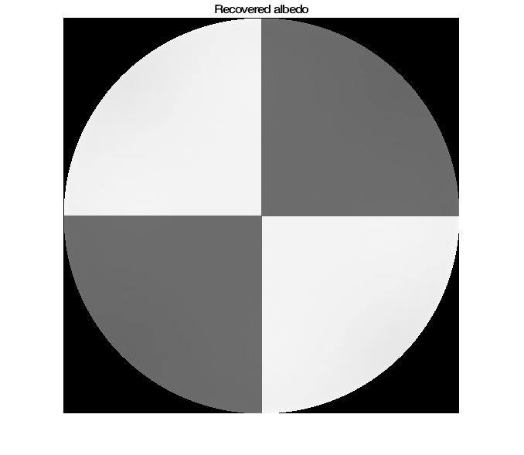

K = 100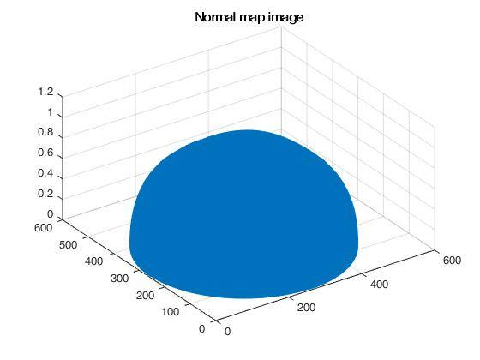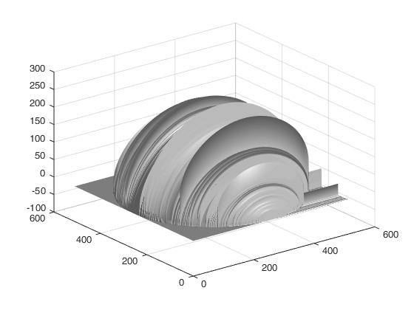

**2. Color Spaces**

The goal of this assignment is to use Matlab to convert images between RGB and other color spaces.

We created a function that is called with two arguments: the name of the image to be converted, and the color space to be converted to. We experimented with the given image “bricks.jpg” as well as other colorful images.

**Opponent Color Space**

Follow equations.

// insert images

**rgb Color Space**

Normalize RGB channels.

// insert images

**HSV Color Space**

Use rgb2hsv built in function.

// insert images