Responsive

**DEADLINE:** Oct 13, 2021

## FOLDER STRUCTURE

|  |  |
| --- | --- |
| SP3_HW2/*     └─ task/**      └─ SP3_HW2.docx**      └─ examples/**  └─ desktop.png**  └─ hover-effects.png**  └─ mobile.png**  └─ tablet.png**  └─ homework/*     └─ img/*      └─ news1.jpg *  └─ news2.jpg *  └─ post1.jpg *  └─ post2.jpg *  └─ post3.jpg *  └─ post4.jpg *  └─ section1.jpg *     └─ css/*  └─ styles.css*  └─ index.html* | * - required  ** - restricted (no need to submit) |

## TASK

In this homework, you should create a web page and provide styles for specific screen resolutions as shown in the pictures (pixel perfect is not required):

* *examples/desktop.png* - shows how the page should look like on 1280px
* *examples/tablet.png* - shows how the page should look like on 768px
* *examples/mobile.png* - shows how the page should look like on 320px

**Requirements:**

* The @media query breakpoints that are used in the example:
  + Mobile < 768px
  + Tablet min-width: 768px
  + Desktop min-width: 1280px
* You can use mobile first or desktop first approach. It’s up to you;

**Figure 1**:

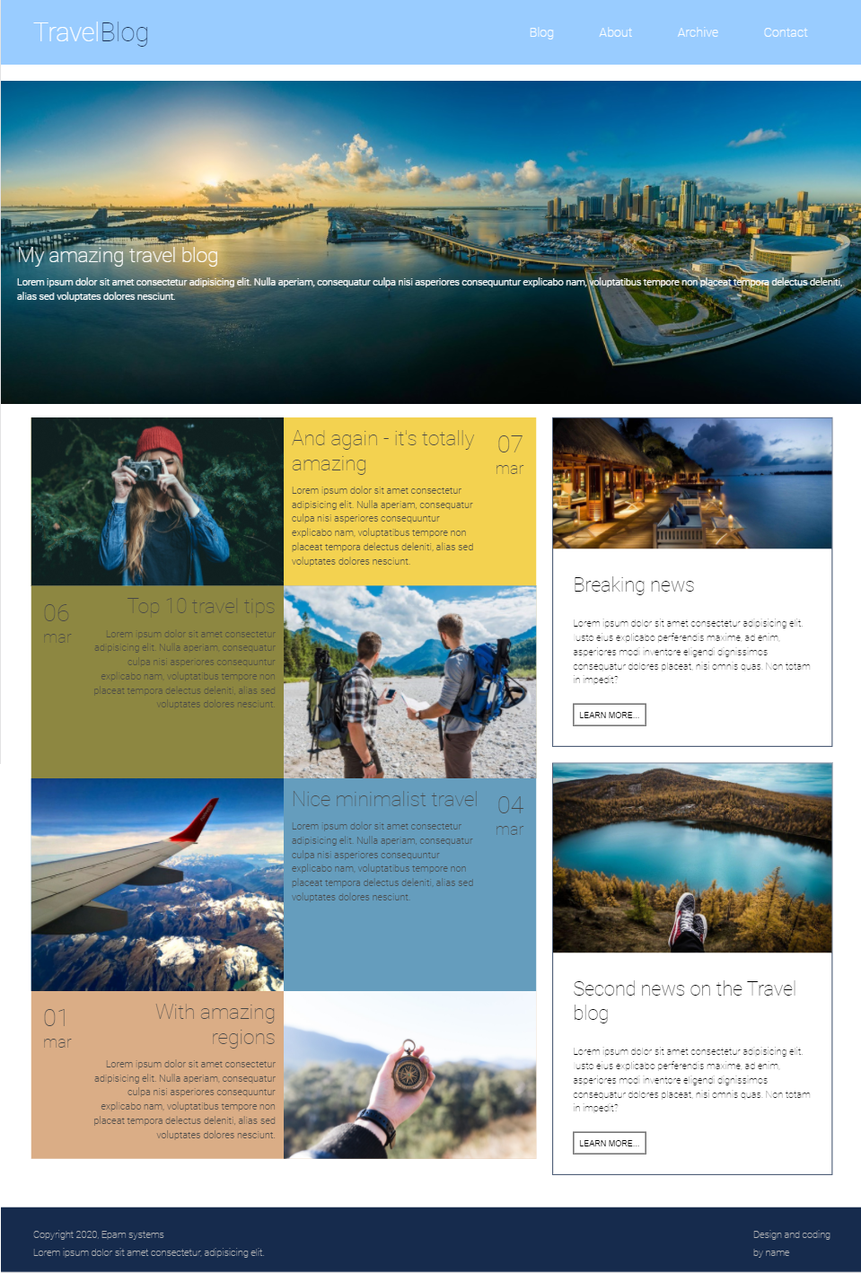

**Figure 1 - post elements**

Navigation and first section have width: 100%.

* The even posts should have description on the left and preview image on the right
* The odd posts should have description on the right and preview image on the left (reverse)

Please note! This logic should not be ‘hardcoded’ in HTML or CSS. Please use appropriate pseudo-class to place elements.

So, in case we need to add a new post, then the last added item should be shown reversed regarding the previous one.

* Menu items, post description and “Learn more” buttons should have animated hover effects as shown in **image 2**:

**Figure 2 - menu items and post elements hover effects**

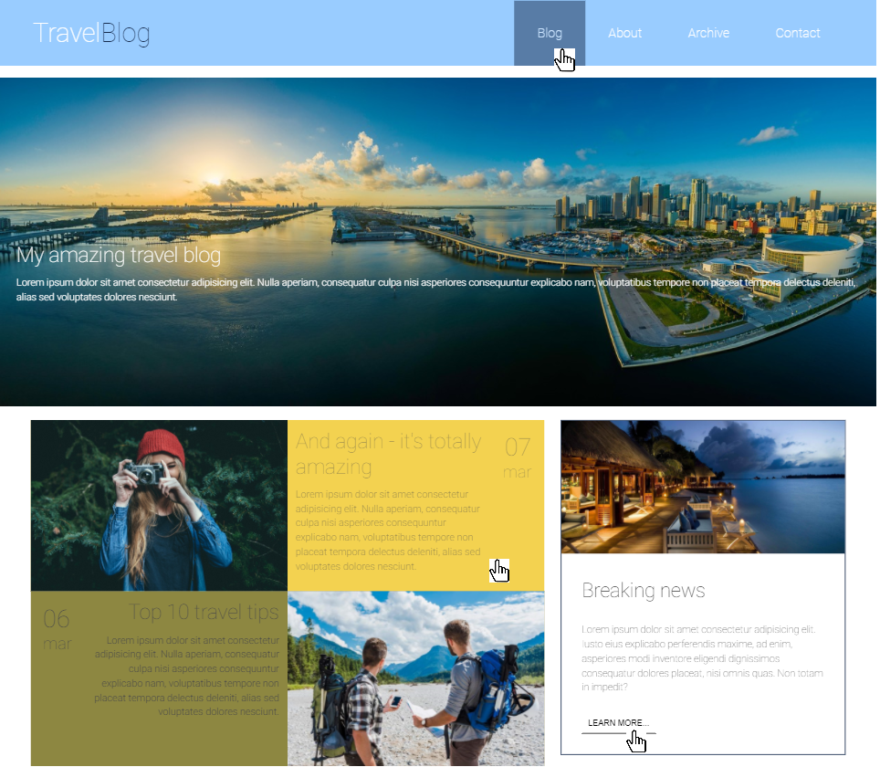

* The sandwich button appears in **tablet** and **phone** mode BUT they shouldn’t do anything, just replace the menu from desktop view (**image 3**):



to

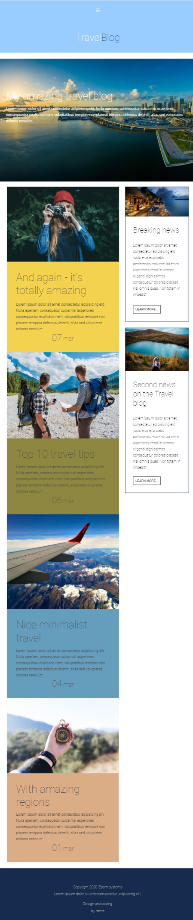

**Figure 3 - menu transformation**

* In styles.css file you can find colors references. Please don`t forget to remove unnecessary comments after you use it.

## RESTRICTIONS

* Please use pure CSS only, without any preprocessors;
* Don’t use any 3rd party tools or libs (e.g. Bootstrap);
* Use only styles.css file for your CSS code without splitting it;
* Usage of **JavaScript** is forbidden;
* Adding **task/** and **examples/** folders is forbidden. Do not push it to repository (only homework/ folder should be pushed);
* No requirements for browser support (should work properly in Google Chrome last version).

## BEFORE SUBMIT

* Verify that all functionality is implemented according to requirements;
* Format your code (remove redundant spaces, lines of code etc.);
* Add only related to your code, valid comments;
* Validate in <https://validator.w3.org/> and <https://jigsaw.w3.org/css-validator/> ;
* Make sure your GitLab folder structure meets the required one (without **task** and **examples** folders)

## SUBMIT

* The **SP3_HW2** folder should be uploaded to GitLab repository **“SP-3”** into **main** branch

## USEFUL LINKS

* <https://developer.mozilla.org/en-US/docs/Web/CSS/position>
* <https://developer.mozilla.org/en-US/docs/Web/CSS/@media>
* <https://css-tricks.com/snippets/css/a-guide-to-flexbox/>
* <https://css-tricks.com/snippets/css/complete-guide-grid/>