Recommender Systems - Course Project Report
Cumulative report template - Parts 1, 2, and 3
Team
Members
For Part 3 track: select one | A / B / C
GitHub repository link

How to use this template
- This is one cumulative report. Extend and revise the same document at each project stage.
- Maximum length: 4 pages at Part 1, 8 pages at Part 2, and 12 pages for the final report, excluding references.
- Keep the section headings below. You may add subsections where useful.
- All explanations and justifications requested in the project specification belong in this report.
- The Results Sheet contains the complete standardized numerical record. In the report, include only the tables and figures needed to support your analysis.
- Delete all italic instructional text before the final submission.

1. Part 1 - Data, Protocol and Baselines

1.1 Data characterization
MovieLens 1M contains 1,000,209 ratings from 6,040 users. The movie metadata lists 3,883 movies, but only 3,706 have received ratings. The remaining 177 movies have no ratings. Using the rated movies, the user-item matrix density is 4.47%.
Measure | Value
Unique users | 6,040
Catalogued / rated movies | 3,883 / 3,706
Ratings | 1,000,209
Density (rated catalogue) | 4.47%
Ratings per user: mean / median / range | 165.60 / 96 / 20–2,314
Ratings per rated movie: mean / median / range | 269.89 / 123.5 / 1–3,428
Share by top 10% users / movies | 38.09% / 44.45%
Ratings are not evenly distributed across users or movies. The most active 10% of users submitted 38.09% of all ratings, and the top 10% of movies received 44.45%. This leaves many movies with relatively few ratings, which may affect how well recommendation methods work for less popular titles.
Ratings also tend to be positive. The numbers of 1-star to 5-star ratings are 56,174, 107,557, 261,197, 348,971, and 226,310, respectively. Rating 4 is the most common, and about 57.5% of ratings are either 4 or 5.
Ratings were submitted between 25 April 2000 and 28 February 2003 (UTC). Most were submitted in 2000 (90.46%), with the highest monthly total in November 2000 (290,793 ratings). Activity fell sharply afterward, so the team will need to consider this imbalance when deciding on the temporal split. The timestamps show when ratings were submitted, not when the movies were watched.
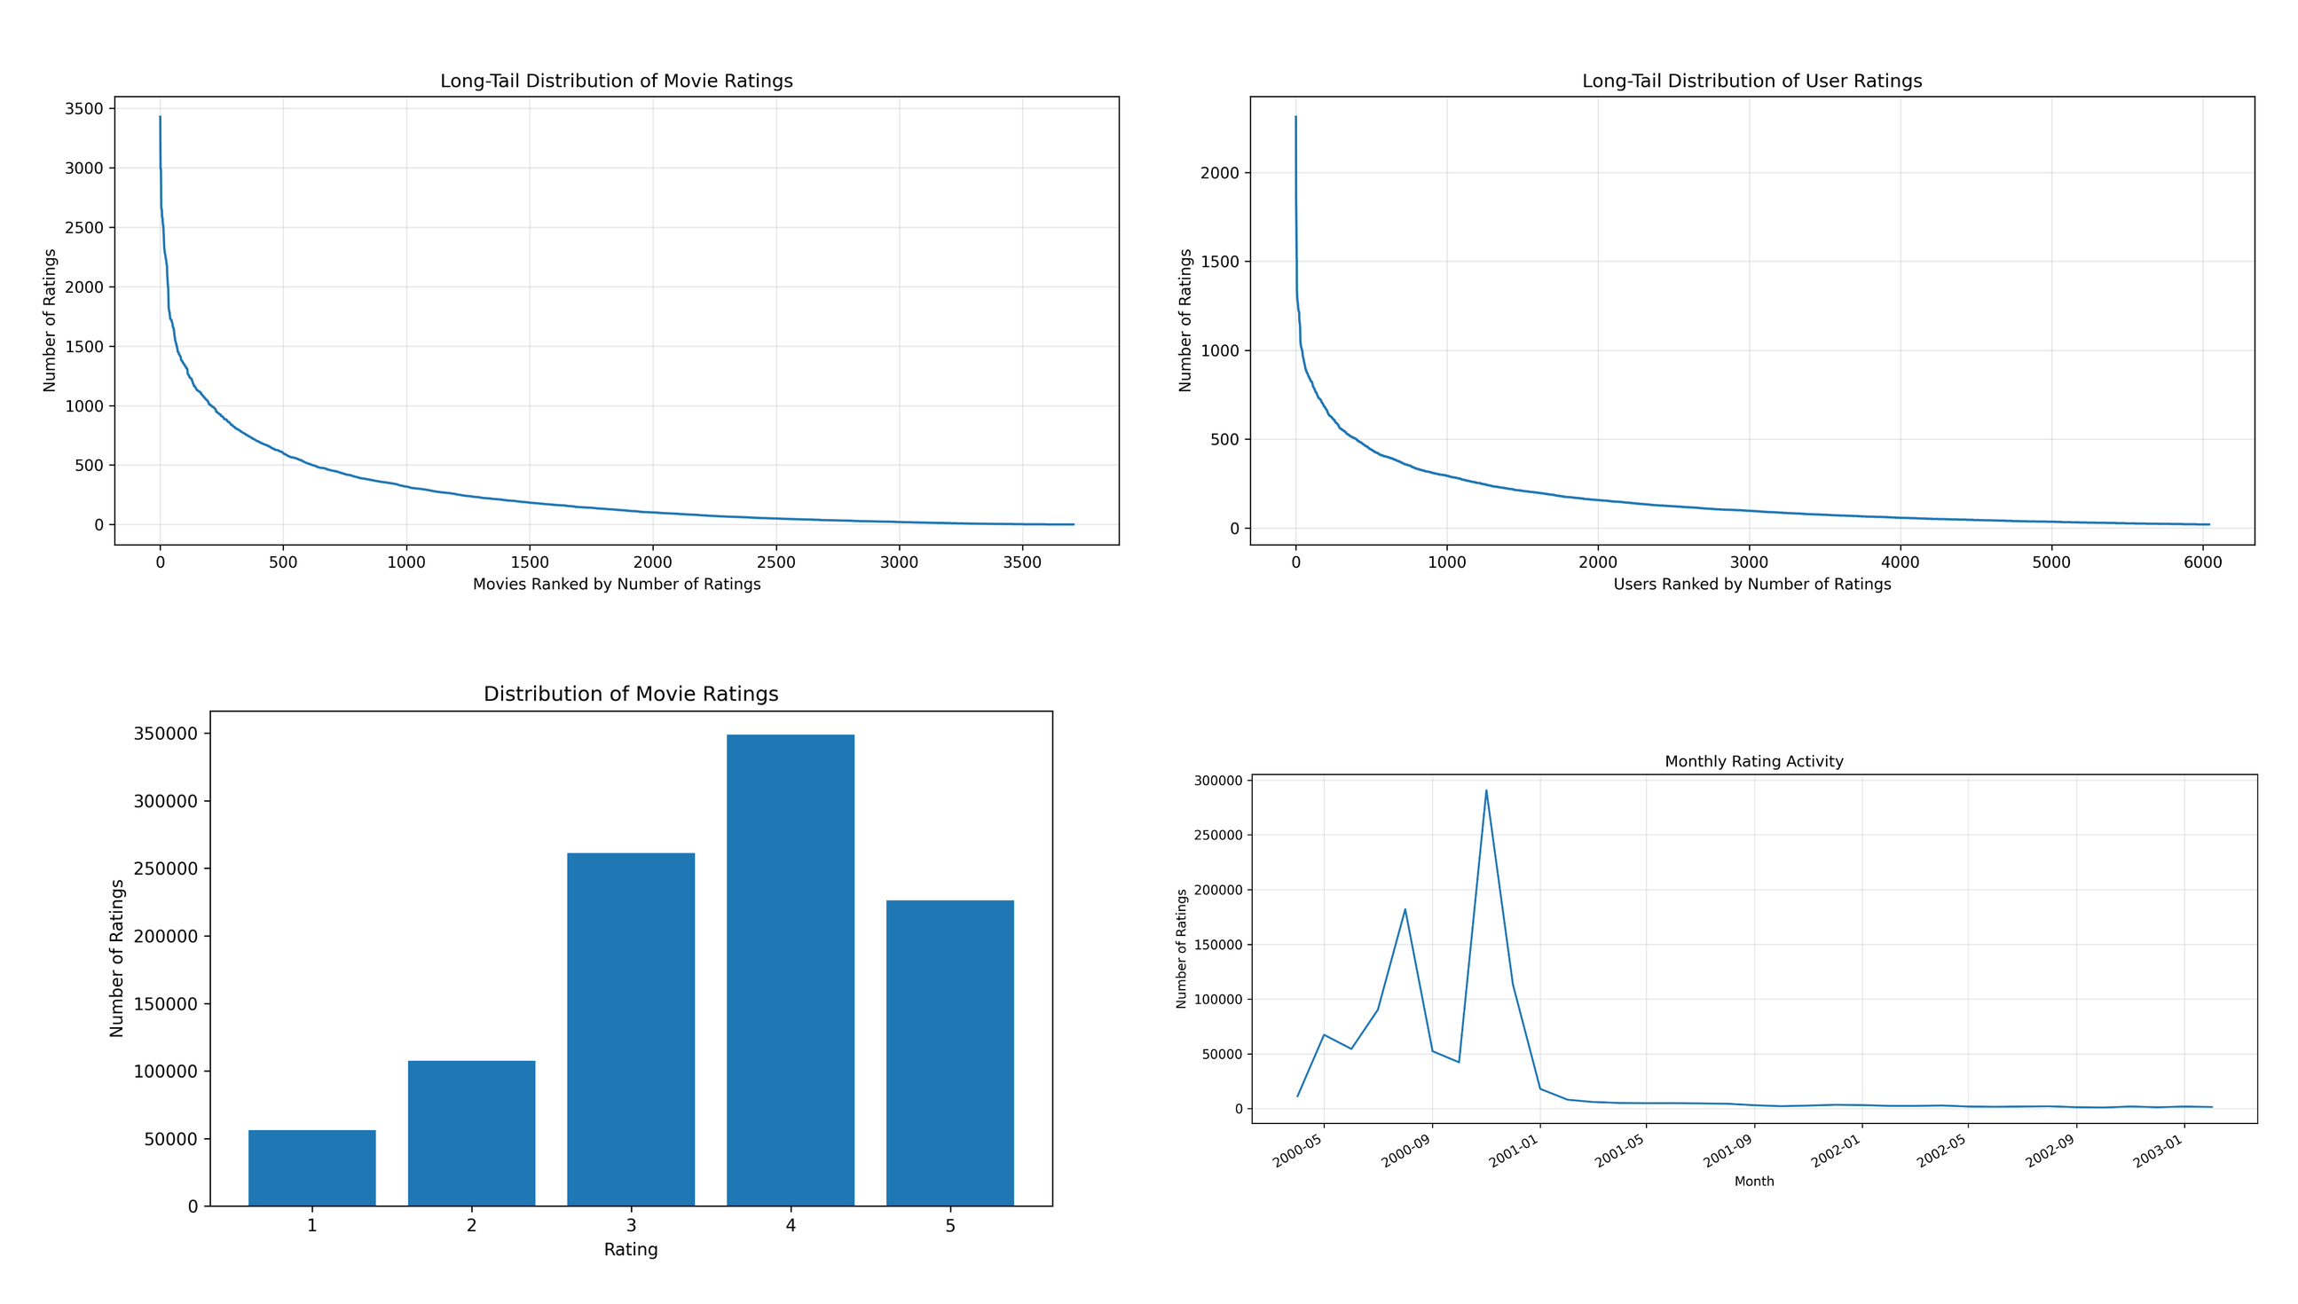
Figure 1. EDA distributions (clockwise from top left): movie popularity, user activity, monthly rating activity, and rating values.

1.2 Preprocessing and feedback treatment
We checked the three data files for missing values and duplicate records. We also checked for repeated user-movie ratings, ratings outside the 1 to 5 scale, and user or movie IDs missing from the metadata. No problems were found in these checks, so we did not remove any interactions for the EDA. We loaded the movie titles with latin-1 encoding to read special characters correctly.
For the EDA, we used the original 1 to 5 star ratings without converting them into binary feedback. (The team still needs to document the choices made for model training, including the positive-feedback threshold, any user or movie filtering rules, and how many interactions those rules affect. This part can be completed once the training and evaluation protocol is finalized).

1.3 Train/validation/test split
Specify the temporal split exactly and justify it.

1.4 Evaluation protocol
Specify the candidate set, ranking setup, metrics, and other protocol decisions. Justify the major choices with reference to the relevant lecture material.

1.5 Baseline methods and settings
Describe item-based kNN and the Most Popular variants, including the settings that were evaluated. For item-based kNN, report and justify the selected neighborhood size k and similarity measure.

1.6 Results and analysis
Present the important Part 1 results. Interpret them rather than reproducing the entire Results Sheet.

2. Part 2 - Models and Honest Comparison

2.1 Models
Describe the additional models and paradigms. Clearly identify the self-implemented algorithm and explain its implementation.

2.2 Hyperparameter tuning and variability
Describe the validation-only tuning procedure, search spaces/budgets, random seeds, and confidence intervals or statistical testing.

2.3 Overall results
Present and discuss the main comparison. Explain important differences and avoid unsupported claims.

2.4 Disaggregated analysis
Report and interpret results broken down by at least two of the required dimensions: items with few vs. many training interactions, low- vs. high-activity users, popular vs. long-tail items, and early vs. late test period. Define any thresholds used and focus on findings that change or qualify the overall conclusions.

2.5 Sparsity ablation
Report and discuss the 100%, 50%, and 20% training-interaction experiments, including changes in the ranking between models.

3. Part 3 - Beyond Accuracy

3.1 Selected track and motivation
State Track A, B, or C and briefly motivate the selected intervention/extension.

3.2 Method
Describe only your selected track. The Track A/B/C guidance below is provided as instructions; delete the guidance for the two tracks you did not select before submission.

If Track A - Diversity and popularity bias
State the base recommender, selected re-ranking method, genre-vector item representation, trade-off parameter, and exact item-distance measure. Describe how the parameter was swept.

If Track B - Fairness
Define the release-decade provider proxy, report and justify the final decade boundaries and group sizes, state and justify the adopted fairness notion, describe the consumer groups based on MovieLens user attributes, and identify the stage and form of the mitigation.

If Track C - Group recommendations
State the selected synthetic group type and justify the chosen group size (3-5). Describe the three aggregation strategies. Identify which strategy was extended to the sequential scenario and explain how satisfaction is carried forward between recommendation rounds.

3.3 Results and trade-offs
Present the required track-specific results. Track A: report intra-list diversity, catalogue coverage, Gini and calibration error across the parameter sweep, and discuss the accuracy-diversity frontier. Track B: report position-weighted exposure against catalogue share, per-group consumer-side accuracy, and the fairness-performance frontier. Track C: compare group satisfaction, disagreement and minimum member satisfaction across the three aggregation strategies, then analyse how member and group satisfaction develop in the sequential scenario.

3.4 Cost and interpretation
State what is gained, what is lost, and who bears the cost where applicable. Explain what operating choice or strategy you would select and why.

3.5 "One number we cannot explain"
Identify one result you do not fully understand and describe how you would investigate it.

4. Discussion and Conclusions
Summarize the main findings across the project. Discuss limitations, failed approaches where relevant, and what the experiments support.

5. Contribution Statement
For each team member, provide two or three sentences describing their contribution.

6. Use of AI Assistants
State which AI tools were used and for what. If none were used, state that explicitly.

References
List references used in the report. References do not count toward the page limit.

