#### Case Study: Inappropriate Use of Surveys

#### by Vasilisa Lukashevich

#### (Unit 5 Research Methods and Professional Practice May 2023)

**The task:**

In 2018, Cambridge Analytica was in the news in the United Kingdom and the USA (Confessore, 2018) for obtaining and sharing data obtained from millions of Facebook users. They obtained the data through innocuous surveys on Facebook (you may have seen this type of survey and probably participated at times). This is probably the highest profile of surveys used for alternative means and, probably, monetary gains. However, this happens often through various media.

Consider how exactly this happened and why it was used. Find one or two further examples of inappropriate use of surveys and highlight the impact of all these examples from the various ethical, social, legal and professional standpoints that apply.

**The answer:**

The Cambridge Analytica case gained widespread attention following the scandal surrounding the 2016 US election. The researchers utilised data from tens of millions of Facebook users without their consent. For example, they aimed to create typical profiles of liberal or conservative supporters, presumably to manipulate their opinions more effectively (Noor, 2018).

They perceived Facebook as an open data source; however, the data were obtained through a specific application tool called the "This Is Your Digital Life", which took into account not only user responses, but also the information about their friends and their connections. As a consequence, Meta, the company formerly known as Facebook, has agreed to pay a $725 million fine but denies any wrongdoing (Raymond, 2022). Cambridge Analytica filed for bankruptcy in 2018.

The researchers mentioned in interviews that many other companies engaged in similar practices. Given that I still come across offers for surveys and quizzes on social media platforms, I assume that the process has not ceased after the Cambridge Analytica incident. It looks like the perceived value of the acquired information outweighs the fear of being fined.

Another example of the inappropriate use of surveys is misconduct in research. According to Okonta, P.I. & Rossouw, T. (2014), over 96% of the 133 surveyed scholars believed that some form of misconduct had happened in their workplace in Nigeria. The most frequent form of improper scientific behaviour is data falsification (although we hope that this research is different). Of course, engaging in misconduct is unprofessional.

We are currently living in an era marked by a crisis in science, as it has brought to light the fabrication of data in numerous previous studies. One famous example is the case of Dr. Wakefield and the vaccine controversy. In 1998, a team of scholars published a study in The Lancet suggesting a link between the measles, mumps, and rubella (MMR) vaccine and the development of autism. However, it was later revealed that they manipulated and misrepresented data in the study (Rao & Andrade, 2011). Now, we can see the red stamp "Retracted" on this publication on The Lancet website (in the picture below).

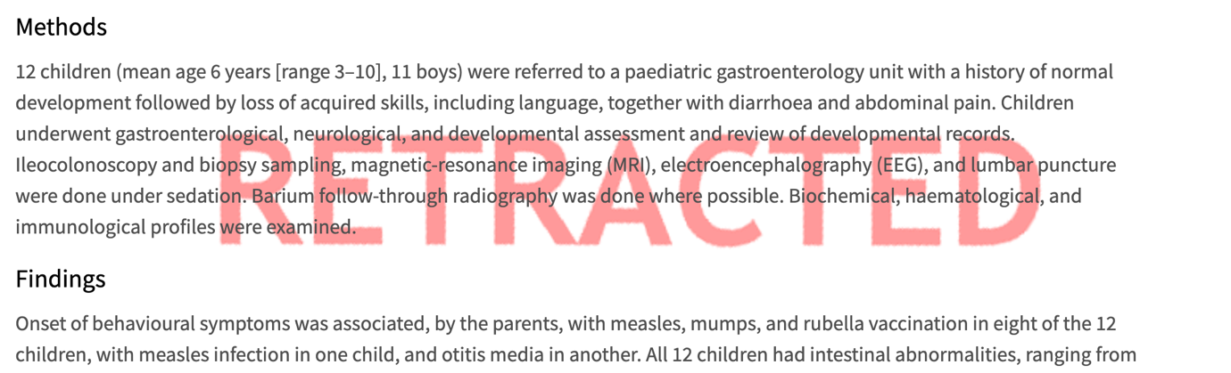

In response, new projects such as Open Science (www.unesco.org/en/open-science) have emerged, aiming to facilitate a clearer, more reliable, and inclusive scientific process.

To sum up, exercising reasonable criticality is crucial for the further development of science in order to avoid erroneous inferences. That is why the replication of studies and the reevaluation of results are essential to assess reliability and professionalism.

**References**

Noor, P. (23 Mar, 2018) There are plenty more like Cambridge Analytica. I know – I've used the data. *The Guardian*. Available from: https://www.theguardian.com/commentisfree/2018/mar/23/plenty-more-like-cambridge-analytica-data-facebook [Accessed 2 Jul 2023]

Rao, T.S. & Andrade, C. (2011) The MMR vaccine and autism: Sensation, refutation, retraction, and fraud. *Indian journal of psychiatry, 53*(2), p.95.

Raymond, N. (24 Dec 2022) Facebook parent Meta to settle Cambridge Analytica scandal case for $725 million. *Reuters.* Available from: https://www.reuters.com/legal/facebook-parent-meta-pay-725-mln-settle-lawsuit-relating-cambridge-analytica-2022-12-23/ [Accessed 2 Jul 2023]

Wakefield, A.J., Murch, S.H., Anthony, A., Linnell, J., Casson, D.M., Malik, M., Berelowitz, M., Dhillon, A.P., Thomson, M.A., Harvey, P. & Valentine, A. (1998) RETRACTED: Ileal-lymphoid-nodular hyperplasia, non-specific colitis, and pervasive developmental disorder in children. *The Lancet, 351*(9103), pp.637-641.