# Laboratory Work №3

**REVIEW OF THE C ++ LANGUAGE. CONSTRUCTIONS OF**

**CHOICE if, if else. CYCLES while, do while, for.**

Task: according to the option (student number in the group list) calculate the

function Y (x) (see table), for which the variable x changes:

for students with a list number 1-5 from -11 to 11 in steps of 0.5

for students with a number on the list 6-10 from -8 to 8 for with a step of 0.2

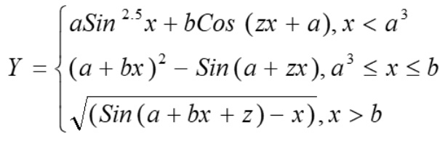

1. make a menu:

(using switch)

case 1: implement using the operator for;

case 2: implement using the operator while;

case 3: implement using the operator do while;

with a choice of variable parameters, for my variant is 14:

for case 1 - variables will have values: a = 0.8, b = 0.8, z = e^x

for case 2 - variables will have values: a = 1.2, b = 2.3, z = e^2x

for case 3 - variables will have values: a = 1.9, b = 9.2, z = e^3

Results:

1.

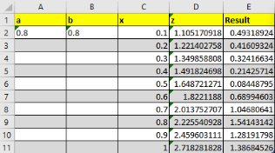

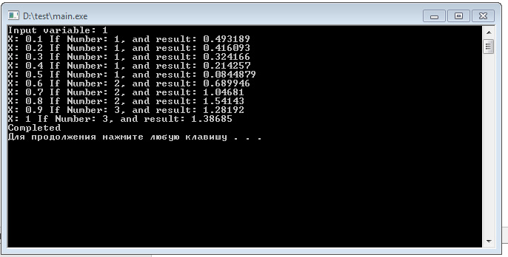

2.

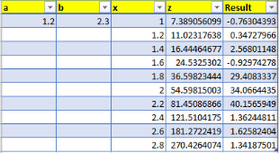

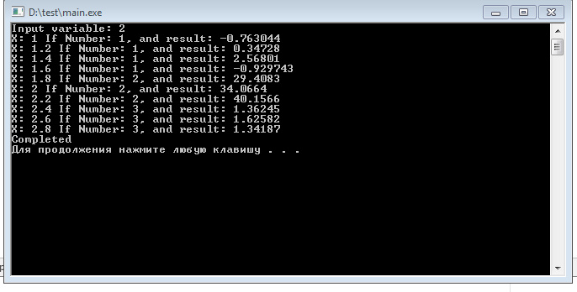

3.

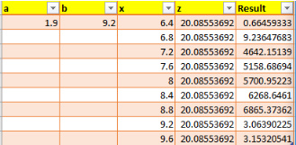

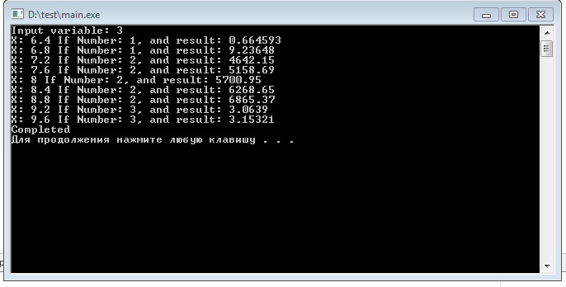

FlowChart:

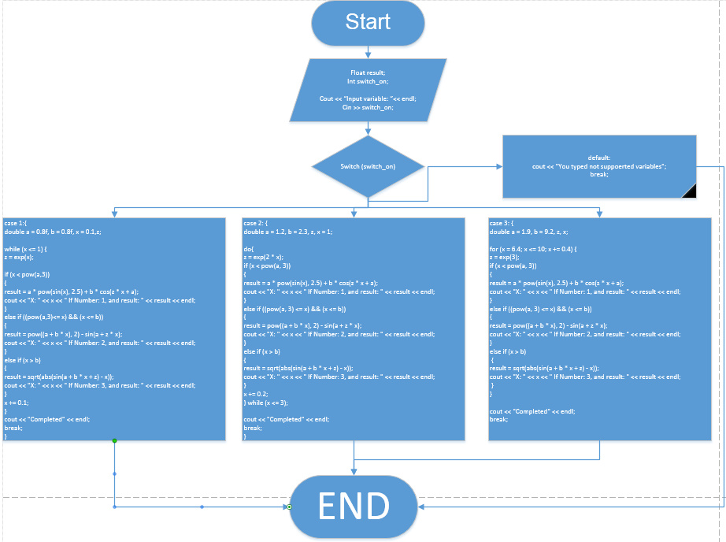

Link on Github:

https://github.com/Vasiliy-Pot/potapenko_vasiliy/tree/Laboratory_Work_3

Conclusion:

I learned how to deal with loops and cycles.