While Loop

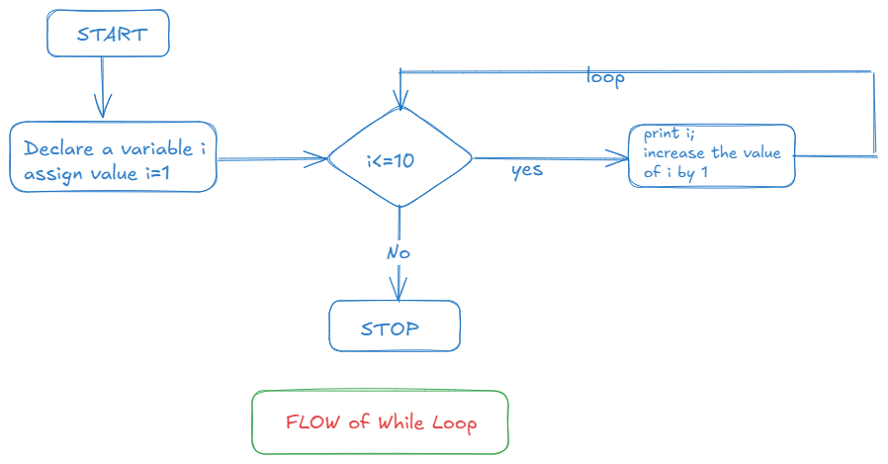

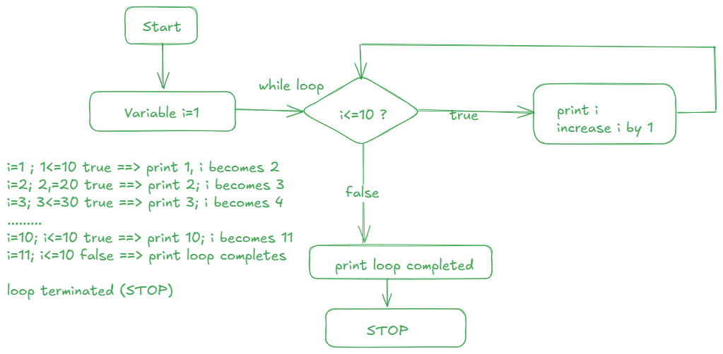

While loop is called as Entry Control Loop because it controlling from Entrance means if the condition is not true it will not proceed.

**Do While Loop**

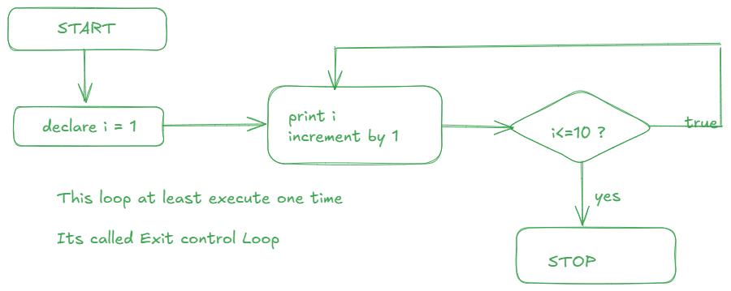

For Loop

Starts with for keywords takes 3 things separated by ; (semicolon)

For(declaration;condition;increment){

//Block of Code

}

For(var i=1;i<=10;i++){

Console.log(i)

}

//Declaration runs only for the very first time

//next 2 increment and conditions check executes everytime