<!DOCTYPE html>

<html lang="en">

<head>

<meta charset="UTF-8">

<meta name="viewport" content="width=device-width, initial-scale=1.0">

<title>Website Task - Grid Layout</title>

<style>

\* {

margin: 0;

padding: 0;

box-sizing: border-box;

}

body {

font-family: Arial, sans-serif;

background-color: #f5f6fa;

display: flex;

flex-direction: column;

min-height: 100vh;

}

header {

background-color: #4CAF50;

color: white;

padding: 20px;

text-align: center;

}

nav {

margin-top: 10px;

}

nav a {

color: white;

margin: 0 10px;

text-decoration: none;

font-weight: bold;

}

.cards-container {

display: grid;

grid-template-columns: repeat(2, 1fr);

grid-template-rows: repeat(2, auto);

gap: 20px;

padding: 40px 20px;

flex: 1;

justify-items: around;

}

.card {

background: white;

padding: 20px;

width: 90%;

max-width: 350px;

border-radius: 8px;

box-shadow: 0 2px 8px rgba(0, 0, 0, 0.1);

}

.card h2 {

color: #4CAF50;

margin-bottom: 10px;

}

.card p {

color: #555;

}

footer {

background-color: #333;

color: white;

text-align: center;

padding: 15px 10px;

}

footer a {

color: #4CAF50;

margin: 0 5px;

text-decoration: none;

}

footer a:hover {

text-decoration: underline;

}

@media (max-width: 768px) {

.cards-container {

grid-template-columns: 1fr;

}

}

</style>

</head>

<body>

<header>

<h1>Welcome to Your Website Task</h1>

<nav>

<a href="#">Home</a>

<a href="#">About</a>

<a href="#">Contact</a>

</nav>

</header>

<main class="cards-container">

<div class="card">

<h2>About CSS</h2>

<p>Cascading Style Sheets (CSS) allow you to style and layout your web pages, adding colors, spacing, and more.</p>

</div>

<div class="card">

<h2>Box Model</h2>

<p>The CSS box model describes the rectangular boxes generated for elements. It includes margins, borders, padding, and the actual content.</p>

</div>

<div class="card">

<h2>Responsive Design</h2>

<p>Responsive design ensures your webpage looks great on all devices, from desktops to mobile phones.</p>

</div>

</main>

<footer>

<p>Created by [Student Name] | Follow us on

<a href="#">Instagram</a> |

<a href="#">Twitter</a> |

<a href="#">LinkedIn</a>

</p>

</footer>

</body>

</html> 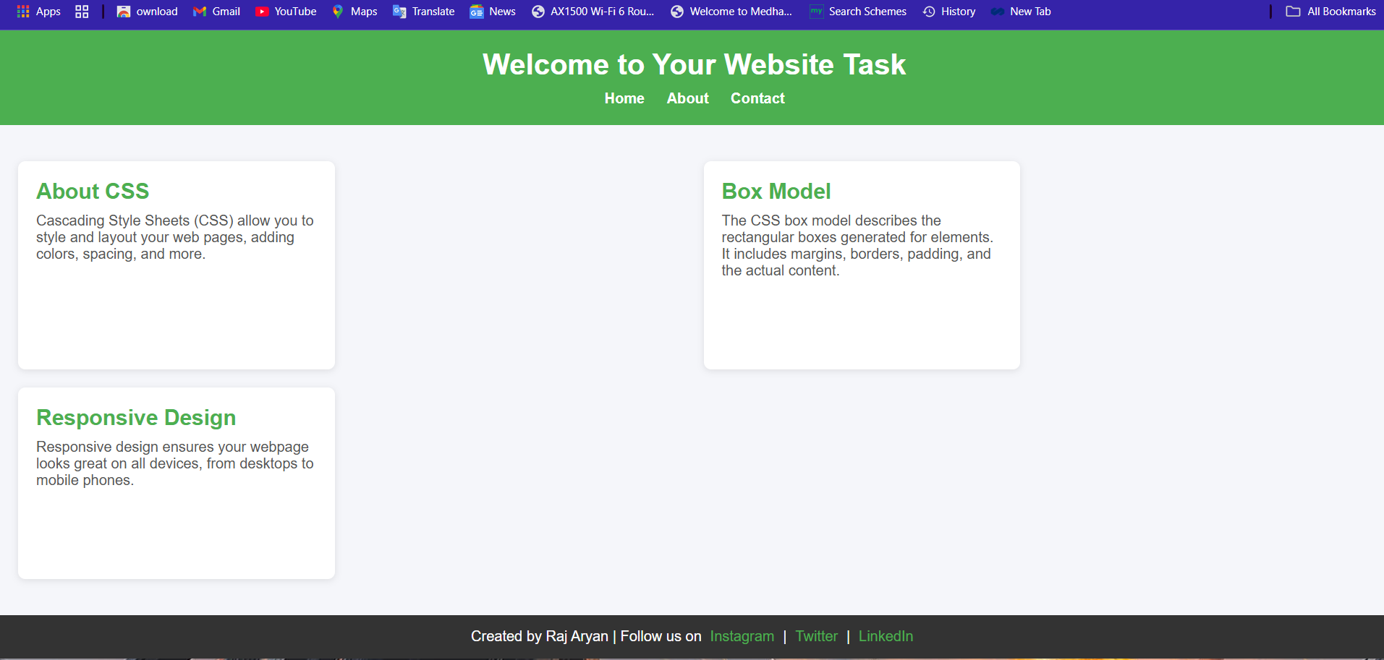

Github link🡪https://github.com/Vasisth05/activity2-3.git