**Table layout programms**

**Name**:-**Vasita Ratan R**.

**1)table1.html**

<!DOCTYPE html>

<html lang="en">

<head>

<meta charset="utf-8">

<title>table-1</title>

</head>

<body>

<table border="3">

<tr>

<td rowspan="4">page1</td>

</tr>

<tr>

<td>page3</td>

</tr>

<tr>

<td>page4</td>

</tr>

<tr>

<td>page5</td>

</tr>

<tr>

<td colspan="3">page2</td>

</tr>

</table>

</body>

</html>

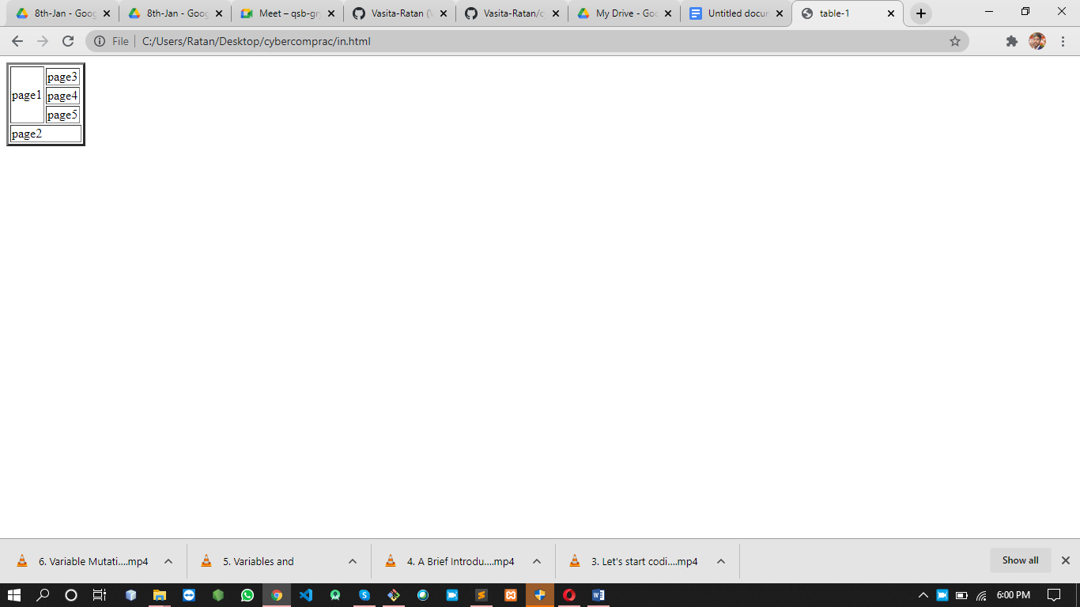

**2)table2.html**

<!DOCTYPE html>

<html lang="en">

<head>

<meta charset="utf-8">

<title>table-1</title>

</head>

<body>

<table border="3" bgcolor="yellow">

<tr bgcolor="green">

<th>Name</th>

<th>Favorite sport or league</th>

<th>Favorite team</th>

<th>Favorite social media</th>

</tr>

<tr>

<td align="center">Vasita Ratan</td>

<td align="center"><a href="FIFA world cup soccer">FIFA world cup soccer</a></td>

<td align="center"><a href="Brazil">Brazil</a></td>

<td align="center"><a href="Brazil">Instagram</a></td>

</tr>

<tr>

<td align="center">your name</td>

<td align="center"><a href="National football">National football</a></td>

<td align="center"><a href="New orliean sents">new orliean sents</a></td>

<td align="center"><a href="Reddit">Reddit</a></td>

</tr>

<tr>

<th align="center">Totals</th>

<td align="center">2</td>

<td align="center">2</td>

<td align="center">2</td>

</tr>

<tr>

<td colspan="4" align="center">My First Table!</td>

</tr>

</table>

</body>

</html>

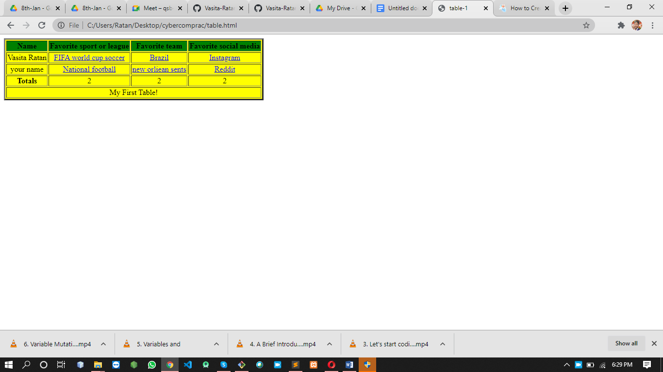

3)**table3.html**

<!DOCTYPE html>

<html lang="en">

<head>

<meta charset="utf-8">

<title>table-1</title>

</head>

<body>

<table border="5" >

<tr >

<th>Heading1</th>

<th>Heading2</th>

<th colspan="3">Heading3</th>

</tr>

<tr>

<td align="center" valign="top">cell 1 text</td>

<td align="center">cell 2 text A</td>

<td align="center">cell 3 text </td>

</tr>

<tr>

<td>a long piece of cell text all on one line without a break</td>

<td align="center">cell text </td>

<td align="center">cell text aligned right </td>

</tr>

<tr>

<th>cell text</th>

<td></td>

<td bgcolor="gray">graphic background</td>

</tr>

<tr>

<td colspan="12" align="center">Mid-table Heading</td>

</tr>

<tr>

<td>thing todo today</td>

<td rowspan="6" align="center" valign="top"><div style="width: 4px"><span>week 26</span></div></td>

<td>Monday</td>

</tr>

<tr>

<td bgcolor="red">thing to do tueday</td>

<td bgcolor="red">tueday</td>

</tr>

<tr>

<td>thing todo today</td>

<td>wendsday</td>

</tr>

<tr>

<td align="center" bgcolor="green">thing todo today</td>

<td bgcolor="green">Thursday</td>

</tr>

<tr>

<td>stuff to tidy up <b>begore the weekend!!!</b></td>

<td>friday</td>

</tr>

</table>

</body>

</html>

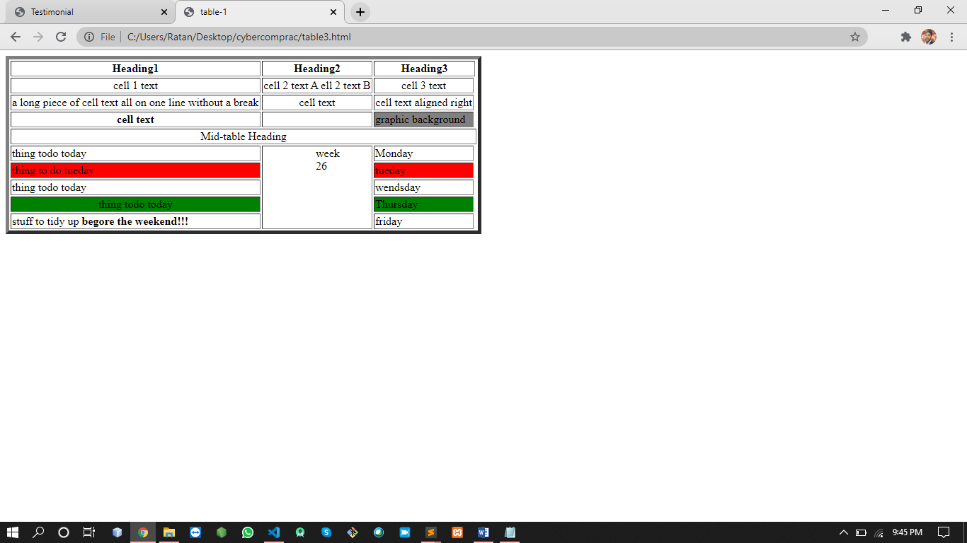

**4)table4.html**

<!DOCTYPE html>

<html>

<head>

<title>Inner Table Demonstrate</title>

</head>

<body>

<center>Example:-Nested</center>

<table border="1" align="center">

<tr>

<td colspan="3" height="70px" align="center"><b>CI</td>

<td width="20" align="center"><b>All Genders</td>

<td height="20" align="center"><b>By Gender

<table border="2" align="center">

<tr>

<th><b>Male</th>

<th><b>Female</th>

</tr>

<tr>

<td>9215604</td>

<td>4512358</td>

</tr>

</table>

</td>

</tr>

<tr>

<td width="50" align="center"><b>Rural</b></td>

<td align="center">6521458</td>

<td align="center" colspan="2">4215389</td>

<td align="center" colspan="2">421348</td>

</tr>

</table>

</body>

</html>

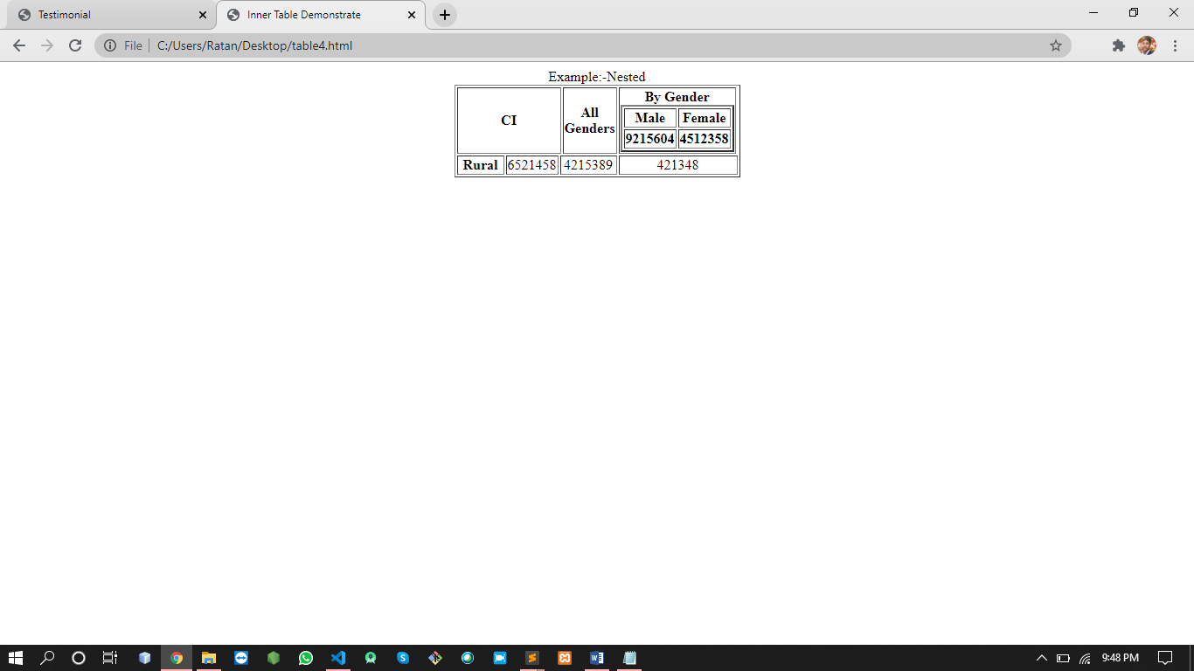

**5)form.html**

<!DOCTYPE html>

<html>

<body style="color: gray">

<form>

<table border="2" align="center" style="width: 750px,height:750px" >

<center><b>-:Simple Form:-</b></center>

<tr>

<td><label for="Firstname"><b>Firstname</b></label></td>

<td><input type="text" placeholder="Enter Firstname" name="Firstname" id="Firstname" style="width: 320px" required></td>

</tr>

<tr>

<td><label for="middlename"><b>Middlename</b></label></td>

<td><input type="text" placeholder="Enter middlename" name="middlename" id="middlename" style="width: 320px" required></td>

</tr>

<tr>

<td><label for="lastname"><b>Lastname</b></label></td>

<td><input type="text" placeholder="Enter lastname" name="lastname" id="lastname" style="width: 320px"required></td>

</tr>

<tr>

<td><label for="gender"><b>Gender</b></label></td>

<td><input type="radio" name="male" id="male" value="male" required>

<label for="male">Male</label>

<input type="radio" name="female" id="female" value="female"required>

<label for="female">Female</label>

<input type="radio" id="other" name="gender" value="other">

<label for="other">Other</label></td>

</tr>

<tr>

<td><b><label for="Address">Address</label></b></td>

<td><textarea name="Address" id="Address" placeholder="Enter Address.." style="width: 320px" required></textarea></td>

</tr>

<tr>

<td><label for="psw"><b>Password</b></label></td>

<td> <input type="password" placeholder="Enter Password" name="psw" id="psw" style="width: 320px"required></td>

</tr>

<tr>

<td><label for="psw-repeat"><b>Repeat Password</b></label></td>

<td><input type="password" placeholder="Repeat Password" name="psw-repeat" id="psw-repeat" style="width: 320px"required></td>

</tr>

<tr>

<td align="center" colspan="1"><button type="file" class="filebtn">Choose file</button></td>

<td align="center" colspan="2"><button type="submit" class="submitbtn">submit</button></td>

</tr>

</table>

</div>

</form>

</body>

</html>

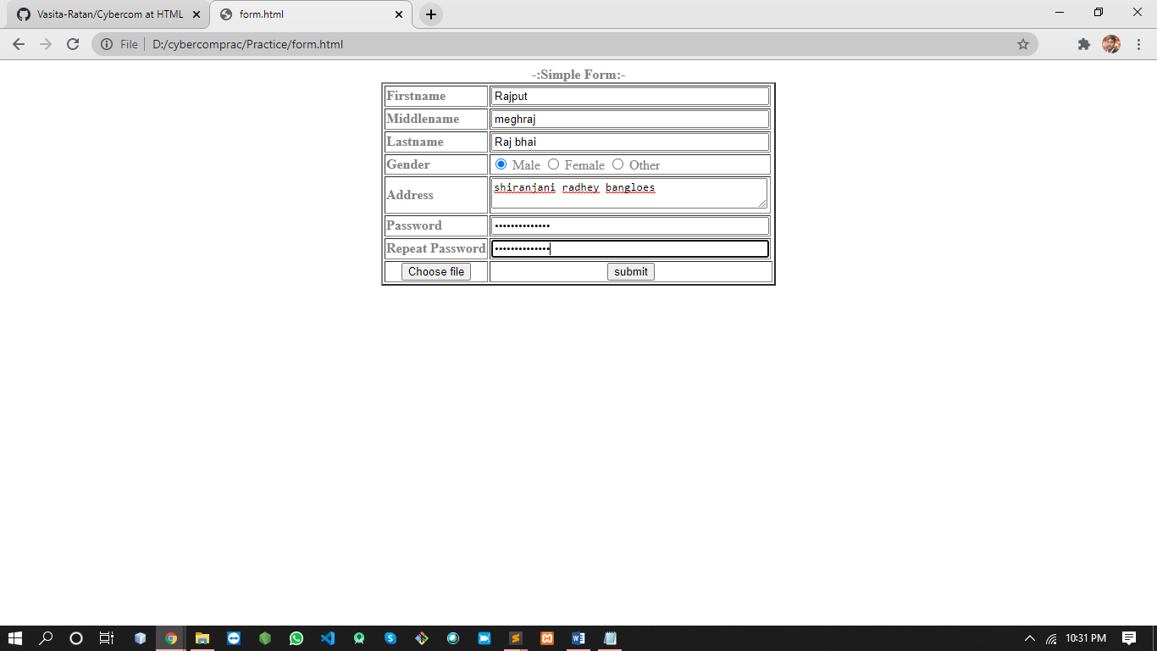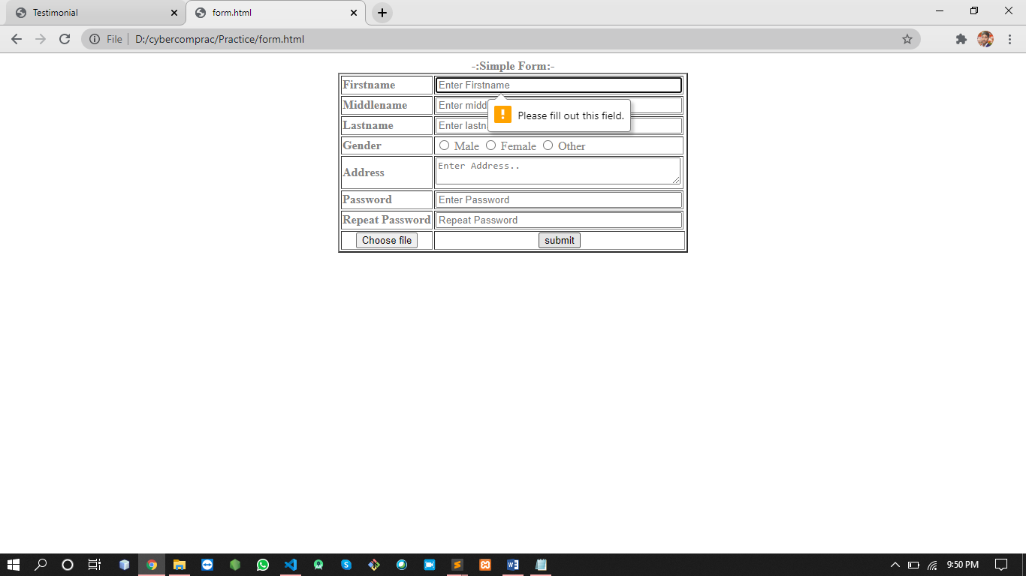

**6)saction,html**

<!DOCTYPE html>

<html>

<head>

<meta charset="utf-8">

<title>Testimonial</title>

<link rel="stylesheet" type="text/css" href="style.css">

</head>

<body>

<div class="Section">

<h1>Testimonial</h1>

<p>my hase this is our simple demonstrate vision of the about us page then we have to show <br>all admin portfolioajhasj hdfwe jfghwe sghsd3er fjdgfdhferert djshdj7eer kdfjjyterj</p>

<span class="border"></span>

<div class="ps">

<table align="center">

<tr>

<td align="center"><div class="box" align="center"><a href="#"><img src="./res/p1.jfif" width="50px" height="50px"><p>my self meghraj sing rajput i am software engineer and i am a<br>ekjr uiwe hdgf jkjf jjdkf jhdf lrtu ghgs hdfge kdfe<br>shgsdghsd jkdf kfge kjfge jhjef hgfdfd jkdfhf ghhdf</p></a><p><b>Meghraj</b><p><center>hello</center></div></td>

<td><div class="box" ><a href="#"><img src="./res/p2.jfif" width="50px" height="50px"><p>meghraj sderkr rtjjh jhhjhft hhjkkf hjfdf kjg<br>ekjr uiwe hdgf jkjf jjdkf jhdf lrtu ghgs hsdj hf<br>shgsdghsd jkdf kfge kjfge jhjef hgfdfd jkdfhf ghhdf</p></a><p><b>YashRaj</b><p><center>hello</center></div></td>

<td><div class="box"><a href="#"><img src="./res/p3.jfif" width="50px" height="50px"><p>meghraj sderkr rtjjh jhhjhft hhjkkf hjfdf kjg<br>ekjr uiwe hdgf jkjf jjdkf jhdf lrtu ghgs<br>shgsdghsd jkdf kfge kjfge jhjef hgfdfd jkdfhf ghhdf</p></a><p><b>Vishwaraj</b><p><center>hello</center></div></td>

</tr>

</table>

</div>

</div>

</body>

</html>

**Style.css**

*{

margin: 0;

padding: 0;

font-family: sans-serif;

}

.Section{

overflow: hidden;

text-align: center;

background: gray;

padding: 60p;

}

.Section h1{

text-transform: uppercase;

margin-bottom: 60px;

color: white;

font-size: 40px;

}

.border{

display: :block;

margin: auto;

width:10px;

height: 10px;

background: gray;

margin-bottom: 10px;

}

.ps{

margin-bottom: 5px;

}

.ps a{

display: inline-block;

margin: 10px;

width: 195px;

height: 195px;

overflow: hidden;

border-radius: 100%;

align-content: center;

}

.box{

width: 270px;

height: 300px;

background: white;

margin: 25px 25px;

box-sizing: border-box;

font-size: 17px;

text-align: center;

position: relative;

justify-content: center;

}

