**Table layout programms**

**Name**:-**Vasita Ratan R**.

**1)table1.html**

<!DOCTYPE html>

<html lang="en">

<head>

<meta charset="utf-8">

<title>table-1</title>

</head>

<body>

<table border="3">

<tr>

<td rowspan="4">page1</td>

</tr>

<tr>

<td>page3</td>

</tr>

<tr>

<td>page4</td>

</tr>

<tr>

<td>page5</td>

</tr>

<tr>

<td colspan="3">page2</td>

</tr>

</table>

</body>

</html>

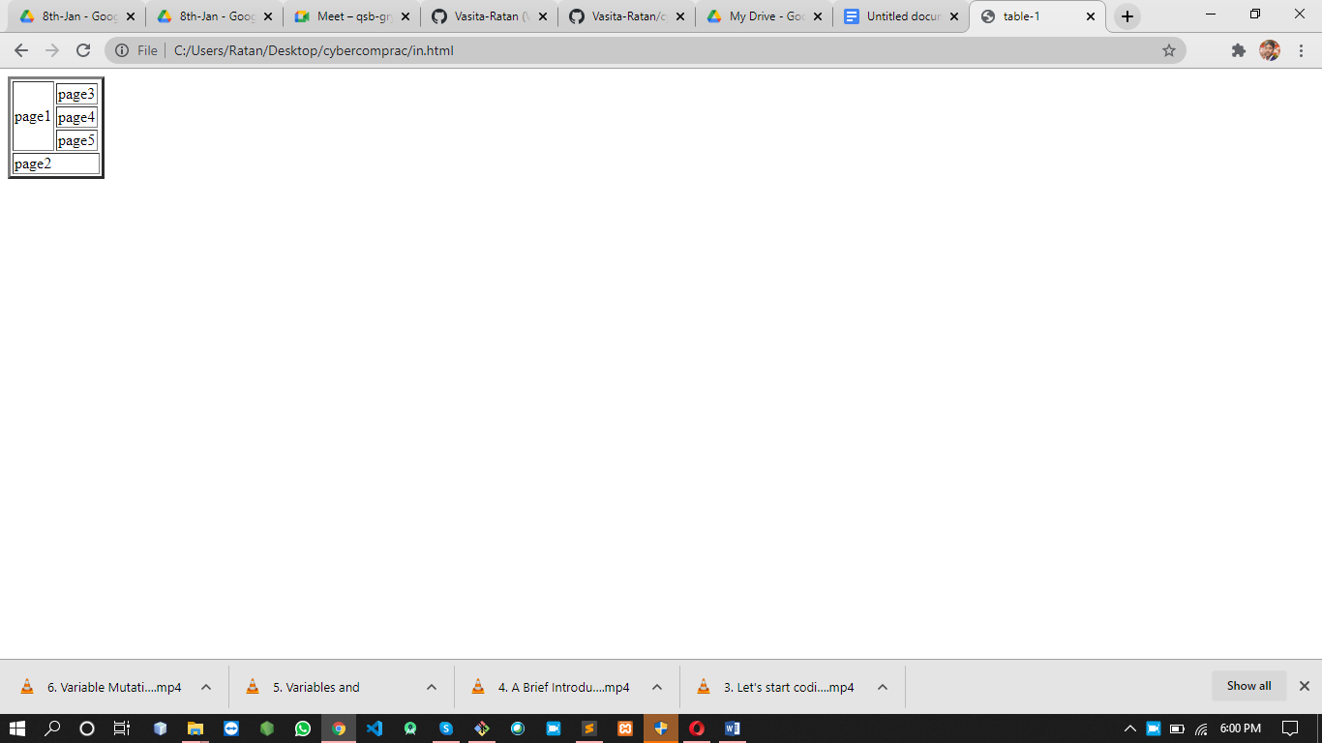

**2)table2.html**

<!DOCTYPE html>

<html lang="en">

<head>

<meta charset="utf-8">

<title>table-1</title>

</head>

<body>

<table border="3" bgcolor="yellow">

<tr bgcolor="green">

<th>Name</th>

<th>Favorite sport or league</th>

<th>Favorite team</th>

<th>Favorite social media</th>

</tr>

<tr>

<td align="center">Vasita Ratan</td>

<td align="center"><a href="FIFA world cup soccer">FIFA world cup soccer</a></td>

<td align="center"><a href="Brazil">Brazil</a></td>

<td align="center"><a href="Brazil">Instagram</a></td>

</tr>

<tr>

<td align="center">your name</td>

<td align="center"><a href="National football">National football</a></td>

<td align="center"><a href="New orliean sents">new orliean sents</a></td>

<td align="center"><a href="Reddit">Reddit</a></td>

</tr>

<tr>

<th align="center">Totals</th>

<td align="center">2</td>

<td align="center">2</td>

<td align="center">2</td>

</tr>

<tr>

<td colspan="4" align="center">My First Table!</td>

</tr>

</table>

</body>

</html>

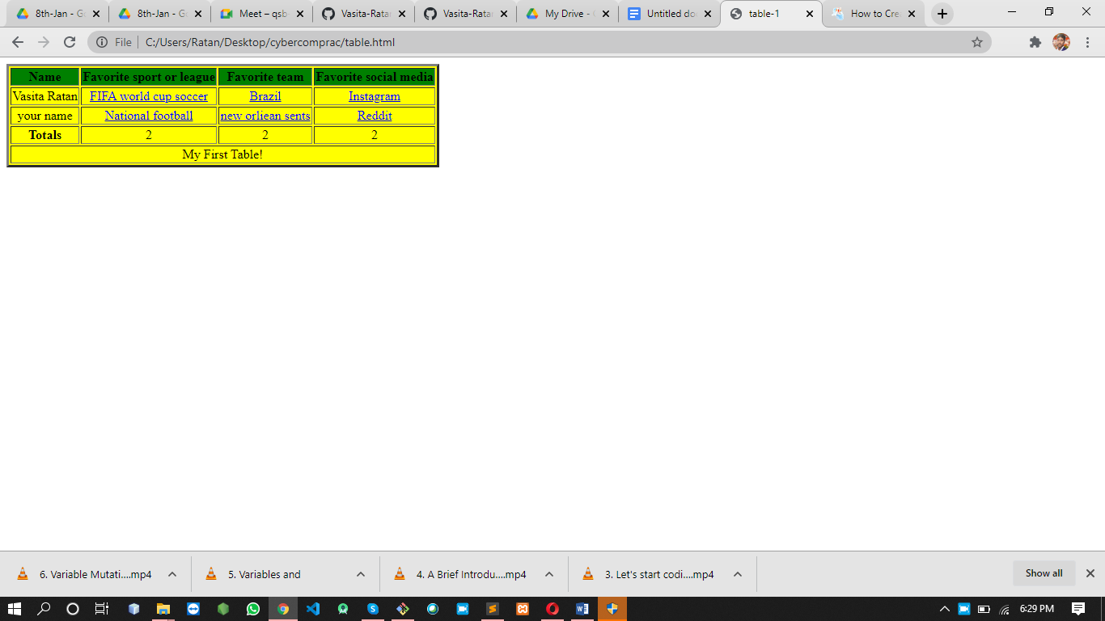

3)**table3.html**

<!DOCTYPE html>

<html lang="en">

<head>

<meta charset="utf-8">

<title>table-1</title>

</head>

<body>

<table border="5" >

<tr >

<th>Heading1</th>

<th>Heading2</th>

<th colspan="3">Heading3</th>

</tr>

<tr>

<td align="center" valign="top">cell 1 text</td>

<td align="center">cell 2 text A</td>

<td align="center">cell 3 text </td>

</tr>

<tr>

<td>a long piece of cell text all on one line without a break</td>

<td align="center">cell text </td>

<td align="center">cell text aligned right </td>

</tr>

<tr>

<th>cell text</th>

<td></td>

<td bgcolor="gray">graphic background</td>

</tr>

<tr>

<td colspan="12" align="center">Mid-table Heading</td>

</tr>

<tr>

<td>thing todo today</td>

<td rowspan="6" align="center" valign="top"><div style="width: 4px"><span>week 26</span></div></td>

<td>Monday</td>

</tr>

<tr>

<td bgcolor="red">thing to do tueday</td>

<td bgcolor="red">tueday</td>

</tr>

<tr>

<td>thing todo today</td>

<td>wendsday</td>

</tr>

<tr>

<td align="center" bgcolor="green">thing todo today</td>

<td bgcolor="green">Thursday</td>

</tr>

<tr>

<td>stuff to tidy up <b>begore the weekend!!!</b></td>

<td>friday</td>

</tr>

</table>

</body>

</html>

