DAY 1 Monday

Linux Basics and CentOS Administration

**Network Administration**

[Type of Files in Linux](https://www.cherryservers.com/blog/a-complete-guide-to-understanding-linux-file-system-tree#type-of-files-in-linux)

* [/ ( Root Directory)](https://www.cherryservers.com/blog/a-complete-guide-to-understanding-linux-file-system-tree#--root-directory)
* [/home](https://www.cherryservers.com/blog/a-complete-guide-to-understanding-linux-file-system-tree#home)
* [/root](https://www.cherryservers.com/blog/a-complete-guide-to-understanding-linux-file-system-tree#root)
* [/boot](https://www.cherryservers.com/blog/a-complete-guide-to-understanding-linux-file-system-tree#boot)
* [/bin](https://www.cherryservers.com/blog/a-complete-guide-to-understanding-linux-file-system-tree#bin)
* [/sbin](https://www.cherryservers.com/blog/a-complete-guide-to-understanding-linux-file-system-tree#sbin)
* [/dev](https://www.cherryservers.com/blog/a-complete-guide-to-understanding-linux-file-system-tree#dev)
* [/etc](https://www.cherryservers.com/blog/a-complete-guide-to-understanding-linux-file-system-tree#etc)
* [/media](https://www.cherryservers.com/blog/a-complete-guide-to-understanding-linux-file-system-tree#media)
* [/mnt](https://www.cherryservers.com/blog/a-complete-guide-to-understanding-linux-file-system-tree#mnt)
* [/tmp](https://www.cherryservers.com/blog/a-complete-guide-to-understanding-linux-file-system-tree#tmp)
* [/opt](https://www.cherryservers.com/blog/a-complete-guide-to-understanding-linux-file-system-tree#opt)
* [/var](https://www.cherryservers.com/blog/a-complete-guide-to-understanding-linux-file-system-tree#var)
* [/run](https://www.cherryservers.com/blog/a-complete-guide-to-understanding-linux-file-system-tree#run)
* [/proc](https://www.cherryservers.com/blog/a-complete-guide-to-understanding-linux-file-system-tree#proc)
* [/usr](https://www.cherryservers.com/blog/a-complete-guide-to-understanding-linux-file-system-tree#usr)

File system

A file system is the methods and the data structures that an operating system uses to keep track of files.

Told about VI editor

Vi files.txt

Click on i to get into insert mode

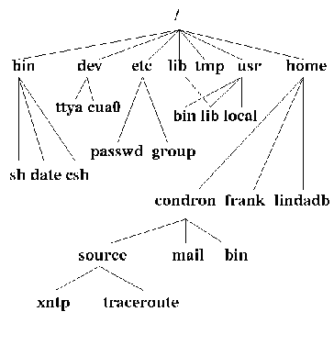

Useradd Rahul

Passwd Rahul

Exitr

Touch files.txt

Cat>>mkt.txt

Cat mkt.txt

Touch { 1,2,3 …. 10}

ls

touch { 5.6.6 … 10}

ls

touch 12 13 14 15 16

ls

mkdir a b c d

dir

mkdir -p x>y>z

dir

ls -l

cd x

dir

**ACL**

ll file 1

setfacl -m u:user1:rw file1

an **alias** is a shortcut that allows you to create a custom command or replace an existing command with a simpler one

alias name='command'

alias ll='ls -la'

alias

unalias name