**Evaluation of global gridded climate products in reproducing spatial and temporal variation in precipitation in central Panama**

Vicente Vasquez1* and Helene C. Muller-Landau1

1 Smithsonian Tropical Research Institute, P.O. Box 0843-03092, Balboa Ancón, Republic of Panamá

* Corresponding author: [vicenteavv7@gmail.com](mailto:vicenteavv7@gmail.com)

**Abstract**

Tropical forests vary widely in their precipitation regimes and seasonal water availability, but high-quality in situ (ground-based) meteorological data are rare, and few studies have evaluated the performance of global gridded climate products in the tropics. We compared the performance of eleven high-resolution gridded climate products against in situ datasets spanning high rainfall variation in central Panama. The gridded products almost all captured the broad trends of spatial and seasonal rainfall variation in central Panama, and all underestimated precipitation in the wettest sites, especially in the dry season, but differed widely in their performance. Seasonal and interannual variation were best captured by CHIRPSv2, while spatial variation was best captured by CHELSA 2.1, which has finer spatial resolution. Our ability to quantify performance was constrained by limited data availability, even in this region with relatively many high-quality long-term in situ datasets, highlighting the need for more investment in ground-based data collection.

**Keywords:** precipitation, Panama, climate reanalyses, satellite-based precipitation; rain gauge; validation; tropical forests

**Introduction**

Tropical forests vary widely in their total annual precipitation and its seasonal distribution, and thus in the frequency, intensity and duration of drought stress, and this in turn drives considerable variation in tropical forest communities and ecosystems (Muller-Landau et al., 2021). Information on local climate, and especially precipitation, is thus critically important for ecological studies in tropical forests. Research on Barro Colorado Island (BCI) has benefited from an exceptionally strong meteorological monitoring program (Paton and Stallard, 2023). However, such high-quality in situ (ground-based) meteorological data are relatively scarce in Panama and most other tropical forest regions (Malhi and Wright, 2004; Clark, 2007).

Global gridded climate products provide a potential alternative for characterizing climate when local measurements are not available (Burton et al., 2018). These global climate products are produced by combining data from in situ and/or satellite sensors with statistical and/or mechanistic models. A plethora of such datasets now yields a wide array of options for researchers; e.g., an initial search for this study yielded 23 publicly available precipitation products (Table S2). Unfortunately, relatively few studies have evaluated the performance of any of these datasets in reproducing spatial and temporal climate variation in tropical landscapes, much less provided quantitative comparisons to inform choice among these datasets (Trenberth et al., 2001; Burton et al., 2018).

Central Panama is an excellent region for evaluating the performance of global climate products in reproducing precipitation patterns in the tropics. Annual precipitation varies more than twofold due to a steep rainfall gradient from the drier Pacific to the wetter Caribbean side of the isthmus, as well as elevational rainfall variation (Muller-Landau et al., 2023; Paton and Stallard, 2023). And importantly, the region features a relatively large number of high-quality, long-term rainfall monitoring sites, reflecting the importance of rainfall for the operation of the Panama Canal as well as the legacy of the Smithsonian Tropical Research Institute (Paton, 2022; Paton, 2023; Paton and Stallard, 2023)

Here, we evaluate ten high-spatial-resolution gridded climate datasets against in situ rainfall data in central Panama. We first specifically assess their ability to capture spatial variation including the steep regional rainfall gradient, as well as elevational variation. For those datasets with high temporal resolution data, we further evaluate their accuracy and precision in reproducing seasonal and interannual variation. Our aim is to provide guidance for researchers seeking to choose among available gridded datasets to estimate rainfall in tropical sites lacking nearby ground stations. We treated the in situ data as “truth” in evaluating the gridded climate datasets, though we recognize that not all differences necessarily reflect errors in the global gridded climate products. Most fundamentally, rain gauge data reflect rainfall at a single point (<0.1 m2), whereas gridded climate products provide values for average rainfall over an area more than a million times larger (>1 km2). Rain gauges also systematically underestimate precipitation by ~9-23% due to wind effects and evaporation (Pollock et al., 2018).

**Methods**

*Study region*

The focal region is centered on Barro Colorado Island and the Panama Canal (Figure 1). It encompasses a narrow isthmus with a steep regional rainfall gradient from the drier Pacific to the wetter Caribbean side, as well as a 425 km2 manmade lake (Gatun Lake, since 1913) and orographic variation from sea level to 1340 m elevation.

*Datasets*

In situ rainfall data were collected at 79 stations, including 73 maintained by the Panama Canal Authority (ACP) and 6 maintained by the Smithsonian Tropical Research Institute (STRI). Rainfall data were collected using automated tipping buckets and manual rain gauges (Paton, 2022). Data were pre-screened by Steve Paton. The temporal extent of in situ records varied among sites, from 1 to 103 years of data per station. The in situ data also contained gaps of missing data due to sensor failures or other problems. We restricted our analyses to subsets of sites having more complete data during the years covered by the gridded datasets, as detailed below.

We evaluated precipitation products from 11 publicly available gridded climate datasets with spatial resolutions of 0.05 degrees (approximately 5.5 km) or better (Table 1, see also Table S2 for a complete list of datasets considered). We did not consider coarser resolution products because of the steepness of climate gradients in the focal region. Gridded datasets were resampled at 0.008333-degree resolution using the raster package (Hijmans et al., 2023b). The time periods covered vary among gridded datasets and spanned 1970-2016 (Table 1). The gridded climate products tested here are not independent – they share many of the same forcing datasets and/or algorithms (Table S2).

*Statistical analyses*

Our analyses of spatial variation focused on two response variables: total annual precipitation and total January to April precipitation, the latter a proxy for dry season precipitation. To visualize spatial patterns of precipitation for each gridded dataset, we computed average annual precipitation and average January to April precipitation for each grid cell of each dataset and mapped these across the region. For analyses of performance in capturing spatial variation, we used in situ data for 31 sites each having 32 or more complete years of data during 1970-2016. We used gridded data for the raster cells including the ground station locations, or the closest non-null values. (Some stations fell within grid cells that were largely water, which had null values in some gridded datasets.) We gap-filled the ground station time series of annual precipitation and January to April precipitation. Specifically, for each response variable (annual precipitation, January to April precipitation), we fit linear mixed models with random effects for year and fixed effects for site, including all site-year combinations with complete data. We then used the predictions of these models for missing site-year combinations. For each gridded dataset, we calculated the observed mean annual precipitation and mean January to April precipitation for each ground station from the gap-filled data, restricting to the years included in that gridded dataset. We evaluated the performance of each gridded dataset in capturing spatial variation in each response variable using scatterplots, linear regressions (for predicting the in situ data from the gridded data), and the following metrics: the Pearson correlation coefficient, root mean square error (RMSE), mean absolute error (MAE) and mean bias across the 31 sites.

2. Mean bias=

where *yi* is the value for the gridded dataset for site *i*, *xi* is in situ value for site *i*, and *n* is the number of sites.

We evaluated the performance of the gridded datasets in capturing temporal variation in precipitation at nine focal ground stations that each had 44 or more years of data during 1970-2016. These included two precipitation records for Barro Colorado Island. BCICLEAR is the STRI meteorological record from the lab clearing, which combines data from an automated tipping bucket with a manual rain gauge (the total in the manual rain gauge is distributed across days in accordance with the totals in the automated tipping bucket). BCI and the other seven stations were ACP sites monitored with electronic rain gauges. The nine sites ranged in mean annual rainfall from 2088 to 3947 mm/year during 1970-2016 (Figure 4). To evaluate performance in capturing seasonal variation, we first calculated the mean rainfall for each calendar month at each site for the year’s corresponding to each gridded dataset, then calculated Pearson correlation coefficients, RMSE, and MAE over the 12 calendar months for each site and dataset, and finally averaged these statistics over the nine sites for each dataset. To evaluate performance in capturing interannual variation, we calculated Pearson correlation coefficients, RMSE, MAE, and mean bias % for total annual rainfall across years for each site and dataset, and then averaged the results over sites. Missing values were not gap-filled, but simply omitted. Interannual variability could be assessed only for six gridded datasets with publicly available time series between 1979 and 2016.

All analyses were conducted in R version 4.2.1 (R Core Team, 2022) using the packages terra, sp, raster, tmap, and seegSDM (Pebesma and Bivand, 2005; Tennekes, 2018; Hijmans et al., 2023a; Hijmans et al., 2023b). Complete code is presented in online supplementary material in the Smithsonian Figshare repository.

**Results**

*Spatial patterns*

All the gridded datasets show higher annual precipitation at higher elevation and on the Caribbean (northwest) side of the isthmus, consistent with in situ observations, but they differ widely in the strength of these gradients and the details of the patterns (Figure 2, top). The datasets differ even more strongly in their spatial patterns of January to April (dry season) precipitation (Figure 2, bottom). The gridded precipitation datasets perform moderately well in capturing annual spatial variation, with Pearson correlation coefficients ranging between 0.35 to 0.88. For January to April precipitation, correlation coefficients vary from 0.14 to 0.86 (Figure 4, Table 2). However, all have substantial errors, with RMSE of 276-548 mm for annual precipitation, and 80-130 mm for dry season precipitation. The spatial pattern for total annual precipitation across the in-situ stations is best captured by CHIRPS v2.0, CHELSA 2.1, CHPclim v1.0, and CHELSA EarthEnv, while CHIRPS v2.0, TERRAclim and CHPclim v1.0 best capture the variation in Jan-Apr precipitation (Pearson r>0.8 in all cases). The CHIRPS v2.0 dataset had the lowest RMSE and MAE for both mean annual precipitation and January-to-April precipitation. In general, the gridded datasets systematically underestimate precipitation at the wettest sites, those at high elevation and along the Caribbean coast (Figures 3, 4).

The datasets vary strongly in their biases relative to the in-situ data. Given the known tendency towards under catchment in rain gauge measurements and the algorithms to compensate for this, we expected all the gridded datasets to exhibit substantial positive biases relative to the in-situ data. For total annual precipitation, 7 of 11 gridded datasets average substantially higher values consistent with this expectation, but the remaining 4 showed small negative bias (mean bias ranged from -44 to +418 mm; Table 2). Further, 10 of 11 gridded datasets systematically *underestimate* dry season precipitation relative to in situ data (mean bias ranged from -63 to +5 mm, Table 2). Examination of the patterns of bias at across sites reveals that the gridded products all exhibit the expected modest positive bias (higher values than in situ) in the lower rainfall lowland sites, and all have strong negative bias at high rainfall high elevation sites (Figures 3, 4). The PBCOR-corrected datasets have higher precipitation totals, and thus systematically shift the mean bias upwards.

*Seasonal and interannual patterns*

All gridded datasets did well at reproducing the broad patterns of seasonal variation in mean rainfall among calendar months (Pearson correlations between 0.93 and 0.98, Table 2). However, all underestimated dry season precipitation in the wettest sites (Figure 5). CHIRPSv2 had the highest Pearson correlation for seasonality (0.98) and the smallest average RMSE (23 mm).

Interannual variability in the rain gauge data was less well reproduced in the gridded climate products, especially at the wetter sites (Figure 6). The best datasets – specifically CHIRPS v2.0 and CHELSA W5E5 had Pearson correlation coefficients of 0.74 and 0.69, respectively across sites, but other datasets did much worse (r=0.26 to 0.59, Table 4). The highest annual rainfall years observed in in situ measurements at the wet sites were almost never mirrored in the gridded datasets (Figure 6).

**Discussion (~800 words)**

*Performance of gridded climate products in Panama*

The high-resolution gridded climate products analyzed here all did moderately well in capturing the broad trends of spatial and seasonal variation in precipitation in central Panama, as reflected in high Pearson correlations. However, all of them underestimated precipitation in the wettest sites, especially dry season precipitation. In general, the products performed less well at reproducing spatial variation in dry season precipitation and interannual variation in total annual precipitation.

Unsurprisingly, our analyses suggest that different climate products are best for different applications. For studies of among-site variation within central Panama, we recommend CHELSA 2.1, which best captured spatial variation in total annual precipitation and offers ~1 km spatial resolution (and includes values for grid cells that are mostly or entirely water). For analyses requiring time series, we recommend CHIRPSv2 which best captured seasonal and interannual variation and is available at daily resolution from 1981 to near real time. Note that CHIRPSv2 is has only 0.05 degree (~5 km) spatial resolution; CHELSA W5E5 offers higher spatial resolution daily time series for 1979-2016, and also performed well in capturing seasonal and interannual variation. The steep precipitation gradient of Panama, and the narrow isthmus requires high resolution products. Products with coarser than 0.05 degrees resolution miss most of the local variability.

*Interpretation and comparisons with other studies*

Interpretation of differences among the climate products in RMSE, MAE and mean bias relative to the in situ data is complicated by the known systematic undercatch in rain gauge measurements, as well as by the fact that some of our in situ datasets also directly contribute to some of the gridded climate products. Given that in situ data are systematic underestimates, accurate climate products should show substantial positive mean bias relative to the in situ observations, and this will elevate their RMSE and MAE. Most of the climate products show substantial positive mean bias (90-414mm) for total annual precipitation, on the order of what would be expected to compensate for undercatch. The exceptions are WorldClim and TERRA, which share a forcing dataset that is an observational network, thus approaching in situ values. Some of our in situ stations are included in the observational datasets that inform WorldClim, TERRA, and CHPclim v1.0, and thus we expect these products to exhibit higher performance relative to these in situ datasets, even though they are likely to perform more poorly at independent validation stations. It's also important to keep in mind that the gridded climate products evaluated here are not all independent – there are many shared forcing datasets among them, which can in part explain similarities in performance (Table 1).

Our findings on the performance or gridded precipitation products are broadly consistent with previous studies, although there have been relatively few studies in the tropics, and most of those have included only one or a few gridded products. López-Bermeo et al. (2022) and Paredes Trejo et al. (2016) found that CHIRPSv2 does well in reproducing spatial, seasonal, and interannual variation in rainfall in the Angioquia region of Colombia and in Venezuela, respectively. Burton et al (2018) evaluated CHIRPS and three other satellite-based rainfall products in tropical South America and Africa, finding that CHIRPS and TRMM did best (we did not include TRMM in our analysis because of its coarse resolution of 0.25 degrees). Bastidas Oejo et al. (2019) found that CHELSA1.2 and Worldclim both showed very good performance in reproducing rainfall patterns in northwest Colombia, with CHELSA1.2 doing somewhat better, also consistent with our findings.

*Recommendations for future research*

Future analyses should build on the work here by incorporating additional in situ datasets, applying more sophisticated methods to assess the performance of the gridded climate products, and evaluating additional variables. We’ve included only rain gauges in our evaluation; data from local weather radar, weirs, and other measurements of river and lake levels could be integrated to more comprehensively assess precipitation patterns. Their inclusion would require more complex analyses, including accounting for distance effects in the radar data and applying hydrological models to link rainfall with runoff. The rain gauge data could also be better utilized by incorporating explicit, empirically supported models for how point measurements such as rain gauges are expected to differ from average values over large areas, ideally also accounting for environmental heterogeneity within grid cells, and by incorporating sites with shorter time series. Here we’ve evaluated only precipitation; a more complete treatment would also encompass other variables important for predicting drought stress and forest ecosystem function, notably including potential evapotranspiration, temperature, and windspeed.

Our ability to quantify performance was constrained by limited data availability, even in this region with relatively many high-quality, long-term in situ datasets. For example, the gridded datasets exhibit quite different patterns of precipitation in the northwestern area examined, which lacked ground stations for evaluation (Figures 1, 2). The relatively good performance of the gridded products should not be taken as a reason to reduce investment in ground data. These products ultimately depend on high-quality in situ data, which enters into these products in multiple ways. Especially given the high topographic and land cover heterogeneity in this region, a more even and denser network of stations is needed to fully capture regional climate variation, better evaluate the gridded products, and contribute to better products themselves. We thus recommend investing more in meteorological data collection and curation.

**Acknowledgments**

We gratefully acknowledge the work of Steve Paton and many technicians at the Smithsonian Tropical Research Institute and the Autoridad del Canal de Panama (as well as its precursor, the Panama Canal Commission) in collecting, cleaning, and curating the in situ meteorological data. This work builds on previous unpublished analyses and code by KC Cushman.

Table 1. Key characteristics of the gridded climate products analyzed here. Almost all these products have a forcing dataset that is a climate reanalysis (ERA interim, ERA5, JRA-55); climate reanalyses combine past observations with mechanistic climate models to generate time series of multiple climate variables.

|  |  |  |  |  |  |  |
| --- | --- | --- | --- | --- | --- | --- |
| **Name** | **Forcing dataset** | **Resolution (degrees)** | **Resolution (km)** | **Time period** | **Native format** | **Citation** |
| CHELSA 1.2 | Reanalysis dataset: ERA interim | 0.0083333 | ~1 | 1979-2013 | Climatology, monthly timeseries | (Karger et al., 2018) |
| CHELSA 2.1 | Reanalysis dataset: ERA5 | 0.0083333 | ~1 | 1981-2010 | Climatology, monthly timeseries | (Karger et al., 2018) |
| CHELSA EarthEnv | Reanalysis dataset:ERA5 | 0.0083333 | ~1 | 2003-2016 | Daily timeseries | (Karger et al., 2021b) |
| CHELSA W5E5 | Reanalysis dataset:  WFDE5 | 0.0083333 | ~1 | 1979-2016 | Daily timeseries | (Karger et al., 2021a) |
| CHIRPS v2  (Merged dataset) | Satellite products: TMPA  Observational dataset:  GTS | 0.05 | ~5.5 | 1981-2022 | Monthly timeseries | (Funk et al., 2014) |
| CHPclim v.1.0 | Observational dataset:  GHCN & FAO.  Assisted with satellites | 0.05 | ~5.5 | 1980-2009* | Climatologies | (Funk et al., 2015) |
| TERRA | Spatially interpolated dataset:  WorldClim V2  Reanalysis dataset: JRA-55 | 0.04166667 | ~5 | 1981-2010 | Climatology, monthly timeseries | (Abatzoglou et al., 2018) |
| WorldClim V2  (Spatially interpolated dataset) | Observational dataset: WMO & FAO | 0.0083333 | ~1 | 1970-2000 | Climatologies | (Fick and Hijmans, 2017) |
| PBCORCHELSA 1.2 | ERA interim & USGS, GRDC, etc. | 0.0083333 | ~1§ | 1979-2013 | Climatologies | (Karger et al., 2018; Beck et al., 2020) |
| PBCOR CHPclim | GHCN & FAO & USGS, GRDC, etc. | 0.05 | ~5.5 | 1980-2009* | Climatologies | (Funk et al., 2015; Beck et al., 2020) |
| PBCOR WorldClim | WMO & FAO & USGS, GRDC, etc. | 0.0083333 | ~1§ | 1970-2000 | Climatologies | (Fick and Hijmans, 2017; Beck et al., 2020) |

* Adjusted to 1980-2009, although FAO doesn’t provide temporal extent for its normal

§ PBCOR (Precipitation Bias Correction) versions of products are created by multiplying the original product by the PBCOR factors. The native resolution of the PBCOR bias correction factors is 0.05 degrees; these are resampled to the resolution of the original datasets to produce the bias corrected datasets.

Table 2. Summary statistics for the performance of different gridded climate products in relation to the in situ rain gauge observations in central Panama. Performance in relation to spatial variation is based on analysis of data for 31 sites each having 32 or more complete years of data during 1970-2016. Performance in reproducing seasonal variation among averages for calendar months and interannual variation in total annual precipitation is based on nine ground stations having complete data for 1979-2016. R is the Pearson correlation coefficient, RMSE is root mean squared error, MAE is mean absolute error, and Mean bias % is the mean relative error. Bold highlights the best performance within each column. Only some of the gridded products had time series enabling evaluation of seasonal and interannual patterns.

|  |  |  |  |  |  |  |  |  |  |  |  |  |
| --- | --- | --- | --- | --- | --- | --- | --- | --- | --- | --- | --- | --- |
| **Gridded Climate Product** | **Spatial variation among 31 sites in total annual precipitation** | | | | **Spatial variation among 31 sites in January-to-April precipitation** | | | | **Seasonal variation within 9 sites** | | **Interannual variation within 9 sites** | |
| **R** | **RMSE** | **Mean bias (mm)** | **MAE** | **R** | **RMSE** | **Mean bias (mm)** | **MAE** | **R** | **RMSE** | **R** | **RMSE** |
| CHELSA 1.2 | 0.79 | 337 | 77 | 267 | 0.62 | 106 | -33 | 62 | 0.97 | 31 | 0.31 | 836 |
| CHELSA 2.1 | 0.86 | 492 | 404 | 451 | 0.60 | 104 | **-4** | 69 | 0.97 | 42 | 0.57 | 608 |
| CHELSA EarthEnv | 0.85 | 317 | 74 | 259 | 0.66 | 90 | 5 | 60 | 0.94 | 24 | 0.59 | 625 |
| CHPclim | 0.85 | 379 | 255 | 334 | **0.86** | 90 | -45 | 56 | 0.96 | 29 |  |  |
| WorldClim 2.1 | 0.64 | 400 | -15 | 329 | 0.46 | 119 | -50 | 83 | 0.95 | 34 |  |  |
| CHIRPS 2.0 | **0.88** | **276** | 101 | **227** | 0.82 | **80** | -21 | **48** | **0.98** | **23** | **0.74** | **463** |
| CHELSA-W5E5v1.0 | 0.35 | 493 | **-8** | 399 | 0.14 | 123 | -8 | 82 | 0.97 | 42 | 0.69 | 657 |
| Terra Climate | 0.78 | 406 | -44 | 339 | 0.84 | 110 | -63 | 73 | 0.93 | 33 | 0.26 | 671 |
| PBCOR CHELSA 1.2 | 0.75 | 378 | 109 | 308 | 0.60 | 108 | -32 | 66 | 0.97 | 28 |  |  |
| PBCOR CHPclim | 0.77 | 548 | 418 | 466 | 0.81 | 87 | -32 | 53 | 0.96 | 36 |  |  |
| PBCOR WorldClim 2.1 | 0.55 | 420 | -11 | 337 | 0.32 | 130 | -58 | 93 | 0.96 | 36 |  |  |

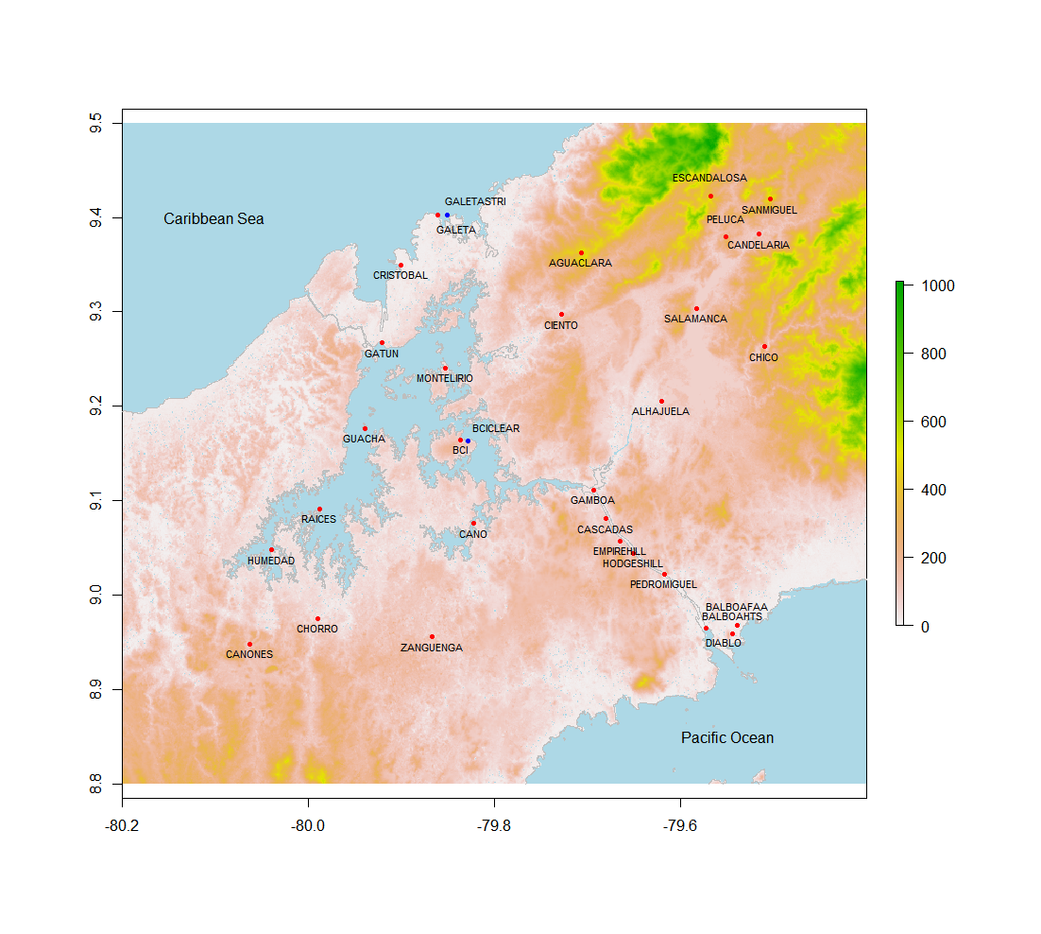

Figure 1. Topographic map of the focal region, indicating the location of in situ measurement sites used in this analysis including ACP stations (red) and STRI stations (blue).



Figure 2. Mean climatologies for each gridded climate product. Note that the temporal range varies among datasets (Table 1).



Figure 3. Relative bias (of in situ measurement) for of the gridded climate products in relation to in situ measurements at different sites for total annual precipitation (top) and January-April precipitation (bottom).

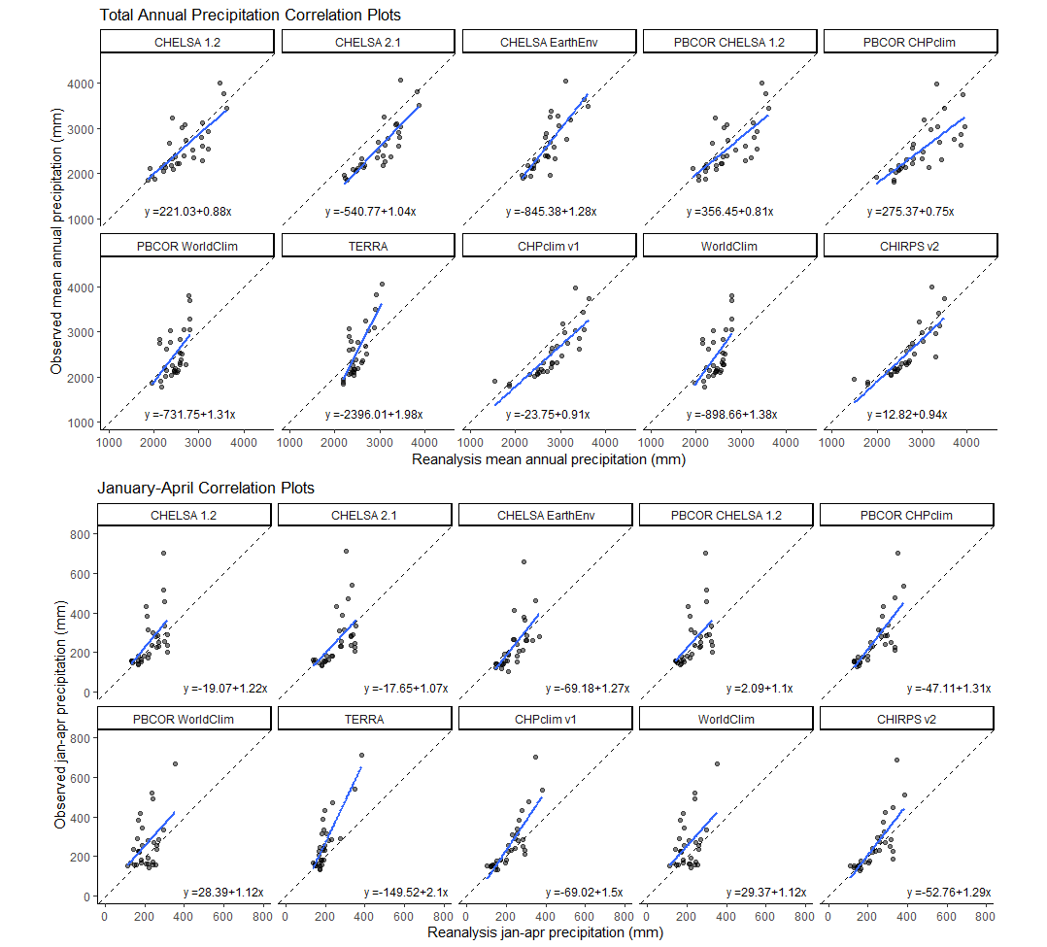

Figure 4. The relationship of predicted precipitation in gridded climate products to observed precipitation in ground datasets, for total annual precipitation (left) and January to April precipitation (right).



Figure 5. Seasonal patterns in the gridded climate products and in the in situ observations for nine sites (note that BCI and BCICLEAR are in the same grid cell, and are graphed as “Ground” and “Ground manual”, respectively). Sites are ordered from highest to lowest rainfall.

Figure 6. Interannual variability in precipitation in the gridded climate products and in the in situ observations for nine sites (note that BCI and BCICLEAR are in the same grid cell, and are graphed as “Ground” and “Ground manual”, respectively). Sites are ordered from highest to lowest rainfall.

**References**

Abatzoglou, J. T., S. Z. Dobrowski, S. A. Parks, and K. C. Hegewisch. 2018. TerraClimate, a high-resolution global dataset of monthly climate and climatic water balance from 1958–2015. *Scientific Data*, 5: 170191. <https://doi.org/10.1038/sdata.2017.191>

Bastidas Osejo, B., T. B. Vargas, and J. A. Martinez. 2019. Spatial distribution of precipitation and evapotranspiration estimates from WorldClim and Chelsa datasets: Improving long-term water balance at the watershed-scale in the Urabá region of Colombia. *International Journal of Sustainable Development and Planning*, 14: 105-117. <https://doi.org/10.2495/SDP-V14-N2-105-117>

Beck, H. E., T. R. McVicar, M. Zambrano-Bigiarini, C. Alvarez-Garret, O. M. Baez-Villanueva, J. Sheffield, D. Karger, and E. F. Wood. 2020. Bias correction of global high-resolution precipitation climatologies using streamflow observations from 9372 catchments. *Journal of Climate*, 33: 1299-1315. <https://doi.org/10.1175/JCLI-D-19>–0332.1

Burton, C., S. Rifai, and Y. Malhi. 2018. Inter-comparison and assessment of gridded climate products over tropical forests during the 2015/2016 El Niño. *Philosophical Transactions of the Royal Society B: Biological Sciences*, 373. <https://doi.org/10.1098/rstb.2017.0406>

Clark, D. A. 2007. Detecting tropical forests’ responses to global climatic and atmospheric change: current challenges and a way forward. *Biotropica*, 39: 4-19

Fick, S. E., and R. J. Hijmans. 2017. WorldClim 2: new 1-km spatial resolution climate surfaces for global land areas. *International Journal of Climatology*, 37: 4302-4315. <https://doi.org/10.1002/joc.5086>

Funk, C., A. Verdin, J. Michaelsen, P. Peterson, D. Pedreros, and G. Husak. 2015. A global satellite-assisted precipitation climatology. *Earth Syst. Sci. Data*, 7: 275-287. <https://doi.org/10.5194/essd-7-275-2015>

Funk, C. C., P. J. Peterson, M. F. Landsfeld, D. H. Pedreros, J. P. Verdin, J. D. Rowland, B. E. Romero, G. J. Husak, J. C. Michaelsen, and A. P. Verdin. 2014. A quasi-global precipitation time series for drought monitoring. *U.S. Geological Survey Data Series*, 832

Hijmans, R., R. Bivand, E. Pebesma, and M. Summer. 2023a. terra: Spatial Data Analysis (1.7-3) [R package].

Hijmans, R., J. van Etten, M. Sumner, J. Cheng, D. Baston, A. Bevan, and R. Bivand. 2023b. raster: Geographic Data Analysis and Modeling (3.6-14) [R package].

Karger, D. N., O. Conrad, J. Böhner, T. Kawohl, H. Kreft, R. W. Soria-Auza, N. E. Zimmermann, H. P. Linder, and M. Kessler. 2018. Data from: Climatologies at high resolution for the earth’s land surface areas. *EnviDat*. <https://doi.org/https://doi.org/10.16904/envidat.228.v2.1>

Karger, D. N., S. Lange, C. Hari, C. P. O. Reyer, and N. E. Zimmermann. 2021a. CHELSA-W5E5 v1.1: W5E5 v1.0 downscaled with CHELSA v2.0. ISIMIP Repository. <https://doi.org/10.48364/ISIMIP.836809.1>

Karger, D. N., A. M. Wilson, C. Mahony, N. E. Zimmermann, and W. Jetz. 2021b. Global daily 1km land surface precipitation based on cloud cover-informed downscaling. *Scientific Data*. <https://doi.org/doi.org/10.1038/s41597-021-01084-6>

López-Bermeo, C., R. D. Montoya, F. J. Caro-Lopera, and J. A. Díaz-García. 2022. Validation of the accuracy of the CHIRPS precipitation dataset at representing climate variability in a tropical mountainous region of South America. *Physics and Chemistry of the Earth, Parts A/B/C*, 127: 103184. <https://doi.org/https://doi.org/10.1016/j.pce.2022.103184>

Malhi, Y., and J. Wright. 2004. Spatial patterns and recent trends in the climate of tropical rainforest regions. *Philosophical Transactions Of The Royal Society Of London Series B-Biological Sciences*, 359: 311-329. <https://doi.org/10.1098/rstb.2003.1433>

Muller-Landau, H. C., K. C. Cushman, E. E. Arroyo, I. Martinez Cano, K. J. Anderson-Teixeira, and B. Backiel. 2021. Patterns and mechanisms of spatial variation in tropical forest productivity, woody residence time, and biomass. *New Phytologist*, 229: 3065-3087. <https://doi.org/https://doi.org/10.1111/nph.17084>

Muller-Landau, H. C., C. Piponiot, F. Mello, S. Aguilar, S. Lao, D. Mitre, and R. Condit. 2023. Forest Biomass Carbon Stocks and Fluxes in a Broader Context: Insights and Opportunities Associated with the Central Panama Plot Network. In *The First 100 Years of Research on Barro Colorado: Plant and Ecosystem Science*, ed. H. C. Muller-Landau and S. J. Wright: Smithsonian Institution Scholarly Press

Paredes Trejo, F. J., H. A. Barbosa, M. A. Peñaloza-Murillo, M. Alejandra Moreno, and A. Farías. 2016. Intercomparison of improved satellite rainfall estimation with CHIRPS gridded product and rain gauge data over Venezuela. *Atmósfera*, 29: 323-342. <https://doi.org/https://doi.org/10.20937/ATM.2016.29.04.04>

Paton, S. 2022. Panama Canal Authority: Monthly Rain_ACP_Vertical.xlsx. <https://doi.org/https://doi.org/10.25573/data.10304306.v8>

Paton, S. 2023. *2022 Meteorological and Hydrological Summary for Barro Colorado Island.* Smithsonian Tropical Research Institute. <https://smithsonian.figshare.com/articles/dataset/Yearly_Reports_Barro_Colorado_Island/11799111>

Paton, S., and R. F. Stallard. 2023. The climate of Barro Colorado Island. In *The First 100 Years of Research on Barro Colorado Island: The Physical Basis*, ed. R. F. Stallard: Smithsonian Institution Scholarly Press

Pebesma, E. J., and R. S. Bivand. 2005. Classes and methods for spatial data in R. *R News*, 5: 9-13

Pollock, M. D., G. O'Donnell, P. Quinn, M. Dutton, A. Black, M. E. Wilkinson, M. Colli, M. Stagnaro, L. G. Lanza, E. Lewis, C. G. Kilsby, and P. E. O'Connell. 2018. Quantifying and Mitigating Wind-Induced Undercatch in Rainfall Measurements. *Water Resources Research*, 54: 3863-3875. <https://doi.org/https://doi.org/10.1029/2017WR022421>

Team, R. C. 2022. *R: A language and environment for statistical computing.* R Foundation for Statistical Computing (Vienna, Austria). <https://www.R-project.org/>

Tennekes, M. 2018. tmap: Thematic Maps in R.:. *Journal of Statistical Software*, 84: 1-39. <https://doi.org/10.18637/jss.v084.i06>

Trenberth, K. E., D. P. Stepaniak, J. W. Hurrell, and M. Fiorino. 2001. Quality of Reanalyses in the Tropics. *Journal of Climate*, 14: 1499-1510. <https://doi.org/10.1175/1520-0442(2001)014><1499:QORITT>2.0.CO;2