Table 1. Key characteristics of the gridded climate products analyzed here. Almost all these products have a forcing dataset that is a climate reanalysis (ERA interim, ERA5, JRA-55); climate reanalyzes combine past observations with mechanistic climate models to generate time series of multiple climate variables.

|  |  |  |  |  |  |  |
| --- | --- | --- | --- | --- | --- | --- |
| **Name** | **Forcing dataset** | **Resolution (degrees)** | **Resolution (km)** | **Time period** | **Native format** | **Citation** |
| CHELSA 1.2 | Reanalysis dataset: ERA interim | 0.0083333 | ~1 | 1979-2013 | Climatology, monthly timeseries | Karger et al., 2018 |
| CHELSA 2.1 | Reanalysis dataset: ERA5 | 0.0083333 | ~1 | 1981-2010 | Climatology, monthly timeseries | Karger et al., 2018 |
| CHELSA EarthEnv | Reanalysis dataset:ERA5 | 0.0083333 | ~1 | 2003-2016 | Daily timeseries | Karger et al., 2021 |
| CHELSA W5E5 | Reanalysis dataset:  WFDE5 | 0.0083333 | ~1 | 1979-2016 | Daily timeseries | Karger et al., 2022 |
| CHIRPS v2  (Merged dataset) | Satellite products: TMPA  Observational dataset:  GTS | 0.05 | ~5.5 | 1981-2022 | Monthly timeseries | Funk et al., 2015 |
| CHPclim v.1.0 | Observational dataset:  GHCN & FAO.  Assisted with satellites | 0.05 | ~5.5 | 1980-2009* | Climatologies | Funk et al., 2015 |
| TERRA | Spatially interpolated dataset:  WorldClim V2  Reanalysis dataset: JRA-55 | 0.04166667 | ~5 | 1981-2010 | Climatology, monthly timeseries | Abatzoglou et al., 2018 |
| WorldClim V2  (Spatially interpolated dataset) | Observational dataset: WMO & FAO | 0.0083333 | ~1 | 1970-2000 | Climatologies | Fick & Hijmans, 2017 |
| PBCORCHELSA 1.2 | ERA interim & USGS, GRDC, etc. | 0.0083333 | ~1§ | 1979-2013 | Climatologies | Beck et al., 2020; Karger et al., 2018 |
| PBCOR CHPclim | GHCN & FAO & USGS, GRDC, etc. | 0.05 | ~5.5 | 1980-2009* | Climatologies | Beck et al., 2020; Funk et al., 2015 |
| PBCOR WorldClim | WMO & FAO & USGS, GRDC, etc. | 0.0083333 | ~1§ | 1970-2000 | Climatologies | Beck et al., 2020; Fick & Hijmans ,2017 |

* Adjusted to 1980-2009, although FAO doesn’t provide temporal extent for its normal

§ PBCOR (Precipitation Bias Correction) versions of products are created by multiplying the original product by the PBCOR factors. The native resolution of the PBCOR bias correction factors is 0.05 degrees; these are resampled to the resolution of the original datasets to produce the bias corrected datasets.

Table 2. Summary statistics for the performance of different climate reanalysis datasets in relation to the in situ rain gauge datasets in central Panama. Performance in relation to spatial variation is based on analysis of data for 31 sites each having 32 or more complete years of data during 1970-2016. Performance in reproducing seasonal variation among averages for calendar months and interannual variation in total annual precipitation is based on nine ground stations having complete data for 1979-2016. R is the Pearson correlation coefficient, RMSE is root mean squared error, MAE is mean absolute error, and Mean bias % is the mean relative error. Bold highlights the best performance within each column. Only some of the gridded products had time series enabling evaluation of seasonal and interannual patterns.

|  |  |  |  |  |  |  |  |  |  |  |  |  |
| --- | --- | --- | --- | --- | --- | --- | --- | --- | --- | --- | --- | --- |
| **Dataset** | **Spatial variation among 31 sites in total annual precipitation** | | | | **Spatial variation among 31 sites in January-to-April precipitation** | | | | **Seasonal variation within 9 sites** | | **Interannual variation within 9 sites** | |
| **R** | **RMSE** | **Mean bias (mm)** | **MAE** | **R** | **RMSE** | **Mean bias (mm)** | **MAE** | **R** | **RMSE** | **R** | **RMSE** |
| CHELSA 1.2 | 0.78 | 356 | 90 | 283 | 0.57 | 109 | -31 | 67 | 0.97 | 48 | 0.31 | 836 |
| CHELSA 2.1 | **0.85** | 507 | 414 | 463 | 0.56 | 108 | **-1** | 74 | 0.97 | 63 | 0.57 | 608 |
| CHELSA EarthEnv | 0.82 | 351 | 100 | 286 | 0.65 | 92 | 5 | 62 | 0.94 | 54 | 0.59 | 625 |
| CHIRPS | 0.84 | **324** | 137 | **264** | 0.77 | **85** | -16 | **52** | **0.98** | **37** | **0.75** | **459** |
| CHPclim v1 | 0.84 | 412 | 283 | 365 | 0.82 | 92 | -40 | 58 | 0.96 | 54 |  |  |
| TERRA | 0.79 | 408 | -55 | 339 | **0.85** | 111 | -65 | 74 | 0.93 | 63 | 0.26 | 671 |
| WorldClim | 0.58 | 423 | -38 | 355 | 0.47 | 121 | -54 | 86 | 0.94 | 60 |  |  |
| PBCOR CHELSA 1.2 | 0.73 | 405 | 145 | 335 | 0.54 | 110 | -26 | 66 | 0.97 | 52 |  |  |
| PBCOR CHPclim | 0.75 | 598 | 460 | 510 | 0.77 | 91 | -25 | 56 | 0.96 | 62 |  |  |
| PBCOR WorldClim | 0.56 | 427 | -32 | 361 | 0.47 | 121 | -53 | 85 | 0.94 | 61 |  |  |
| CHELSA W5E5 | 0.35 | 499 | **-3** | 407 | 0.12 | 125 | -9 | 85 | 0.96 | 63 | 0.69 | 657 |

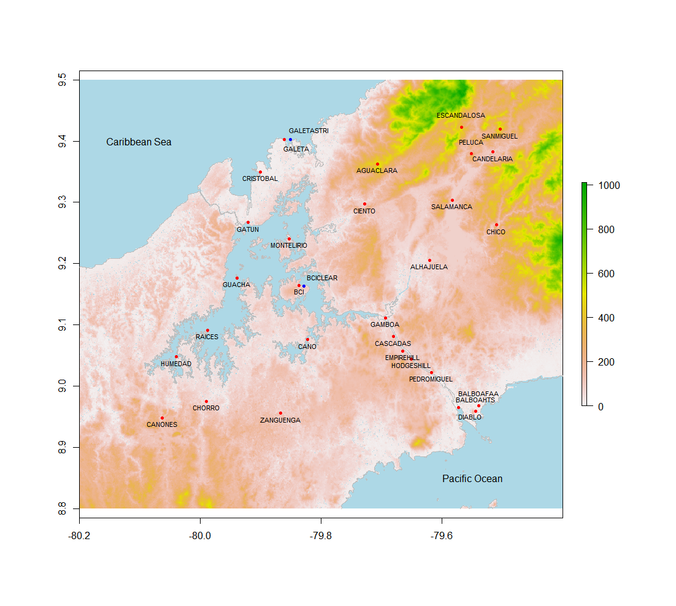

Figure 1. Topographic map of the focal region, indicating the location of in situ measurement sites used in this analysis including ACP stations (red) and STRI stations (blue).



Figure 2. Mean climatologies for each climate reanalysis dataset. Note that the temporal range varies among datasets (Table 1).



Figure 3. Relative bias (of in situ measurement) for of the gridded climate products in relation to in situ measurements at different sites for total annual precipitation (top) and January-April precipitation (bottom).

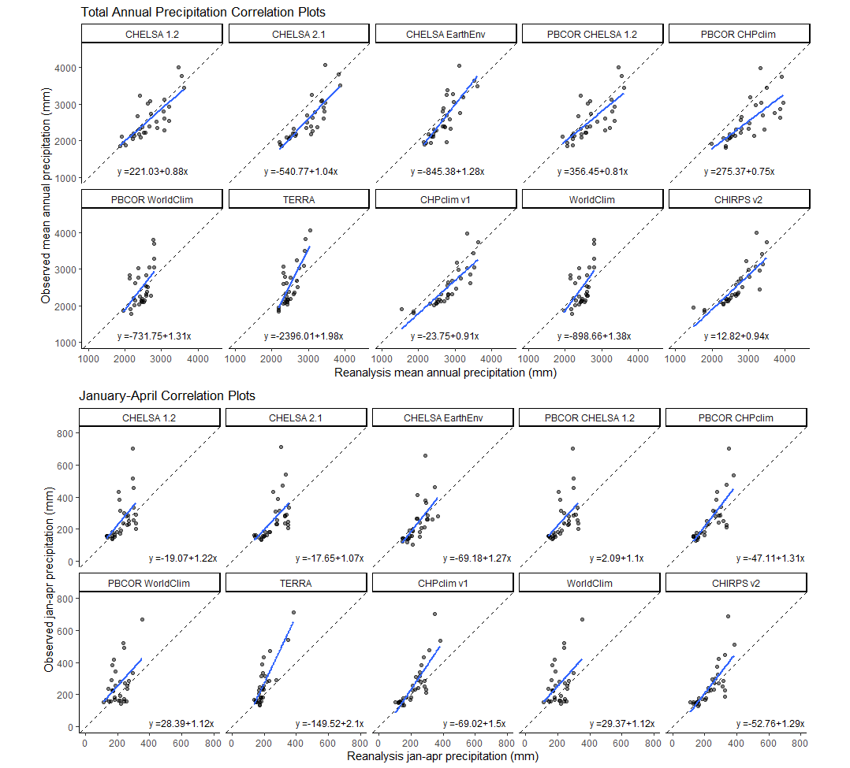

Figure 4. The relationship of predicted precipitation in reanalysis datasets to observed precipitation in ground datasets, for total annual precipitation (left) and January to April precipitation (right).



Figure 5. Seasonal patterns in the ground data and in climate reanalysis values for nine sites (note that BCI and BCICLEAR are in the same grid cell). Sites are ordered from highest to lowest rainfall.

Figure 6. Interannual variability in precipitation in the ground data and climate reanalysis datasets for nine sites (note that BCI and BCICLEAR are in the same grid cell). Sites are ordered from highest to lowest rainfall.