Symbolic mathematics

**SpreadCommander** include **Math.Net.Numerics** and **Math.Net.Symbolics** libraries and allows to perform symbolic mathematic calculations.

Script below shows host to perform symbolic calculations in **SpreadCommander**.

Simple operations:

2*a

a^2

1 + 1/x

1/(a*b)

Output to different formats:

1/(a*b)

a^(-1)*b^(-1)

\frac{1}{ab}

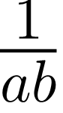

Parsing:

1/(a*b)



Evaluating functions:

0.166666666666667

0.166666666666667

Output to LaTeX:

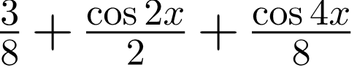

Taylor expansion:

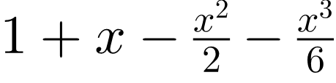

Table of Contents

Symbolic mathematics 1

Simple operations: 1

Output to different formats: 1

Parsing: 1

Evaluating functions: 1

Output to LaTeX: 1

Taylor expansion: 1

Table of Contents 2