Data Structures and Algorithms
Assignment 5

BST – Red Black Tree

As the first BST, I implemented a Red Black Tree.
(3-10 lines) Firstly, I initialized the nodes. Every node has a key, left and right children, a parent, a colour and a value. The colour is 1 for red and 0 for black.
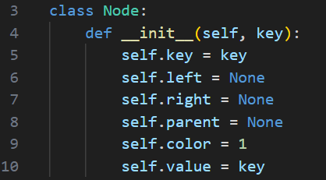

(12-19 lines) Then I initialized the NIL nodes. Their colour is always black, so we used 0.
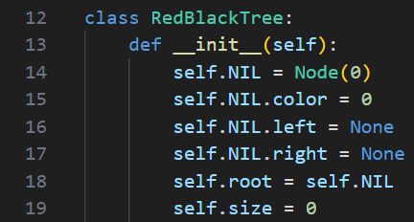

(21-54 & 147-185lines) Insertion function :
I start with the creation of a node and I insert it as in a regular BST.
Then I colour the new node as red.
The _fix_insert can handle and restore the Red-Black Tree because of some violations. So, if the uncle node is red, we have to recolour the uncle, the parent and the grandparent. If the uncle is black and the new node is an inner child, then I rotate. But if the uncle is black and the new node is an outer child, then I rotate and recolour.

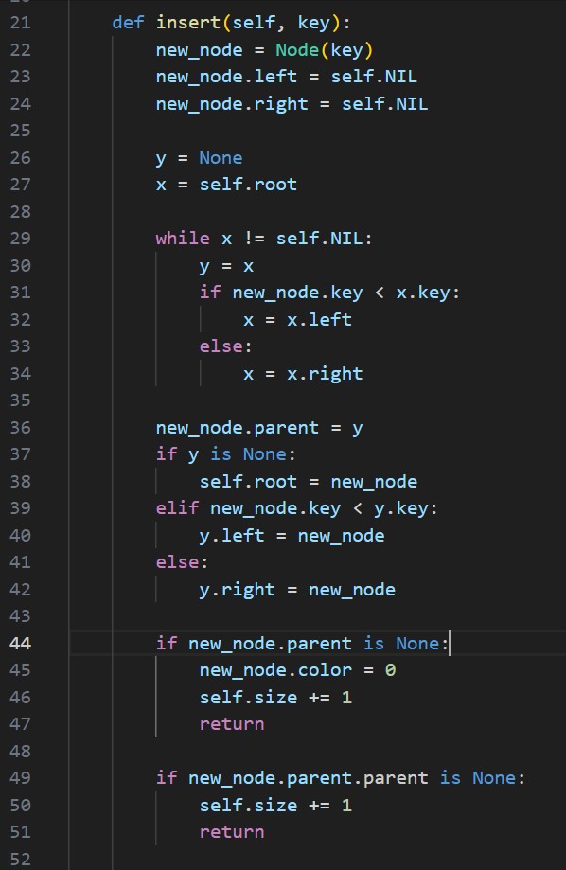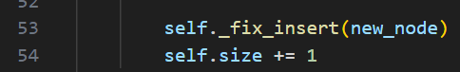
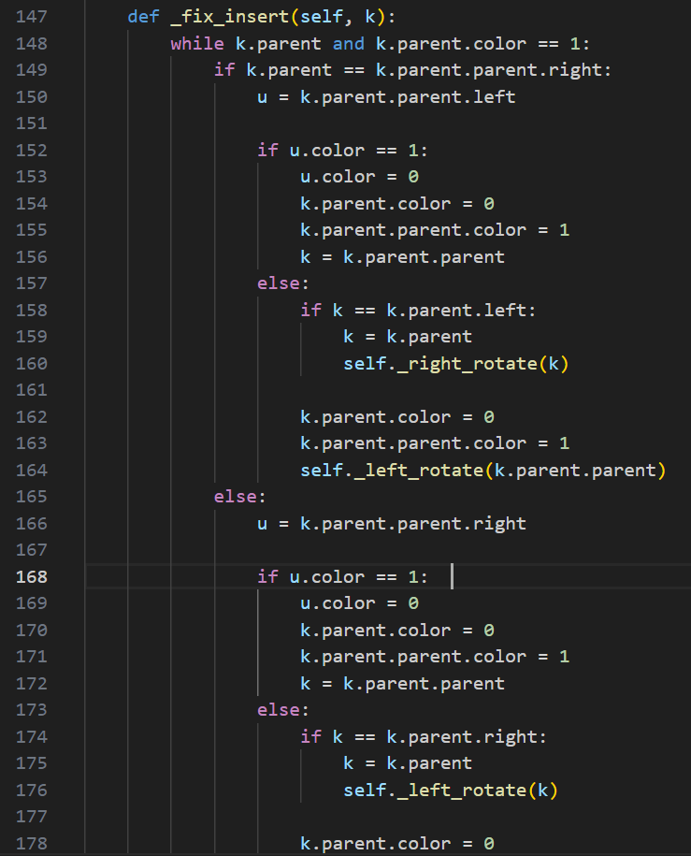

(56-92 & 187-236 lines) Delete function :
Firstly, we have to find the node that we want to delete using the standard BST. Depending on how many children the node has, I decide what to do. So, if it has no children, we totally remove it. If is has 1 child, I replace it with its child. If it has 2 children, I should find its successor, replace the node’s key with the successor’s key and remove the successor.
If the removed node was black, I use _fix_delete to fix any violations that may happened. The delete operation uses helper operations, such as Transplant, Rotation and Minimum.
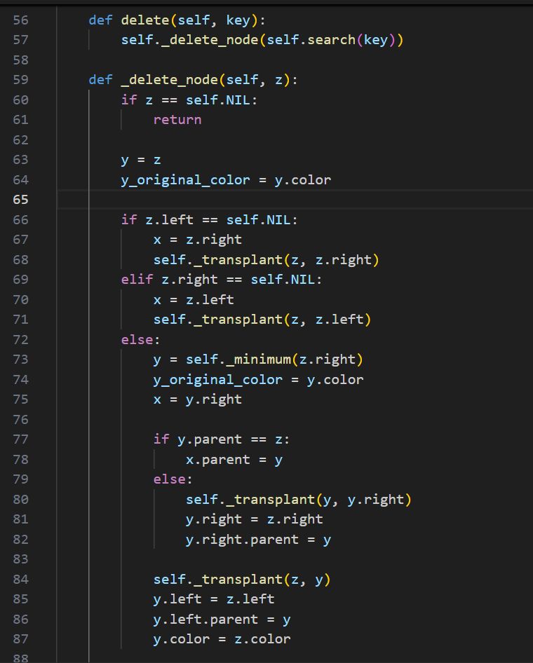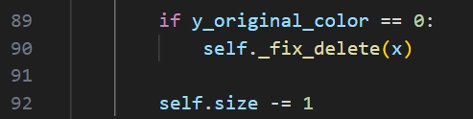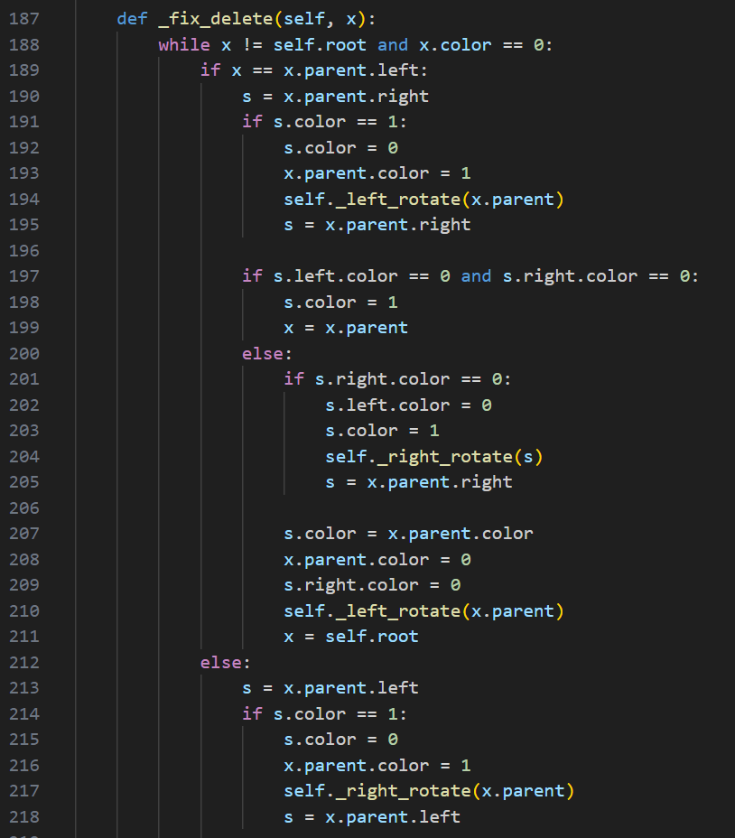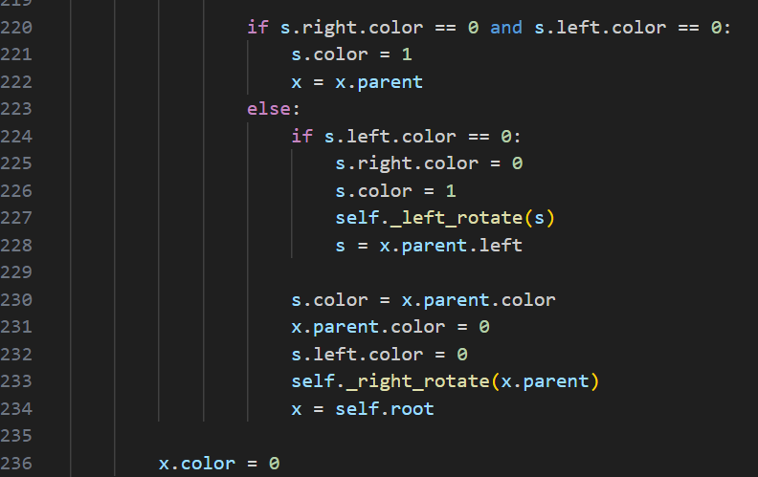

(94-107 lines) Search function :
For this operation, we start at root node. So, if the current node is a NIL node, the key does not exist in the tree. If the current node's key matches the search key, then I return the node. If the search key is less than the current node's key, then I search the left subtree. However, if the search key is greater than the current node's key, then I search the right subtree.
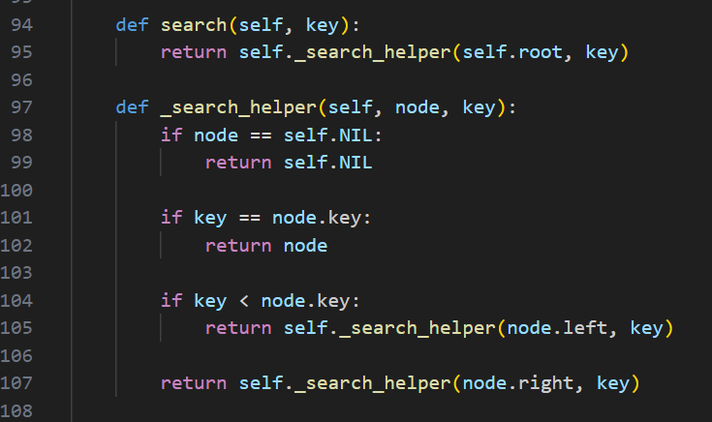
(109-145 lines) Rotation :
The rotate function helps balance the tree after the delete.
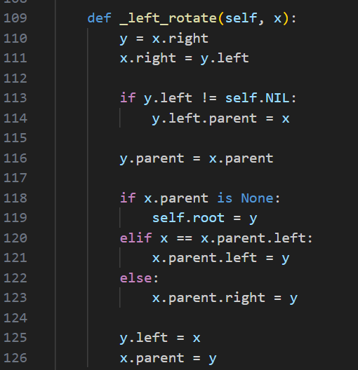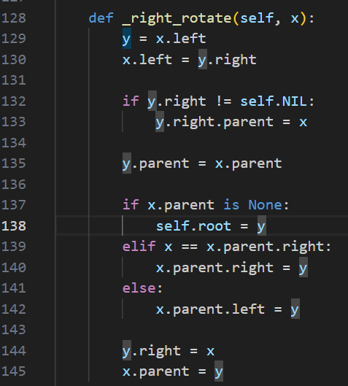

(238-246 lines) Transplant :
I use transplant to replace a subtree with an other subtree during the delete.
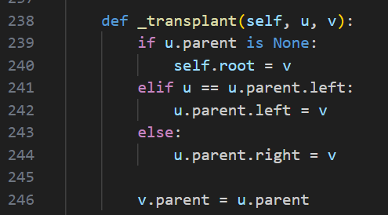

(248-251 lines) Minimum :
I use it to find the minimum key in a subtree by following the left children until I reach the NIL node.
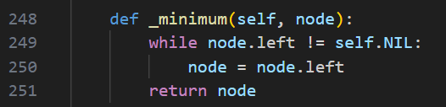

BST – (2,3) Tree

(3-24 lines) 1st Class :
Firstly, the class gives the keys -which is a list of 1 or 2 keys- the children -which is a list of 0, 2 or 3 child nodes- and the parent -the parent node.
Also, it gives some helper methods.
Is_leaf() : Checks if the node has no children
Is_full() : checks if the node has has 2 keys already
Add_key() : adds a key to the node, while maintaining sorted order
Add_child() : adds a child node, while maintaining the order based on the keys
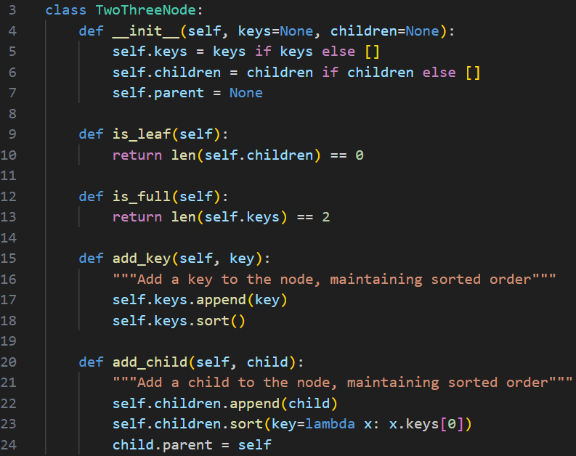

(31-51 lines) Search :
The search function, firstly, checks if the key exists in the current node. If it doeesn’t and I am at a leaf, then the key doesn’t exist. Otherwise, I compare the key with the node’s keys to determine which child to search. So, if the key is smaller than the first key, then I search the left child. If the key is greater than the first key but smaller than the second key (if it exists), then I search the middle child. If the key is greater than the second key, then I search the right child.
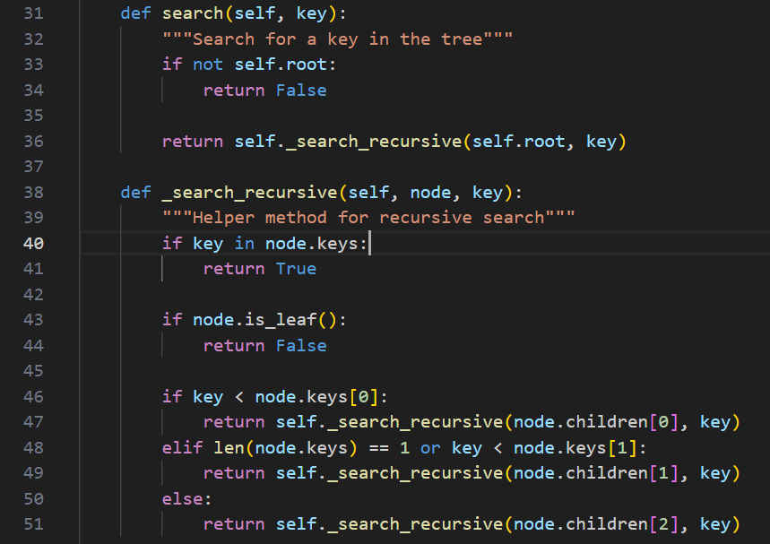

(53-122 lines) Insert :
Beginning with the insert function, we check if the tree is empty and if it is, then we create a new root node with the key. Then using Binary Search, we find the appropriate leaf node for the insertion. If the key already exists, then I do nothing. Then I insert the key into the leaf node and any necessary splitting is being handled.
The _find_leaf_for_insertion is a helper function that checks the whole tree, so it can find the appropriate leaf node for insertion.
The _insert_in_node function adds a key to a node and if it’s possible, it adds a child node. If the node can have more than 2 keys, it splits the node.
The _split_node function does the splitting when there are 3 keys. The middle key is promoted as the parent node, the left key stays in the original node and the right key goes to a new node. If the split node was the root, then a new root would be created. This whole function is the reason why the tree grows in height while it maintains balance.
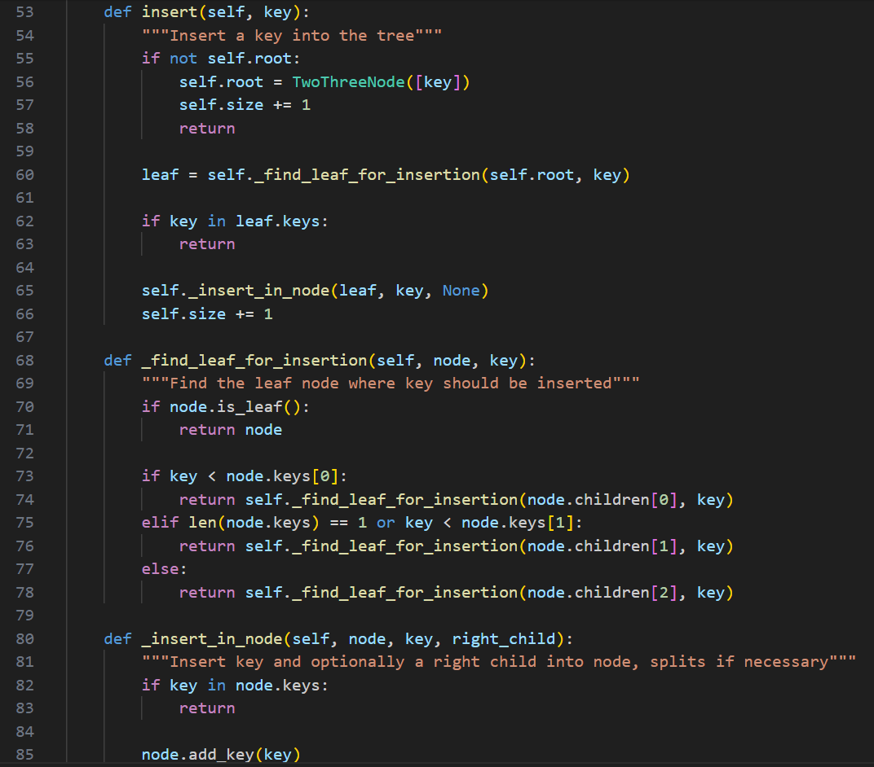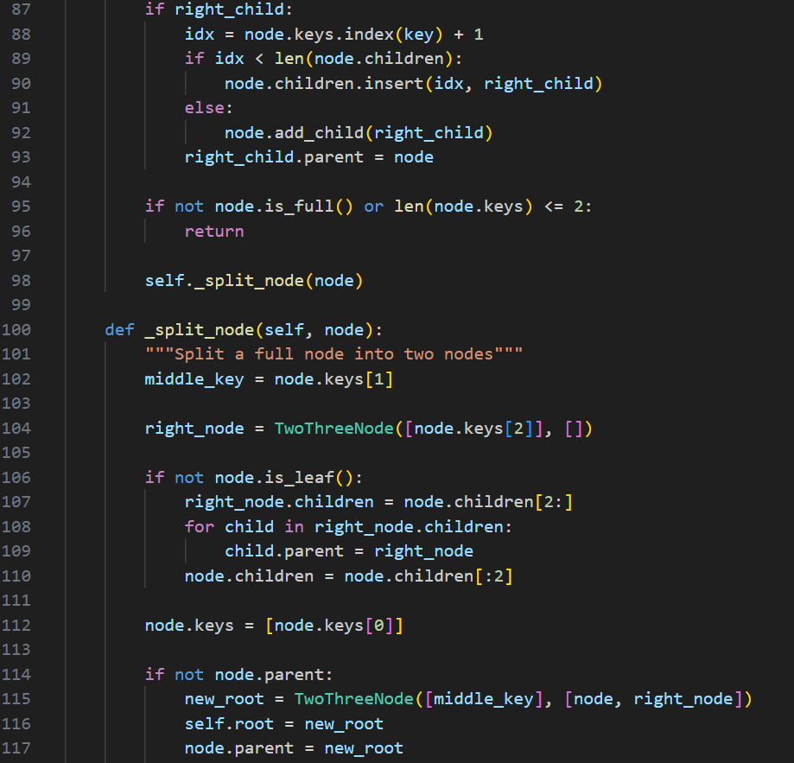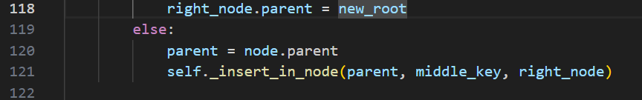

(123-140 lines) Delete :
Firstly, the delete finds the node that contains the key. If the node is a leaf, then I remove the key. If the node is internal, I replace the key with its successor and I delete the successor from its leaf.
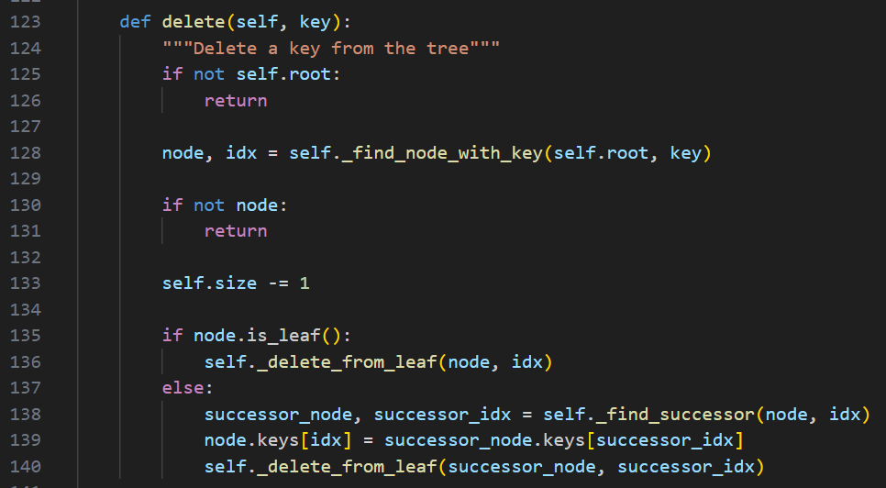

(142-162 lines) Find :
I use 2 helper functios.
I try to find the key in the tree and as a result I get the node containing the key and the index of the key within that node. Then, I try to find the successor, so I can replace the deleted key.
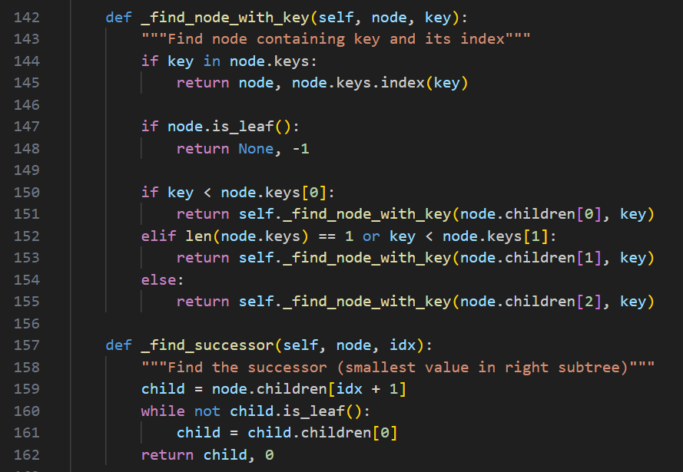

(164-173 lines) Delete :
We remove a key from a leaf. If the node still has keys or it's the root, I’m done. Otherwise, the node has less keys than required and it needs rebalancing.
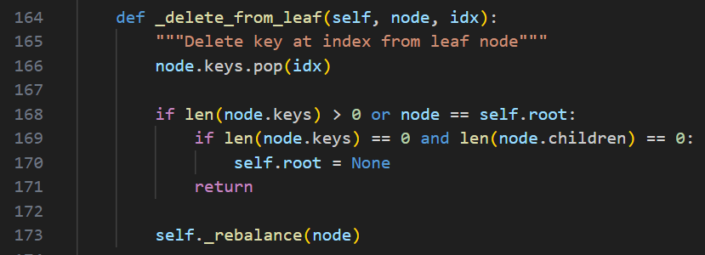

(175-194 lines) Rebalance :
So, I use the Rebalance function. This function can handle some specific problems. If the node is the root, then it handles it well. Otherwise, it uses other functions to borrow a key from a sibling (left or right). If it can’t borrow a key, then it merges with a sibling (left or right).
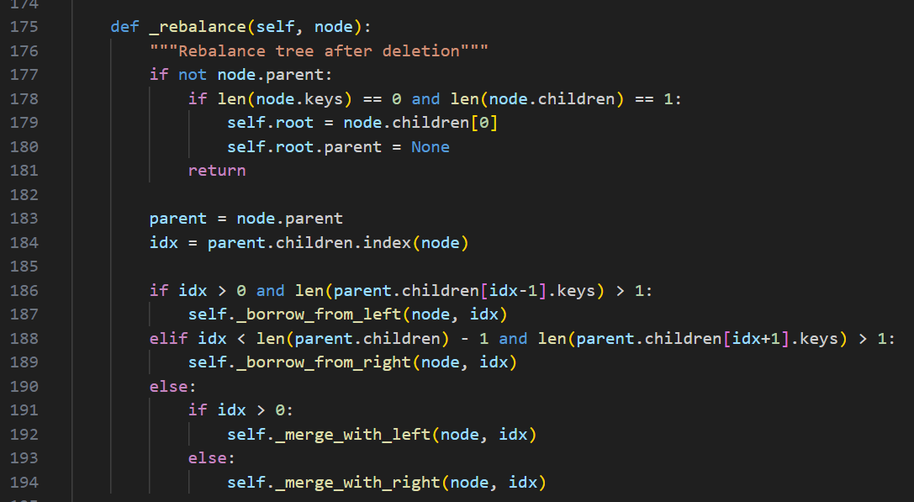

(196-222 lines) Borrow :
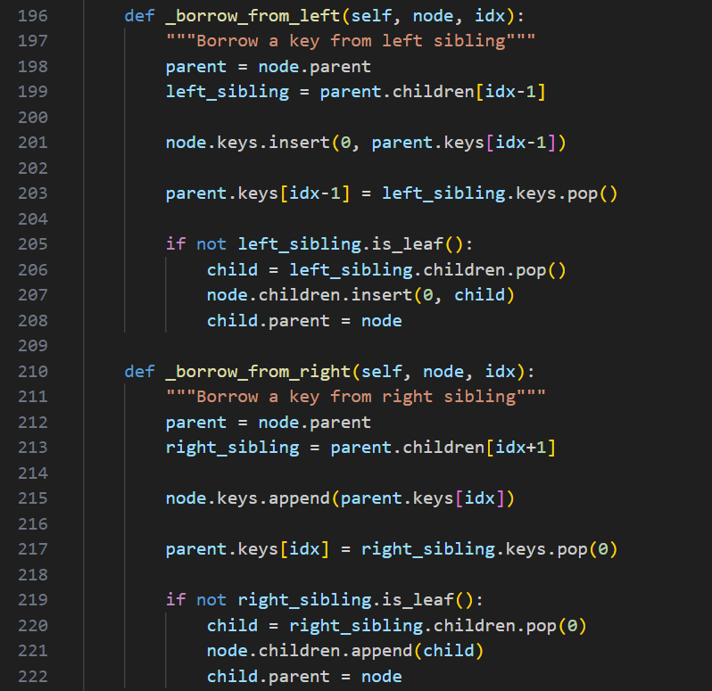

(224-264 lines) Merge :
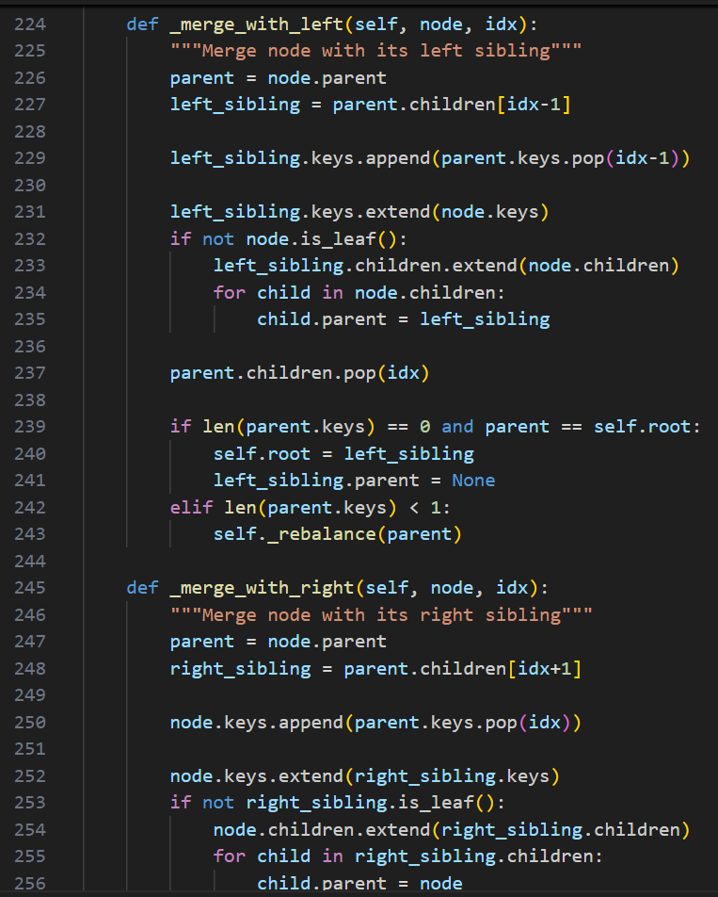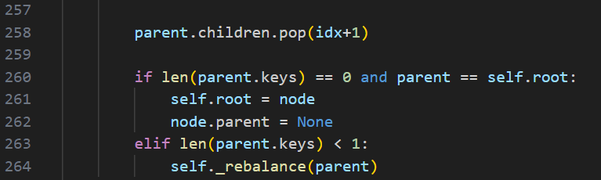

Hask Table
(3-20 lines) Firstly, I initialize the hash table and then I prepare the 2 hash functions. The 1st is just a basic one and the 2nd ensures the step size.
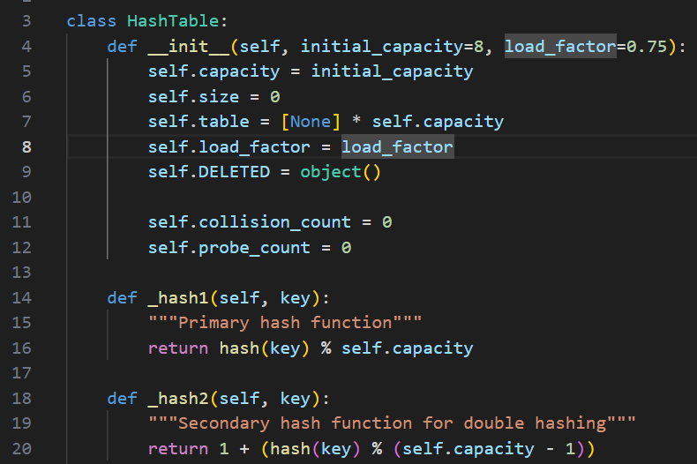

(22-42 lines) Position :
Then I use the function _get_position, so I can find all the correct index where the key already exists or where is should be inserted. This operations uses double hashing.
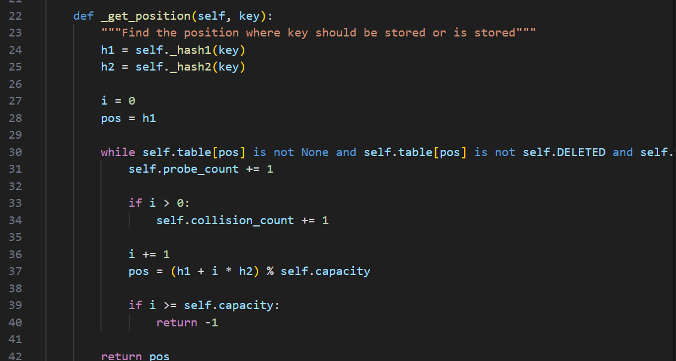

(44-56 lines) Insert :
Insert starts with a key-value pair. Is the key exists, then it updates the value. Otherwise, it finds an available spot and it inserts the new pair.
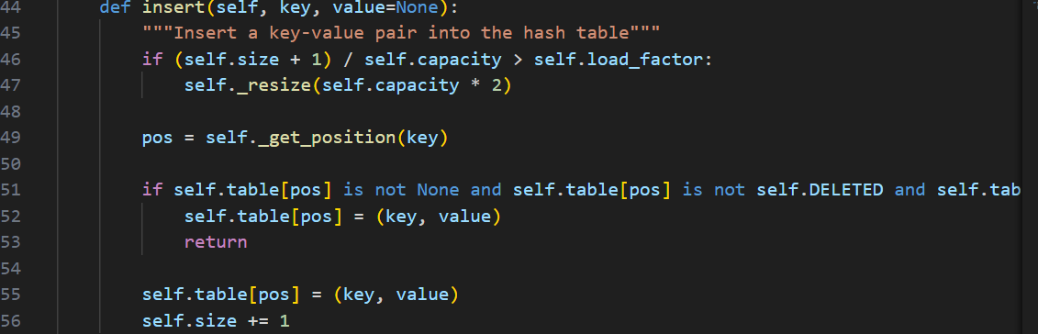

(58-65 lines) Search :
The search function searches for a key and if it finds it, it returns the value of it.
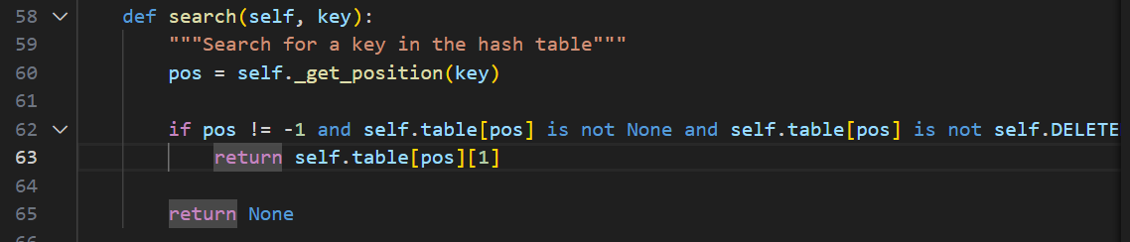

(67-80 lines) Delete :
It deletes a key and marks its place as deleted. If the table becomes too empty, it shrinks.
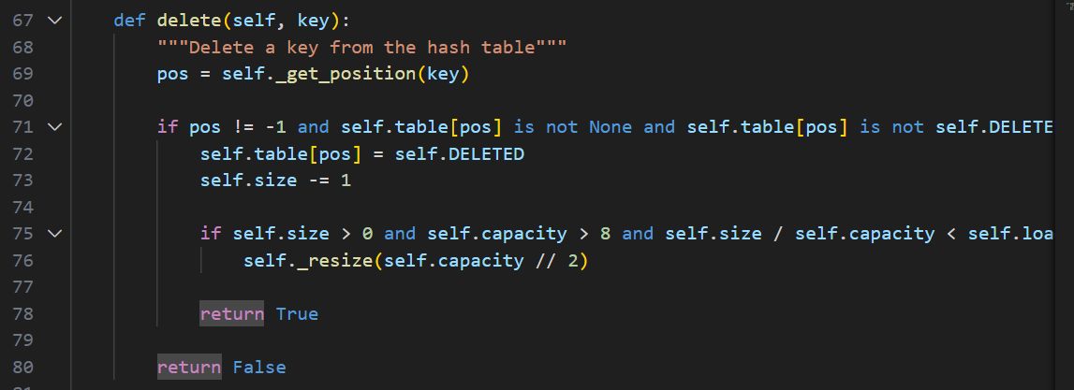

Testing
After testing in the same code a BST, a Red-Black Tree and a Hash Table, I get the following results. In any case, we observe that a BST can give way better results that the other 2 implementations. Also, Red-Black Tree and Hash Table give almost the same results in every scenario. However, in Insert function Hash Table is a little bit better than Red-Black Tree and in Search and Delete operations Red-Black Tree is a little bit better than Hash Table.
