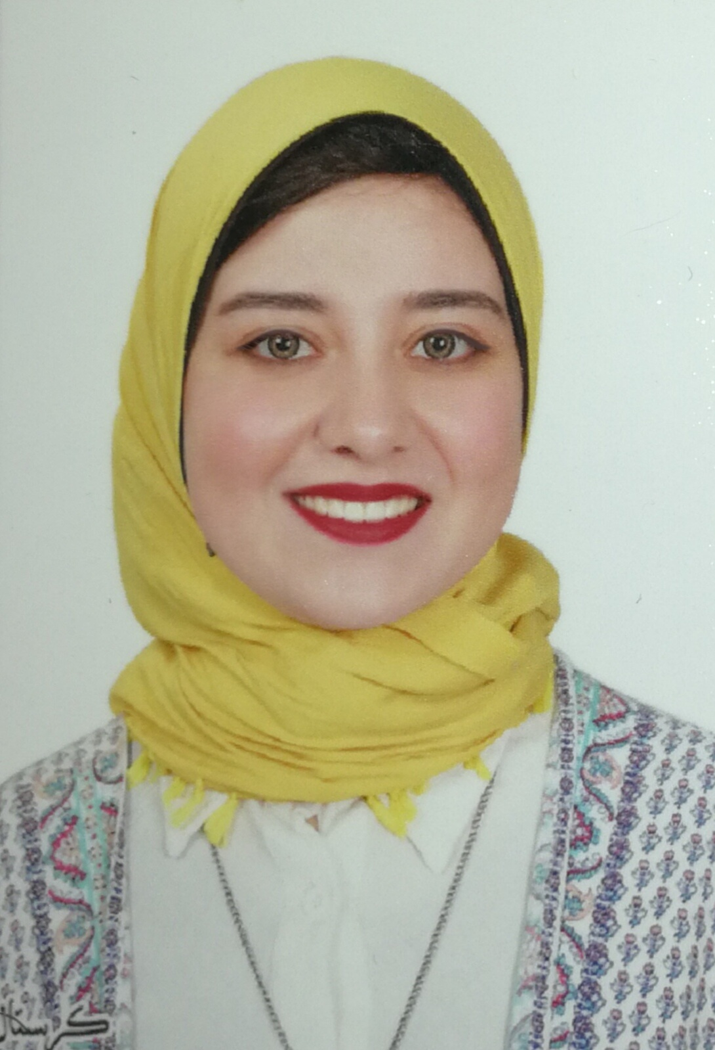
Reem Mohamed Behery

Contacts:
- Address: Abu Dhabi, United Arab Emirates
- E-mail: Reem.behery91@hotmail.com
- Mobile: +971 52 121 9882

Objective:
- Seeking a Medical Sales Representative position as I am very interested and have a passion for the medical field.

Education:
- Lycée la liberté d'Alexandrie. Grade: 96%
- Faculty of Veterinary medicine  Alexandria University Class 2016

Courses:
- Food Safety Specialist Professional Certificate from Arab Academy for Science and Technology and Maritime Transport.
- Good Manufacturing Practices (GMPs).
- Hazard Analysis and Critical Control Point (HACCP).
- ISO 22000:2005 Food Safety Management System Awareness.
- Professional Medical Representative at EIPICO Pharmaceutical Company (Soft Skills).
- Emergency-1st Aid at ICC for Medical courses.

( The Certificates are authenticated from UAE embassy and the Egyptian Ministry of Foreign affairs )

Working Experience:
- working as a Medical Representative at Pharma cure Pharmaceutical Industries.

Personal Skills:
- Teamwork
- Time management
- Creative Thinking
- Presentation Skills
- Communication skills
- self motivation
- Self Learning
- Working under stress

Languages:
- Arabic: Mother tongue.
- English: Fluent spoken, read and written.

Basic Computer Skills:
- Windows Operating System.
- Microsoft Office (Microsoft Word  Microsoft Excel  Microsoft Access  Microsoft Power Point  Microsoft Outlook).

Personal Information:
- Date of Birth: 01 December 1991
- Nationality: Egyptian
- Religion: Muslim
- Marital State: Married
- Visa Status: Residence Visa
- UAE Driving License: Valid

