Curriculum Vitae 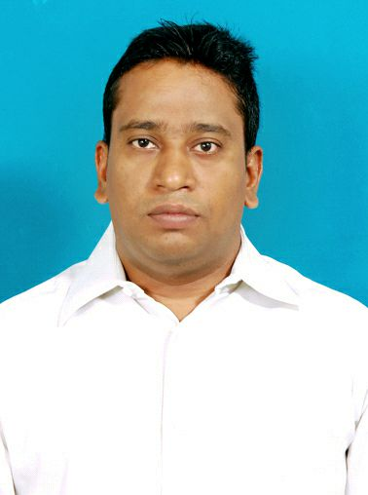

MOHAMMAD USMAN

Mobile - +971 5669 98141
Email: usmanmd113@gmail.com

CAREER OBJECTIVE:

To work in a platform in an esteemed organization which helps me to deliver the best from me in order to fulfil the organization's motto? To gain knowledge and improve from the resources those are provided from the organization. And the organization being the spring board, which helps me to jump up in my career.

ACADEMIC QUALIFICATION:

- Diploma in Electronics and Communication ENGG at VKR & VNB polytechnic Gudivada
From State Board of Technical University Scored 61.25%
- Board of Secondary Education: 62%
- (B-Tech ( I T ) from Nimra College of Engineering and Technology.)

OTHER QUALITFICATION:

- Diploma in Fire and Safety from NIFE Institute Kochi Kerala.

Work Experience:

- Worked at American Oncology Institute as Business Development Executive in Vijayawada from January 2016 to 08 March 2018.
Job Responsibilities:
- Conducting CME Meetings: Inviting Doctors for a CME (Continuing medical Education) classes
- Conducting Medical Camps: Every month we conduct Medical camps in various places
with free medical checkups
- Out Reach Calls with Doctors
- Meeting Doctors daily as per Schedule
- Conversion of Doctor's to Refer

- Worked as Content Associate Manager in Sports195 India IT Services Pvt Ltd from August 2013 to November 2014.
- Worked as a Co-Brand Site developer on Live Site.
- Direct contact with Mexican Team.
- Support Team regarding Issues related to Assign Task.
- Maintain and Update all the related information of Sports on Sport195.com website.
Worked as League Manager in M10 Digital work Digital Solutions pvt LTD from1st August 2012 to 31st July 2013
- Updating scores for the soccer teams
- Entering data related to sports profiles
- Maintaining day to day results.

Worked as Asst Safety Manager in YM Drugs Industry at Koilagudem, Hyderabad for 6months.
- Conducting Safety awareness about Safety among employees of the company
- Monitoring and maintenance of Personal Safety Equipment
- Conducting periodic inspection of Hazards

PERSONAL PROFILE
Father's Name : Sk. Abdul Azeez
Mothers name - Sk Safura Bibi
Sex : Male
Date of Birth : 22nd August 1984
Marital Status : Married
Nationality : Indian Muslim
Religion - Islam
Languages Known : English, Urdu, Hindi, and Telugu.
Permanent Address - S/o Sk Abdul Azeez, Dno-8-5-32, TSP Street Wynchipet,
Vijayawada Pin:520 001, Andhra Pradesh, INDIA
Current Address - Abu Dhabi, Musaffah, Malbar building, near to Safer maal.

DECLARATION:

I hereby declare that above information is true to the best of my knowledge and belief.

Place: Abu Dhabi(UAE) USMAN MOHAMMAD

(Signature)
Md usman

