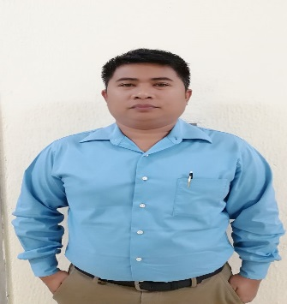



■



ELECTRA STREET HAMED CENTER ABU DHABI,



UNITED ARAB EMIRATES



■



*taubronegel22@gmail.com*



+



Mobile no. 056 812 4219



Tel. No. 026274401



**RONEGEL S. TAUB**

**WORK EXPERIENCE**

**Etisalat (**Emerging Technologies CO.LLC**)**

**Position: Consumer telecom assistant (Costumer service, outdoor Sales)**

**Duties and Responsibility:**

* Generate sales and submit to the management on daily, weekly bases
* Utilize all available resources to reach out prospects and turn those prospects into customer
* Collaborate with the management team to improve marketing materials and ex [and the company’s marketing presence in the territory
* Attend industry trade shows to accumulate new leads and make productive contact with existing clients
* Update client information in the company contact database
* Stay on top of industry trends to identify potential opportunities for company growth

**Etisalat (**Emerging Technologies CO.LLC**)** Telesales & Costumer Assist.

**Position: Telesales (outbound and inbound)**

**Duties and Responsibility:**

* Update client information in the company contact database
* Customer service and telesales
* Calling and generating leads to make a close sale of all Etisalat products and upgrades.

**Bank of Dipolog Inc.** MBO Supervisor

**(Rural Bank)**

* Account officer
* Teller post
* Cashier post
* Housing Loans
* SME Loans

**Phil-Am Life** Financial Adviser

(Insurance AIA Group)

* Life and Endowment Plan
* Housing Insurance
* Car Insurance
* Educational Plan

**Training and Seminars Attended**

**Simple Bookkeeping Training** **Customer Service and voice enhancement**

Resource Person: Mrs. Emma Alianza HRD Emerging Technology Inc.

Director for Finance & accounting, TSKI Sept. 6, 2015

TaytaysaKauswagan, Incorporated

Cebu City, October 2010

**LEADERSHIP TRAINING** **Handling Objections**

Isabelita , E. Lopez St., Jaro Iloilo City HRD Emerging Technology Inc

September 30, 2006 Sept. 6, 2015

**DEBT MANAGEMENT AND BUDGETING** **Product Knowledge** (All Etisalat Product)

Rodirics Resort, Taway, Ipil, Zamboanga Sibugay February 13-14, 2009

**Basic of Micro Financing** **Risk Management Training**

Rizal Ave. Dipolog City Banco Dipolog

Banco Dipolog Dipolog City

Sept. 7 to Nov. 16,2013 Every Saturday and Sunday class Dec. 7 to 8, 2013

Tertiary : Bachelor of Science in Criminology (1999-2003) Zamboanga del Sur Maritime Institute of technology



**E**



**D**



**U**



**C**



**A**



**T**



**I**



**O**



**N**



**A**



**L**



**A**



**T**



**T**



**A**



**I**



**N**



**M**



**E**



**N**



**T**



**P**



**E**



**R**



**S**



**O**



**N**



**A**



**L**



**I**



**N**



**F**



**O**



**R**



**M**



**A**



**T**



**I**



**O**



**N**

Age : 34 years old

Date of Birth : 19th October 1982

Citizenship : Filipino

Civil Status : Separated

Height : 5” 4

Language Proficiency:Filipino and English

Visa Status :Cancel Visa

I hereby certify that the above information mentioned is true and correct to the best of my knowledge.