Create a new local repository
git init

Check out a repository

Create a working copy of a local repository:
git clone /path/to/repository

For a remote server, use:
git clone username@host:/path/to/repository

Add files

Add one or more files to staging (index):
git add <filename>
git add *

Commit changes to head (but not yet to the remote repository):
git commit -m "Commit message"

Commit any files you've added with git add, and also commit any files
you've changed since then:
git commit -a

Push

Send changes to the master branch of your remote repository:
git push origin master

Status

List the files you've changed and those you still need to add or commit:
git status

Connect to a remote repository

If you haven't connected your local repository to a remote server,
add the server to be able to push to it:
git remote add origin <server>

List all currently configured remote repositories:
git remote -v

Branches

Create a new branch and switch to it:
git checkout -b <branchname>

Switch from one branch to another:
git checkout <branchname>

List all the branches in your repo, and also tell you what branch
you're currently in:
git branch

Delete the feature branch:
git branch -d <branchname>

Push the branch to your remote repository, so others can use it:
git push origin <branchname>

Push all branches to your remote repository:
git push --all origin

Delete a branch on your remote repository:
git push origin :<branchname>

Fetch and merge changes on the remote server to your working directory:
git pull

To merge a different branch into your active branch:
git merge <branchname>

Update from the remote repository

Fetch and merge changes on the remote server to your working directory:
git pull

To merge a different branch into your active branch:
git merge <branchname>

View all the merge conflicts:

View the conflicts against the base file:

Preview changes, before merging:
git diff
git diff --base <filename>
git diff <sourcebranch> <targetbranch>

After you have manually resolved any conflicts, you mark the changed file:
git add <filename>

Tags

You can use tagging to mark a significant changeset, such as a release:
git tag 1.0.0 <commitID>

CommitId is the leading characters of the changeset ID, up to 10,
but must be unique. Get the ID using:
git log

Push all tags to remote repository:
git push --tags origin

Undo local changes

If you mess up, you can replace the changes in your working tree
with the last content in head:

Changes already added to the index, as well as new files, will be kept.
git checkout -- <filename>

Instead, to drop all your local changes and commits,
fetch the latest history from the server and point your
local master branch at it, do this:
git fetch origin
git reset --hard origin/master

Search

Search the working directory for foo():
git grep "foo()"

git add – (staging) git add <file name>
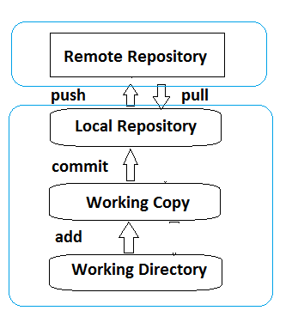
git commit –m ‘Some message’. It moves files to local repository
git push – move changes from local to remote repository
git push origin master
get pull - move changes from remote to local repository


git checkout –b features_x Create new branch features_x
git checkout master Switch back to master
git checkout feature_x Switch to feature_x
git merge feature_x merge branch feature_x to the current branch master
git push origin <branch> Push the branch to the remote repository

