Documentation for C++ area calculation.

In theory, it should be possible, using perspective correction to scale for distance, to calculate the area of an object in a picture given various camera and picture data. This would work by using trigonometry to convert the pixel units used in the image to actual real-world sizes. In practice, however, this is proving to be a bit difficult. This difficulty has proven itself over several methods of calculating the area of objects, and the difficulty is as follows:

The scaling algorithms used are clearly not adequate.

When scaling up based on how far away the object in question is from the camera, the results presented by the algorithm were far too large and appeared to scale too quickly for the given data.

When scaling up based on a perspective transformation, the result was still too small for distant objects, despite the nature of the perspective transformation.

The problem shared by these scaling algorithms, it seems, is the conversion between real-world and pixel coordinates. It may be possible that these algorithms were returning the correct number of pixels, however the actual correct size of the object needs to be known. It is thus that it should be possible to obtain the correct area with the correct input units, namely, it should be possible to obtain the correct area given correct real-world points.

To calculate these real-world points, various data about the image will need to be calculated.

First calculation: The “height” of the image, namely how far out the image goes. This can be calculated as a side of an imaginary triangle extending out from the camera, as is illustrated below:
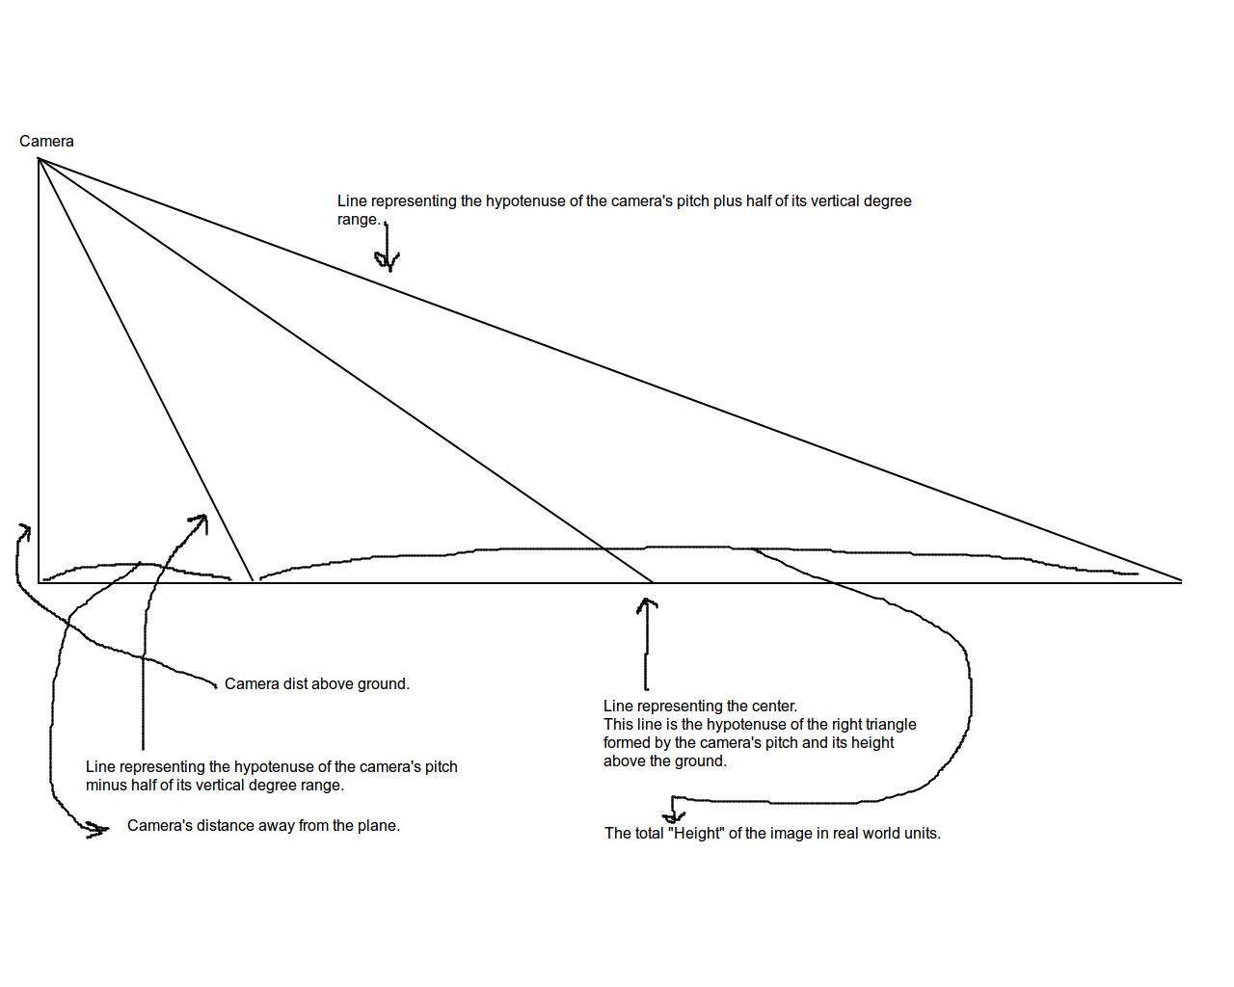
Second calculation:
The width of the topmost and bottommost parts of the image should be calculated in order to calculate how the image scales over real-world space.

