Documentation for the Resolution Change activity.

ChangeResolutionActivity is the name of one of the internal activities in SquirrelGPU that allows the user to choose a capture resolution. It loads a list of resolutions from the camera and presents that list to the user. Because of the way the lists work, it would be very difficult to convert this into a proper setting for the Settings Activity.

For the purposes of this documentation, the XML resources for the ChangeResolutionActivity are assumed to be a part of the activity, rather than a mark-up for how it should look. Additionally, let // be a comment in the documentation.

class ChangeResolutionActivity:
Extends: ListActivity. //This allows the activity to make use of a dynamic list of elements that this activity will use to show resolutions.
Private Data: ListView internalView, Camera camCopy, List<Size> sizeList, String[] sizeNames.
public void getSizeData()
Args: none.
Description: Sets sizeList to the list of supported resolutions available from the camera.
Algorithm:
Set sizeList to the list of resolutions contained in camCopy's parameters.
public void sizeToString()
Args: none.
Description: Converts the list of sizes into a list of human-readable strings that will be displayed in the list.
Algorithm:
Declare a loop variable.
Initialize sizeNames as a new string array.
For every element in the sizeList:
If the current element in sizeList is the current camera resolution:
Set the sizeName equal to the string value of the size, but put “--Current setting.” at the end.
Else
Set the sizeName equal to the string value of the size.
Endif.
End loop.
public void setListView()
Args: none.
Description: Sets an array adapter for the list to be made from an array of strings.
Algorithm:
See description.
protected void onCreate()
Args: Bundle savedInstanceState
Description: The Android entry point for this activity. Sets up and displays the resolution list.
Algorithm:
Run the onCreate method in the superclass.
Set the layout for the activity.
Get an instance of the camera in order to obtain its resolutions.
Check to see if the internal view is null.
If it is, then print out an error message.
Get the size data from the camera.
Use that data to fill the string array.
Display the list.
public boolean onCreateOptionsMenu()
Args: Menu menu.
Description: This is supposed to be a place where the programmer could put options menu items, however this activity has no real need for that, so it does nothing.
Algorithm:
Inflate the menu according to the data in the XML markup for this activity. //There is no such data, so it does nothing.
Return true.
public void onListItemClick()
Args: ListView tmp, View v, int pos, long id
Description: This is a function inherited from the ListActivity class. It is called whenever the user “clicks on” one of the options listed.
Algorithm:
Using the position passed to the function, set MainActivity's static data members publicWidth and publicHeight to the new width and height values.
Print out a debug message.
Release the data input camera. //Should probably be done earlier.
Finish the activity.
private Camera getCameraInstance()
Args: none.
Description: Attempts to get a camera instance from the OS so that the program can get resolutions, etc.
Algorithm:
Declare a camera object.
Try to open the camera.
Catch any exception.
Do nothing with the exception.
Print an error message.
Return the camera instance.

Screenshots of the activity being used:

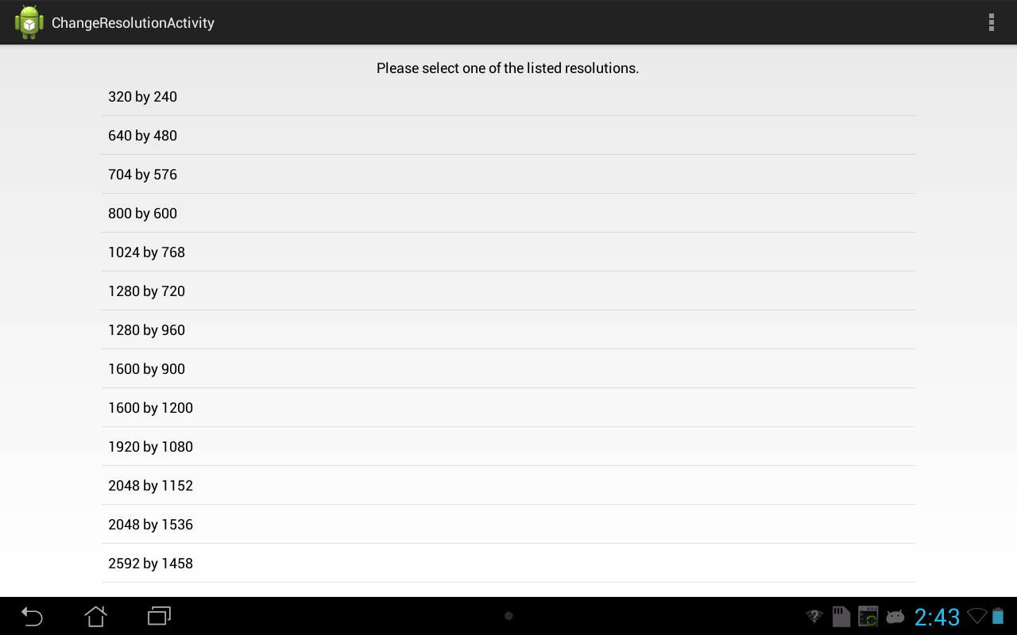
The resolution activity as it appears on the Asus tablet with no changes.

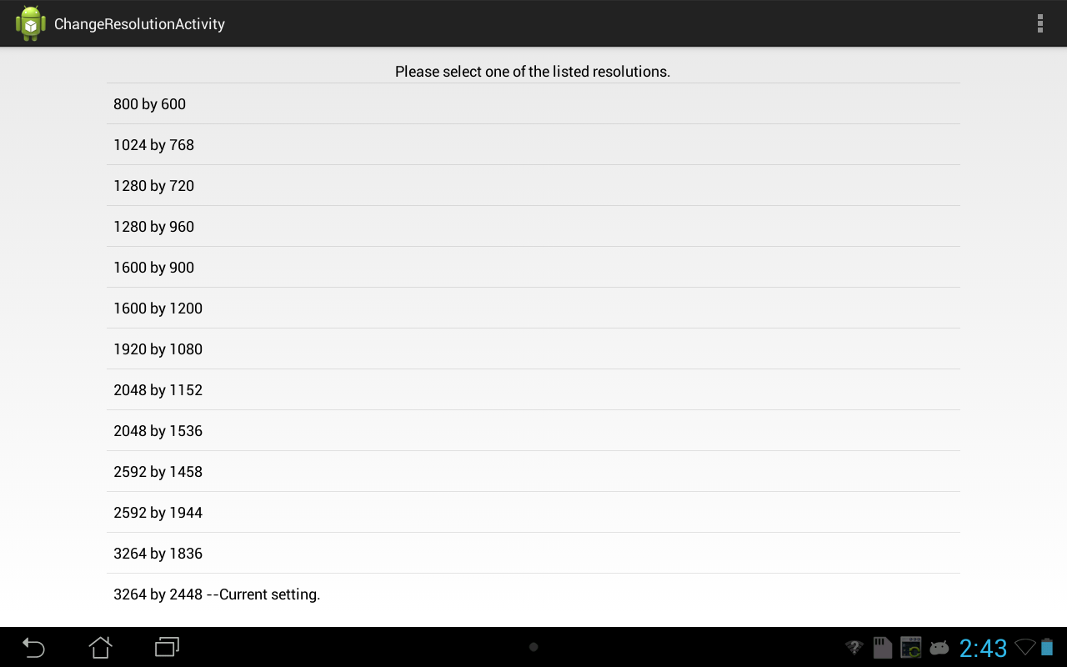
The resolution activity showing the current setting after being scrolled down.

