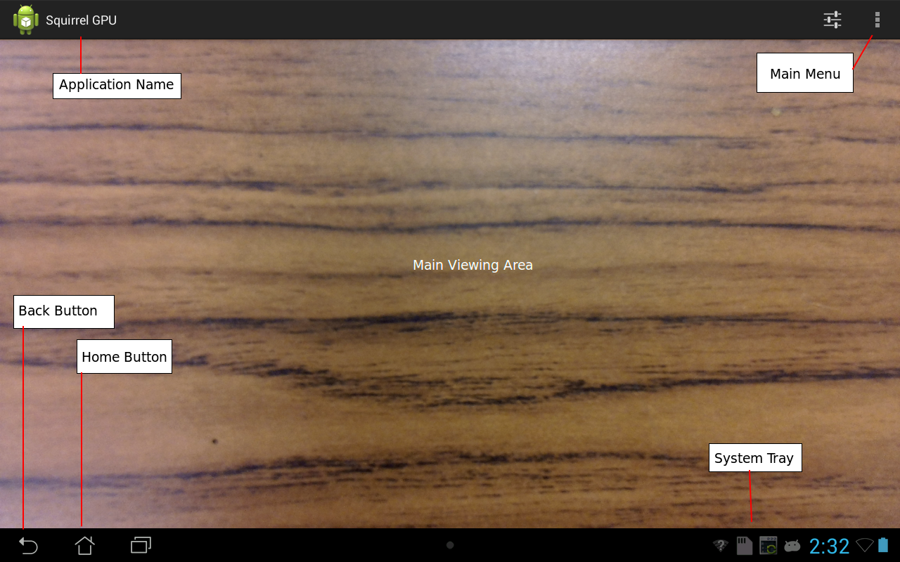
This is a preliminary manual for the program.

Section 0-0: Introduction
WildCam is a computer vision tool that automatically captures video footage of specified objects as soon as they fall within the device's field of view. This manual will document the proper procedures and usage for the program.

0-1: How is this useful?
Because WildCam can automatically capture various objects almost as soon as they come into view, it has numerous applications in the realms of security, surveillance, population reporting and more.

0-2: Why WildCam?
WildCam provides several advantages over other object tracking solutions. The first advantage is that the program can be used on a wide array of devices run by the Android 4.2 or later operating systems. It is for this reason that WildCam can be deployed cheaply and quickly over a wide area to suit your needs. Additionally, WildCam is more likely to capture relevant data, thanks to its ability to sort and detect objects, then filter them by real-world area. The area filter prevents the program from returning results that are too large or small.

0-3: How to read this document.
This users manual is intended to be read through at least once. The document has also been broken into brief sections so that it can be used as a reference later on.

Section 1-0: The Main Screen
The first thing that you should see when starting the program is a view of whatever the camera is currently viewing. In the top right corner of the screen should be a menu. This menu allows you either go directly to the settings screen or directly change various image capture-related settings as quickly as possible. See figure 1 for an example of what the screen should look like.

Figure 1: The Main Screen. While there may be differences in how it looks here and how it looks on your device, this screen should be fundamentally the same.
Note how various objects are labeled.

1-1: The Main Menu
Moving on from the main screen is the Main Menu. This menu, as previously mentioned in Section 1-0, allows you to change various settings in the program directly, in addition to accessing the settings menu itself. See Figure 2 to see what the menu should look like. Some of the items that can be accessed in the menu are: AutoCapture Frequency, Change Resolution, Target Object Area, and the Settings Screen. For every item in the settings menu except for the Settings screen, a dialog box will appear in the center of the screen when you select the item. From this dialog box, the item can be changed.
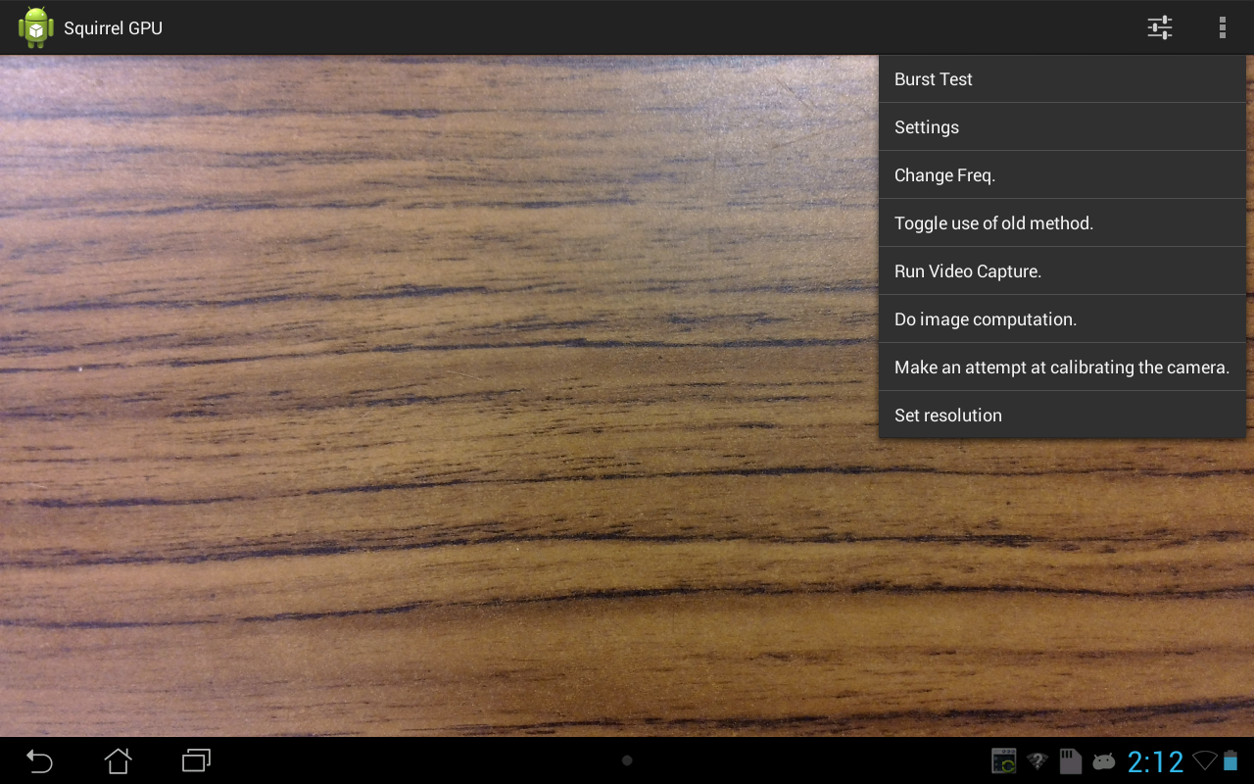
Figure 2: (Above) The Main Menu allows you to select and directly change various options and settings present in the program.
Figure 3: (Below) This is the Set Resolution dialog. It lists every resolution that your camera is capable of capturing. Note: Depending on how many resolutions your camera supports, this list may or may not need to be scrolled in order to see all resolutions.

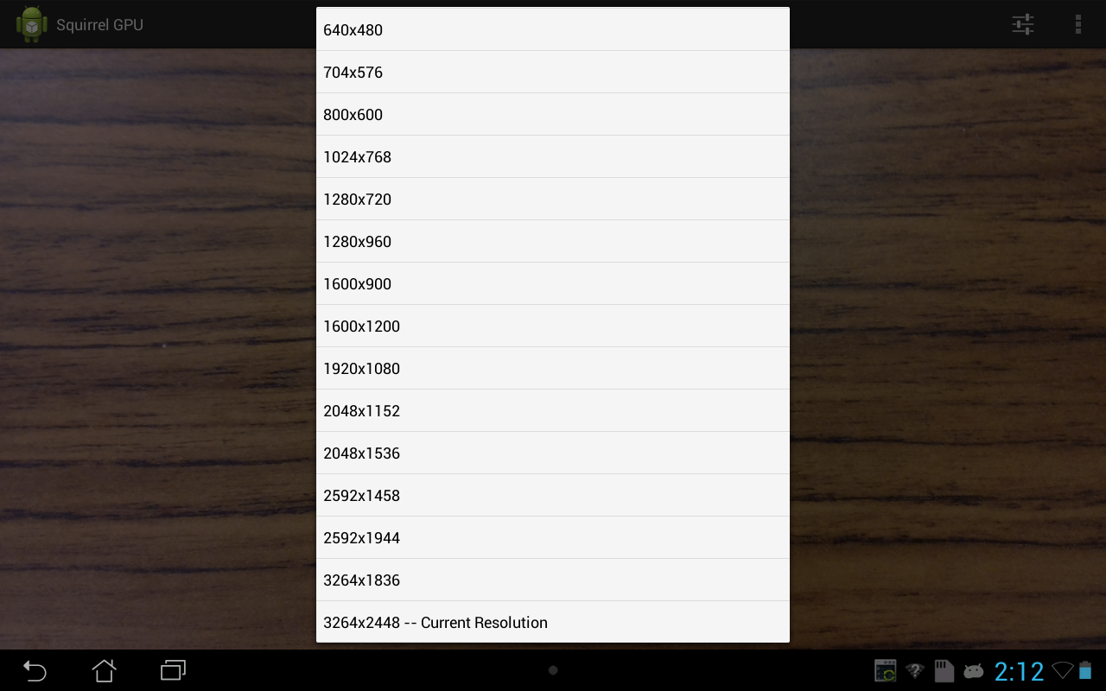
1-2: Starting The Program
Over the previous few sections, a general overview of the visible parts of the main screen was given. There is, however, one part of the screen that isn't shown at first, and that is the Start Pop-up. To show the Start Pop-up, simply tap any part of the screen. From that place, you should see a small box. This box features the current total amount of storage remaining for image and video captures, as well as a button to start the image capture and processing process. To remove the Start Pop-up, simply tap elsewhere on the screen. The pop-up also disappears when you open up the main menu or start the capture. Before you start the program, you may want to change some of the program's settings in order to customize the image processing and capture.
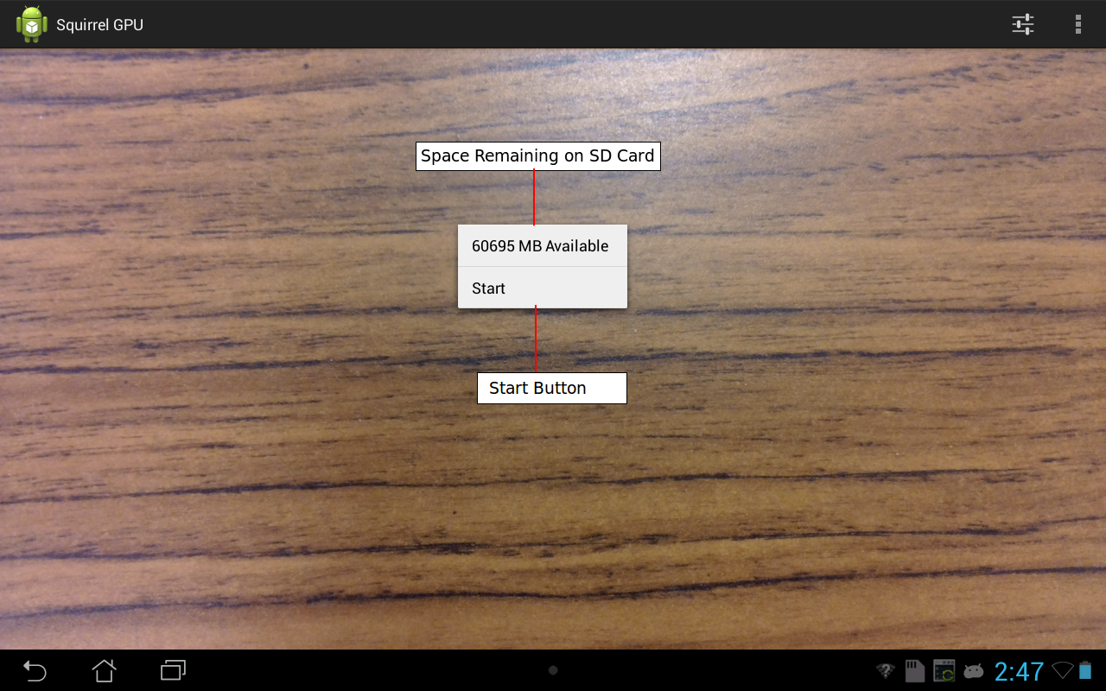
Figure 4: The Start Pop-up allows you to start the image capture. It also shows how much storage is available for the program to use.

1-3: Stopping The Program
During the image capture, the top bar of the program will change in response to the new mode of operation. Rather than just the title of the program, it will also list the resolution that you set earlier in addition to the text, “RUNNING.” While the top bar is in this state, the viewing area will occasionally stutter. This is completely normal, as the device can't show a live preview and take a picture at the same time. Additionally the main menu cannot be accessed during the capture. To stop the capture, tap any area of the screen and select “Stop.” It should be noted that if the stop pop-up does not appear immediately, then the program is likely to be bogged down. The pop-up should appear eventually.
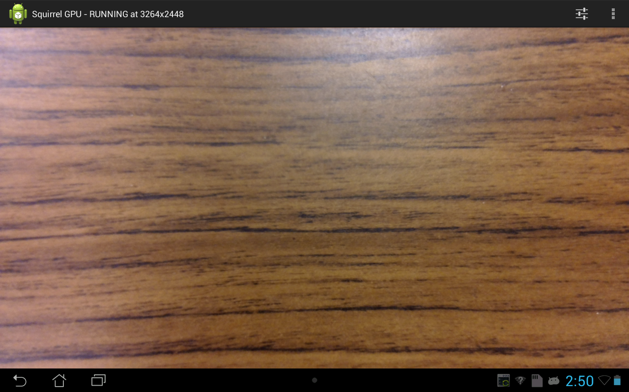
Figure 5: (Above) This is the program as it is running. Note the changed title bar in the top of the screen.
Figure 6: (Below) This is the stop pop-up. It is shown whenever you tap the screen while the program is running. It also retains the storage space meter, so it can be a helpful way of checking whether the device is about to run out of storage.
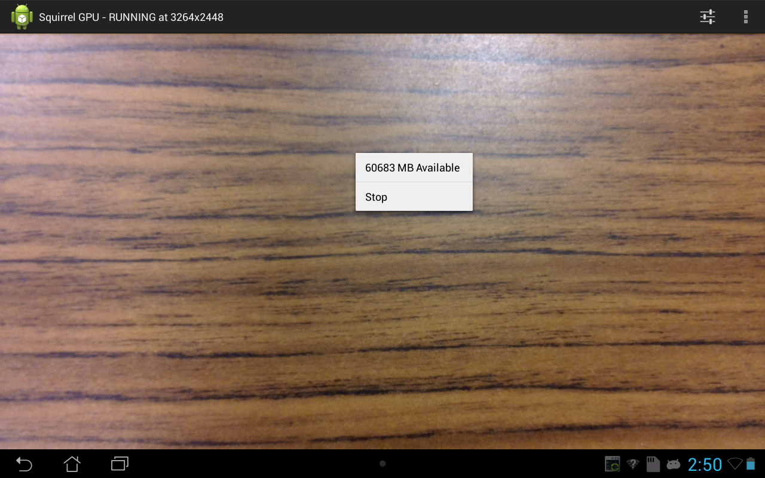
Section 2-0: The Settings Screen
When you select “Settings” from the main menu, the program will switch to a different screen named the Settings Screen. It is from this screen that you can not only change the settings that you can change as dialog boxes in the main menu, but also some advanced settings necessary to fine-tune the image capture. See figure 7 for the general layout of the settings screen.
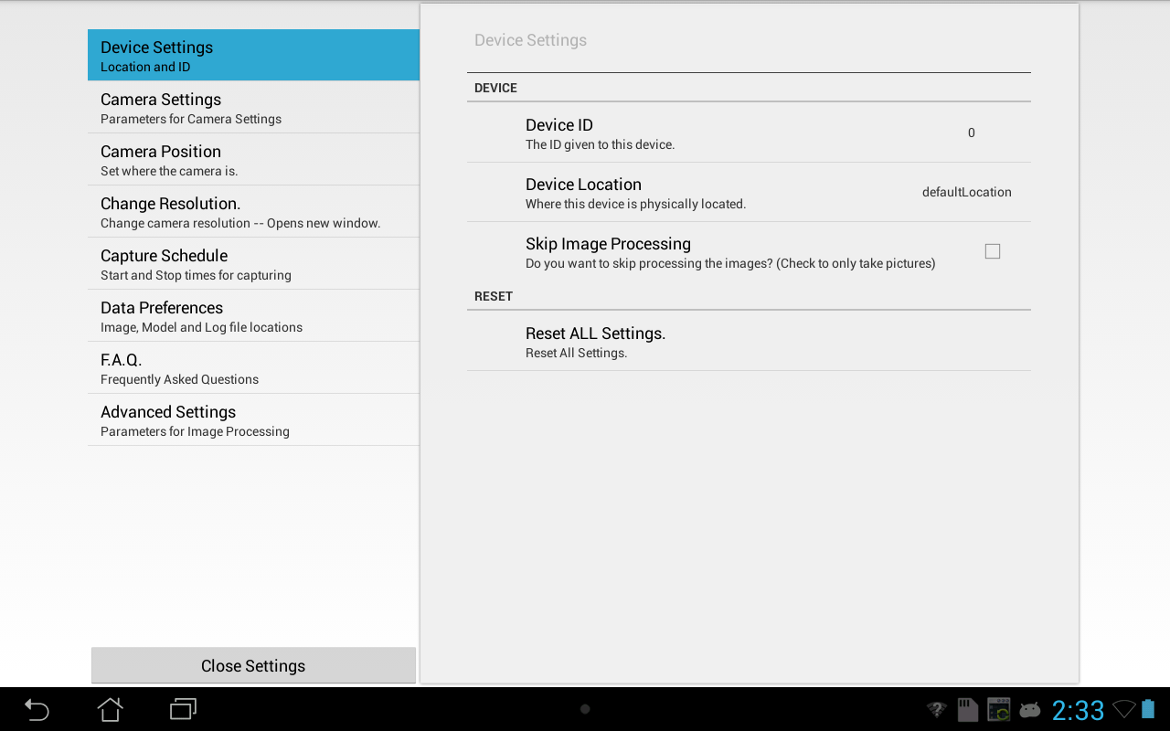
Figure 7: This is the the Settings Screen. It is from here that you can fine-tune some of the inner workings of the program.

2-1: Device Settings
The first panel that is selected when the settings screen is opened is the Device Settings Panel. From this panel, you can change the device's ID number and location. These values are used by the program in naming files and populating logs, so be sure to change these to meaningful values if you will need to work with more than one device. Additionally, from this screen you can reset all settings to their defaults, as well as tell the program to skip image processing, if you just want it to take a picture every few seconds. To see these fields, see Figure 7.

2-2: Camera Settings
The second panel is named Camera Settings. It is from this panel that you can change a few camera and image capture settings. The camera related settings include the focus mode, scene mode, and white balance. The capture-related settings include minimum and maximum detectable widths and heights. Please note that the widths and heights can be changed from the Main Menu. See Figure 8 for the layout of this screen.
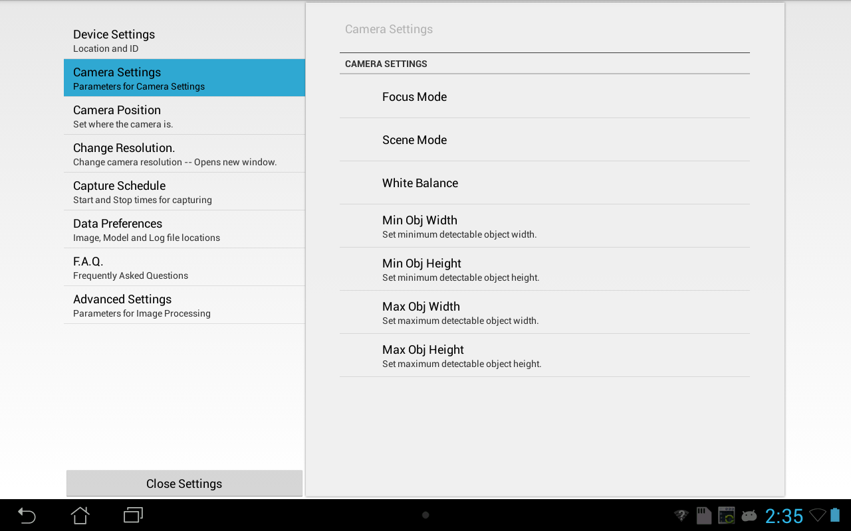
Figure 8: Shown is the Camera Settings Screen. From here you can change various camera and image capture settings.

2-3: Camera Resolution
This panel is the settings-menu equivalent of the change resolution dialog, except that instead of opening a dialog box, it opens its own screen. This is because of the wide range of resolutions presents on some devices. Aside from that, it is very similar to the dialog box and should be regarded as the same.

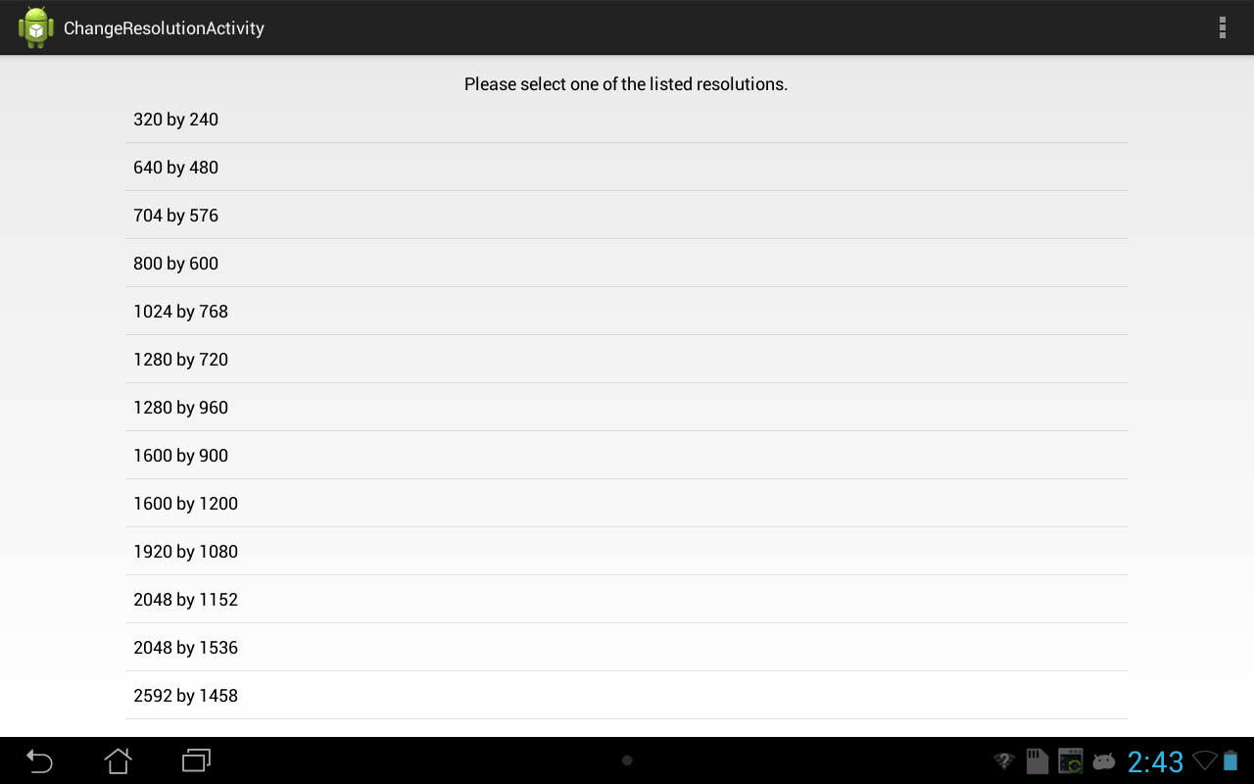
Figure 9: This is the camera resolution screen. It is functionally identical to the resolution change dialog box. Note the lack of a cancel button. To cancel, either select the current resolution or press the back button.
2-4: Capture Schedule
The capture schedule panel allows you to select the time range during which the program will allow itself to capture images and process them. This is for automated capture stations, and to provide that maximum amount of time, set the start time to 12:00 AM and 11:59 PM. It may be possible to set the times from 12:00 AM to 12:00 PM, however the program may think that the 12 hour period from 12:00AM to 12:00 noon was intended. The capture cycle interval represents the number of seconds to elapse before the program checks whether or not it is still operating within the selected ranges. It could be possible to set this value to the number of seconds in a day, then start the program at any time within the specified working time period, as it would only check during a valid time. As a warning, setting this value to a very small number can slow the program down due to the constant checks.

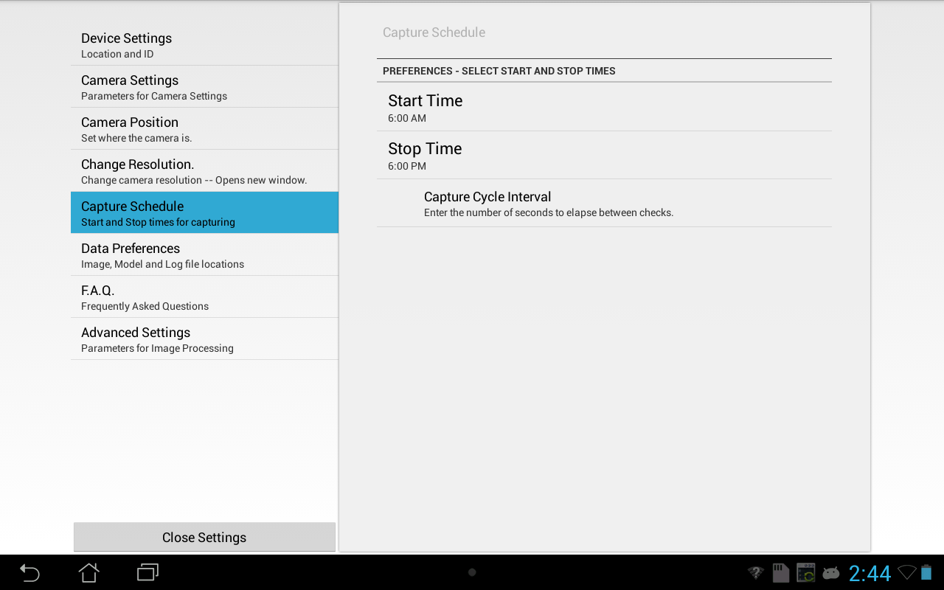
Figure 10: In the figure above is the capture schedule screen. It features various settings related to the times during which the program may capture and process images.

2-5: Data Preferences
The data preferences panel allows you to change where the program stores all of its data. This is mostly a matter of user preference, however it could be used to make various files visible to a Unix-like system. An additional use for this is to re-target where everything is if your specific device has different names for the current SD card, etc.
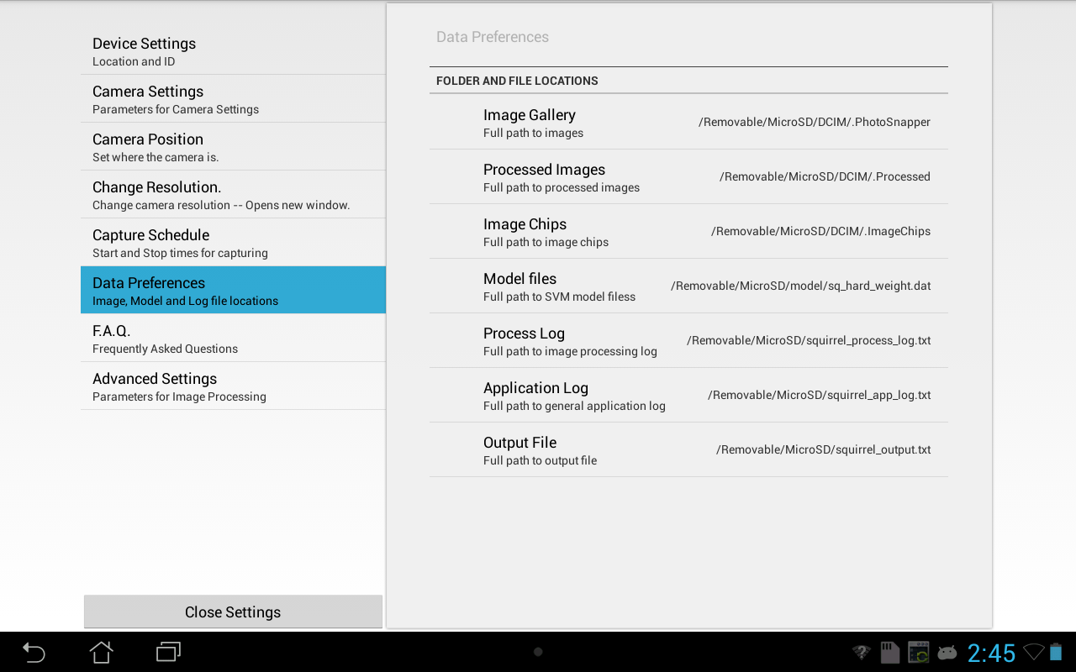
Figure 11: This figure features the data preferences screen. Its purpose is to select the locations for every file that will be used in the program.

2-6: Advanced Settings
The advanced settings pane allows you to change some internal settings to be used by the object detection system. These settings often have some obscure names, so they will be simplified here. The first item listed is named “fudge.” Fudge is essentially the amount of space the program will use as a border around detected objects. The second object, “scale”, represents the scale the image is relative to the real image plane. All of the other parameters listed are very integral to the operation of the program and thus probably should not be changed.
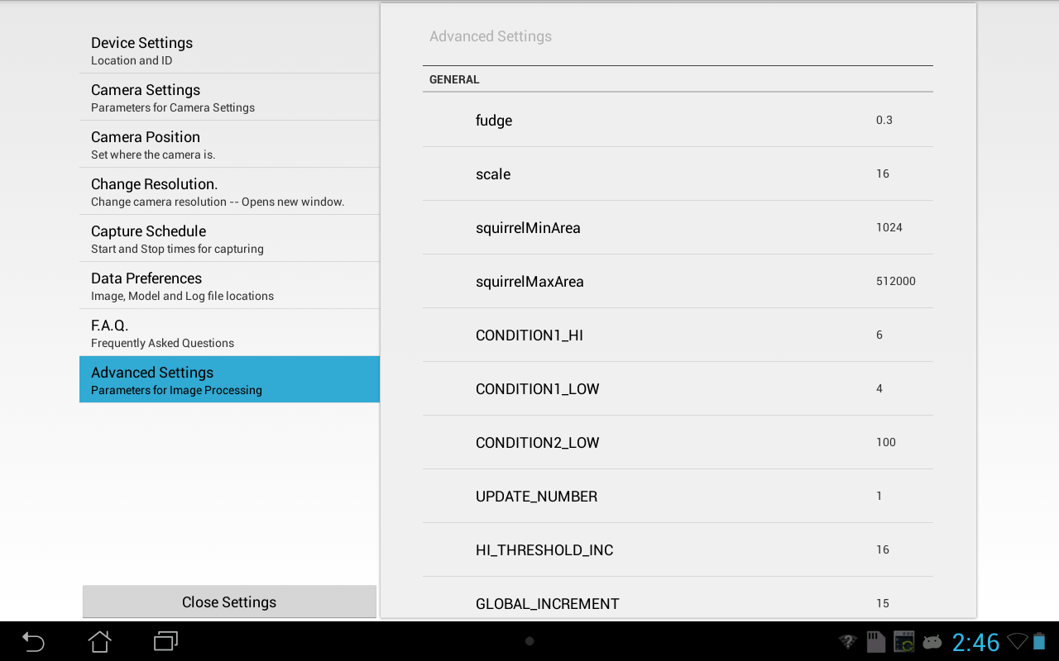
Figure 12: This figure is of the advanced settings screen. There are very few values that should be changed here, namely fudge scale, squirrelMinArea, and squirrelMaxArea.
Section 3-0: Online Documentation
WildCam features an extensive online documentation system that can be accessed from the main menu. This documentation system is a part of the program itself, so the program's documentation can be read in a remote area. This section details the documentation system itself.

