Documentation for the Settings Menu

This document regards the use and configuration of the settings menu. As it is not programmer documentation, there will be no algorithmic descriptions, aside from those that will assist the user in understanding the menu.

The settings screen is an activity in SquirrelGPU that is accessible from the main menu. It purpose is to allow the user to change various parameters that represent how the program works. Some of these parameters include capture resolution, camera orientation, and when the program is allowed to capture pictures.

The first settings menu is called “Device Settings”. This settings menu allows you to change various device settings, such as the ID number to be used by the internal logging, and the location of the device, for photo tagging and sorting. Finally is a setting to allow the application to skip image processing, which doesn't do anything at the moment, but that feature will be implemented shortly.
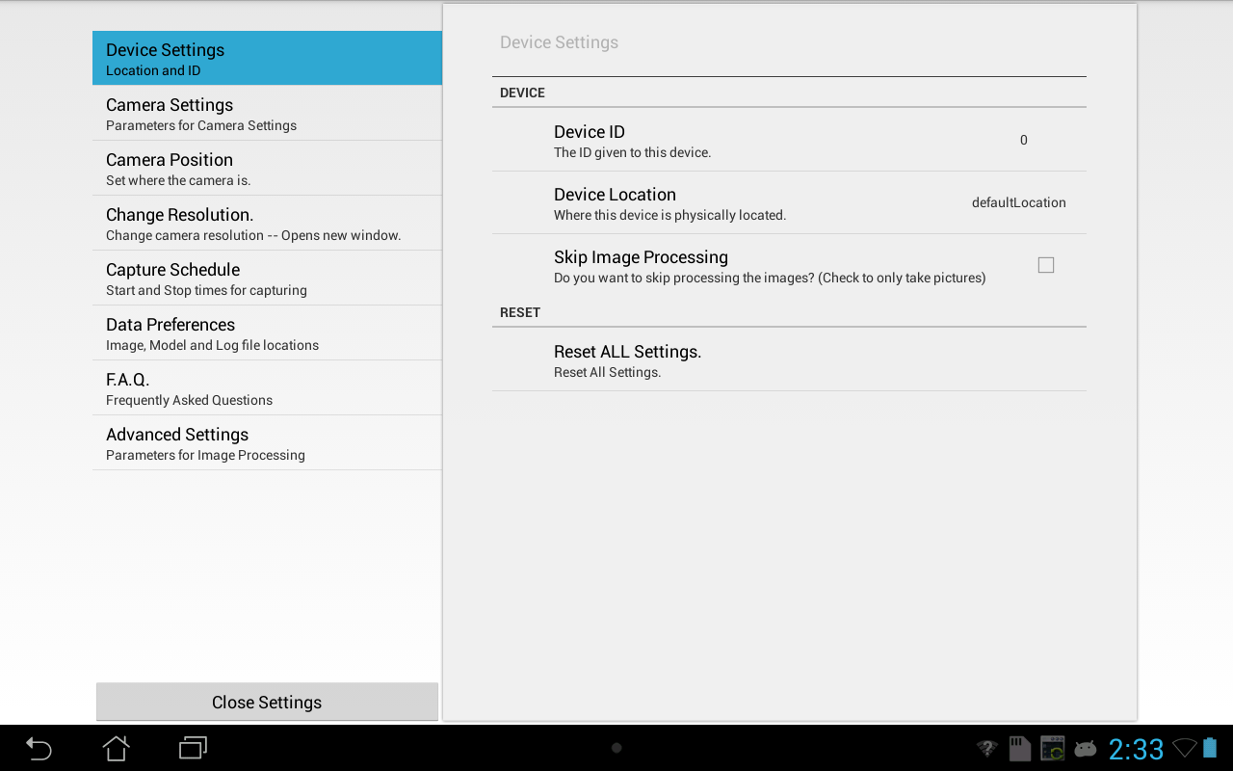
The last item in the Device Settings menu is a button labeled, “Reset ALL Settings”, which will reset all of the settings in the settings activity to their defaults.

The next group of settings is called, “Camera Settings.” This settings menu allows you to change various options to do with the camera and image capture. These options are Focus Mode, Scene Mode, White Balance, Min Obj Width, Min Obj Height, Max Obj Width, and Max Obj Height. Focus Mode, Scene Mode, and White Balance all determine how the camera will take pictures and focus in response to changing external environments. The widths and heights represent how large of a range of objects the algorithm should be allowed to check for. This is to prevent the algorithm from considering objects that are unreasonably large or small to be something that is being checked for.
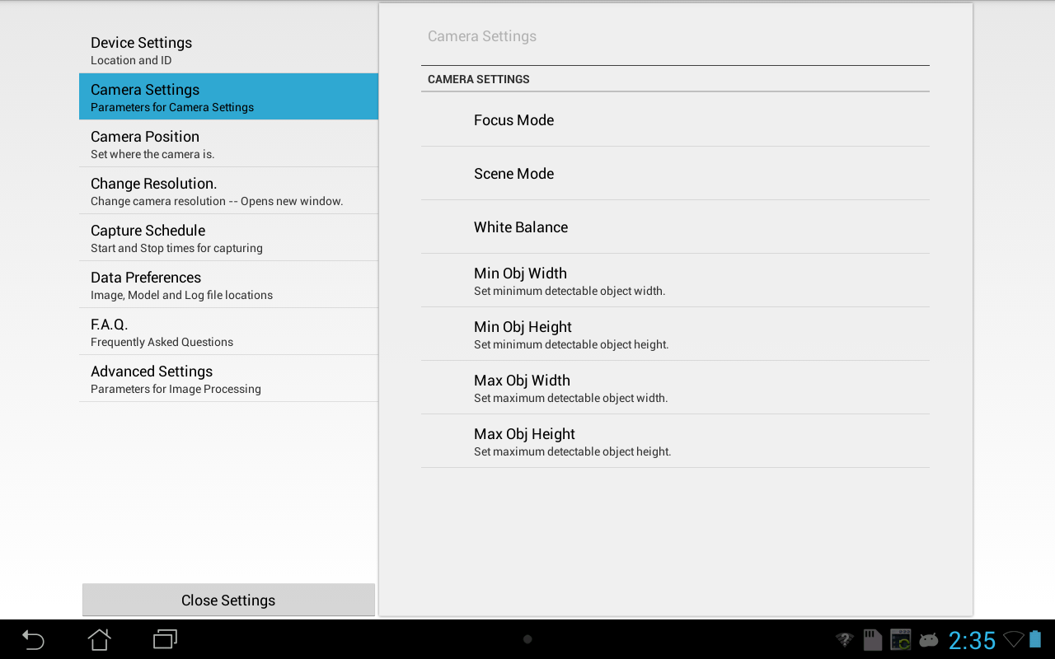
The third group represents where the camera is positioned relative to the plane of which the picture is being taken. It has only one field, and that is the camera's vertical distance above the ground. This allows the program to triangulate the distances between the camera and the object that it is supposed to be detecting. Because the application doesn't enforce any system of measurement, please use the same units to represent the vertical distance above the ground as are used to represent the maximum and minimum areas for detected objects.

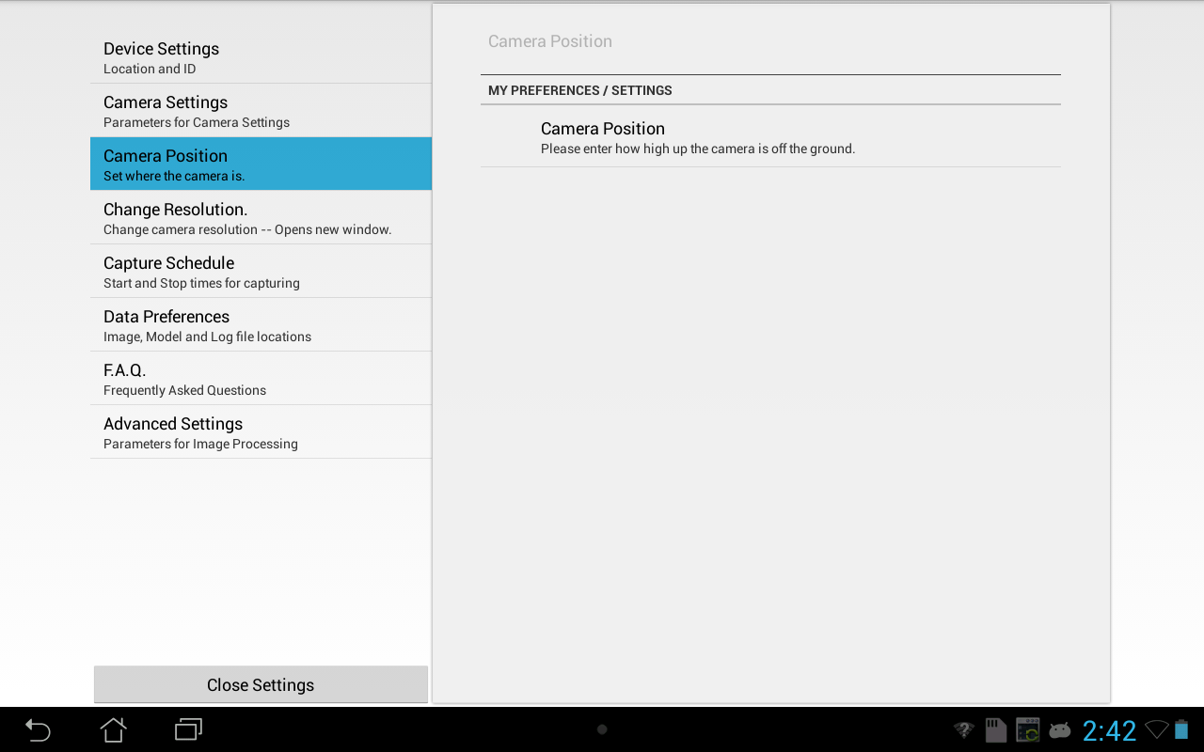
The most unique setting available is the Change Resolution Setting. Rather than being in a pane at the right side of the screen, it opens into its own distinct activity. In this activity is a scrollable list of resolutions. These represent how many pixels wide and high the captured images will be. The advantage of selecting the higher or highest possible resolution(s) is that the program would be able to “see” greater detail. This helps immensely with distant objects, as they may be small enough that a lower resolution would not adequately represent them. Lower resolutions are beneficial when distant objects need not be observed. Some additional benefits of using a lower resolution come from the fact that the device has fewer pixels to keep track of, so the image files are smaller and can be processed faster. To use the resolution activity, first scroll through and see which resolution is marked with “-- Current Resolution.” If the current resolution needs to be changed, then simply touch one of the listed resolutions, as listed are all of the resolutions that your camera can use. If no change is necessary, either press the back button or select the current resolution.
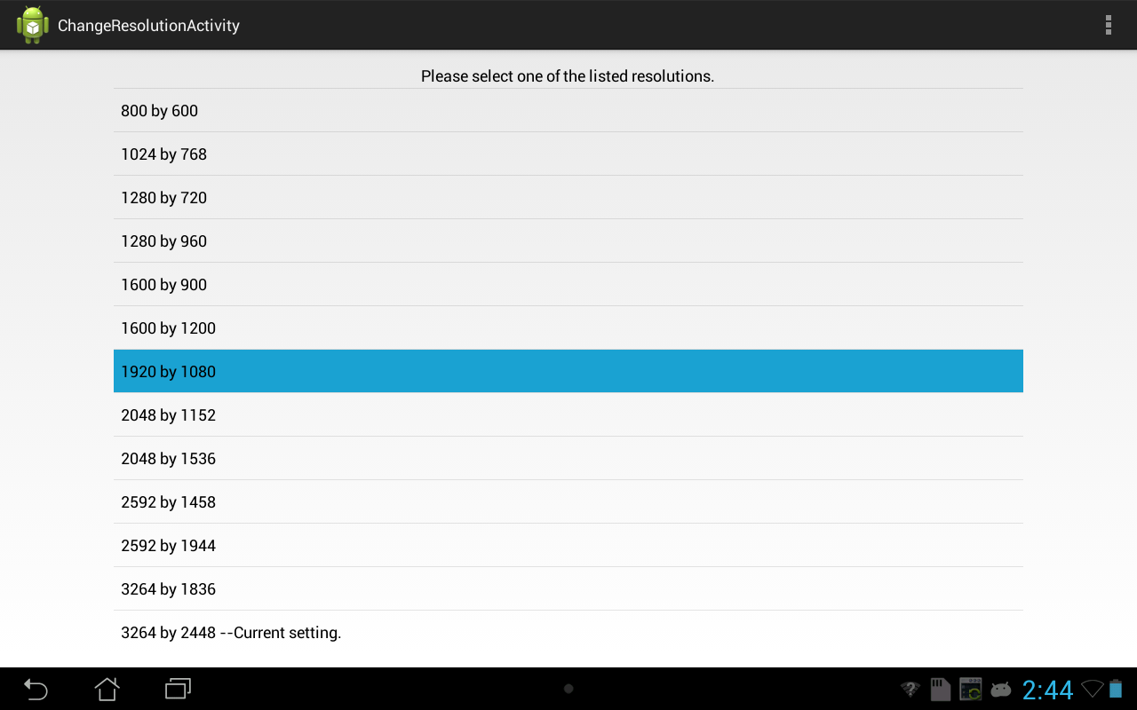
After selecting the resolution in the Change Resolution Activity, the next action should be to set up a capture schedule. When the program has been told to run, the capture schedule will prevent it from processing images outside of the time range specified. The closest option to constantly allowing the program to process images should be 12:00 AM to 11:59 PM, since 12:00 AM to 12:00 AM would be interpreted as never allowing the program to process images. The default capture time is from 6:00 AM to 6:00 PM, which should adequately cover most workdays.
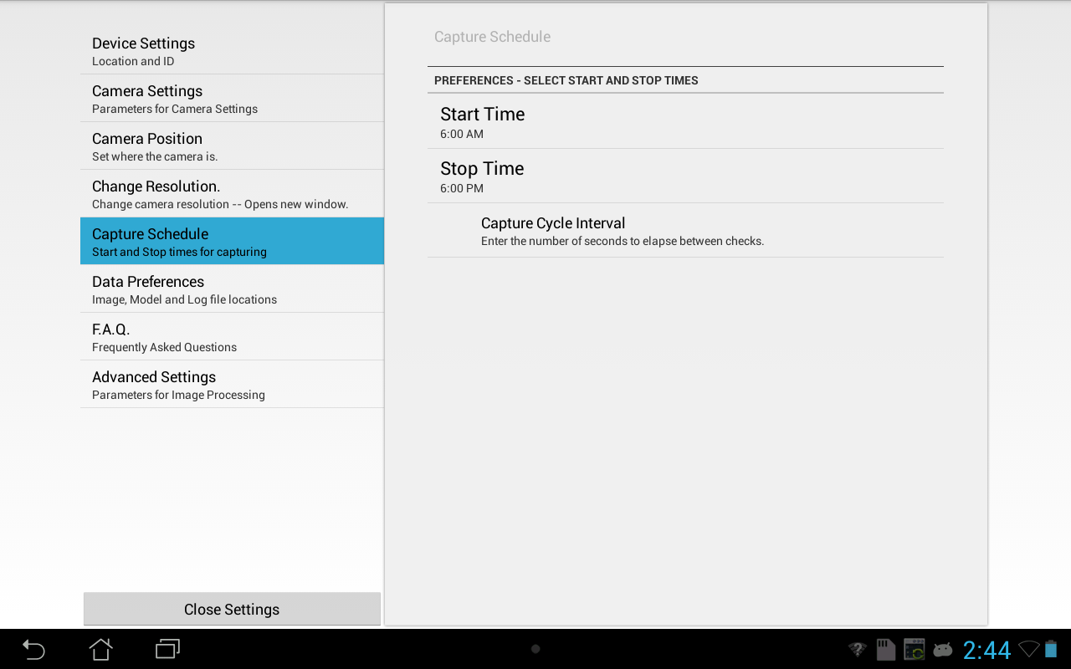
The final setting before the FAQ and Advanced Settings is the Data Preferences setting. Not much should be changed in the setting unless the user would like to change the location from the Android MicroSD card to the internal storage, for example. Another potential use for the data preferences setting could be to disable the hiding that is built into most of the directories used.
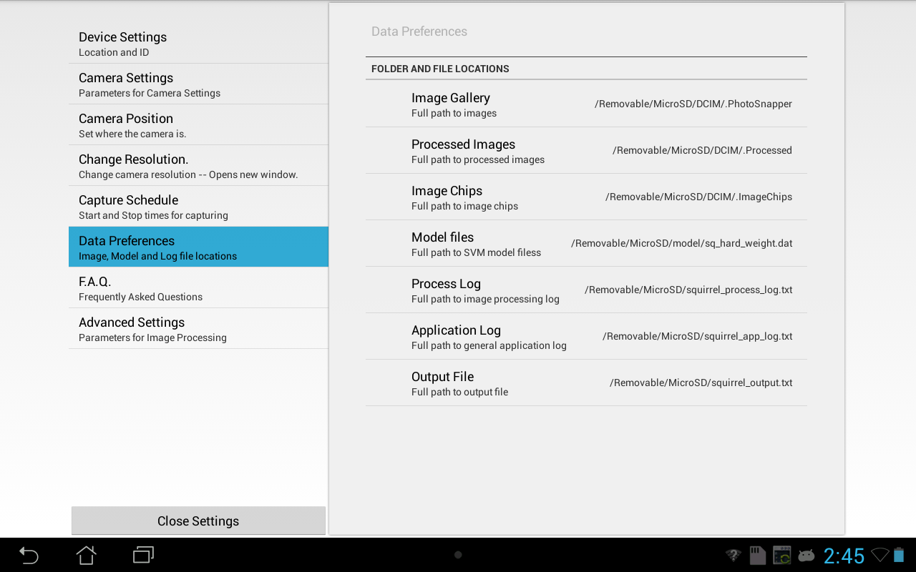
The FAQ setting is a page of frequently asked questions. It is currently not populated with meaningful text, but it should be populated eventually.

The Advanced Settings settings menu is comprised of a list of numeric values that can be adjusted by the user and represent various values used in the detection algorithm.

The first value listed is “fudge”, which is the amount of “slack” that the program will give the borders of objects before accepting them as distinct entities.

The second value listed is “scale”, which may be the amount of scaling that the pipeline considers with every object detected.

SquirrelMinArea and SquirrelMaxArea both represent the minimum and maximum pixel areas the algorithm will consider. This prevents it from checking objects that are unreasonably large by any measurement, and thus saves both time and energy.

All of the other values listed control the internal workings of the Squirrel pipeline and really shouldn't be user-customizable.

