Technical Overview of

WEBBTIDBOK
for

Bukaorta Screening

Hälsoundersökning Mammografi

Gynekologiskt cellprov

Overview
This system is used as a Time Book application for routine examinations to which the patient has been invited.

Through this web application the patient, from here on the same as user, will be able to log on by using the login credentials and following the instructions provided with the previously received invitation.

As a logged in User the person may choose to cancel, reschedule and/or changing location for the appointment for the examination.

The application is modular and it's structure allows for it to scale well and grow with appending new screening time books. Thus it allows for the connection of more Web Services, Message Bundles specific to a new screening form.

This is done by defining and adding new Service Definitions.
A service Definition is constituted by a corresponding Service ID and Message Bundle.
These are defined in:

web-application-config.xml
This file is a key point for the application and it is here where new Service Definitions and other backing beans are defined to allow for further adding examination types and their respective Web Services, message bundles and service id.

Below are some key elements explained and will help in adding further services to Webbtidbok.
X, Y, Z below denotes any other name better describing the service to add.

<!-- The serviceDefinition beans below are instances of class ServiceDefintion -->
<bean id="bookingFactory" class="se.vgregion.webbtidbok.booking.BookingFactoryImpl">
<property name="serviceDefinitions">
<list>
<ref bean="serviceDefinitionX" />
<ref bean="serviceDefinitionY" />
<ref bean="serviceDefinitionZ" />
<!-- Add more serviceDefinitions here as needed -->
</list>
</property>
</bean>

<!-- Clone this serviceDefintionX and adjust it for any other service you need to add -->
<bean id="serviceDefinitionX" class="se.vgregion.webbtidbok.servicedef.ServiceDefinition">
<!-- example: BUKAORTA -->
<property name="serviceID" value="X" />
<!-- example: messages/bukaorta/BukAortaMEssages -->
<property name="messageBundleBase" value="messages/X/Y" />
<!-- an instance of the class BookingFacade -->
<property name="bookingService" ref="XBookingService" />
</bean>

<!-- Clone this XbookingService and adjust it for any other service you need to add -->
<bean id="XBookingService”
class="se.vgregion.webbtidbok.booking.X.XBookingFacadeImpl">
<property name="serviceFactory" ref="XBookingServiceFactory" />
</bean>

<!-- Clone this BookingMapperX and adjust it for any other service you need to add -->
<bean id="XMapper" class="se.vgregion.webbtidbok.booking.X.BookingMapperX" />

<!-- Add references here as needed, basically one per WebService to communicate with -->
<bean id="lookupService" class="se.vgregion.webbtidbok.servicedef.ChainLookupService">
<property name="lookupChain">
<list>
<!-- example: bukaortaLookupService -->
<ref bean="lookupServiceX" />
<ref bean="lookupServiceY" />
<ref bean="ZLookupService" />
</list>
</property>
</bean>

<!-- Add look up services here as needed, basically one per WebService to communicate with -->
<bean id="lookupServiceX"
class="se.vgregion.webbtidbok.servicedef.PasswordMatchLookupService">
<property name="serviceDefinition" ref="serviceDefinitionX" />
<!-- This proprety helps the look up to chose correct web service etc. By defining a prefix pattern which is matched or not matched with the user eneterd password-->
<property name="regexp" value="^SOMEPREFIX.*$" />
</bean>

<!-- Add look up services here as needed, basically one per WebService to communicate with -->
<bean id="wsXLookupServiceExamTypeX" class="se.vgregion.webbtidbok.servicedef.LoginLookupService">
<property name="serviceDefinition" ref="serviceDefinitionX" />
</bean>

Further information is available as comments in this file which is found in the project. More information on where to find the project and how to obtain the code is found further down in this document.

The Pom
Since it is a Maven based project it is strongly advised that you look into and understand the content of this file. Among other things it shows dependencies and WSDL Url's.
How you build this project is described below under headline To start Developing in a Webbtidbok project.

Spring WebFlow
It is just as important to familiarize oneself with Spring Web Flow as this is the how behind the flow(s) in this application. The flows in this application are described in short below.

JSF & Spring Faces
The XHTML files which constitutes UI elements, together with CSS and image resources, all use JSF and SpringFaces to create a UI which can be populated with dynamic content depending on what service the users examination is connected to. JSF & SpringFaces are also used to navigate central parts like the booking calendar and to retrieve text strings from the set Message Bundles.

The Facade
The application is built according to the diagram below.
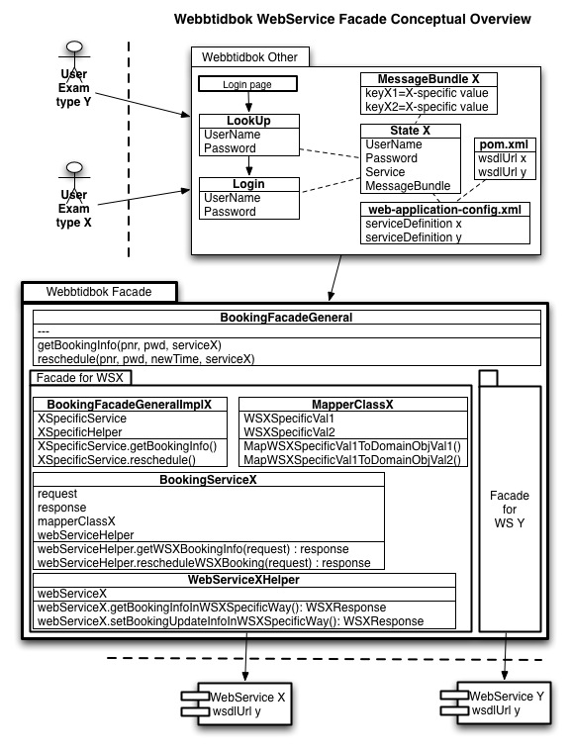

To start Developing in a Webbtidbok project

The content is based on material found following the link below.
http://code.google.com/p/oppna-program/wiki/Anvisningar_Utvecklingsmiljo

Prerequisites
Download and install latest JDK
Set necessary environment variables like JAVA_HOME on your PC

Download and install Maven
Test your installation in the console by typing MVN at the prompt

Download and install Subversion
Test your installation in the console by typing SVN at the prompt

Download and set up Tomcat 6
Test by running it from the console
In your web browser go to localhost:8080

Download the latest and greatest Eclipse
Eclipse IDE for Java EE (or other if you like)
Unzip and place it where you like
Set up a Workspace

Eclipse plugins which are good to have:
Subclipse
M2Plugin (Maven)
Spring IDE

Set up a Google account if you don't already have one which you'd like to use. You need this in order to access the project which is stored at Google Code.

Code Repository
This is the main site for all Oppna-program:
http://code.google.com/p/oppna-program

This is the site for Webbtidbok (Bukaorta screening):
http://code.google.com/p/oppna-program-webbtidbok

There's not much information here, however under the tab Source there are two links to the code repository, one read only and one for committers. If you're to actively work and commit code then apply to whoever is set as Owner to be set up as a Committer.

Once you're signed up as a committer it is important that you navigate to the “googlecode.com password” page under the Source Tab. You have to do this otherwise you cannot check out and / or
commit.

Below is the committer svn checkout for Webbtidbok as an example:
svn checkout https://oppna-program-webbtidbok.googlecode.com/svn/trunk/ oppna-program-webbtidbok --username your.name
When prompted, enter your generated googlecode.com password.

Below is the read-only svn checkout for Webbtidbok as an example:

svn checkout http://oppna-program- webbtidbok.googlecode.com/svn/trunk/bukaorta
oppna-program-webbtidbok-read-only

Copy whichever SVN URL you choose and run it in the console from within whatever folder you chose to keep your workspace.
<drive or root>\path\to\your\workspace\svn checkout ... <enter>
The result is that the code stored in the trunk is checked out to your workspace. Nothing less and nothing more. Depending on what project trunk you check out the structure you end up with in the workspace may look differently. For Webbtidbok (bukaorta screening) the project structure is as follows:
$/workspace/oppna-program-webbtidbok/bukorta/screening/

$/screening/
$/applications
$/composites
$/modules
$/web

Project structure depends on the Referensarkitektur (RA).
http://code.google.com/p/oppna-program/wiki/Anvisningar_Kallkodstruktur
Now you need to take care of all the other stuff.
Eclipse need to recognize the project as a web project, the project need to be built and dependencies need to downloaded and resolved.

Open a console and go to your project in the workspace and type in the mvn string below:

$\workspace\project_x\mvn eclipse:eclipse -Dwtpversion=2.0<enter>

then

$\workspace\project_x\mvn clean install<enter>

These two steps may take a while depending on how long it takes for maven to download all required dependencies. mvn eclipse:eclipse generates project files for this project needed by
Eclipse. -Dwtpversion=2.0 -D defines a system property. Wtp means it's a Web Tools Platform project and version=2.0 means it's a Wtp project version 2.0.

Configure Eclipse
If you're using a Mac it is very important that you change Eclipse default preference concerning Encoding. Open Eclipse then click General, then Workspace and change from Default (MacRoman) to Other and UTF-8.
Under Java, Installed JRE's make sure that the version checked is the one you want.

Choose Maven and enable the Debug Output option, this elaborates further what Maven is up in the Eclipse console. You can also check the Offline option if you need to work and build without an internet connection available.

Maven, Installations. Make sure that the correct Maven (if more than one) is checked. On Mac you have an Embedded version which you could/should run.

In the Maven, User Settings you can make sure that the local maven repository is where you want it to be.
Example: /Users/carstm/.m2/repository

Under Run/Debug and Console you could want to increase the buffer size from 8 000 to 80 000 characters.

Autocompletion support in *.xhtml
Also in Eclipse you'd probably want to use the nice features that comes with autocomplete support. So to be able to enjoy this when working with JavaServer Faces and Spring WebFlow in the xhtml files of this project you need to do three things:
- Download and install Spring IDE and probably restart Eclipse
- Go to Eclipse Preferences, then Spring and tick the empty box before Spring Validator and click OK. Restart and typing <sf: then pressing ctrl + space should provide the tags possible to choose from in the sf namespace.
- For JSF autocompletion in the xhtml files you need to go to Eclipse Preferences, click General and then choose Content Types and expand the Text alternative. Highlight JSP and click the Add... button and fill in *.xhtml in the dialog box. OK everything and restart Eclipse. Typing <f: or <h: and then ctrl + space in any xhtml file where you have imported the JSF namespaces should work.

Import your project into Eclipse
Now open up Eclipse and import the project into your IDE.

Import it as a Java project and then right click on it and enable Maven Dependencies. A small “M” symbol should appear on the project folder in the Project Explorer (PE) in Eclipse.
The project probably indicates numerous errors, like classes which are not found etc.
Right-click again on the project, click Maven and the Update Project Configuration, this should render java classes provided thru the WebSevice (se up in the pom.xml). These are needed to resolve all errors corresponding to classes not found. If nothing happens right click and refresh the project and hope for the best.

Flows
There are six different flows within the application. They are as follows:
- Login
- Display
- Update
- Switch
- Delete
- Help

It is through these flows the user navigates around in the application and the key ones are depicted
below in concept. For a more detailed understanding it is recommended to browse the code in the flows.

Login flow
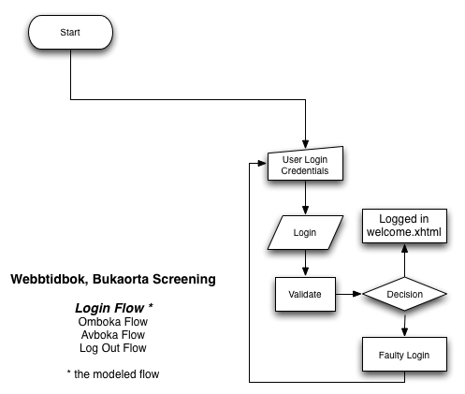

Display flow
Not depicted in diagram form as it only contains redirects to Update (Omboka), Delete (Avboka tid) flow or to Log Out.

Update flow
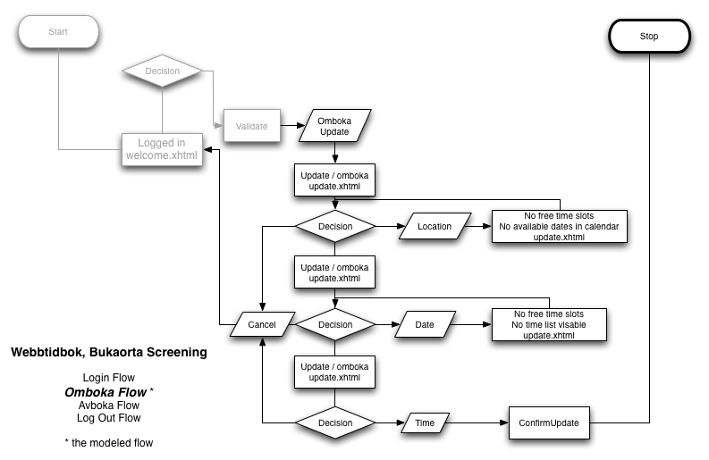

Switch flow
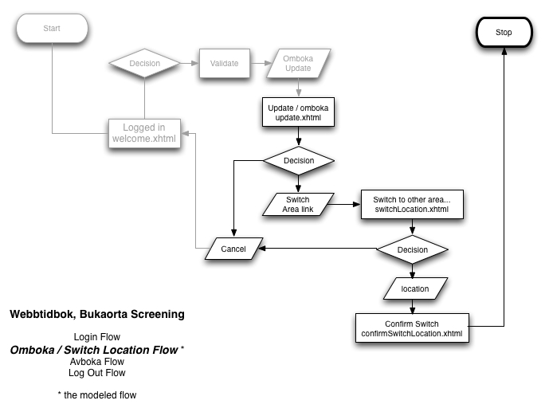

Delete flow
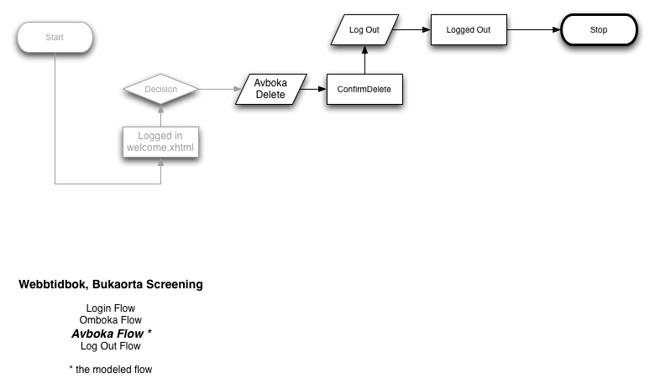

Help flow
Not depicted as this only is a small subflow which has a Cancel button leading back to Welcome page and a Logout button.

Webbtidbok in correspondance with the Reference Architecture (RA)
This is an overview of where the code os this application is found. Most of it is found under composite-webcomp module, the domain objects are in composite types and cryptography necessary for Webbtidbok Bukaorta Screening is found in composite-svc module.
More about the RA is found here:
Referensarkitektur (RA).
http://code.google.com/p/oppna-program/wiki/Anvisningar_Kallkodstruktur

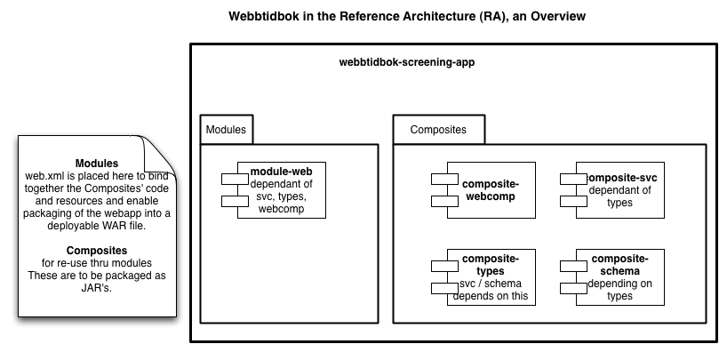

Manual Test Cases
Below are all manual test cases available for the Webbtidnok application.
- They may complement other elements of this document and be used as reference as to how the application is supposed to work.
- They may also be used when performing Acceptance Testing.
- They may be used to ensure functionality as a complement to Unit Testing by the Developer.
There are Manual Test Cases for:
- Login
- Update
- Confirm Update
- Switch
- Delete
and
- Confirm Delete

Login Manual Test Case

TESTFALL FÖR SYSTEMTEST av WEBBTIDBOK

Nr: | - Inloggning  - Välkomstsida | Version: | 1.0
Prioritet: | Normal | Ändrad: | 2010 10 15
Product Backlog Item: | N/A

Syfte och kort beskrivning
Syfte att kontrollera Inloggnings- & Välkomstsidans innehåll och funktionalitet

Förvillkor
Att ha navigerat till startsidan för applikationen i en webläsare.
Att ha tillgång till att testa Webbtidbok i IE 8 eller senare FF 3 eller senare.
Att ha tillgång till testanvändare för både Bukaorta Webbtidbok och Mammografi Webbtidbok.
Att ha senaste GUI specifikationer för systemen är också viktiga att ha tillgång till.

Kommentar
Skrivet av Carl Strömhielm

Testfallet
 | Händelse | Data | Väntad händelse | Faktisk händelse
 | Navigera till startsidan:  Http://localhost:8080/webbtidbok-screening-module-web | N/A | Startsidan visas enl. spec.
 | Kontrollera layout | N/A | Se GUI spec. för resp. undersökning
 | Kontrollera textinnehåll | N/A | Korrekt generellt innehåll enl. spec.  Korrekt stavning. Korrekt paragrafindelning.
 | Kontrollera länk: Här kan du läsa om regionens hälsoundersökningar. | N/A | Sidan http://vard.vgregion.se/sv/Mina-tjanster/Halsoundersokningar-i-Vastra-Gotalandsregionen/  öppnas i ny tab alt. i nytt fönster.
 | Kontrollera länk: Här kan du läsa mer om hur du gör | N/A | Sidan: http://vard.vgregion.se/sv/Mina-tjanster/Sa-har-gor-du-om-du-vill-omboka-din-tid-till-halsoundersokning/  öppnas i ny tab alt. i nytt fönster
 | Kontrollera länk: Läs mer om ultraljudsundersökning | N/A | Sidan:  http://vard.vgregion.se/sv/Undersokningar--behandlingar/Undersokningar/Sjukvardsradgivningen/?CatId=26983&ChapId=27903  öppnas i ny tab alt. I nytt fönster
 | Prova att logga in med fel användarnamn (godtycklig kombination av tecken) | Fel anv.namn | Feltext enl. spec ska visas.
 | Prova att logga in med fel lösenord (godtycklig kombination av tecken) | Fel lösenord | Feltext enl. spec ska visas.
 | Prova att logga in med fel användarnamn & lösenord (godtyckliga kombinationer av tecken) | Fel anv.namn  Fel lösenord | Feltext enl. spec ska visas.
 | Prova logga in med korrekta användaruppgifter  MAMMOGRAFI | 1.Personnummer på testperson.  2.Lösenord | Välommen-sida visas enl. spec. med mammorelaterad rubrik & undersökningsinfo., telenr, teletider, undersökningsrelaterad länk. Namn, persnr. Var & När info.  Omboka - & Avboka tid knappar
 | Prova logga in med korrekta användaruppgifter  BUKAORTA | 1.Personnummer på testperson.  2.Lösenord | Välommen-sida visas enl. spec. med Bukaortarelaterad rubrik & undersökningsinfo., telenr, teletider, undersökningsrelaterade länkar. Namn, persnr. Var & När info.  Omboka - & Avboka tid knappar
 | Prova logga in med korrekta användaruppgifter  BUKAORTA, FLER än 2 ggr | 1.Personnummer på testperson.  2.Lösenord | Välommen-sida visas enl. spec. med Bukaortarelaterad rubrik & undersökningsinfo., telenr, teletider, undersökningsrelaterade länkar. Namn, persnr. Var & När info.  Omboka - & Avboka tid knappar.  OBS! Omboka-knapp utråad. Röd text att det ej går att omboka fler än 2 ggr,
 | Kontrollera Välkomen sidan-länkar  BUKAORTA | N/A | 3 st länkar:  1. Läs mer om kontaktpunkten  Öppnar sidan:  http://www.kontaktpunkten.sahlgrenska.se/sv/SU/Kontakt/Kontaktpunkten/  i ny tab eller nytt fönster.  2. Läs mer om undersökning av stora kroppspulsådern  Öppnar sidan:  http://vard.vgregion.se/sv/Sjukdomar-och-besvar/Regionala-texter/Satsning-pa-att-hitta-pulsaderbrack/  i ny tab elelr nytt fönster.  3. Läs mer om ultraljudsundersökning  Öppnar sidan:  http://vard.vgregion.se/sv/Undersokningar--behandlingar/Undersokningar/Sjukvardsradgivningen/?CatId=26983&ChapId=27903  i ny tab eller nytt fönster.

Övergripande kriterier för godkännande
Att testfallshändelserna ovan godkänns

Datum: |  | Ok:
Namn (testperson): |  | Ej Ok, felrapport lämnad:
 |  | Felrapportens nummer: | N/A

Update Manual Test Case

TESTFALL FÖR SYSTEMTEST av WEBBTIDBOK

Nr: | 3. Ombokaningssidan | Version: | 1.0
Prioritet: | Normal | Ändrad: | 2010 10 15
Product Backlog Item: | N/A

Syfte och kort beskrivning
Syfte att kontrollera Ombokningssidans innehåll och funktionalitet

Förvillkor
Att ha navigerat till inloggningssidan
Att ha loggat in med testperson för Mammografi eller Bukaorta
Att ha på Välkomstsidan klickat på knappen ”Omboka tid”

Kommentar
Skrivet av Carl Strömhielm

Testfallet
 | Händelse | Data | Väntad händelse | Faktisk händelse
 | Kontrollera sidans utseende | N/A | Enl. spec.
 | Kontrollera textinnehåll  BUKAORTA |  | Telefonnr. & telefontider till Kontaktpunkten ska vara korrekt.  ”031-342 69 55 tisdag, onsdag eller torsdag mellan klockan 09:00 - 15:00, alternativt 031-342 24 00.”  I övrigt enl. spec.
 | Kontrollera textinnehåll  MAMMOGRAFI | N/A | Telefonnr. & telefontider ska stämma med den mottagning patienten är inbokad till.  I övrigt enl. spec.
 | Kontrollera bokningsinfo i den grå rutan  Namn  Personnummer  Plats  Tidpunkt  Datum | N/A | Ska stämma överens med patientes uppgifter i kallelsen denne fått i posten alt. stämma med den eventuella ombokn. Patienten gjort.
 | Kontrollera maillänk  BUKAORTA | N/A | kontaktpunkten.su@vgregion.se.
 | Kontrollera hjälplänkar  BUKAORTA | N/A | Länkar:  http://vard.vgregion.se/sv/Mina-tjanster/Sa-har-gor-du-om-du-vill-omboka-din-tid-till-halsoundersokning/Hjalpsida-bukaorta/  och  http://www.kontaktpunkten.sahlgrenska.se/sv/SU/Kontakt/Kontaktpunkten/  öppnas i ny tab eller nytt fönster
 | Kontrollera hjälplänkar  MAMMOGRAFI | N/A | Länken:  http://vard.vgregion.se/sv/Mina-tjanster/Sa-har-gor-du-om-du-vill-omboka-din-tid-till-halsoundersokning/Hjalpsida-mammografi/  öppnas i ny tab eller nytt fönster
 | Kontrollera Drop Down meny  Rätt alternativ | N/A | Beror på vilka alternativ som presenteras via WebService tillhörande den undersökning testanvändaren tillhör.
 | Kontrollera länk:  Omboka till annan plats i regionen  MAMMOGRAFI |  | 1. Länken skall endast synas för mammografipatienter.  2. Länken skall ta användaren till Omboka tid för mammografiundersäkning till annan plats i regionen-sidan.
 | Kontrollera kalender | N/A | 1. Det datum patienten är kallad till ska vara understruket.  2. Det ska gå att bläddra framåt / bakåt i kalendern utan att sidans innehåll förändras utöver datumen i kalendern.  3. Klickbara datum skall vara blå.  4. Vid byte av Location i ovan Drop Down meny skall kalenderns innehåll spegla den nya mottagningens datum med lediga tider för aktuell månad.
 | Kontrollera tidslista | N/A | 1. Tidslistan skall visa lediga tider det datum patienten är bokad.  2. Tidslistan skall ändra innehåll (tider) till att spegla tider för det datum man väljer.  3. Finns inga tider eller patienten bytt månad men ej valt nytt datum skall tidslistan ej synas.  4. Tidslistan ska ha väljknappar för valbara tider.  5. Varannan rad skall vara grå.  6. Tryck på ”Välj” knapp skall leda till att aktuellt datum och tid väljs och patienten ser Bekräfta ombokningssidan.

Övergripande kriterier för godkännande

Datum: |  | Ok:
Namn (testperson): |  | Ej Ok, felrapport lämnad:
 |  | Felrapportens nummer:

Confirm Update Manual Test Case

TESTFALL FÖR SYSTEMTEST av WEBBTIDBOK

Nr: | 4. Bekräfta Ombokning | Version: | 1.0
Prioritet: | Normal | Ändrad: | 2010 10 15
Product Backlog Item: | N/A

Syfte och kort beskrivning
Syfte att kontrollera Ombokningssidans innehåll och funktionalitet

Förvillkor
Att ha navigerat till startsidan för applikationen i en webläsare.
Att ha tillgång till att testa Webbtidbok i IE 8 eller senare FF 3 eller senare.
Att ha tillgång till testanvändare för både Bukaorta Webbtidbok och Mammografi Webbtidbok.
Att ha senaste GUI specifikationer för systemen är också viktiga att ha tillgång till.
Att ha loggat in
Att ha tryckt på ”Omboka tid”-knapp
Att ha gjort en ombokning på Omboka tid sidan

Kommentar
Skrivet av Carl Strömhielm

Testfallet
 | Händelse | Data | Väntad händelse | Faktisk händelse
 | Kontrollera layout | N/A | Se GUI spec. för resp. undersökning  Bla. punker i punktlista.  Grå rutamed bokningsinfo.  Drop Down meny.
 | Kontrollera textinnehåll  BUKAORTA | N/A | Telefonnr. & telefontider till Kontaktpunkten ska vara korrekt.  ”031-342 69 55 tisdag, onsdag eller torsdag mellan klockan 09:00 - 15:00, alternativt 031-342 24 00.”  I övrigt enl. spec.
 | Kontrollera textinnehåll  MAMMOGRAFI | N/A | Telefonnr. & telefontider ska stämma med den mottagning patienten är inbokad till.  I övrigt enl. spec.
 | Kontrollera länken:  Läs mer om mammgrafi  BUKAORTA | N/A | Länken:  http://www.kontaktpunkten.sahlgrenska.se/sv/SU/Kontakt/Kontaktpunkten/  öppnas i ny tab eller nytt fönster
 | Kontrollera länken:  Läs mer om mammgrafi  MAMMOGRAFI | N/A | Länken: http://vard.vgregion.se/sv/Undersokningar--behandlingar/Undersokningar/Sjukvardsradgivningen/?CatId=29639&ChapId=32106  öppnas i ny tab eller nytt fönster
 | Kontrollera bokningsinfo i den grå rutan  Namn  Personnummer  Plats  Tidpunkt  Datum | N/A | Ska stämma överens med patientes uppgifter i kallelsen denne fått i posten alt. stämma med den eventuella ombokn. Patienten gjort.

Övergripande kriterier för godkännande
Att testfallshändelserna ovan godkänns

Datum: |  | Ok:
Namn (testperson): |  | Ej Ok, felrapport lämnad:
 |  | Felrapportens nummer: | N/A

Delete Manual Test Case

TESTFALL FÖR SYSTEMTEST av WEBBTIDBOK

Nr: | - Avboka  - Bekräfta avbokning | Version: | 1.0
Prioritet: | Normal | Ändrad: | 2010 10 15
Product Backlog Item: | N/A

Syfte och kort beskrivning
Syfte att kontrollera Ombokningssidans innehåll och funktionalitet

Förvillkor
Att ha navigerat till startsidan för applikationen i en webläsare.
Att ha tillgång till att testa Webbtidbok i IE 8 eller senare FF 3 eller senare.
Att ha tillgång till testanvändare för både Bukaorta Webbtidbok och Mammografi Webbtidbok.
Att ha senaste GUI specifikationer för systemen är också viktiga att ha tillgång till.
Att ha loggat in
Att ha tryckt på ”Avboka tid”-knapp

Kommentar
Skrivet av Carl Strömhielm

Testfallet
 | Händelse | Data | Väntad händelse | Faktisk händelse
 | Kontrollera layout | N/A | Se GUI spec. för resp. undersökning  Bla. punker i punktlista.  Grå ruta med bokningsinfo.
 | Kontrollera textinnehåll  BUKAORTA | N/A | Telefonnr. & telefontider till Kontaktpunkten ska vara korrekt.  ”031-342 69 55 tisdag, onsdag eller torsdag mellan klockan 09:00 - 15:00, alternativt 031-342 24 00.”  I övrigt enl. spec.
 | Kontrollera länken:  Läs mer om Kontaktpunkten  BUKAORTA | N/A | Länken:  http://www.kontaktpunkten.sahlgrenska.se/sv/SU/Kontakt/Kontaktpunkten/  öppnas i ny tab eller nytt fönster
 | Kontrollera textinnehåll  MAMMOGRAFI | N/A | Telefonnr. & telefontider ska stämma med den mottagning patienten är inbokad till.  I övrigt enl. spec.
 | Kontrollera bokningsinfo i den grå rutan  Namn  Personnummer  Plats  Tidpunkt  Datum | N/A | Ska stämma överens med patientes uppgifter i kallelsen denne fått i posten alt. stämma med den eventuella ombokn. Patienten gjort.
 | Kontrollera Bekräfta avbokningssidans textinnehåll  MAMMOGRAFI | N/A | Textinnehåll skall vara enligt spec. Bla info om faran att tumör kan uppstå snabbt. Två år till nästa inbjudan samt om urvalsgrupp.
 | Kontrollera Bekräfta avbokningssidans länk:  Självundersäkning av brösten  MAMMOGRAFI | N/A | Länken:  http://vard.vgregion.se/sv/Sjukdomar-och-besvar/Symtomguide/Sjukvardsradgivningen/?CatId=28108&ChapId=28109  öppnas i nytt fönster eller ny tab

Övergripande kriterier för godkännande
Att testfallshändelserna ovan godkänns

Datum: |  | Ok:
Namn (testperson): |  | Ej Ok, felrapport lämnad:
 |  | Felrapportens nummer: | N/A

Log Out Manual Test Case

TESTFALL FÖR SYSTEMTEST av WEBBTIDBOK

Nr: | 7. Utloggad sidan | Version: | 1.0
Prioritet: | Normal | Ändrad: | 2010 10 15
Product Backlog Item: | N/A

Syfte och kort beskrivning
Syfte att kontrollera Ombokningssidans innehåll och funktionalitet

Förvillkor
Att ha navigerat till startsidan för applikationen i en webläsare.
Att ha tillgång till att testa Webbtidbok i IE 8 eller senare FF 3 eller senare.
Att ha tillgång till testanvändare för både Bukaorta Webbtidbok och Mammografi Webbtidbok.
Att ha senaste GUI specifikationer för systemen är också viktiga att ha tillgång till.
Att ha loggat in
Att ha tryckt på valfri ”Logga ut”-knapp

Kommentar
Skrivet av Carl Strömhielm

Testfallet
 | Händelse | Data | Väntad händelse | Faktisk händelse
 | Kontrollera layout | N/A | Se GUI spec. för resp. undersökning  Bla. punker i punktlista.  Grå ruta med bokningsinfo.
 | Kontrollera textinnehåll  BUKAORTA & MAMMOGRAFI | N/A | Länken:  http://vard.vgregion.se/sv/Mina-tjanster/Stall-fragor-eller-om-avboka-din-tid-via-telefon/  öppnas i ny tab eller nytt fönster

Övergripande kriterier för godkännande
Att testfallshändelserna ovan godkänns

Datum: |  | Ok:
Namn (testperson): |  | Ej Ok, felrapport lämnad:
 |  | Felrapportens nummer: | N/A

