Experiment-11

Change Hardware compatibility of a VM (Either by clone/create new one) which is already created and configured.

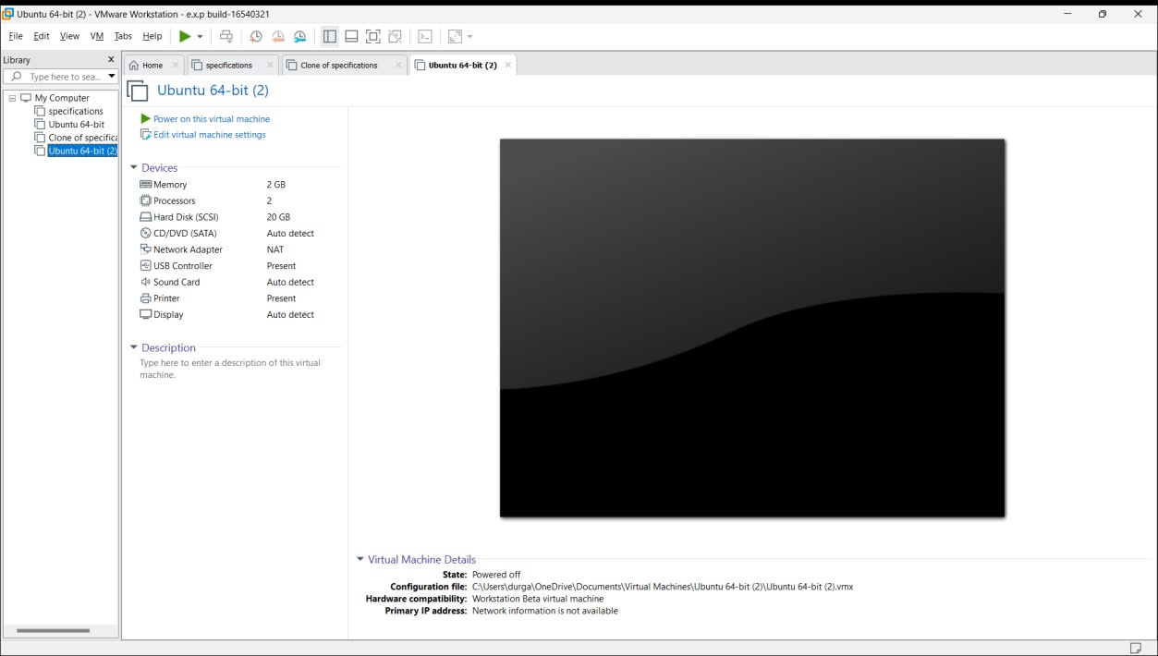

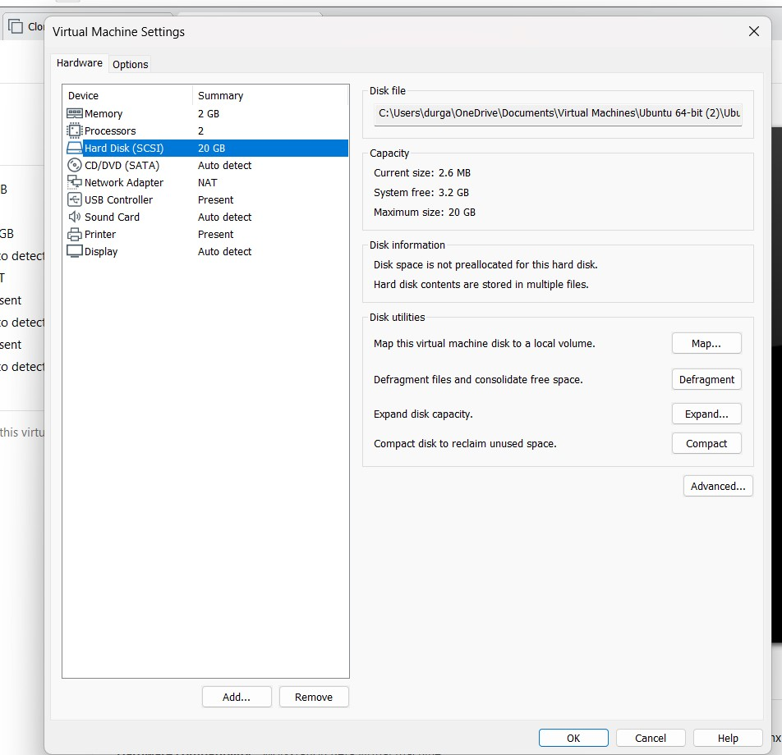

Venkata sunil-192210430

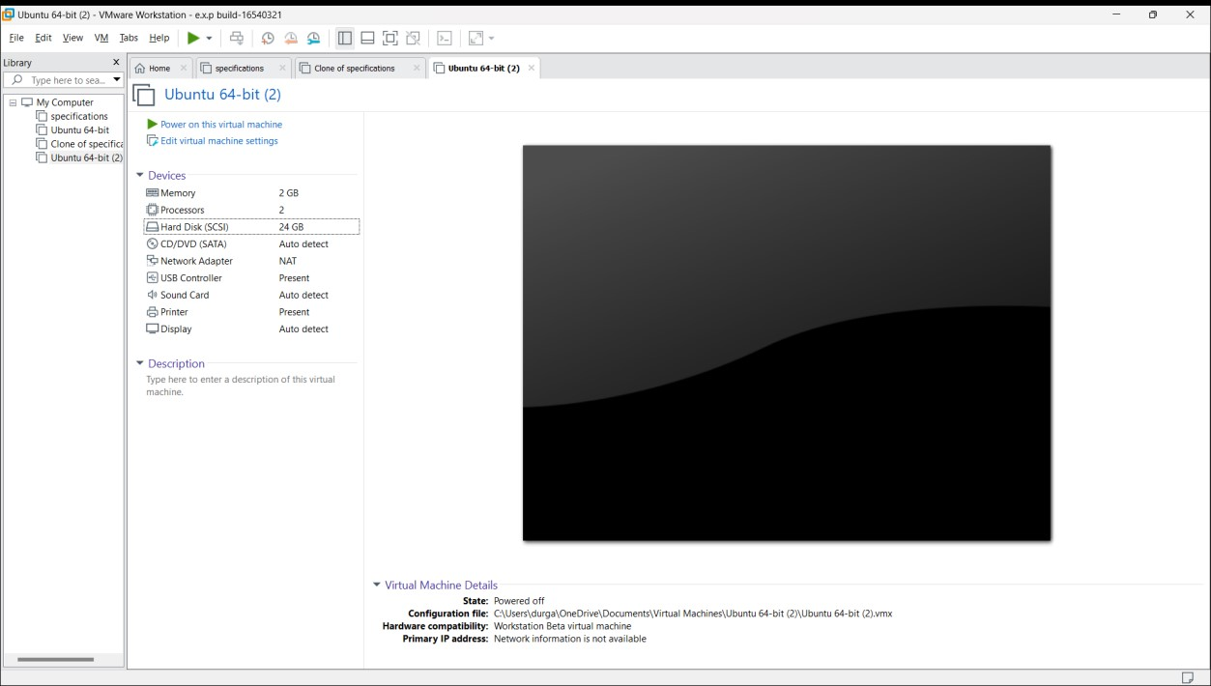

Venkata sunil-192210430