Experiment-4

Create a simple cloud software application for Library book reservation system for SIMATS library using any Cloud Service Provider to demonstrate SaaS

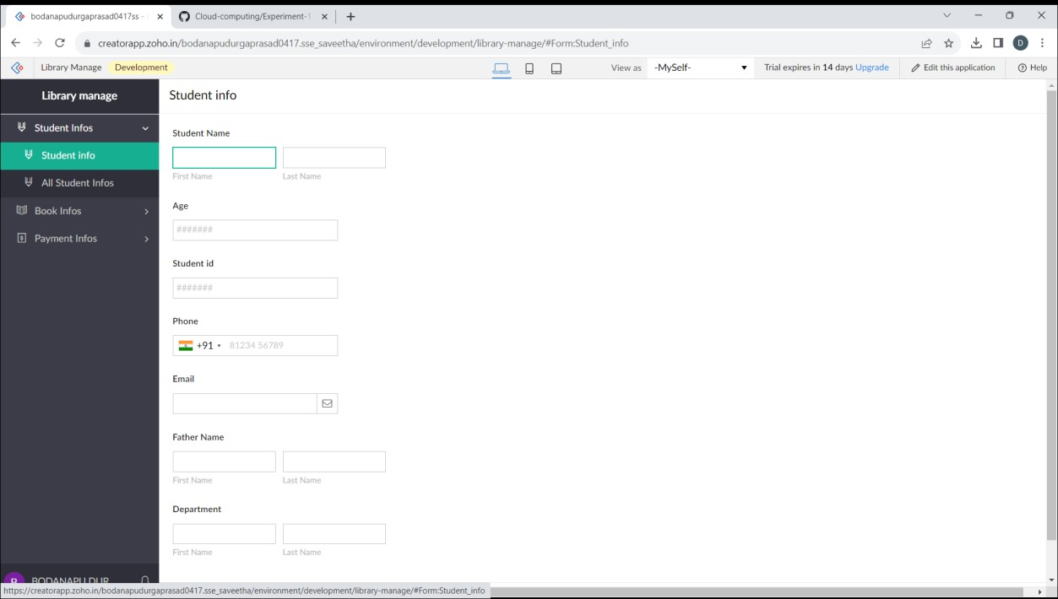

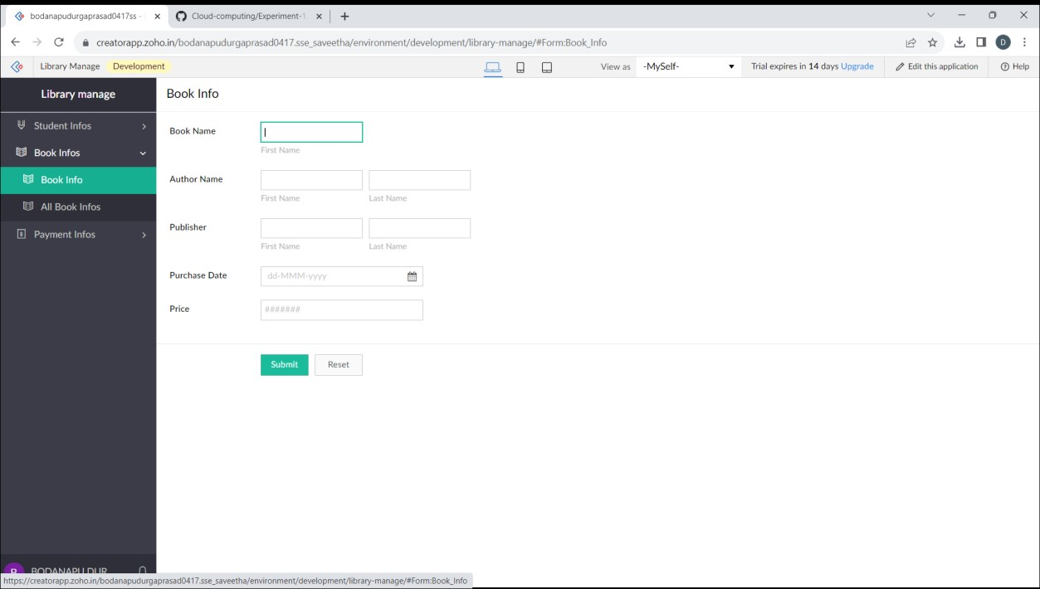

1. Venkata sunil-192210430

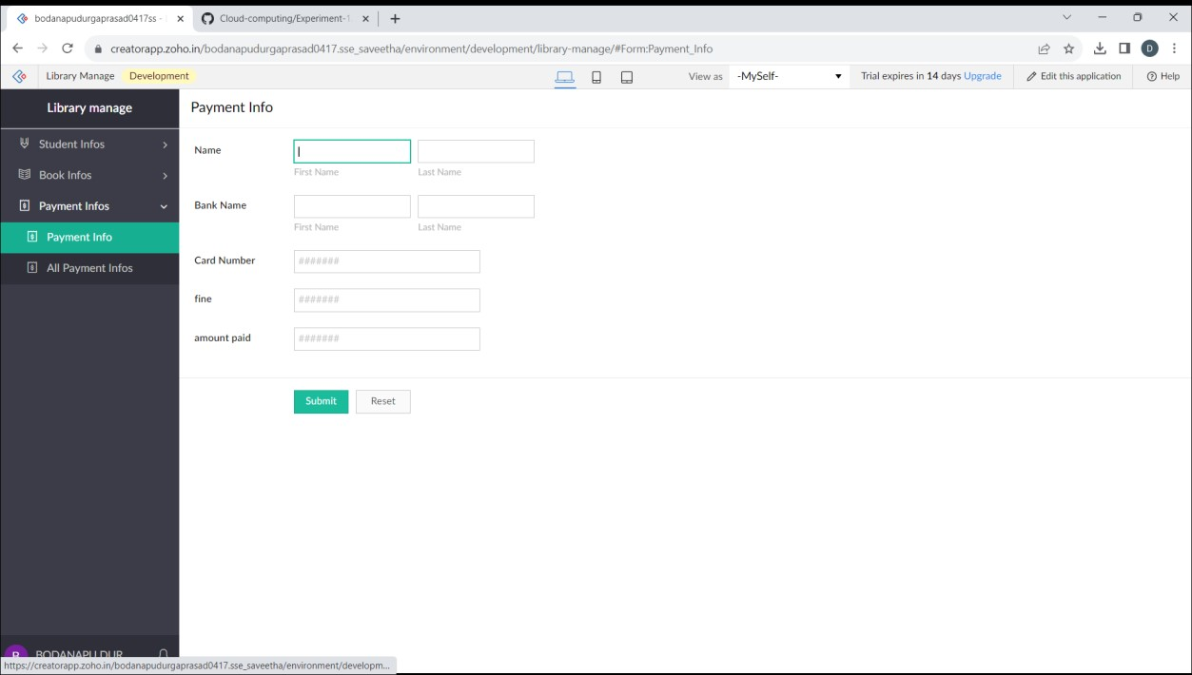

Venkata sunil-192210430