Yannick Kengne Tatcha

CPE301 – SPRING 2018

Design Assignment 1

**DO NOT REMOVE THIS PAGE DURING SUBMISSION:**

The student understands that all required components should be submitted in complete for grading of this assignment.

|  |  |  |  |
| --- | --- | --- | --- |
| **NO** | **SUBMISSION ITEM** | **COMPLETED (Y/N)** | **MARKS**  **(/MAX)** |
| 1 | COMPONENTS LIST AND CONNECTION BLOCK DIAGRAM w/ PINS |  |  |
| 2. | INITIAL CODE OF TASK 1/A |  |  |
| 3. | INCREMENTAL / DIFFERENTIAL CODE OF TASK 2/B |  |  |
| 3. | INCREMENTAL / DIFFERENTIAL CODE OF TASK 3/C |  |  |
| 3. | INCREMENTAL / DIFFERENTIAL CODE OF TASK 4/D |  |  |
| 3. | INCREMENTAL / DIFFERENTIAL CODE OF TASK 5/E |  |  |
| 4. | SCHEMATICS |  |  |
| 5. | SCREENSHOTS OF EACH TASK OUTPUT |  |  |
| 5. | SCREENSHOT OF EACH DEMO |  |  |
| 6. | VIDEO LINKS OF EACH DEMO |  |  |
| 7. | GOOGLECODE LINK OF THE DA |  |  |
|  |  |  |  |
|  |  |  |  |

|  |  |  |  |
| --- | --- | --- | --- |
| 1. | INITIAL CODE |  |  |

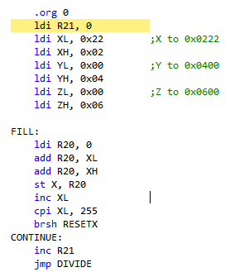

|  |  |  |  |
| --- | --- | --- | --- |
| 2. | Code to check if value is divisible by 5 |  |  |

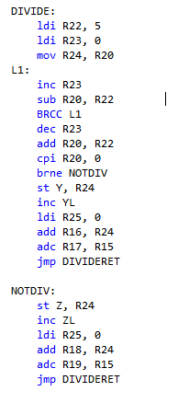

|  |  |  |  |
| --- | --- | --- | --- |
| 3. | Sum values in R16:R17 also R18:R19 |  |  |

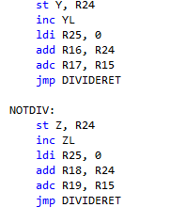

|  |  |  |  |
| --- | --- | --- | --- |
| 4. | Complete code |  |  |

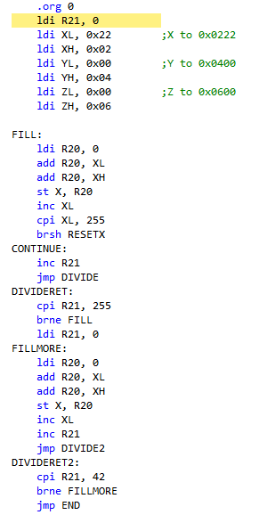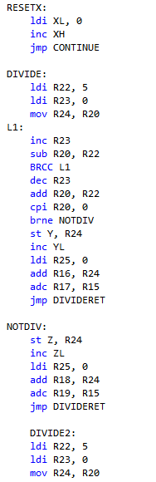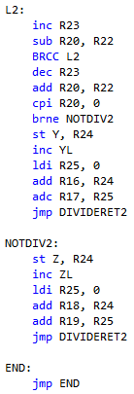

|  |  |  |  |
| --- | --- | --- | --- |
| 5. | Screenshots of each task |  |  |

Task1

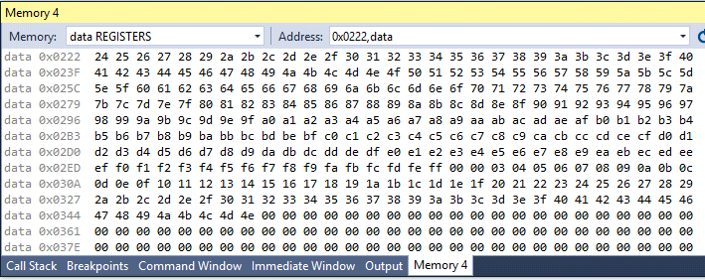

Task2

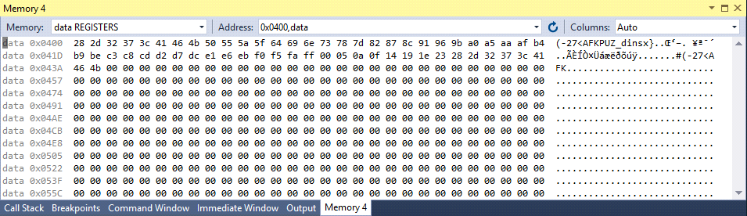

Task3

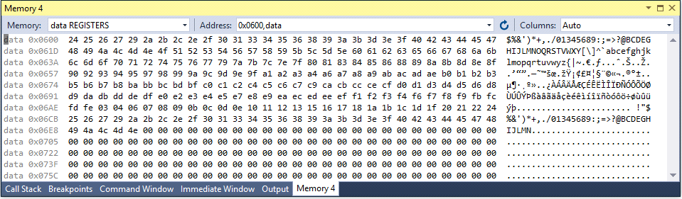

C CODE

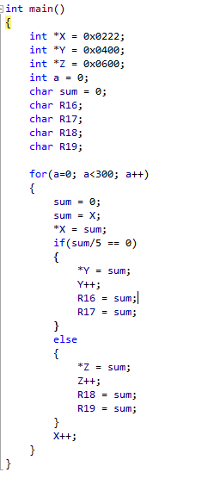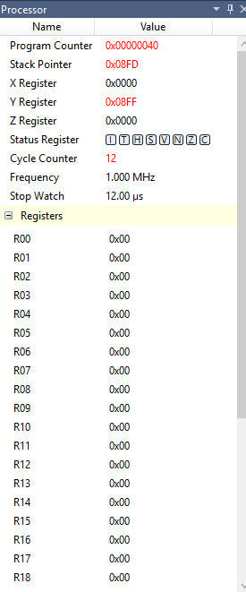

|  |  |  |  |
| --- | --- | --- | --- |
| 2. | GITHUB LINK OF THE DA |  |  |
| https://github.com/Vasty1995/CPE301.git | | | |

**Student Academic Misconduct Policy**

<http://studentconduct.unlv.edu/misconduct/policy.html>

“This assignment submission is my own, original work”.

Yannick Kengne Tatcha