Student Name: Yannick Kengne Tatcha

Student Number: 5003294512

Student Email: kengneta@unlv.nevada.edu

Design Assignment 1:

Q: Write, simulate, and demonstrate using Atmel Studio 7 an assembly code for the AVR ATMEGA328p microcontroller that performs the following functions:

1. Perform a multiplication of a 16-bit multiplicand with an 8-bit multiplier without using the MUL instruction. Use iterative addition to perform the above multiplication.

2. Registers R25:R24 hold the 16-bit multiplicand, R22 hold 8-bit multiplier, and R20:R19:R18 should hold the result.

3. Verify your algorithm and answers using the AVR mul instruction or C or any high-level program.

4. Determine the execution time @ 16MHz/#cycles of your algorithm using the simulation.

CODE:

;

; DA1.asm

;

; Created: 2/13/2019 1:16:50 PM

; Author : YKengne

;

; Test hardware multiplication 16-by-8-bit

;

; Register definitions:

;

.def Res1 = R18

.def Res2 = R19

.def Res3 = R20

.def m1L = R22

.def m1M = R24

.def m2 = R25

;First we load the numbers:

;

; Load Registers

;

.equ m1 = 10000

;

ldi m1M,HIGH(m1) ; upper 8 bits of m1 to m1M

ldi m1L,LOW(m1) ; lower 8 bits of m1 to m1L

ldi m2,250 ; 8-bit constant to m2

;Then we multiply the LSB first:

;

; Multiply

;

mul m1L,m2 ; Multiply LSB

mov Res1,R0 ; copy result to result register

mov Res2,R1

;Now the multiplication of the MSB of m1 with m2 follows:

mul m1M,m2 ; Multiply MSB

mov Res3,R1 ; copy MSB result to result byte 3

add Res2,R0 ; add LSB result to result byte 2

brcc NoInc ; if not carry, jump

inc Res3

NoInc:

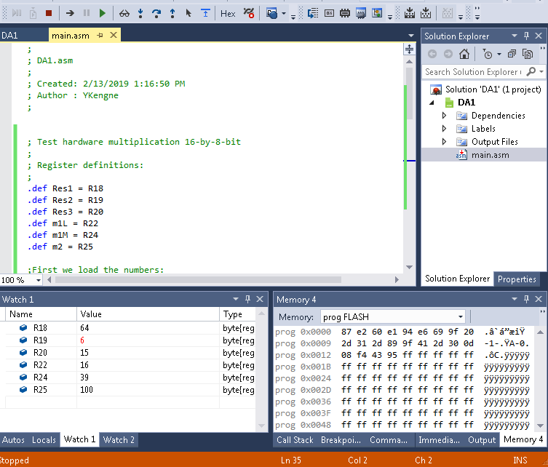

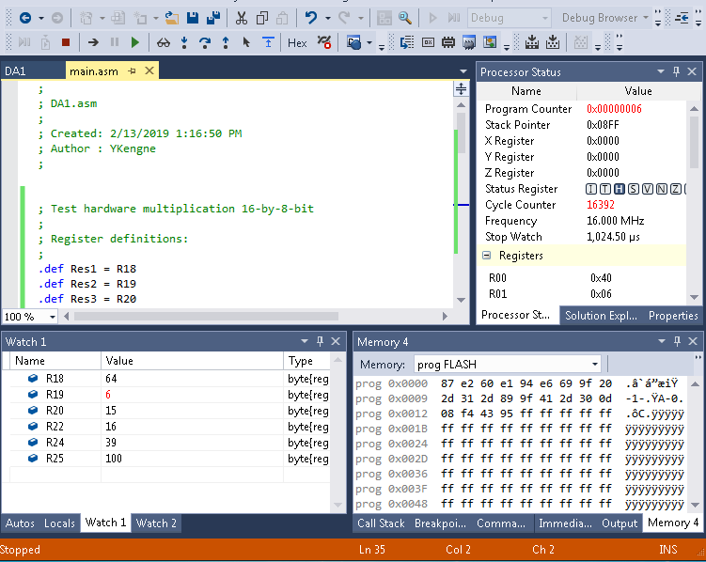

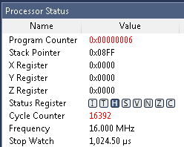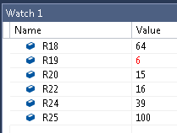

10000 = 0x2710

100 = 0x64

10000 \* 100 = 1000000 or 0x2710 \* 0x64 = 0x0F4240