Yannick Kengne Tatcha

CPE301 – SPRING 2019

Design Assignment 1B

**DO NOT REMOVE THIS PAGE DURING SUBMISSION:**

The student understands that all required components should be submitted in complete for grading of this assignment.

|  |  |  |  |
| --- | --- | --- | --- |
| **NO** | **SUBMISSION ITEM** | **COMPLETED (Y/N)** | **MARKS**  **(/MAX)** |
| 1 | COMPONENTS LIST AND CONNECTION BLOCK DIAGRAM w/ PINS |  |  |
| 2. | INITIAL CODE OF TASK 1/A |  |  |
| 3. | INCREMENTAL / DIFFERENTIAL CODE OF TASK 2/B |  |  |
| 3. | INCREMENTAL / DIFFERENTIAL CODE OF TASK 3/C |  |  |
| 3. | INCREMENTAL / DIFFERENTIAL CODE OF TASK 4/D |  |  |
| 3. | INCREMENTAL / DIFFERENTIAL CODE OF TASK 5/E |  |  |
| 4. | SCHEMATICS |  |  |
| 5. | SCREENSHOTS OF EACH TASK OUTPUT |  |  |
| 5. | SCREENSHOT OF EACH DEMO |  |  |
| 6. | VIDEO LINKS OF EACH DEMO |  |  |
| 7. | GOOGLECODE LINK OF THE DA |  |  |
|  |  |  |  |
|  |  |  |  |

|  |  |  |  |
| --- | --- | --- | --- |
| 1. | INITIAL CODE |  |  |

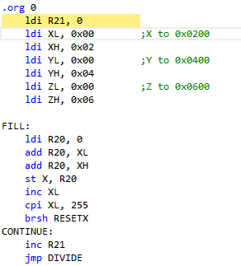

|  |  |  |  |
| --- | --- | --- | --- |
| 2. | Code to check if value is divisible by 5 |  |  |

DIVIDE:

ldi R22, 3

ldi R23, 0

mov R24, R20

L1:

inc R23

sub R20, R22

BRCC L1

dec R23

add R20, R22

cpi R20, 0

brne NOTDIV

st Y, R24

inc YL

ldi R25, 0

add R16, R24

adc R17, R15

jmp DIVIDERET

|  |  |  |  |
| --- | --- | --- | --- |
| 3. | Sum values in R16:R17 also R18:R19 |  |  |

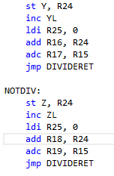

|  |  |  |  |
| --- | --- | --- | --- |
| 4. | Complete code |  |  |

;

; DA1B.asm

;

; Created: 2/20/2019 9:53:23 AM

; Author : YKengne

;

.org 0

ldi R21, 0

ldi XL, 0x00 ;X to 0x0200

ldi XH, 0x02

ldi YL, 0x00 ;Y to 0x0400

ldi YH, 0x04

ldi ZL, 0x00 ;Z to 0x0600

ldi ZH, 0x06

FILL:

ldi R20, 0

add R20, XL

add R20, XH

st X, R20

inc XL

cpi XL, 255

brsh RESETX

CONTINUE:

inc R21

jmp DIVIDE

DIVIDERET:

cpi R21, 255

brne FILL

ldi R21, 0

FILLMORE:

ldi R20, 0

add R20, XL

add R20, XH

st X, R20

inc XL

inc R21

jmp DIVIDE2

DIVIDERET2:

cpi R21, 42

brne FILLMORE

jmp END

RESETX:

ldi XL, 0

inc XH

jmp CONTINUE

DIVIDE:

ldi R22, 3

ldi R23, 0

mov R24, R20

L1:

inc R23

sub R20, R22

BRCC L1

dec R23

add R20, R22

cpi R20, 0

brne NOTDIV

st Y, R24

inc YL

ldi R25, 0

add R16, R24

adc R17, R15

jmp DIVIDERET

NOTDIV:

st Z, R24

inc ZL

ldi R25, 0

add R18, R24

adc R19, R15

jmp DIVIDERET

DIVIDE2:

ldi R22, 3

ldi R23, 0

mov R24, R20

L2:

inc R23

sub R20, R22

BRCC L2

dec R23

add R20, R22

cpi R20, 0

brne NOTDIV2

st Y, R24

inc YL

ldi R25, 0

add R16, R24

adc R17, R25

jmp DIVIDERET2

NOTDIV2:

st Z, R24

inc ZL

ldi R25, 0

add R18, R24

add R19, R25

jmp DIVIDERET2

END:

jmp END

|  |  |  |  |
| --- | --- | --- | --- |
| 5. | Screenshots of each task |  |  |

Task1

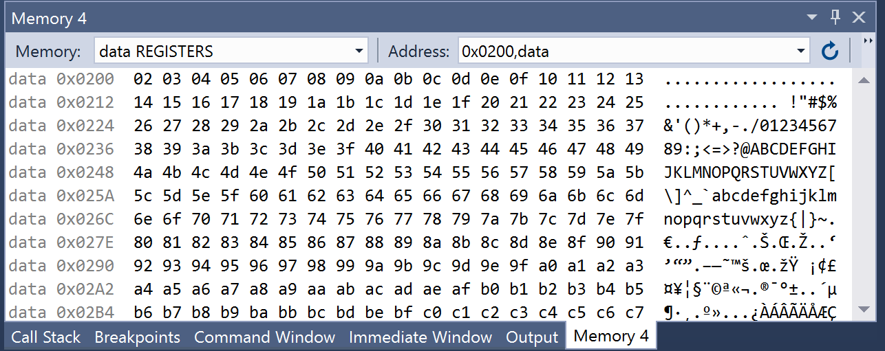

Task2

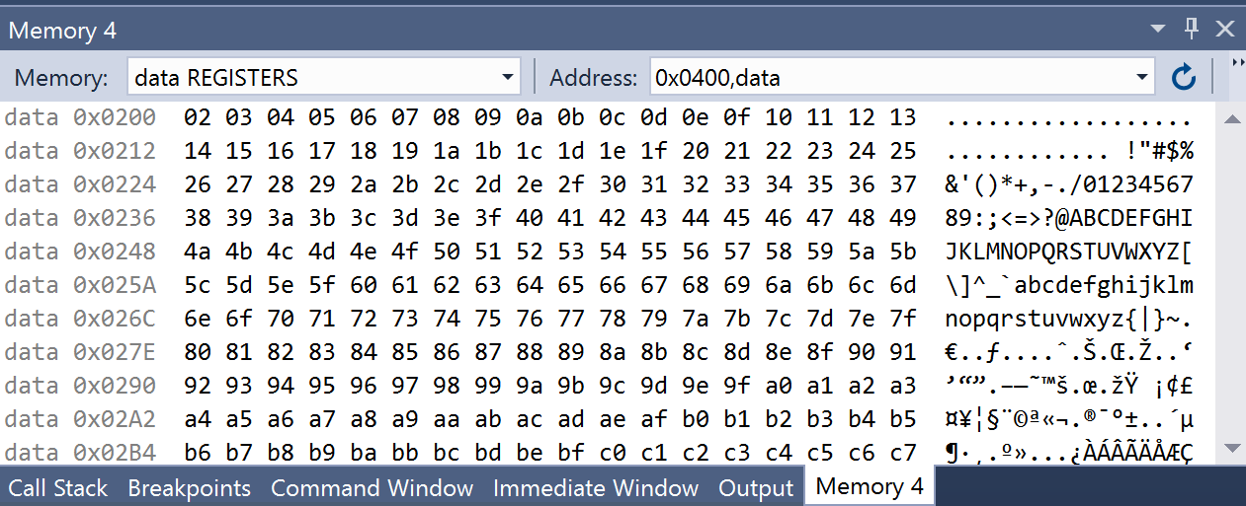

Task3

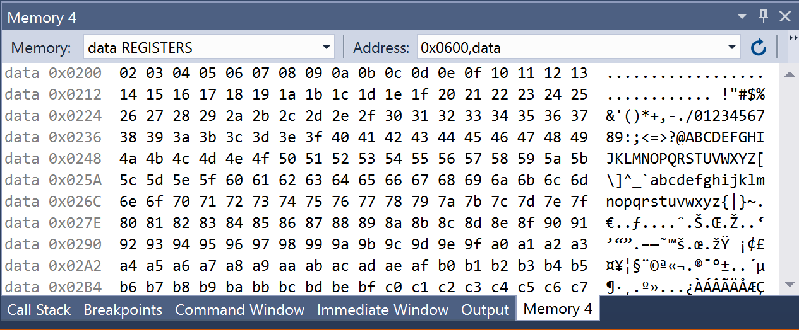

C CODE

#include <avr/io.h>

int main()

{

int *X = 0x0200;

int *Y = 0x0400;

int *Z = 0x0600;

int a = 0;

char sum = 0;

char R16;

char R17;

char R18;

char R19;

for(a=0; a<99; a++)

{

sum = 0;

sum = X;

*X = sum;

if(sum/3 == 0)

{

*Y = sum;

Y++;

R16 = sum;

R17 = sum;

}

else

{

*Z = sum;

Z++;

R18 = sum;

R19 = sum;

}

X++;

}

}

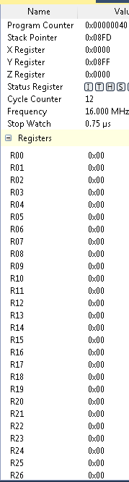

|  |  |  |  |
| --- | --- | --- | --- |
| 2. | GITHUB LINK OF THE DA |  |  |
| https://github.com/Vasty1995/submission_da | | | |

**Student Academic Misconduct Policy**

<http://studentconduct.unlv.edu/misconduct/policy.html>

“This assignment submission is my own, original work”.

Yannick Kengne Tatcha