Yannick Kengne Tatcha

**CPE301 – SPRING 2019**

Design Assignment 2A

Student Name: **Yannick Kengne Tatcha**

Student #: **5003294512**

Student Email: **kengneta@unlv.nevada.edu**

Primary Github address: **https://github.com/Vasty1995/submission_da**

Directory:

1. **COMPONENTS LIST AND CONNECTION BLOCK DIAGRAM w/ PINS**

Components used: ATmega328p chip, atmel studio, red LED, push button, and 10K resistors.

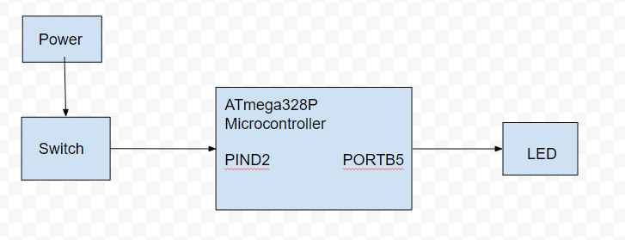

1. **DEVELOPED CODE OF TASK 1/A AND 1/C**

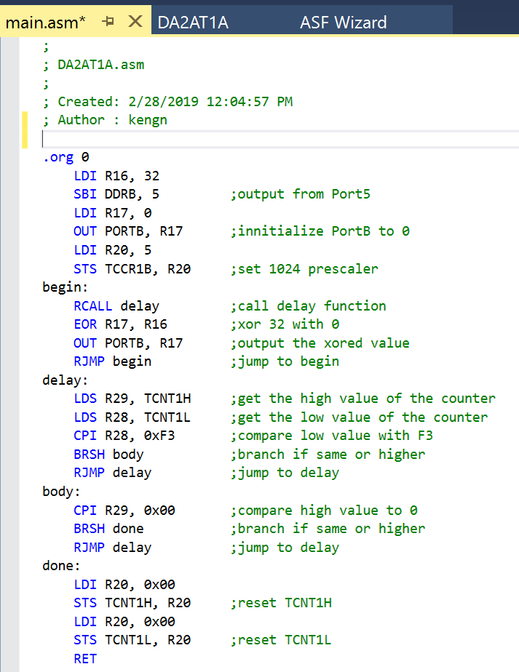

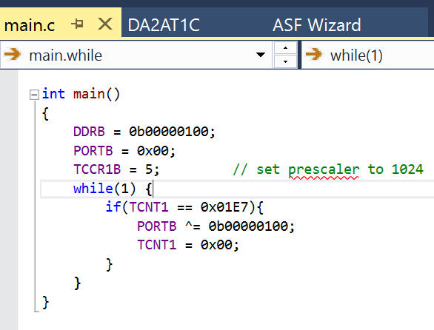

**DEVELOPED CODE OF TASK 2/A AND 2/C**

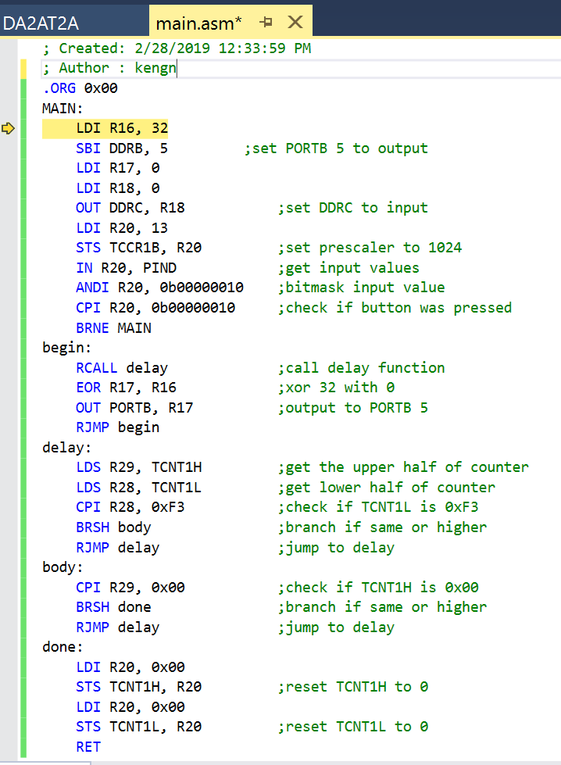

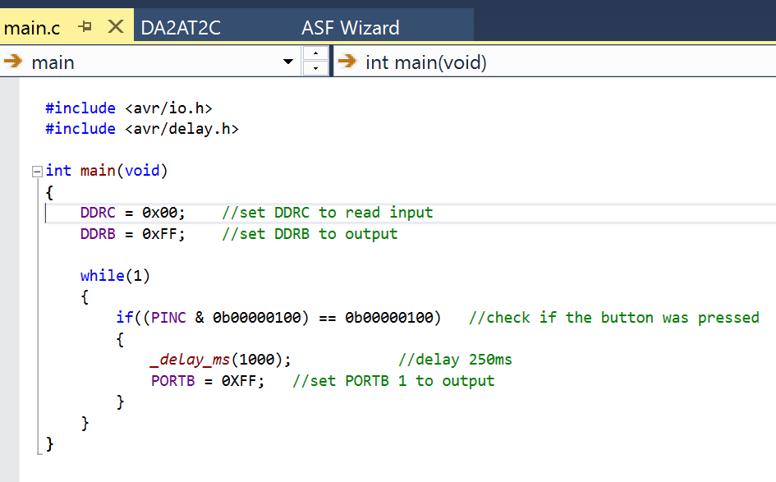

1. **SCHEMATICS**

Task 1,

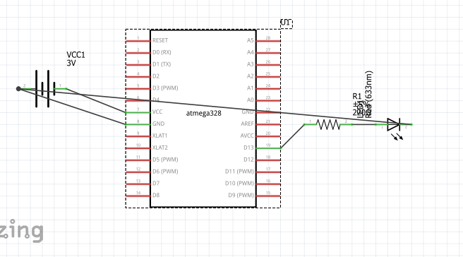

Task 2

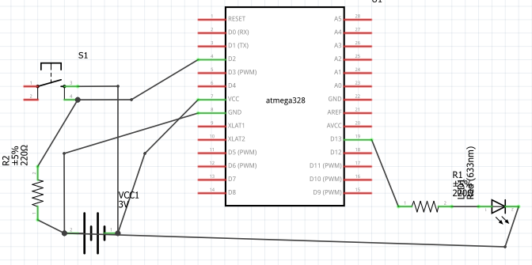

1. **PICTURES OF CIRCUIT SETUP**

TASK 1:

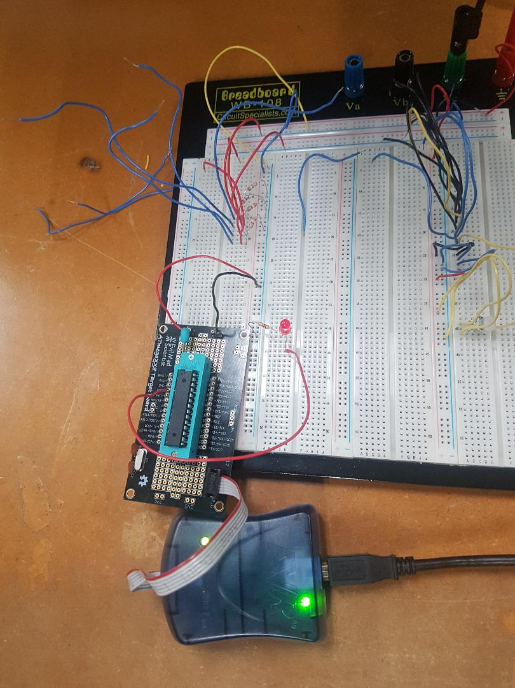

TASK 2:

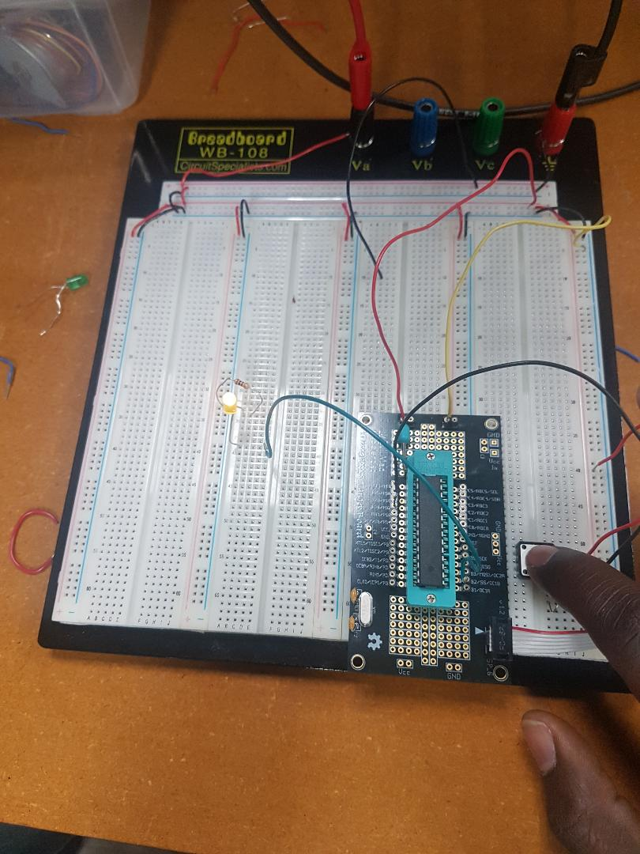

1. **VIDEO LINKS OF EACH DEMO**

<https://www.youtube.com/watch?v=p-YAwcqVBTE&feature=youtu.be>

<https://www.youtube.com/watch?v=GxN5dZDbPBA&feature=youtu.be>

1. **GITHUB LINK OF THIS DA**

**Student Academic Misconduct Policy**

<http://studentconduct.unlv.edu/misconduct/policy.html>

“*This assignment submission is my own, original work*”.

Yannick Kengne Tatcha