CPE301 – SPRING 2019

Design Assignment 2B

Student Name: Yannick Kengne Tatcha

Student #: 5003294512

Student Email: kengneta@unlv.nevada.edu

Primary Github address: https://github.com/Vasty1995/submission_da

Directory: https://github.com/Vasty1995/submission_da

Submit the following for all Labs:

1. AVR ASM code that has been compiled and working for all tasks. Verify the period and duty cycle of the waveforms in simulation and emulation.
2. AVR C code that has been compiled and working for all tasks. Verify the period and duty cycle of the waveforms in simulation and emulation.
3. The C code should be well documented with explanation of every instruction.
4. A word document that contains the code with comments, complete schematics, that includes the AVR, components connected on the breadboard and LED should be included. Follow the template provided.
5. A snapshot of the board with connected components and a video of the complete LED bar blink sequence should be recorded and uploaded to Youtube and the line to be provided for each task.
6. **COMPONENTS LIST AND CONNECTION BLOCK DIAGRAM w/ PINS**

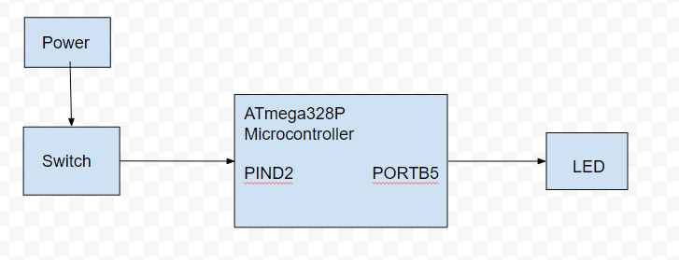

1. **INITIAL/MODIFIED/DEVELOPED CODE OF TASK 1**

Task 1 Assembly Code:

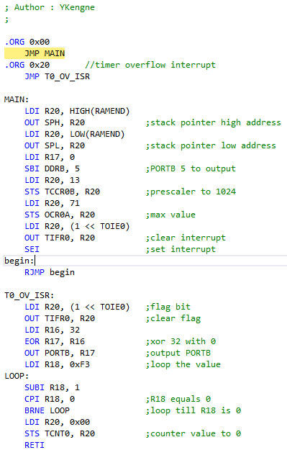

Task 1 C Code:

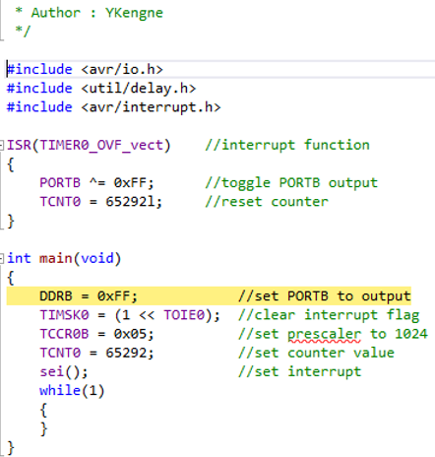

1. **DEVELOPED MODIFIED CODE OF TASK 2/A from TASK 1/A**

N/A

1. **SCHEMATICS**

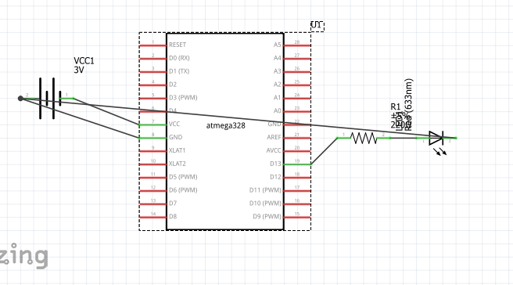

1. **SCREENSHOTS OF EACH TASK OUTPUT (ATMEL STUDIO OUTPUT)**

Task 1:

Assembly:



C:



1. **SCREENSHOT OF EACH DEMO (BOARD SETUP)**

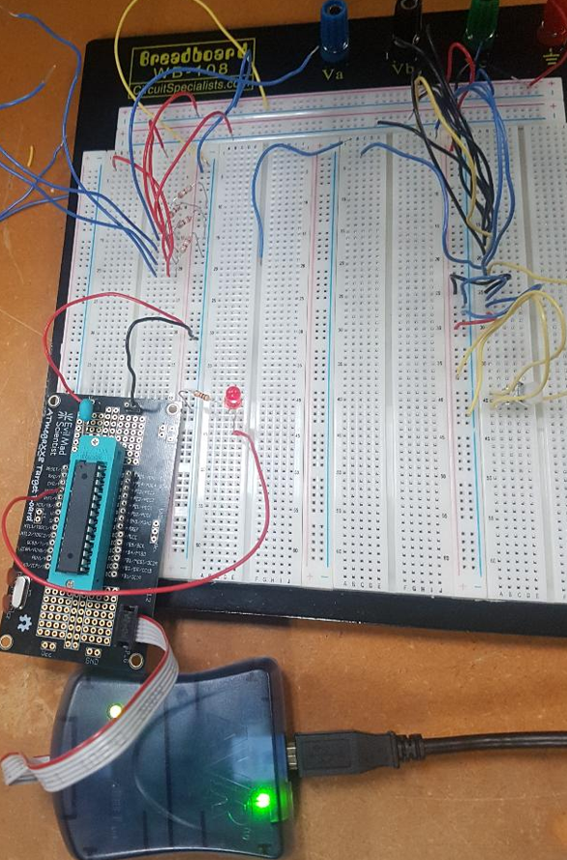

1. **VIDEO LINKS OF EACH DEMO**

<https://youtu.be/GTSQulz4by8>

1. **GITHUB LINK OF THIS DA**

https://github.com/Vasty1995/submission_da

**Student Academic Misconduct Policy**

<http://studentconduct.unlv.edu/misconduct/policy.html>

“This assignment submission is my own, original work”.

Yannick Kengne Tatcha