Decentralized Secure Cloud Storage Using Blockchain
In this project we are using Blockchain and Cloud services to store user data securely. Propose work will divide user file into Blocks and then encrypt each block using AES algorithm and then store each block in IPFS server at different nodes. IPFS will return memory address of stored block and this address will be saved in Blockchain. While downloading application will collect all block addresses from Blockchain and then send request to IPFS with those Block addresses to get all files block and then all blocks will get merge and can be decrypted and download by the client.
By storing data in different nodes we cannot allow attackers to know the address of all file blocks and he cannot download the file. Blockchain will store data in immutable format which cannot be tamper so full security will be provided to user data.
To store data in Blockchain we need to design SMART CONTRACT using SOLIDITY code which contains functions to store and retrieve data and below screen showing Smart Contract designed for decentralized storage.
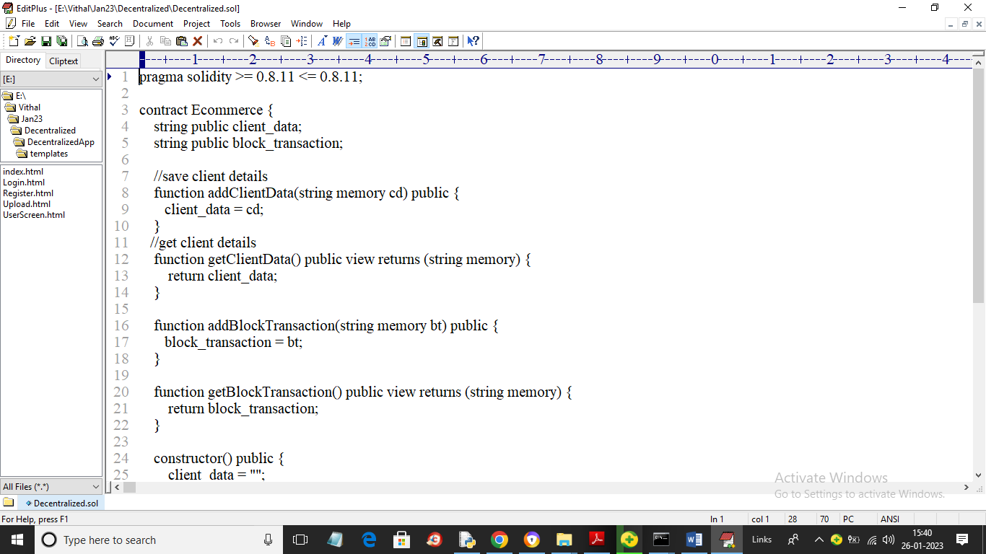
In above smart contract we have functions to save and get client data and file transaction details. We need to deploy this smart contract in Blockchain using TRUFFLE tool by using below steps
- First go inside ‘hello-eth/node_modules/.bin’ folder and then double click on ‘runBlockchain.bat’ file to get below screen
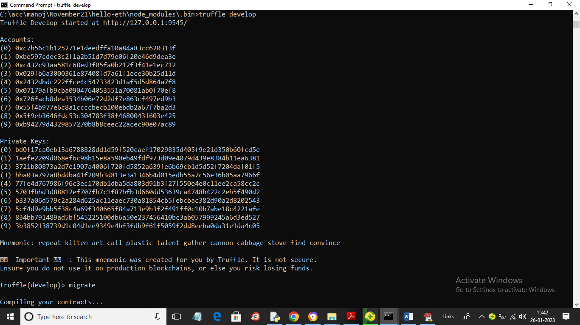
In above screen Blockchain server started with default accounts and private keys and now type command as ‘migrate’ and press enter key to deploy contract in Blockchain and get below output
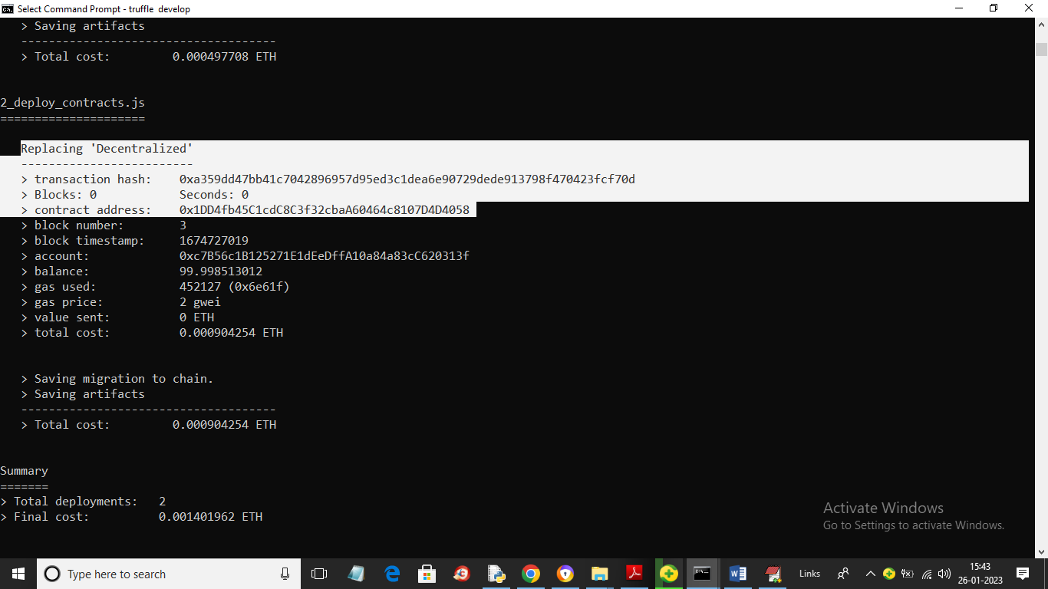
In above screen in white colour text we can see ‘Decentralized’ contract deployed and we got contract address also and this address we need to deploy in PYTHON program to call Blockchain functions to store and retrieve data. Below screen showing python code calling smart contract
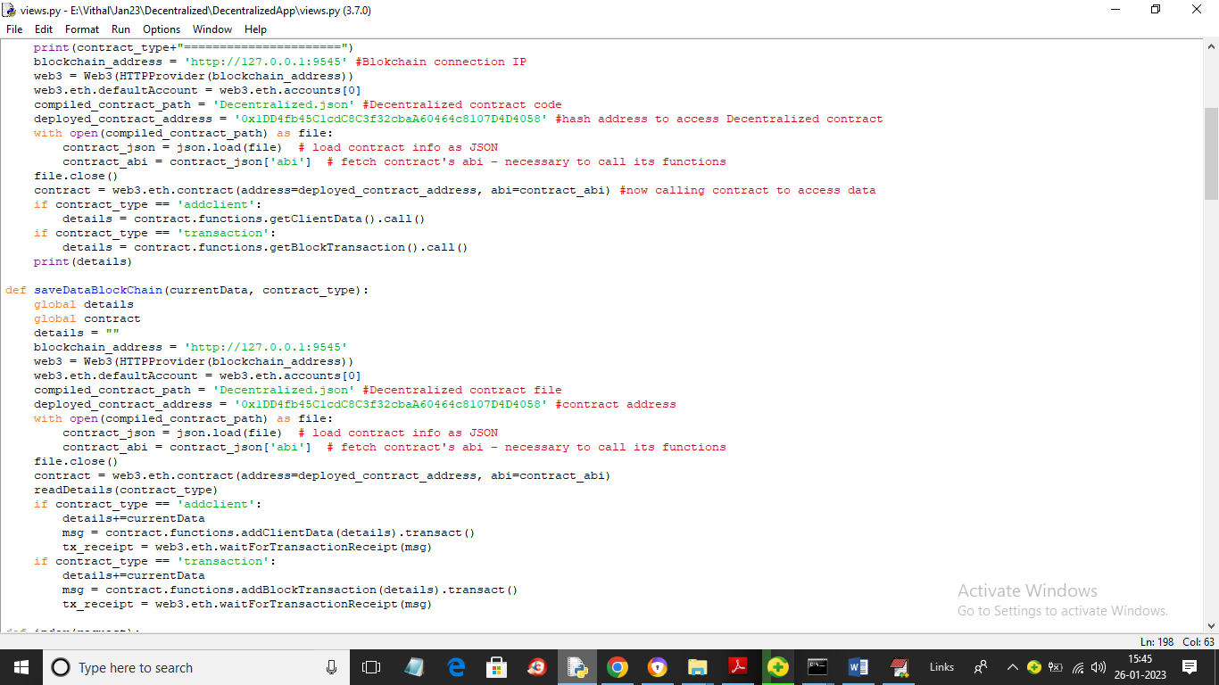
In above screen read red colour comments to know how to call Blockchain functions using python code.

Now double click on ‘Start_IPFS.bat’ file to start IPFS server and get below page

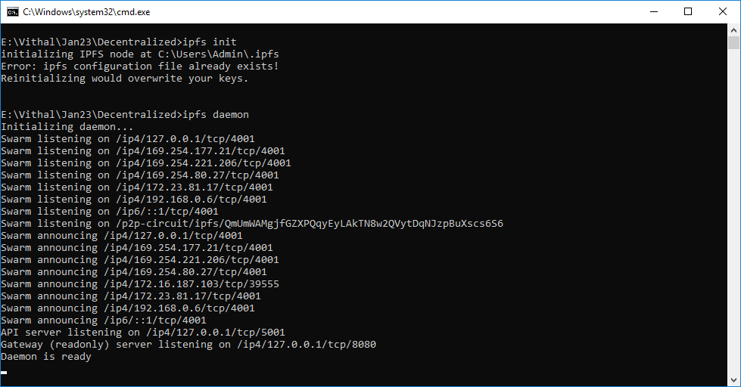

In above screen IPFS server started and now double click on ‘run.bat’ file to start python WEB SERVER and get below page
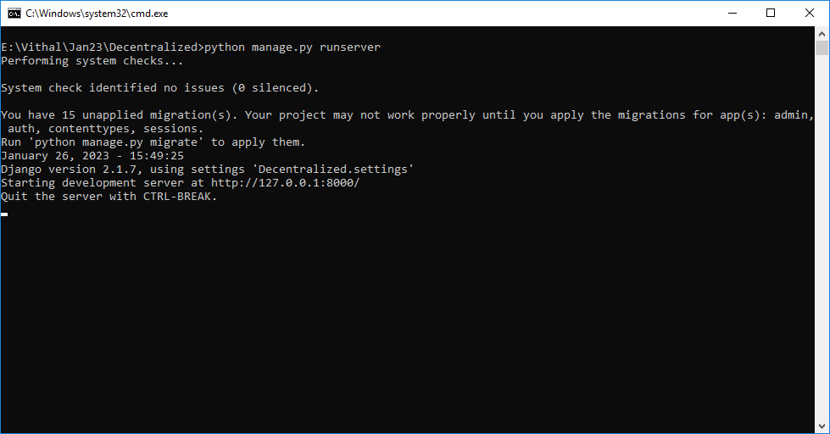
In above screen python server started and now open browser and enter URL as http://127.0.0.1:8000/index.html and press enter key to get below page

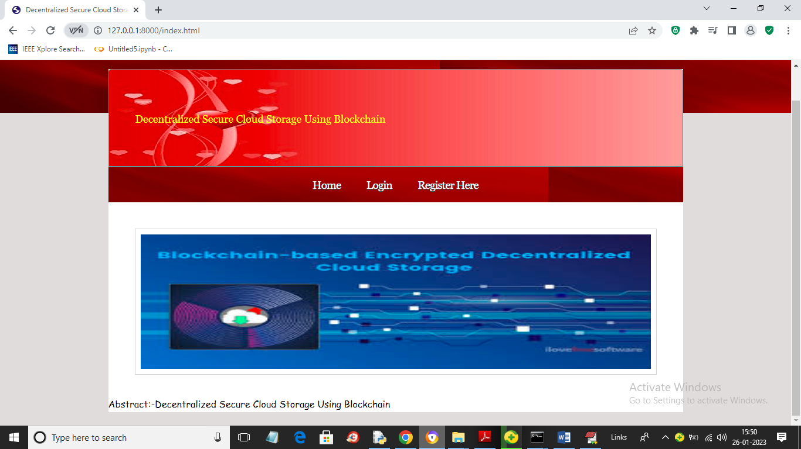

In above screen user can click on ‘Register Here’ link to get below signup page

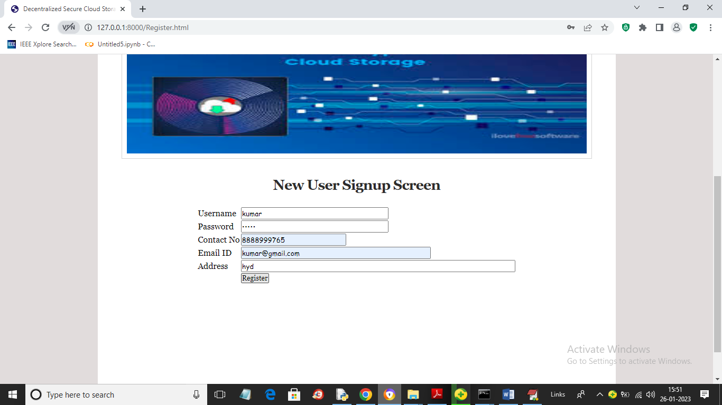

In above screen user is entering signup details and then press button to save client user data in Blockchain and get below output

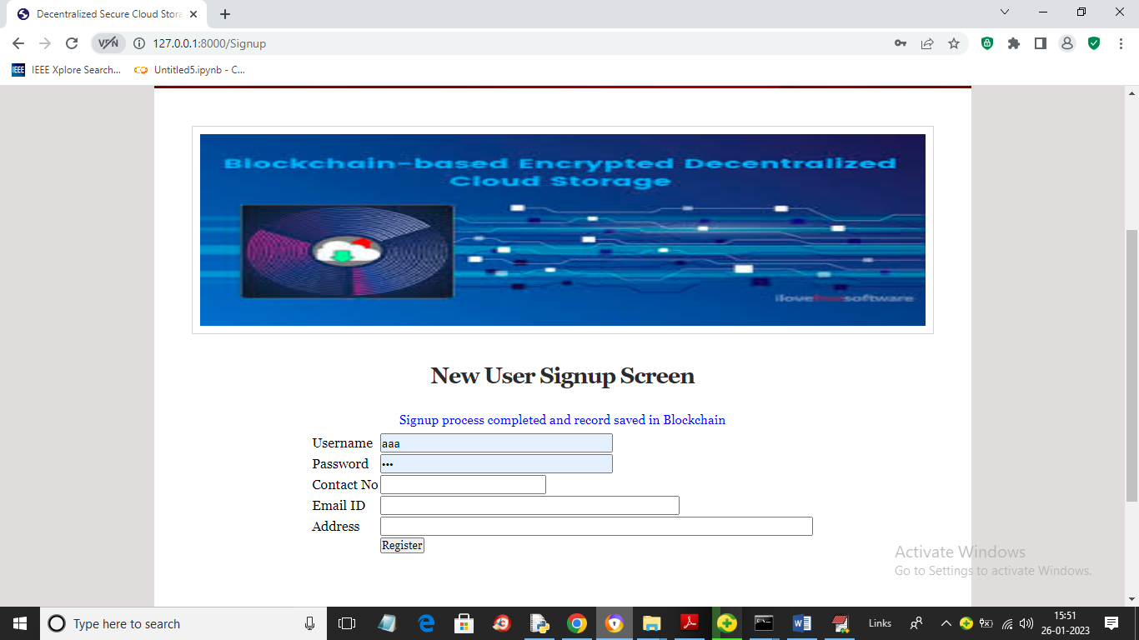

In above screen in blue colour text we can see signup task completed and now click on ‘Login’ link to get below screen

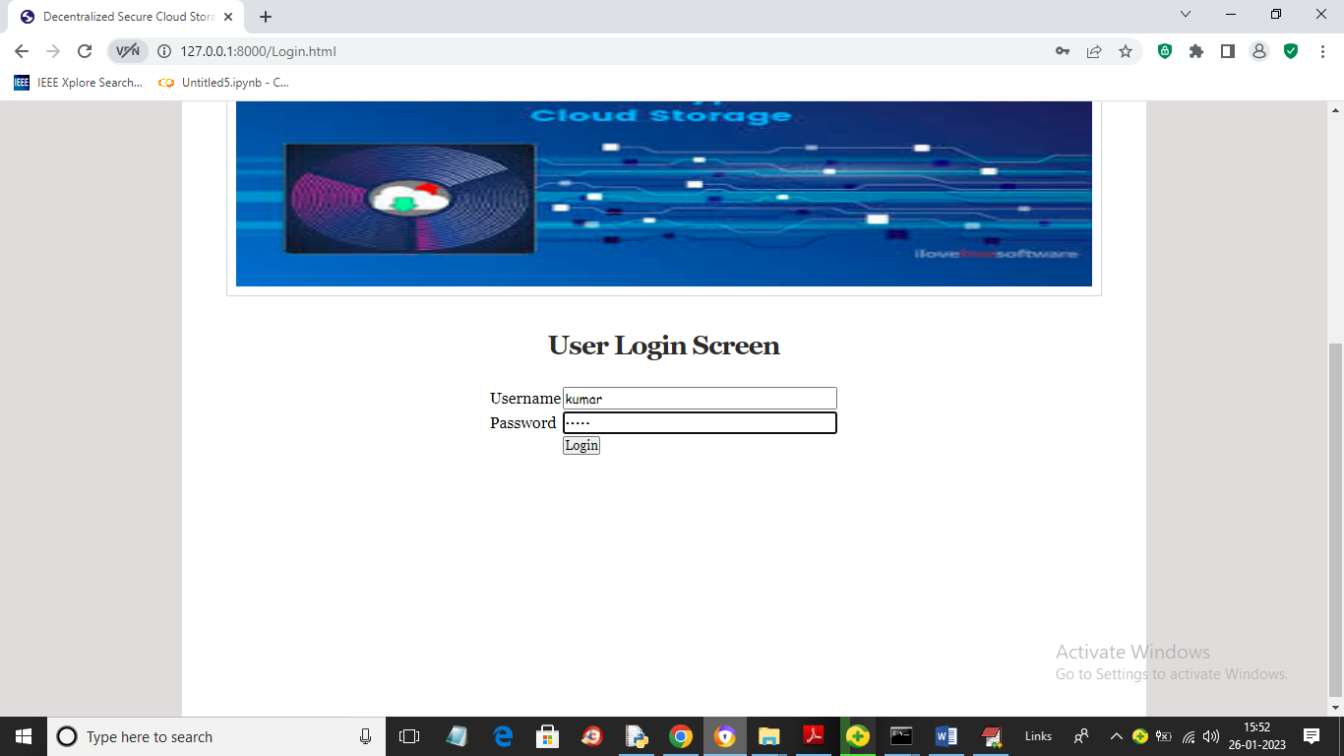

In above screen user is login and after login will get below page

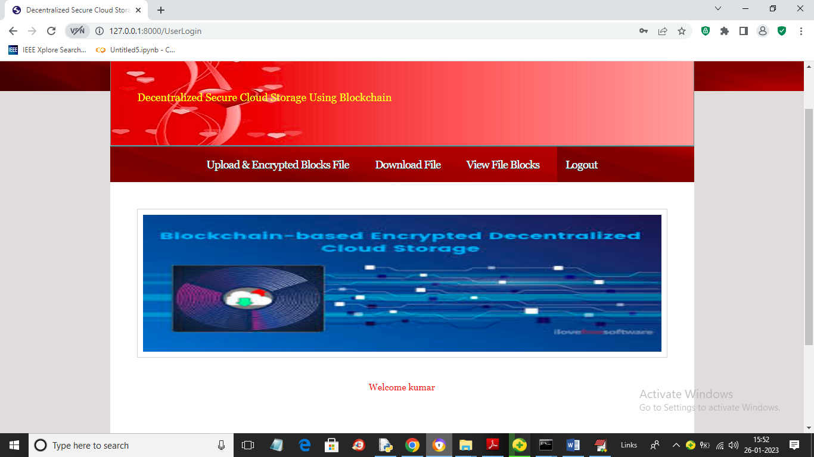

In above screen user can click on ‘Upload & Encrypted Blocks File’ link to upload file in block like below screen

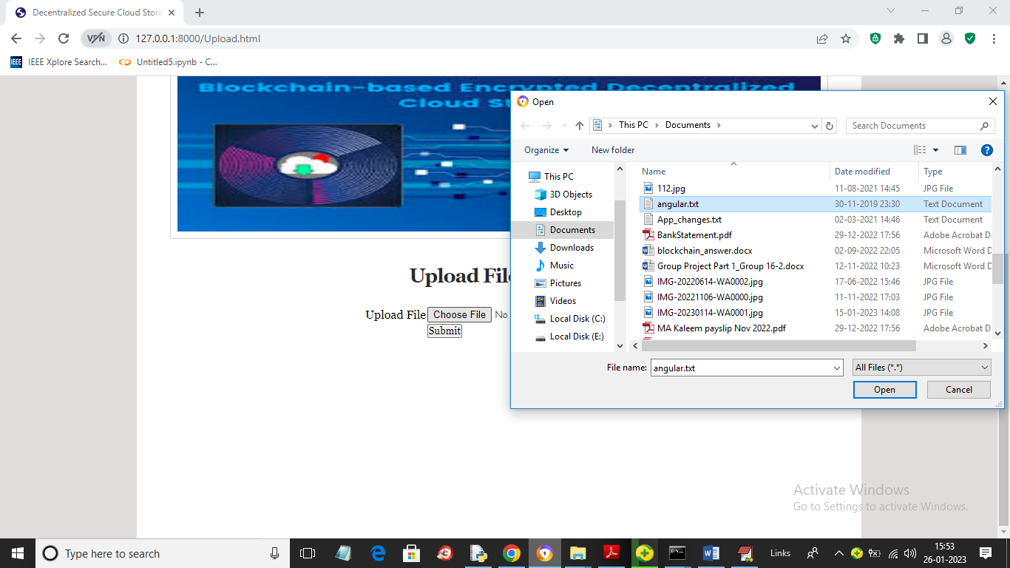

In above screen selecting and uploading file and then click on ‘Open’ and ‘Submit’ button to divide file into blocks and then encrypt each block and then save at different IPFS nodes and Blockchain and get below output

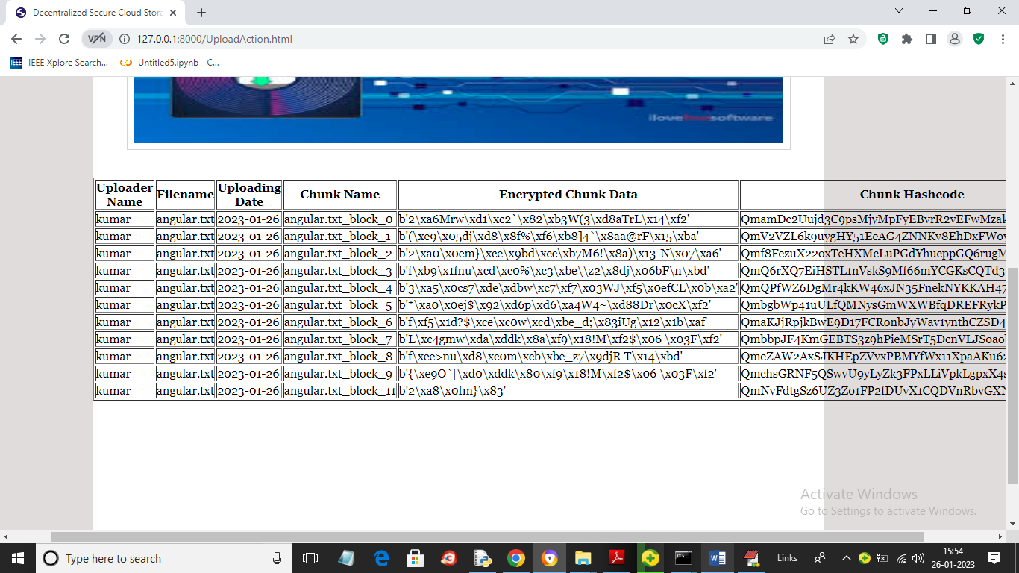
In above screen same file is divided into 11 blocks and we can see name of uploader, filename, chunk (block name), encrypted data and its hash code address of file stored in IPFS and Blockchain. Similarly you can upload other files and while uploading you need to upload small files as big files will take lots of time for encryption. Now click on ‘View Blocks’ link to get below page

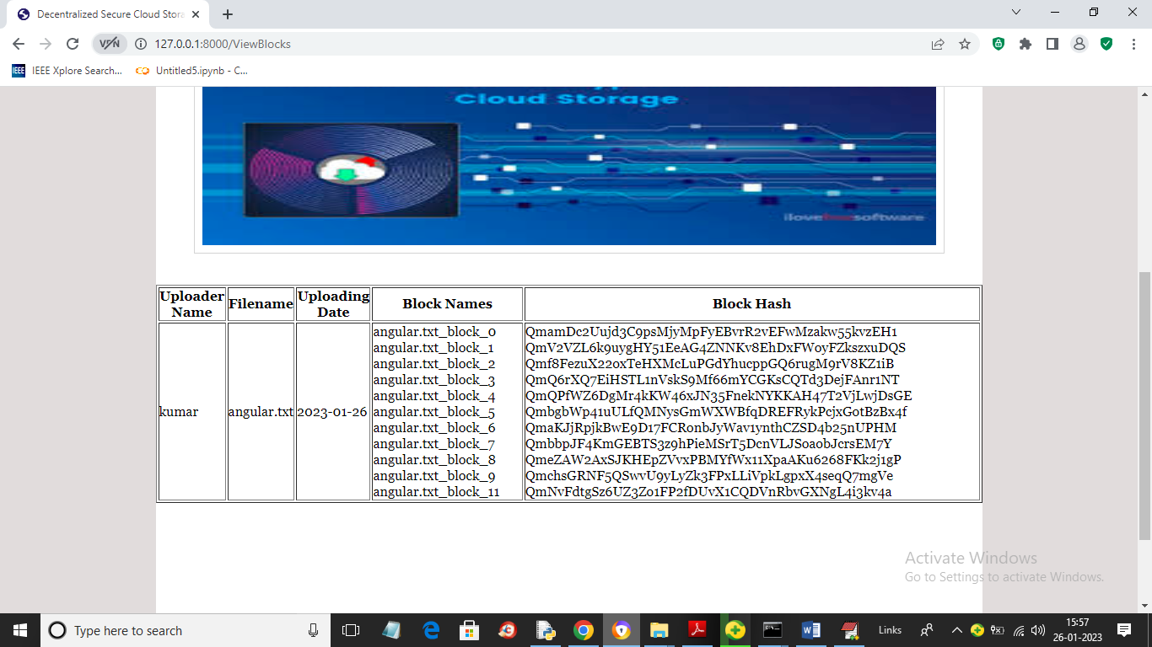

In above screen for each file user can see name of file and its block name and stored address of those blocks in hash code format. Now click on ‘Download File’ link to get below screen

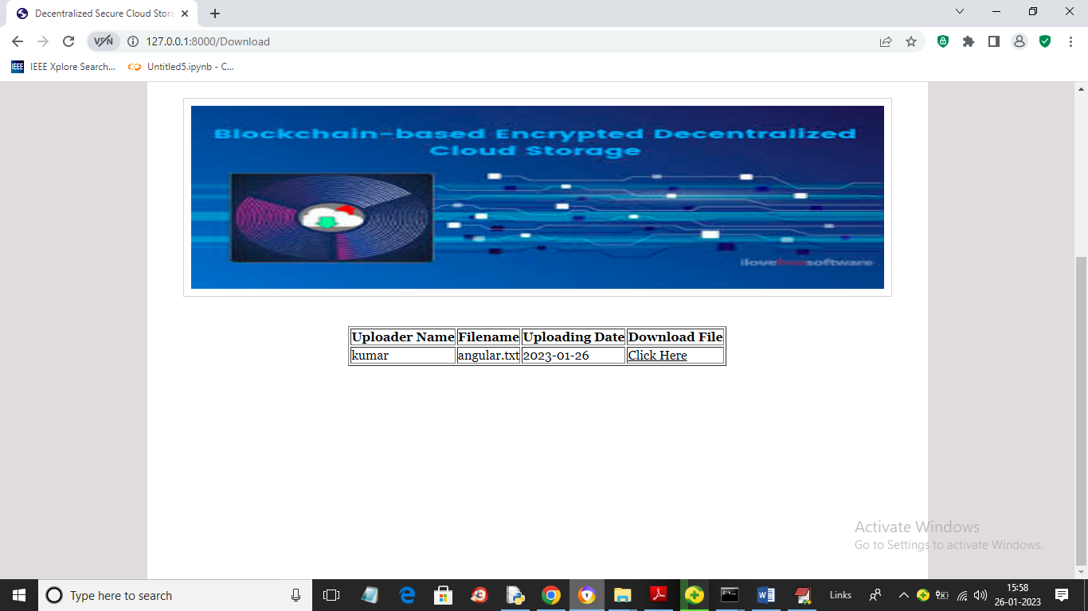

In above screen user can see list of uploaded files and then click on ‘Click Here’ link to download the file
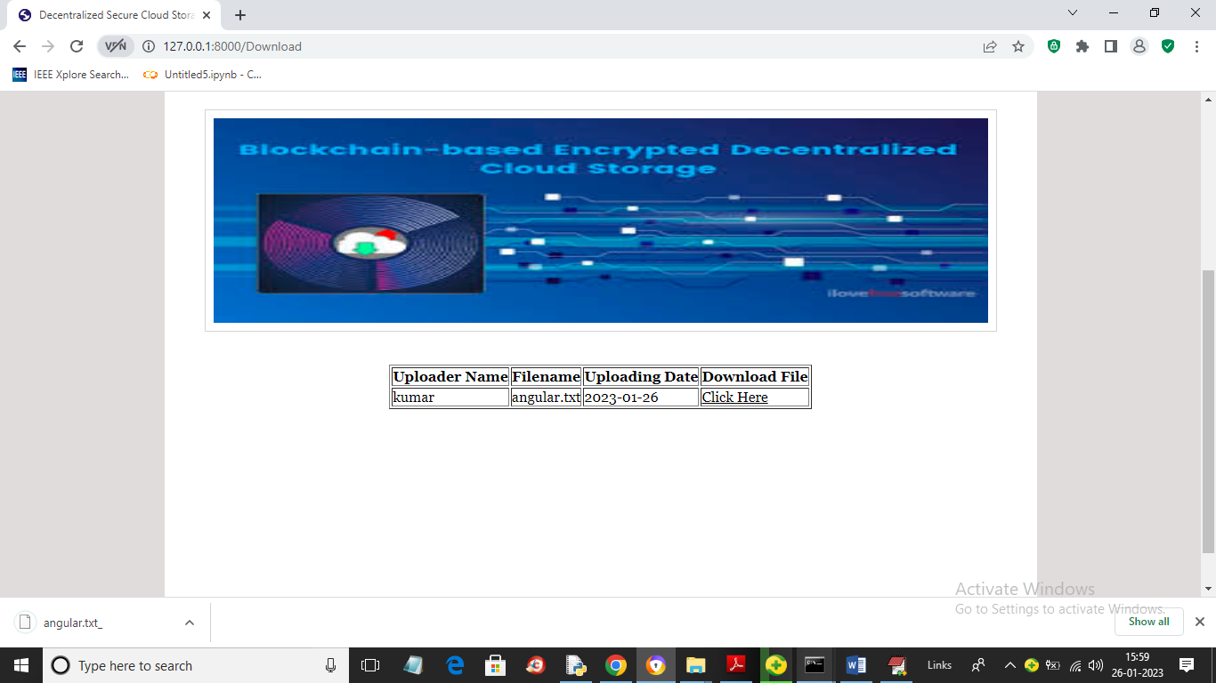

In above screen in browser status bar we can see file is downloading and similarly you can upload and download any type of file. After downloading you can see file in encrypted format.

In Ganache also we can see Decentralized Smart Contract deployed like below screen

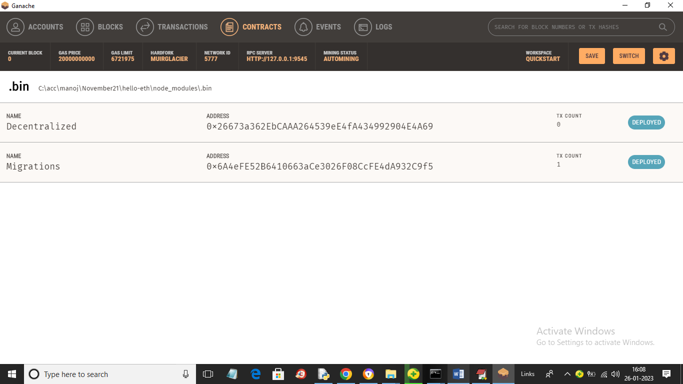

In above screen we can see Decentralized contract deployed

