Deep Learning Approach for Multimodal Biometric Recognition System Based on Fusion of Iris, Face, and Finger Vein Traits

Now-a-days many algorithms are available to authenticate users based on biometric data but all those algorithms are dependent only one single biometric features which is less secured as it’s easy to hack or steal single biometric features. To overcome from such issue author of this paper employing multimodal based biometric recognition which uses multi features like Iris, finger vein and face which is difficult to crack as no attacker or hacker can able to steal features of all 3 biometric.

In propose work to enhance prediction accuracy of multimodal system author employing pre-trained model called VGG16. 3 different VGG16 algorithms get trained on 3 different biometric features. Trained VGG16 3 models will be used to extract optimized trained features and this optimized trained features will be fusion or combine to form new model called Fusion model.

Fusion model will be used to recognized user based on 3 different biometric features. Author has calculate features based accuracy by performing prediction on 3 different models and compare its accuracy with Fusion model score. In both fusion based model score 1s 100% and features based fusion model accuracy is 95 to 99%.

To train all models author has used SDUMLA-HMT dataset which consist of 3 different biometric features. In below screen showing dataset details



In above dataset folder we have 3 different folders and each folder we have person ID folder with his iris, face and finger images like below screen

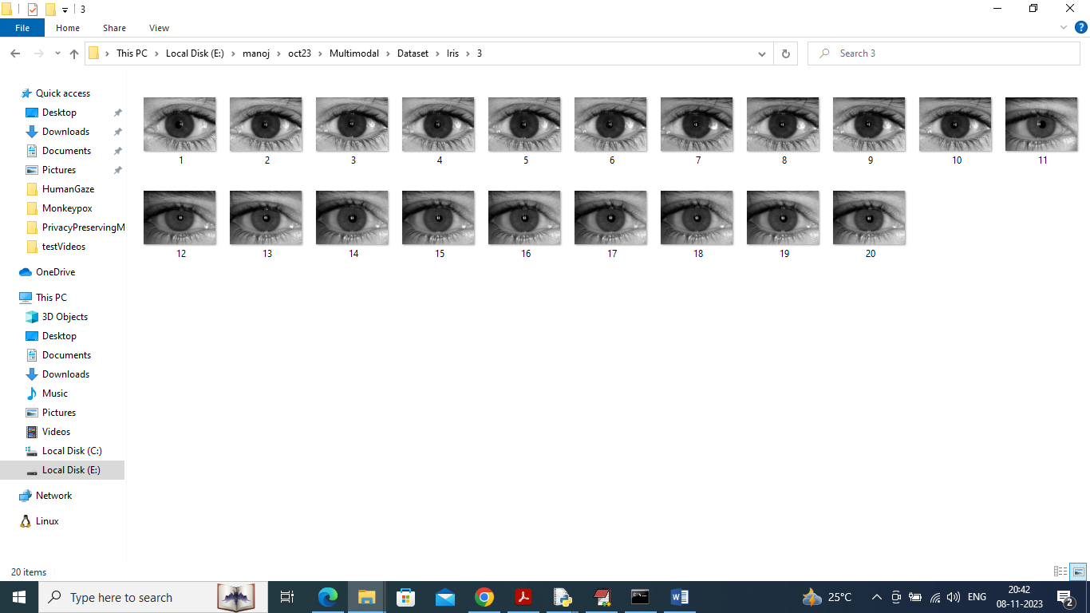

So by using above dataset images will train and test fusion model performance

Extension Concept

In propose work for fusion model author has used single level Softmax layer whose recognition accuracy may not be accurate so as extension we have added multi-layer based CNN, MAXPOOL with Softmax layers which will optimized fusion features multiple times which can help in getting more optimized features which in turn will give high accuracy.

Author has implemented this concept using JUPYTER notebook and we too implemented in JUPYTER notebook and below are the code and output screens with blue colour comments

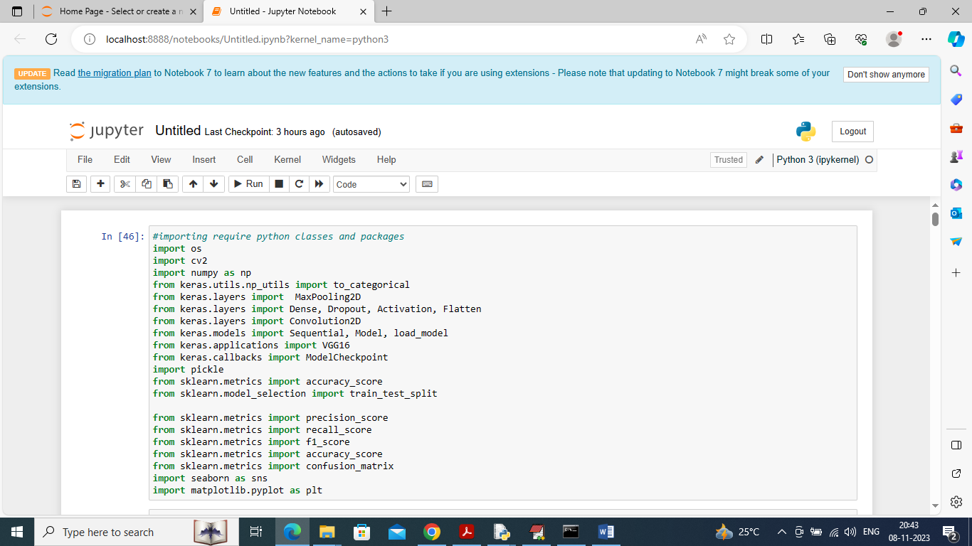

In above screen importing required python classes and packages

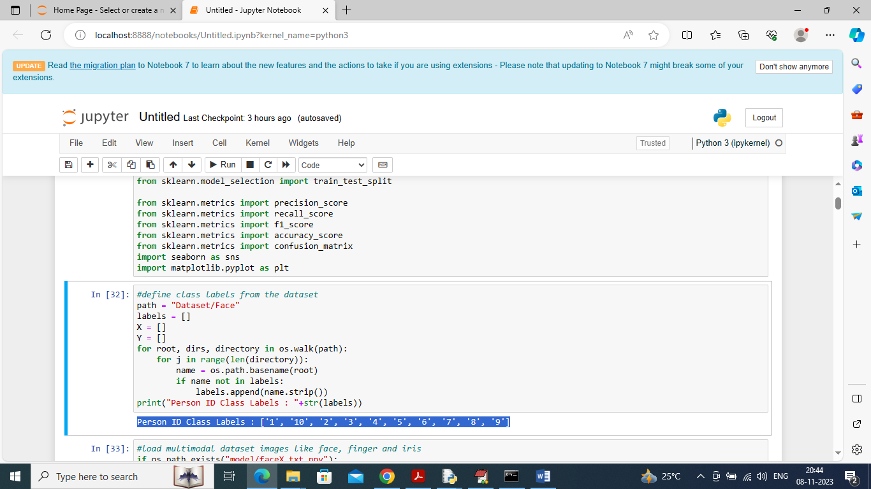

In above screen finding and displaying person ID labels found in dataset

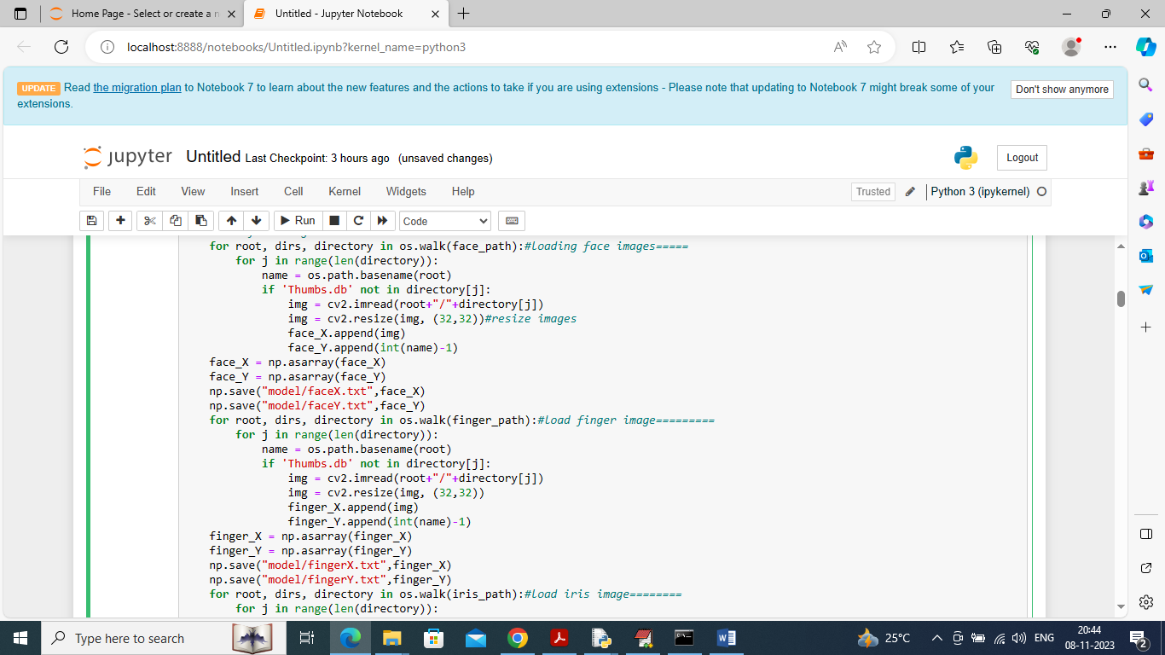

In above screen loading images of all 3 biometric data

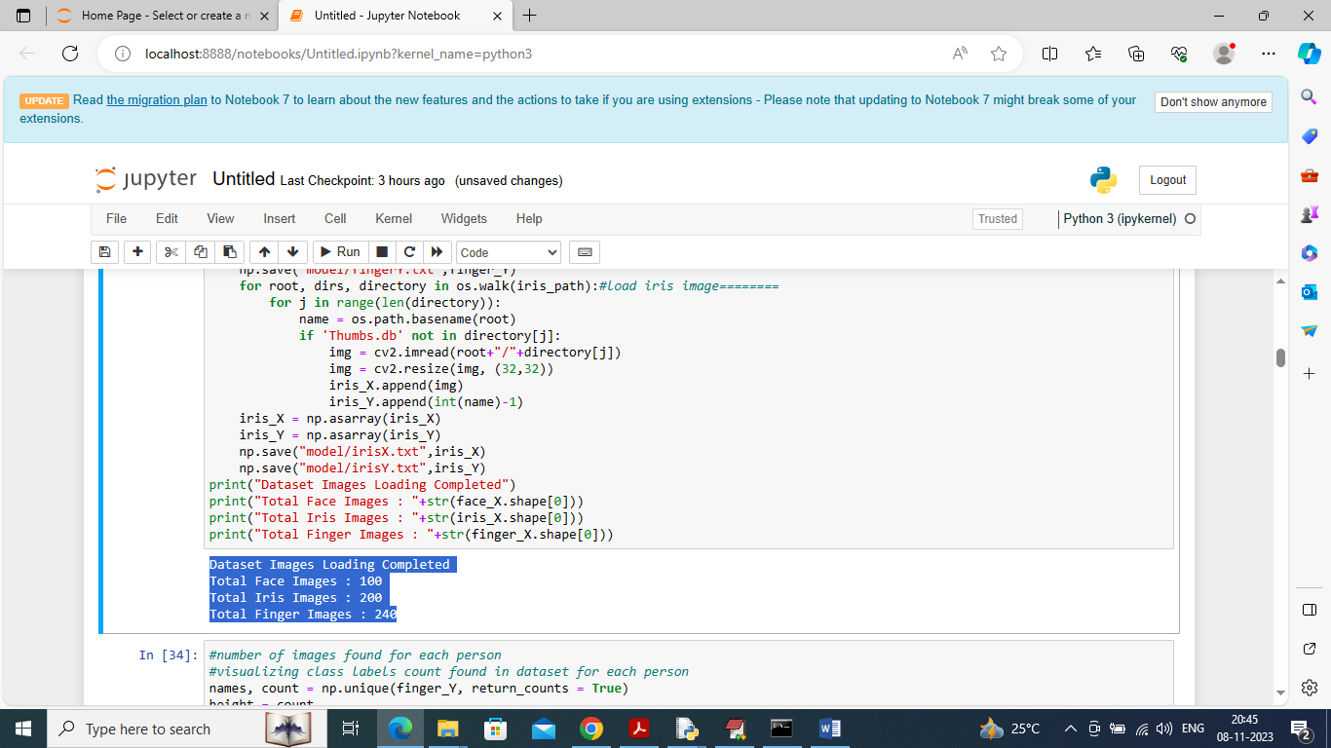

In above screen displaying number of images loaded in each biometric data

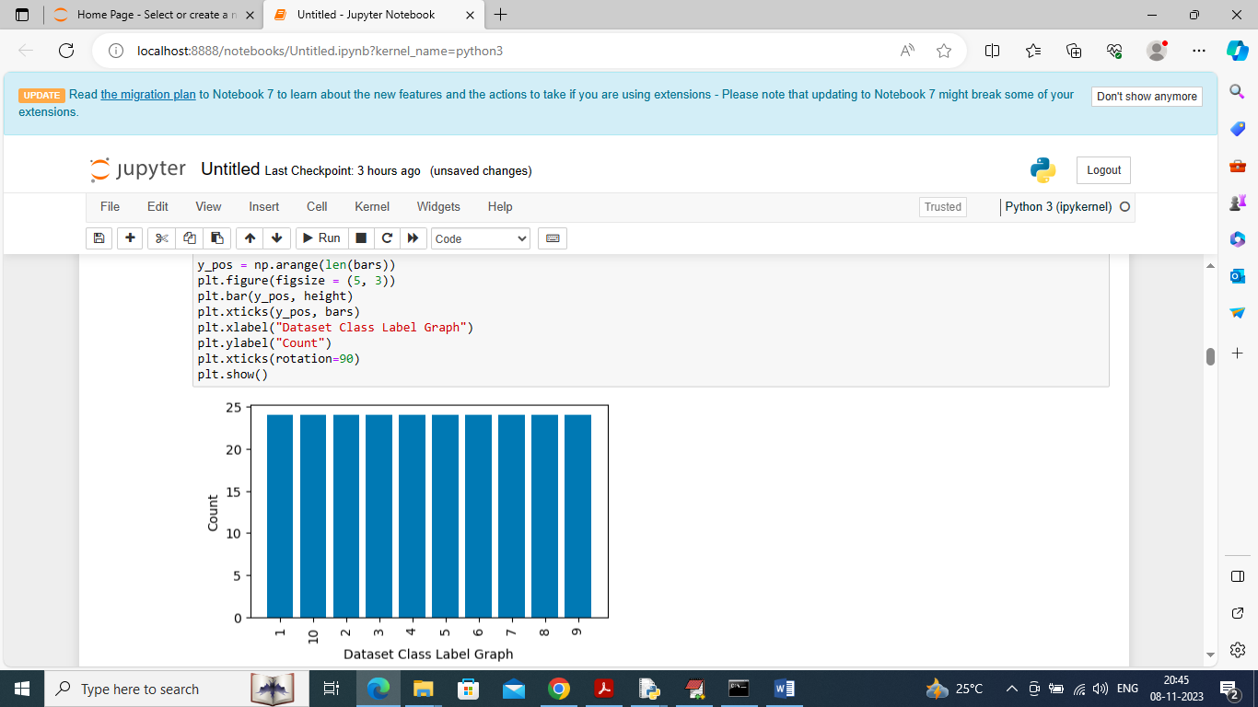

In above graph displaying number of images available in dataset for each person where x-axis represents person ID and y-axis represents counts and from above graph we can say all persons are having equal number of images which we generated through augmented technique to avoid imbalance issue

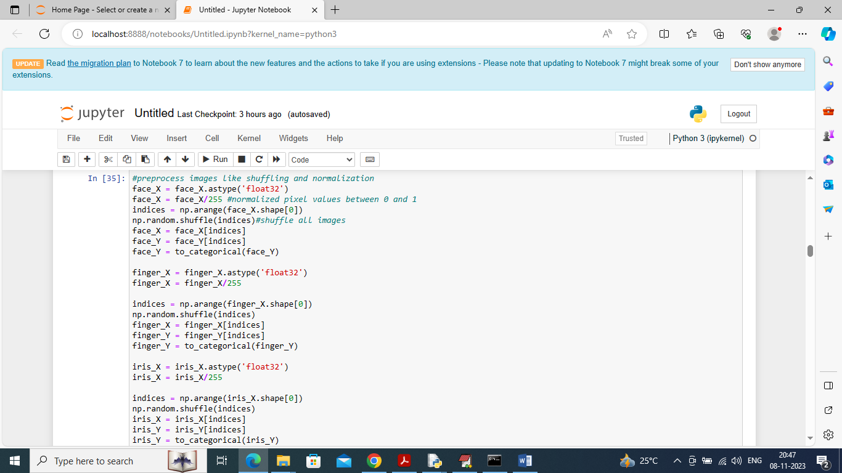

In above screen applying various processing techniques like shuffling and normalization images features

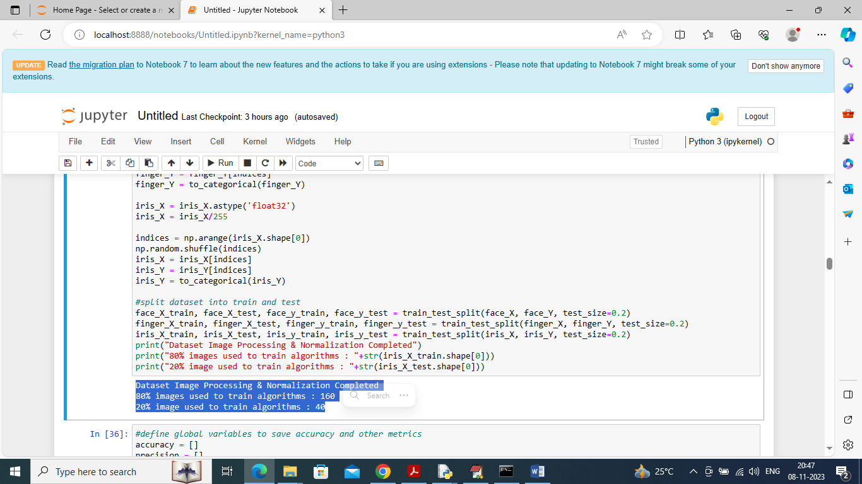

In above screen splitting dataset into train and test where application using 80% dataset images for training and 20% for testing

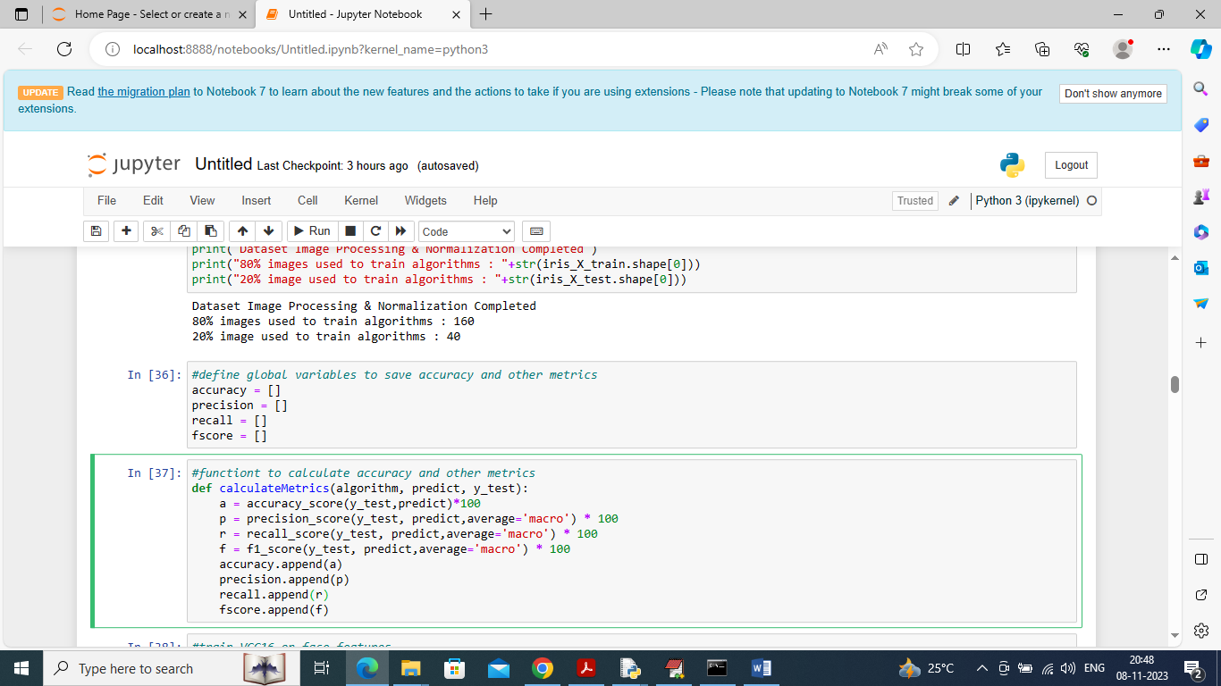

In above screen defining function to calculate accuracy, precision and other metrics

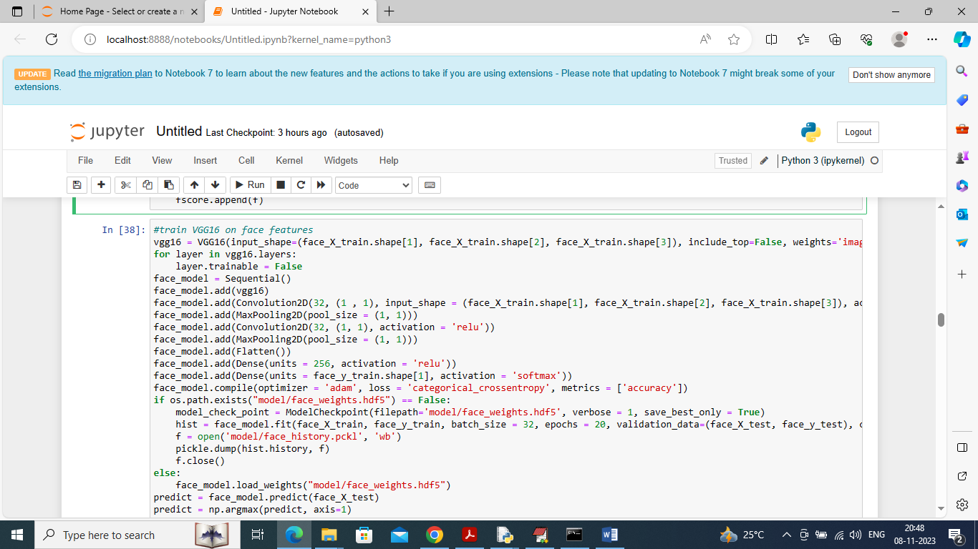

In above screen training VGG16 on face features

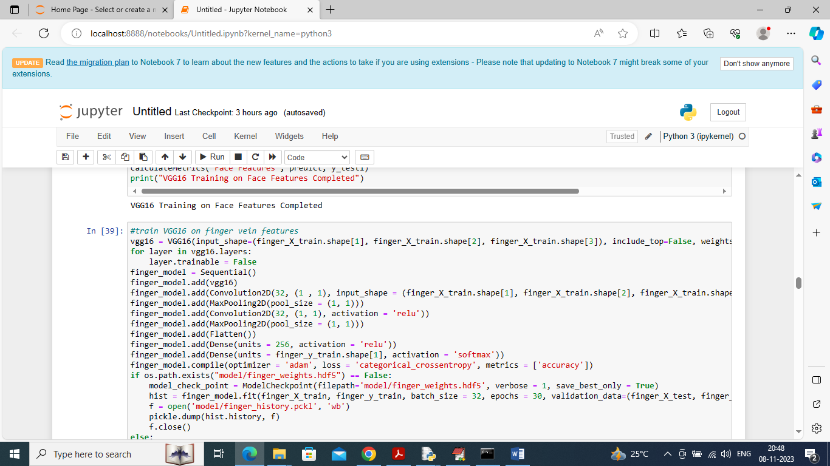

In above screen training VGG16 on Finger Vein images

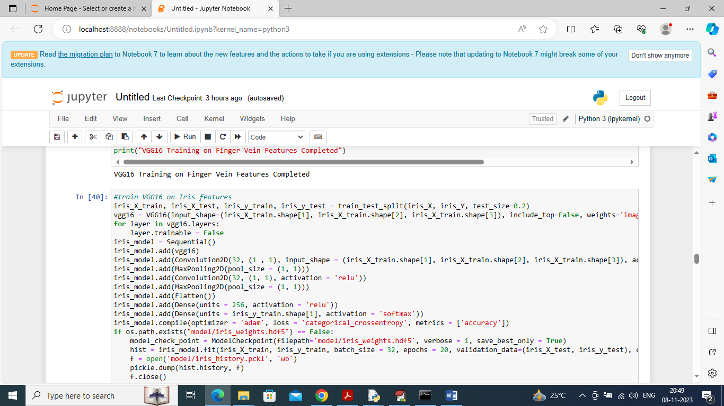

In above screen training IRIS features using VGG16 model

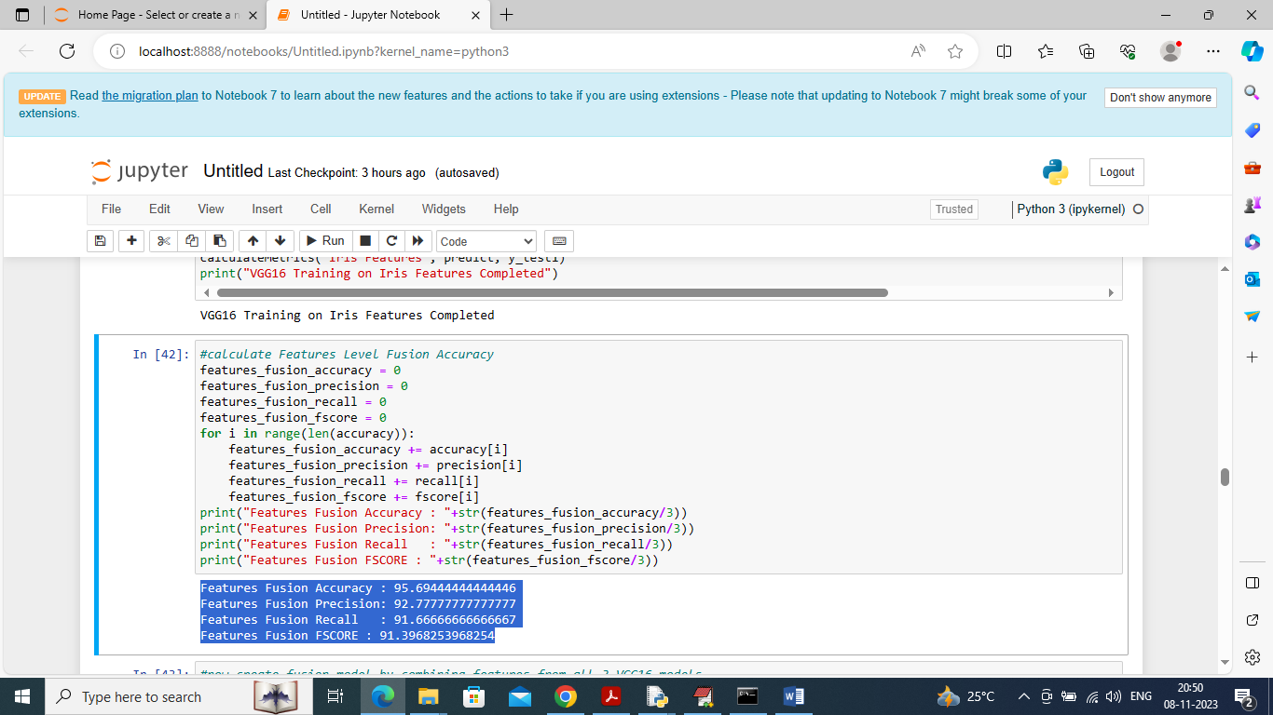

In above screen calculating accuracy and other metrics by taking features from all 3 models and their prediction and in blue colour text we can see Fusion Features got 95% accuracy.

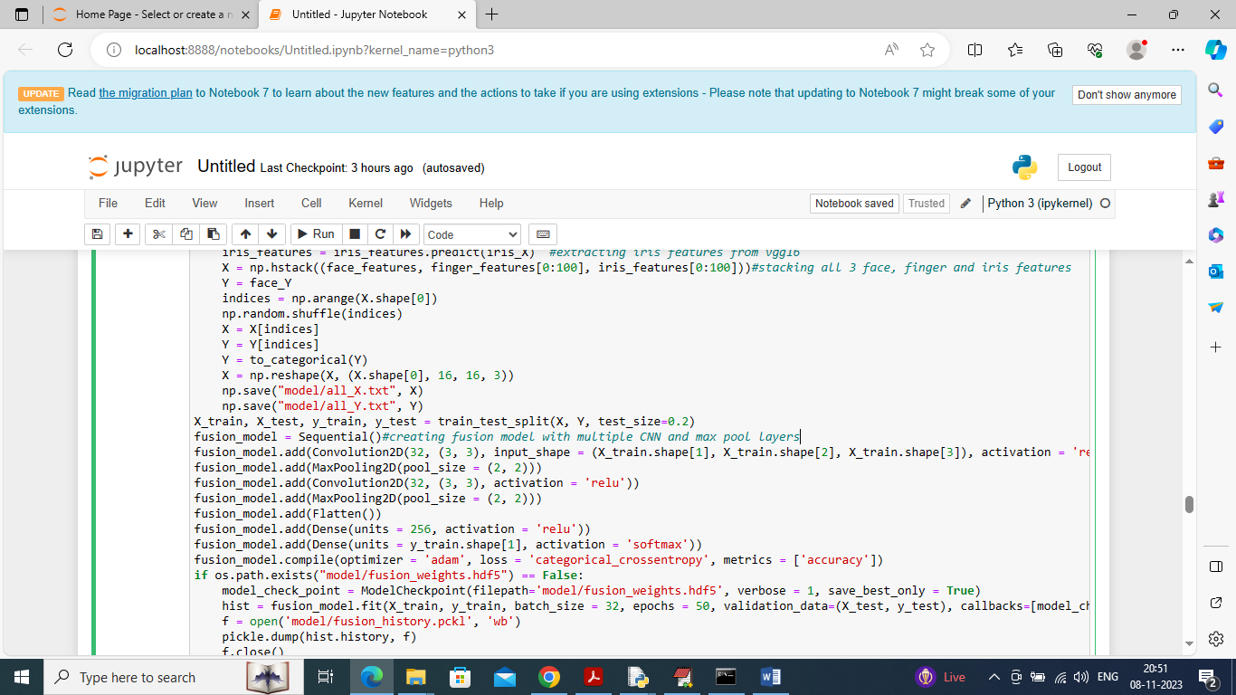

In above screen read blue colour comments to know about extracting and stacking features from all 3 models and then extracted features are getting trained with extension multiple CNN, MAXPOOL and softmax layer instead of single SOFTMAX layer. After executing above code will get below output

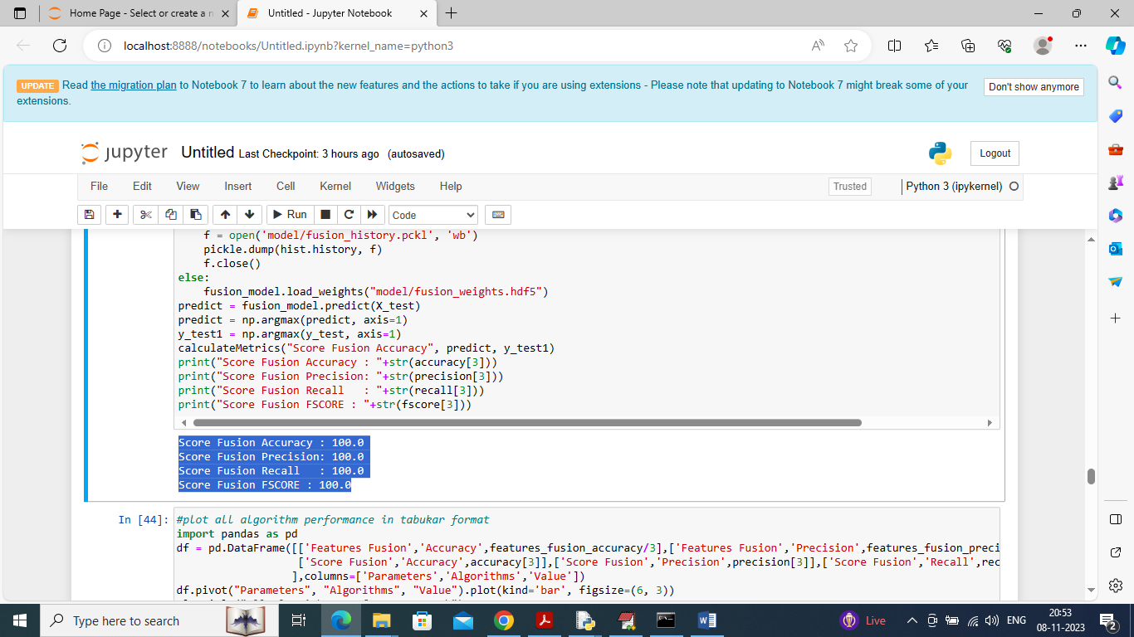

In above screen extension Fusion score model got 100% accuracy and can see other metrics also as 100%

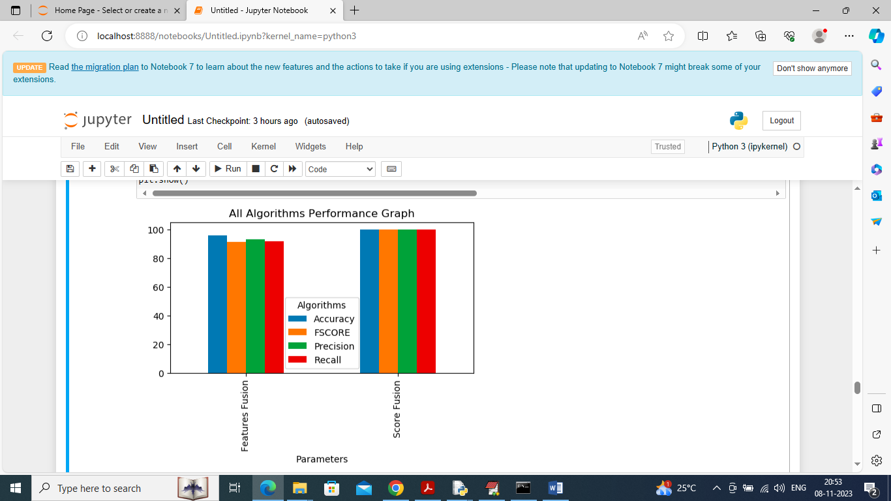

In above graph can see comparison between fusion features and fusion model score and in above graph x-axis represents accuracy and other metrics in different colour bars and y-axis represents values and in both models extension fusion model got high accuracy

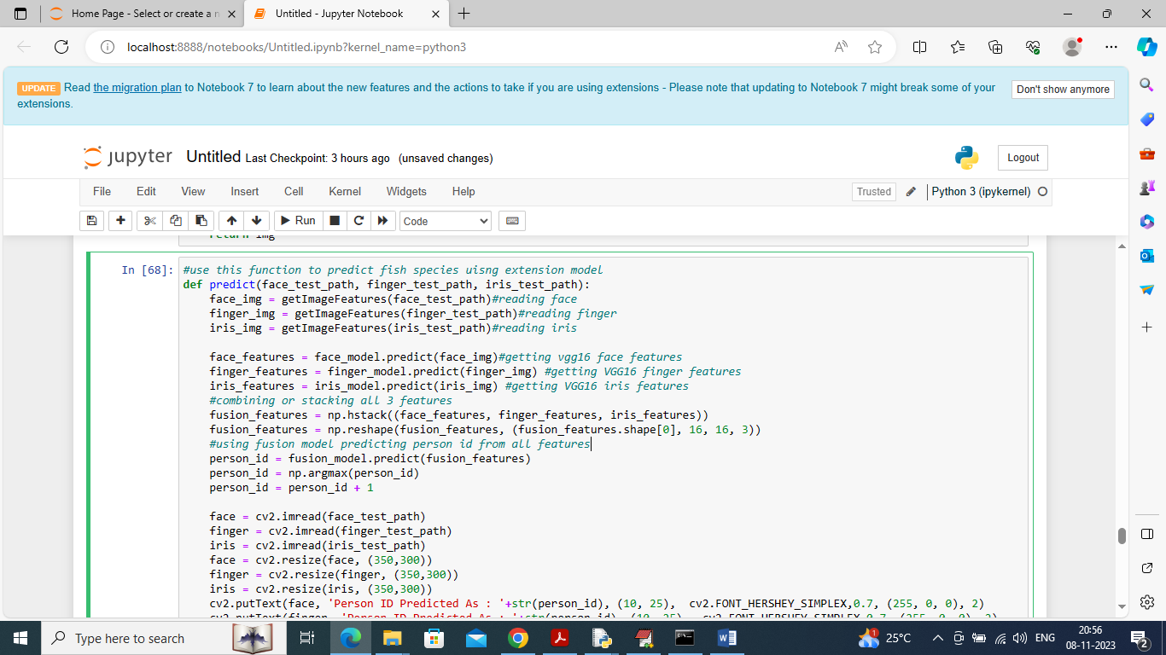

In above screen defining predict function which will read all 3 biometric images and then extract features and then make fusion of all 3 features and then apply fusion model to prediction person id

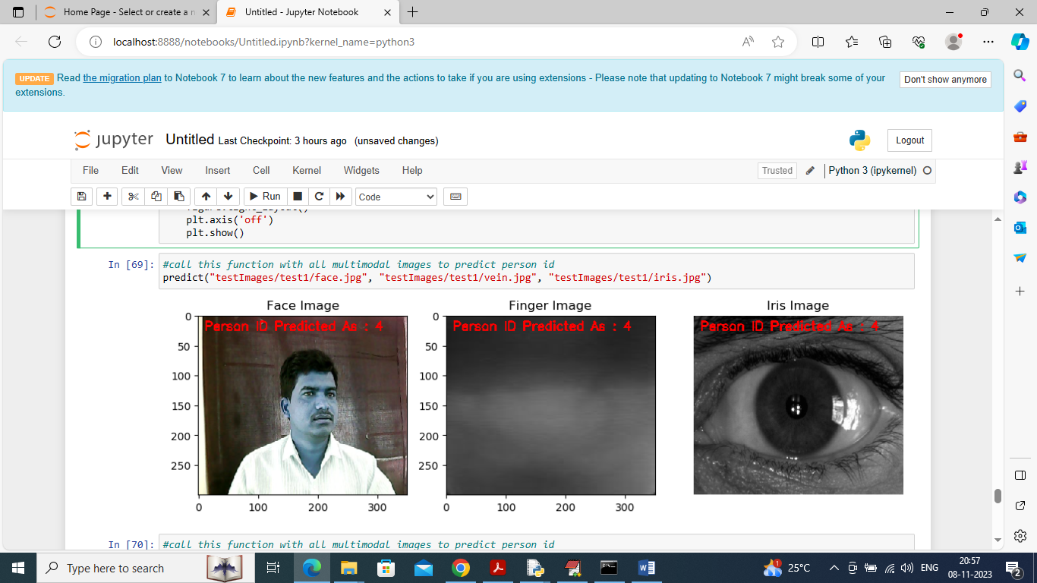

In above screen calling predict function with all 3 images and then in red colour displaying recognized person ID

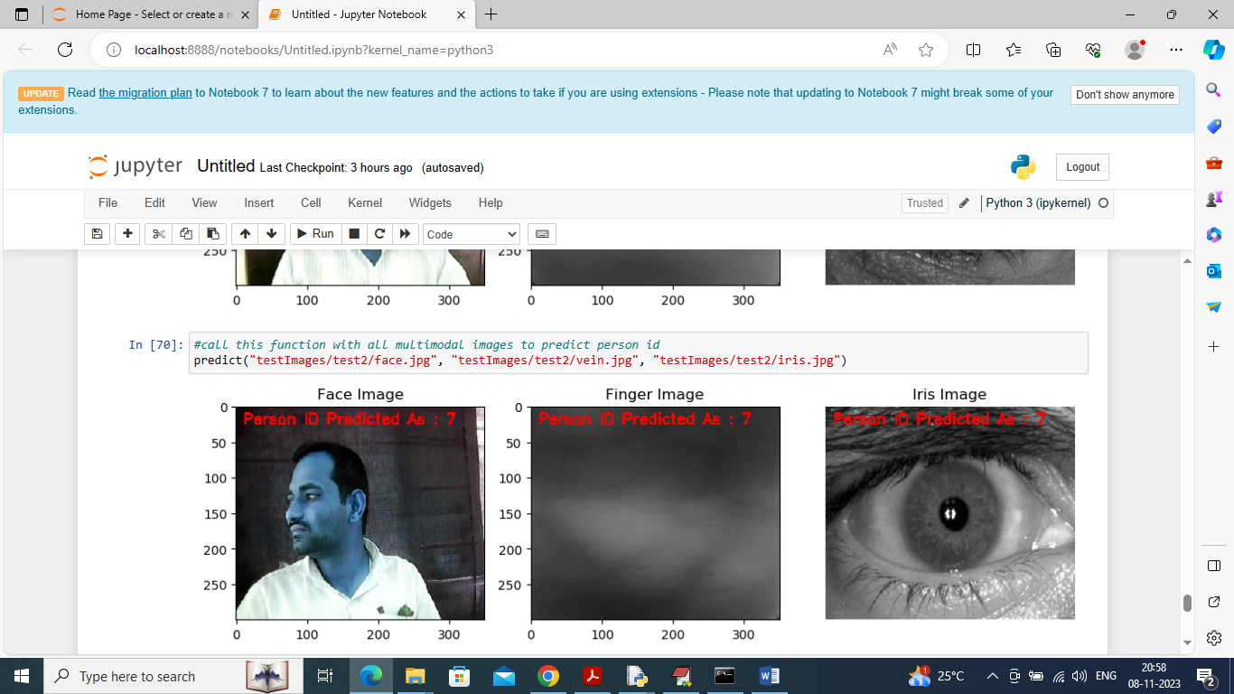

In above screen showing testing output of different sample images

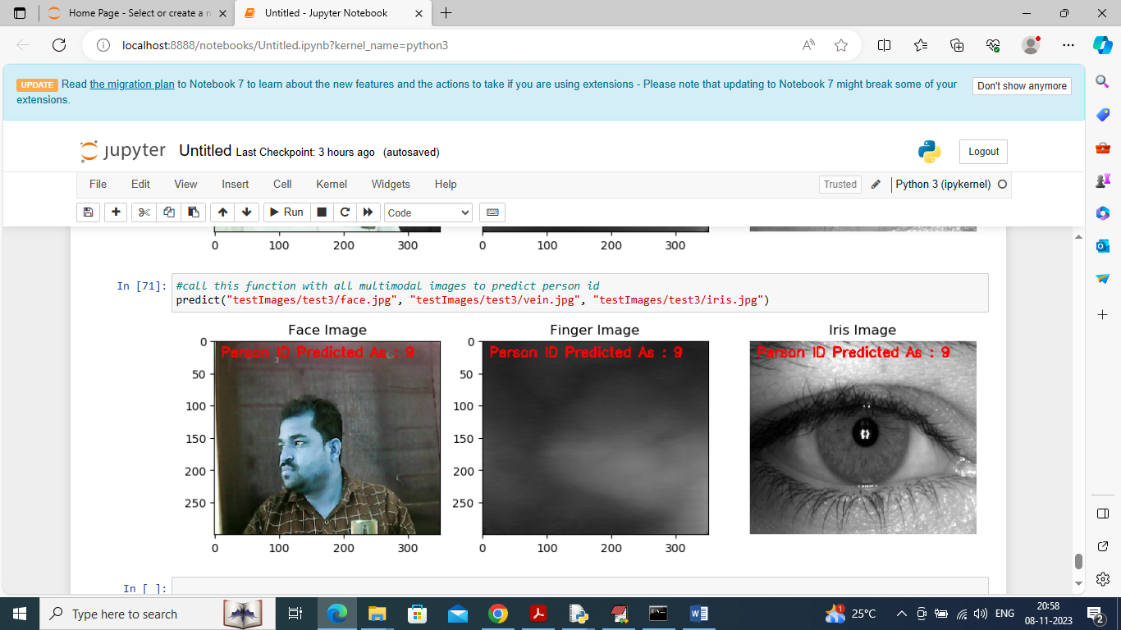

In above screen can see recognition of other samples