Department of Computer Science and Engineering
(AI & ML)
B. Tech. CSE - 5th Semester
Aug – Dec 2026

UE23CS351A
DATABASE MANAGEMENT SYSTEMS (DBMS)

PROJECT REPORT on

AI Symptom-to-Specialist Clinic Triage System

Submitted by:
PES1UG24AM918 | Vasu | 5G
SRN 2 | Name 2 | 5G

Class of Prof. [NAME]
[Lab Faculty]

Abstract
Patients walking into a multi-speciality clinic frequently do not know which specialist they need. They either book the wrong doctor from a dropdown of specialisations or wait for a receptionist to triage them manually, which wastes consultation slots and delays care. This project, TriageCare, routes a patient to the right doctor directly from a free-text description of their symptoms.
The system combines a relational database with a vector database inside a single PostgreSQL 16 instance. Patients, doctors, clinic branches, weekly availability, appointments, payments and prescriptions are stored in normalised relational tables protected by primary/foreign keys, CHECK constraints and an EXCLUDE constraint that makes overlapping bookings for a doctor impossible. Each doctor’s specialisation notes and every patient symptom description are converted into 384-dimensional sentence embeddings (all-MiniLM-L6-v2) and stored in pgvector columns with HNSW indexes. A cosine-similarity search returns the top-3 matching doctors, lightly re-ranked by the doctor’s load, instead of forcing the patient to pick a category.
Booking and payment are executed as one ACID transaction; triggers block double-booking, enforce working hours and daily capacity, validate fees, refund cancelled appointments and write an audit trail; a stored function computes a doctor’s daily load, a stored procedure completes a consultation with its prescription, and views expose the doctor’s daily schedule. Access control is enforced in the database itself through three PostgreSQL roles, column-level GRANTs and Row-Level Security. A Next.js 14 web application provides separate interfaces for Patients, Doctors and Admin/Receptionists. A suite of 35 automated tests verifies constraints, triggers, transactions, RLS and the API; the semantic matcher placed the correct specialty in the top-3 for 15 of 16 seeded cases and at rank 1 for 15 of 16.

Table of Contents
Sl. No | Topic | Page No.
 | Introduction  - Problem Statement | 4
 | User Requirements Specification- Tech Stack | 6
 | E-R Model  - List of Entities [labeling Weak ones]  - List non-simple Attributes  - ER Diagram Snapshot  - ERD from tool like draw.io | 9
 | Relational Model  - List of Relations that are not Entities in ER Model  - Schema Diagram [ensure light background image] | 12
 | SQL DDL Statements | 14
 | SQL DML Statements | 25
 | NoSQL/ Vector Database Commands | 29
8. | Results  - Resulting Tables’ Screenshots | 32
9. | Next.js-Project Tree Structure | 39
10. | Few sample Screenshots of application code and demo | 41
11. | Conclusion and Future Enhancements | 52
12. | Evaluation Rubrics- Completion Status | 53

1. Introduction

a) Problem Statement
Patients often book the wrong specialist or wait days for a manual triage. A person who writes “my chest feels tight and my heart races when I climb stairs” should reach a cardiologist, and “itchy red patches on my elbows that flake off” should reach a dermatologist — but neither sentence contains the words cardiology, palpitations, psoriasis or dermatitis that a keyword filter or a category dropdown depends on. The clinic therefore needs a system that understands free-text symptoms semantically, recommends the most relevant doctors, and then books a consultation without ever double-booking a doctor or losing a payment.

Short Description
TriageCare is a clinic management and triage system for a chain of three clinic branches in Bengaluru. A patient registers, describes their symptoms in their own words with a severity and duration, and receives the three best-matching doctors with a similarity score, branch, fee, experience and the doctor’s current load. The patient selects a free slot (computed by a recursive CTE over the doctor’s weekly shifts) and pays; the appointment and payment are committed atomically. Doctors see their daily schedule and load, complete consultations and write prescriptions; admins/receptionists manage doctors, branches and appointments and view analytics and the audit log.

Objectives
- Design a normalised relational schema (3NF) for patients, doctors, branches, availability, appointments, payments and prescriptions with complete integrity constraints.
- Use pgvector embeddings and cosine similarity so that unstructured symptom text is matched to doctors semantically — the core feature, not a decorative add-on.
- Guarantee consistency under concurrency: no doctor double-booking (trigger + EXCLUDE constraint + advisory lock) and all-or-nothing booking + payment transactions.
- Demonstrate advanced database features: transactions, triggers, stored functions and a procedure, views and a materialized view, B-tree/GIN/HNSW indexing, full-text search and vector similarity search.
- Enforce role-based access (Patient, Doctor, Admin) in both the application and the database (roles, GRANTs, Row-Level Security).
- Provide a functional Next.js web interface with forms, tables, search, filters and dashboards.

Scope
In scope: patient self-registration and login; AI symptom triage with top-3 doctor recommendations and red-flag detection (urgent symptoms trigger an emergency banner); slot discovery and booking with payment; cancellation with automatic refund; doctor daily schedule, load, consultation and prescriptions; doctor profile editing with automatic re-embedding; admin management of doctors and branches, appointment search/filter, analytics dashboard and audit log. Out of scope: real payment-gateway integration (payments are recorded; a gateway failure can be simulated to demonstrate rollback), clinical diagnosis (the system recommends a specialist, it does not diagnose), insurance claims, notifications and tele-consultation.

2. User Requirements Specification

a) Users and Roles
Role | Who | Can do
Patient | Registered member of the public | Register/login; submit symptoms and get top-3 doctors; view free slots; book + pay; cancel; view own appointments and prescriptions
Doctor | Clinic consultant (account created by admin) | View own daily schedule and load; see symptoms of own patients; complete consultation with prescription; mark no-show; edit specialisation notes (re-embedded)
Admin / Receptionist | Front-desk staff | Dashboard analytics; search/filter/cancel/delete appointments; add, update, deactivate, delete doctors; add/delete branches; refresh demand view; read audit log

b) Functional Requirements
ID | Requirement | Description
FR1 | Authentication | Patients self-register; all users log in with e-mail + password (bcrypt). Sessions are signed JWTs in httpOnly cookies (8 h).
FR2 | Symptom triage | Free text (10–2000 chars), severity 1–10, duration in days, optional branch → embedding → top-3 doctors by cosine similarity; keyword-search baseline and “similar past cases” shown alongside.
FR3 | Red-flag screening | Phrases such as chest pain, cannot breathe, fainting, slurred speech or severity ≥ 9 set red_flag and show an emergency-care banner.
FR4 | Slot discovery | Free slots for a doctor on a date generated from weekly shifts minus existing appointments (recursive CTE).
FR5 | Booking + payment | Appointment and payment inserted in a single transaction; failure in any step rolls back both.
FR6 | Double-booking prevention | A doctor can never have two overlapping live appointments; a patient cannot be in two appointments at once; slots must fall within working hours and daily capacity.
FR7 | Cancellation | Patients cancel their own future appointments; the payment is automatically marked refunded.
FR8 | Doctor schedule & load | Doctor sees the day’s appointments (view) and load metrics (stored function) with a 7-day load strip.
FR9 | Consultation | Doctor records diagnosis, advice, follow-up date and medicines; stored procedure writes prescription + items and completes the appointment atomically.
FR10 | Admin management | CRUD on doctors (with automatic embedding) and branches; appointment search & filters; analytics; audit log.

c) Non-functional Requirements
- Integrity: validation at three layers — HTML form constraints, Zod schemas in API handlers and CHECK/FK/UNIQUE/EXCLUDE constraints + triggers in PostgreSQL (the database is the final authority).
- Security: bcrypt password hashes (a CHECK constraint rejects non-bcrypt values); credentials only in environment variables (.env.local, git-ignored); all SQL parameterised; least-privilege database role per request with Row-Level Security.
- Performance: HNSW approximate-nearest-neighbour indexes for vector search, composite and partial B-tree indexes for schedules, GIN index for full-text search.
- Privacy: the “similar past cases” feature searches all patients’ embeddings but returns only aggregated specialisations through a SECURITY DEFINER function — never another patient’s text.

d) Tech Stack and Justification
Layer | Technology | Why this choice for this problem
Frontend | Next.js 14 (App Router, React 18) | Required by the course; one codebase for pages and API; client components for interactive triage/booking forms.
Backend / API | Next.js Route Handlers (Node.js runtime) | Server-side code runs the embedding model and holds database credentials; no separate server to deploy.
SQL database | PostgreSQL 16 | Mature ACID engine with EXCLUDE constraints (range overlap), PL/pgSQL triggers/procedures, Row-Level Security, generated columns, full-text search and — crucially — the pgvector extension.
Vector database | pgvector 0.6 (HNSW, cosine) | Embeddings live next to the relational rows they describe, so one SQL statement can combine similarity ranking with relational filters (active doctors, branch, load) and run inside the same transaction.
Embedding model | all-MiniLM-L6-v2 via Transformers.js (ONNX) | Small (≈90 MB), fast on CPU, strong on short sentence similarity; runs locally — no paid API key and no patient text leaves the server.
Auth & validation | bcryptjs, jose (JWT), Zod | Standard, dependency-light libraries; JWT verification also works in Edge middleware.
Version control | Git + GitHub | Commit history per member; README with setup instructions.

e) Justification of the Vector Database (why not SQL-only)
Symptoms are unstructured, open-vocabulary text. A relational design can only match them through fixed categories (a dropdown) or keyword search. Both fail for lay language: in our own test, PostgreSQL full-text search (plainto_tsquery) returned zero doctors for “My chest feels tight and my heart races when I climb stairs” and for “itchy red patches on my elbows that flake off”, while the vector search ranked two cardiologists (similarity 0.61, 0.54) and two dermatologists first respectively. Embeddings place semantically related phrases close together in vector space regardless of the exact words used, so the vector store is the core of the triage feature. Structured data with strict integrity needs (appointments, payments, prescriptions) remains relational.
Aspect | Design
Data embedded | (1) Doctor document = specialisation name + specialisation description + the doctor’s own specialisation notes (written in clinical and lay terms). (2) Every patient symptom description.
Model | sentence-transformers/all-MiniLM-L6-v2 (6-layer BERT, ONNX), mean pooling, L2-normalised → 384-d vectors.
Storage | doctors.notes_embedding VECTOR(384) and symptom_reports.embedding VECTOR(384) — metadata (specialisation, branch, fee, active flag, patient) lives in the same rows/joined tables.
Index | HNSW (m = 16, ef_construction = 64) with vector_cosine_ops on both columns.
Similarity metric | Cosine distance operator <=>; similarity = 1 − distance (vectors are unit-length, so this equals the dot product).
Retrieval | fn_recommend_doctors(): ANN step takes the 20 nearest active doctors via ORDER BY <=> LIMIT 20 (index scan), optional branch filter, then re-ranks score = similarity − 0.02 × tomorrow’s load fraction and returns the top 3. Results are stored in triage_recommendations.
Secondary use | fn_similar_case_specialties(): k-NN over past symptom reports → specialisations that treated similar completed cases (aggregated only).

f) System Architecture
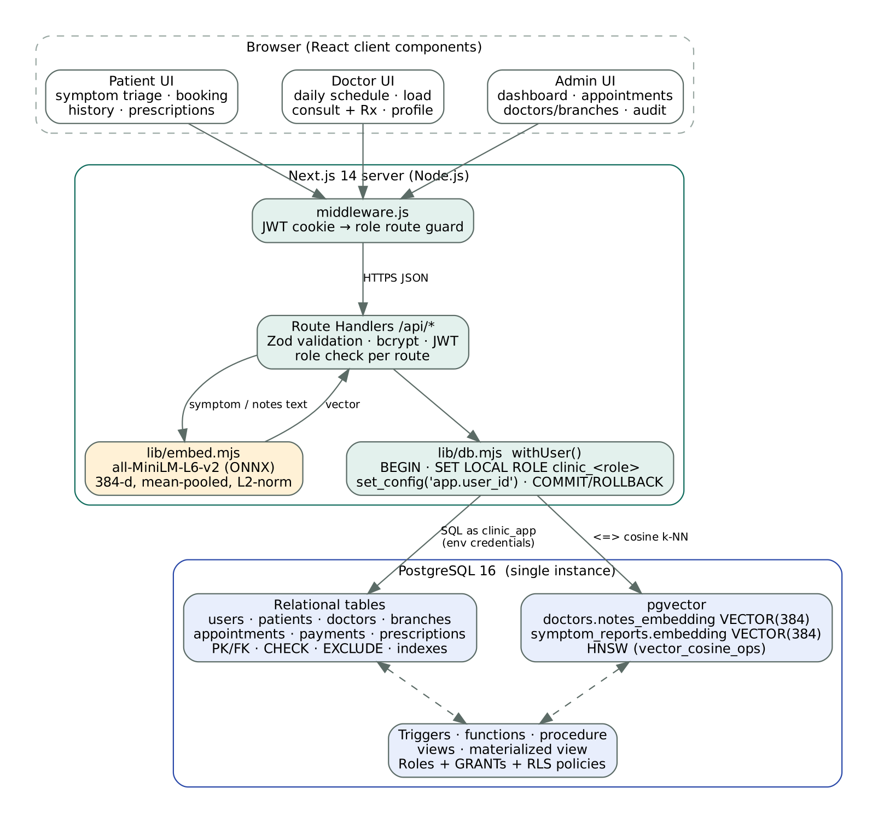
Figure 2.1 – System architecture: browser → Next.js middleware and API → per-request database role → PostgreSQL (relational + pgvector)

3. E-R Model

a) List of Entities (weak entities highlighted)
Entity | Type | Key | Main attributes
USER | Strong (superclass) | user_id | Login identity: email, password_hash, role, full_name, phone, is_active
PATIENT | Strong (ISA USER) | patient_id | date_of_birth, gender, blood_group, address, emergency_contact
DOCTOR | Strong (ISA USER) | doctor_id | license_no, experience, fee, slot length, capacity, specialisation_notes, notes_embedding
BRANCH | Strong | branch_id | name, address (street, city, pincode), phone, opening hours
SPECIALIZATION | Strong | spec_id | name, description
SYMPTOM_REPORT | Strong | report_id | description, severity, duration_days, embedding, red_flag
APPOINTMENT | Strong | appt_id | slot (start_time, end_time), status, reason
PAYMENT | Strong | payment_id | amount, method, status, txn_ref, paid_at
PRESCRIPTION | Strong | rx_id | diagnosis, advice, follow_up_on
DOCTOR_AVAILABILITY | WEAK (owner DOCTOR) | partial key: weekday + start_time | end_time — one weekly working shift
PRESCRIPTION_ITEM | WEAK (owner PRESCRIPTION) | partial key: line_no | medicine, dosage, frequency, duration_days
TRIAGE_RECOMMENDATION | WEAK (owner SYMPTOM_REPORT) | partial key: rank (1–3) | similarity; references the recommended DOCTOR

b) Non-simple Attributes
Attribute | Entity | Kind | How it is handled
address (street, city, pincode) | BRANCH | Composite | Flattened into three columns
slot (start_time, end_time) | APPOINTMENT | Composite | Two TIMESTAMP columns; overlap checked as tsrange(start, end)
age | PATIENT | Derived | age(date_of_birth) computed in v_doctor_daily_schedule
load_pct, booked_minutes | DOCTOR (per day) | Derived | Computed by fn_doctor_daily_load()
search_tsv | DOCTOR | Derived (stored) | GENERATED ALWAYS AS to_tsvector(specialization_notes) STORED
weekly working hours | DOCTOR | Multivalued | Mapped to weak entity DOCTOR_AVAILABILITY
medicines | PRESCRIPTION | Multivalued, composite | Mapped to weak entity PRESCRIPTION_ITEM
notes_embedding, embedding | DOCTOR, SYMPTOM_REPORT | Complex (384-element vector), derived from text | pgvector VECTOR(384) column, HNSW indexed

c) Relationships and Cardinalities
Relationship | Entities | Cardinality / participation
ISA | USER → PATIENT | DOCTOR | Disjoint specialisation (role column); every patient/doctor is a user
BOOKS | PATIENT – APPOINTMENT | 1 : N, appointment total
ATTENDS | DOCTOR – APPOINTMENT | 1 : N, appointment total
HELD_AT | BRANCH – APPOINTMENT | 1 : N (branch derived from doctor by trigger)
HAS_SPEC / WORKS_AT | DOCTOR – SPECIALIZATION / BRANCH | N : 1, doctor total
PAID_BY | APPOINTMENT – PAYMENT | 1 : 1, payment total
RESULTS_IN | APPOINTMENT – PRESCRIPTION | 1 : 0..1
REPORTS / TRIGGERED_BY | PATIENT – SYMPTOM_REPORT / SYMPTOM_REPORT – APPOINTMENT | 1 : N / 0..1 : N
HAS_SHIFT, CONTAINS, RECOMMENDS | identifying relationships of the weak entities | 1 : N (≤ 3 for RECOMMENDS), weak side total

d) ER Diagram
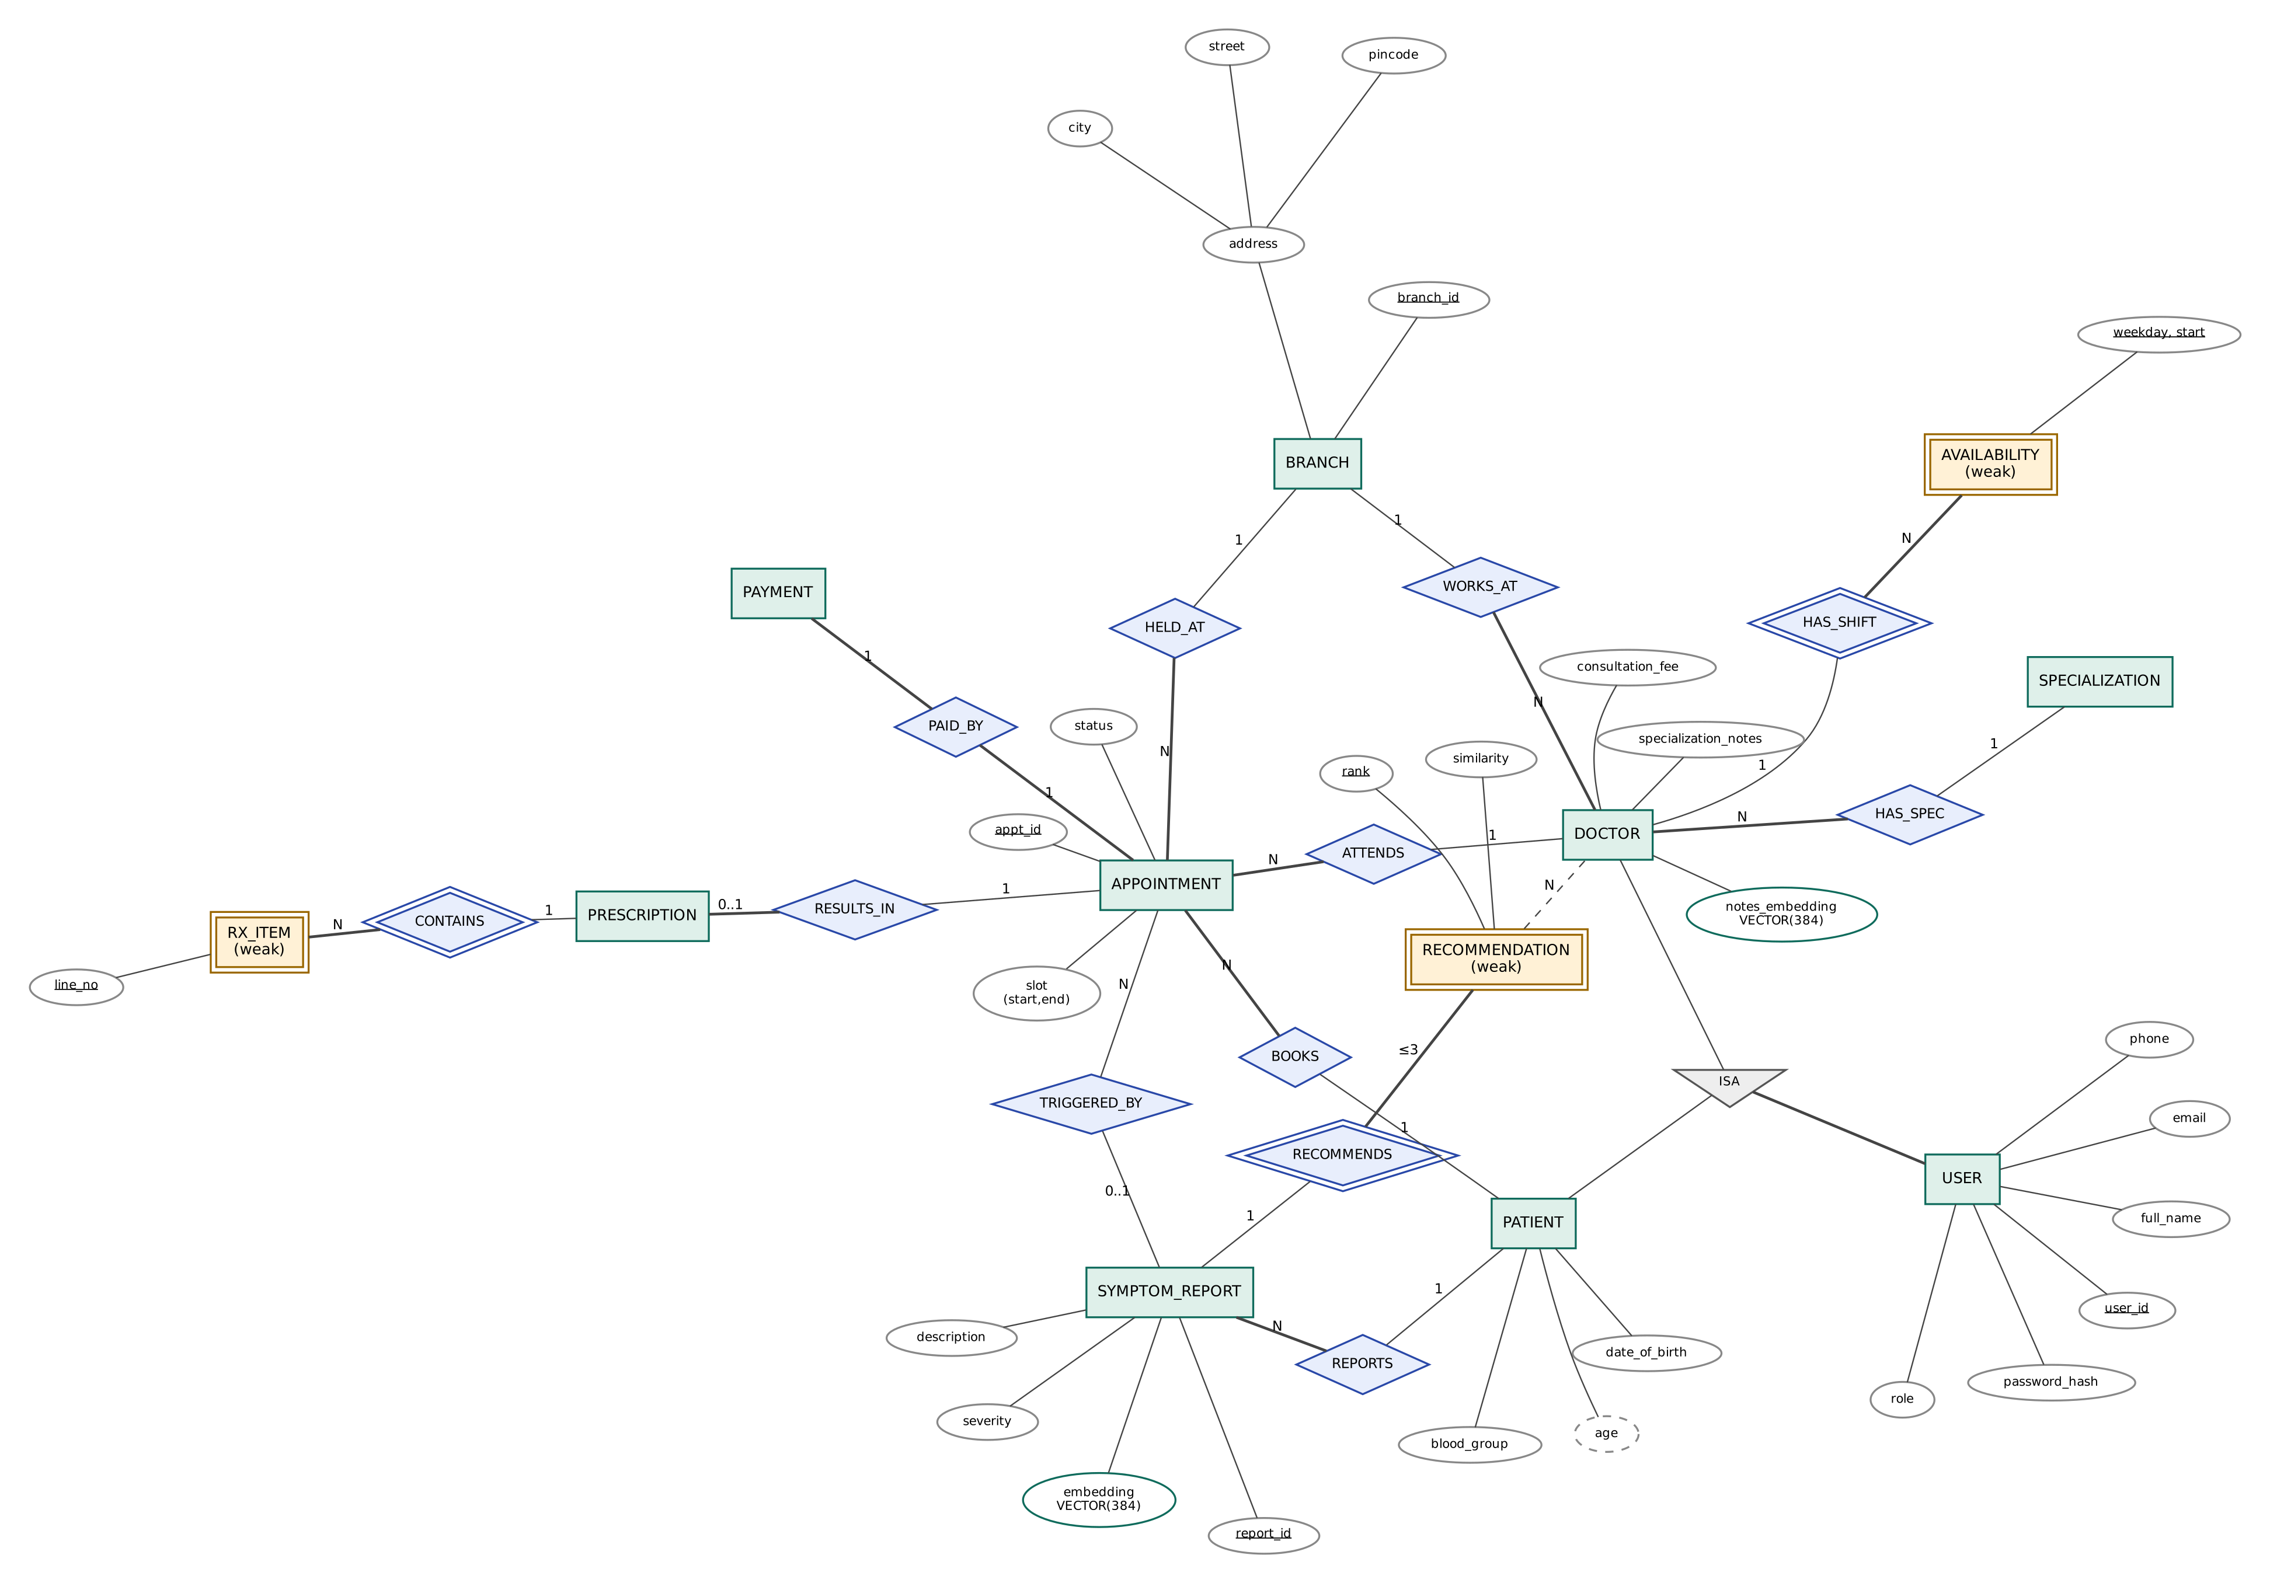
Figure 3.1 – ER diagram (Chen notation; double rectangles/diamonds = weak entities/identifying relationships, bold lines = total participation). Drawn with Graphviz — source: docs/diagrams/er.dot

4. Relational Model

a) List of Relations
Relation (PK underlined in diagram, → = FK) | ER mapping
branches(branch_id, name, street, city, pincode, phone, opens_at, closes_at) | Entity
users(user_id, email, password_hash, role, full_name, phone, is_active, created_at) | Entity (superclass)
patients(patient_id→users, date_of_birth, gender, blood_group, address, emergency_contact) | Entity (subclass, table-per-subclass ISA)
specializations(spec_id, name, description) | Entity
doctors(doctor_id→users, spec_id→specializations, branch_id→branches, license_no, years_experience, consultation_fee, slot_minutes, max_daily_patients, specialization_notes, notes_embedding, embedded_at, search_tsv) | Entity (subclass)
doctor_availability(doctor_id→doctors, weekday, start_time, end_time) | Weak entity
symptom_reports(report_id, patient_id→patients, description, severity, duration_days, embedding, red_flag, created_at) | Entity
triage_recommendations(report_id→symptom_reports, rank, doctor_id→doctors, similarity) | Weak entity — also realises the M:N RECOMMENDS relationship between SYMPTOM_REPORT and DOCTOR
appointments(appt_id, patient_id→patients, doctor_id→doctors, branch_id→branches, report_id→symptom_reports, start_time, end_time, status, reason, created_at, updated_at) | Entity
payments(payment_id, appt_id→appointments UNIQUE, amount, method, status, txn_ref, paid_at) | Entity
prescriptions(rx_id, appt_id→appointments UNIQUE, diagnosis, advice, follow_up_on, created_at) | Entity
prescription_items(rx_id→prescriptions, line_no, medicine, dosage, frequency, duration_days) | Weak entity
audit_log(log_id, table_name, operation, row_pk, actor_id, db_role, old_data, new_data, logged_at) | NOT an ER entity — system relation populated only by triggers
v_doctor_daily_schedule, v_patient_appointment_history, v_doctor_directory, v_branch_revenue_summary, mv_specialization_demand | NOT ER entities — derived relations (views / materialized view)

All 1:N relationships (BOOKS, ATTENDS, HELD_AT, HAS_SPEC, WORKS_AT, REPORTS, TRIGGERED_BY) are mapped as foreign-key columns on the N side; the 1:1 relationships PAID_BY and RESULTS_IN are mapped as UNIQUE foreign keys. Every relation is in 3NF: all non-key attributes depend only on the key (e.g. a doctor’s fee is stored once in doctors and the payment amount is validated against it by a trigger rather than duplicated by design).

b) Schema Diagram
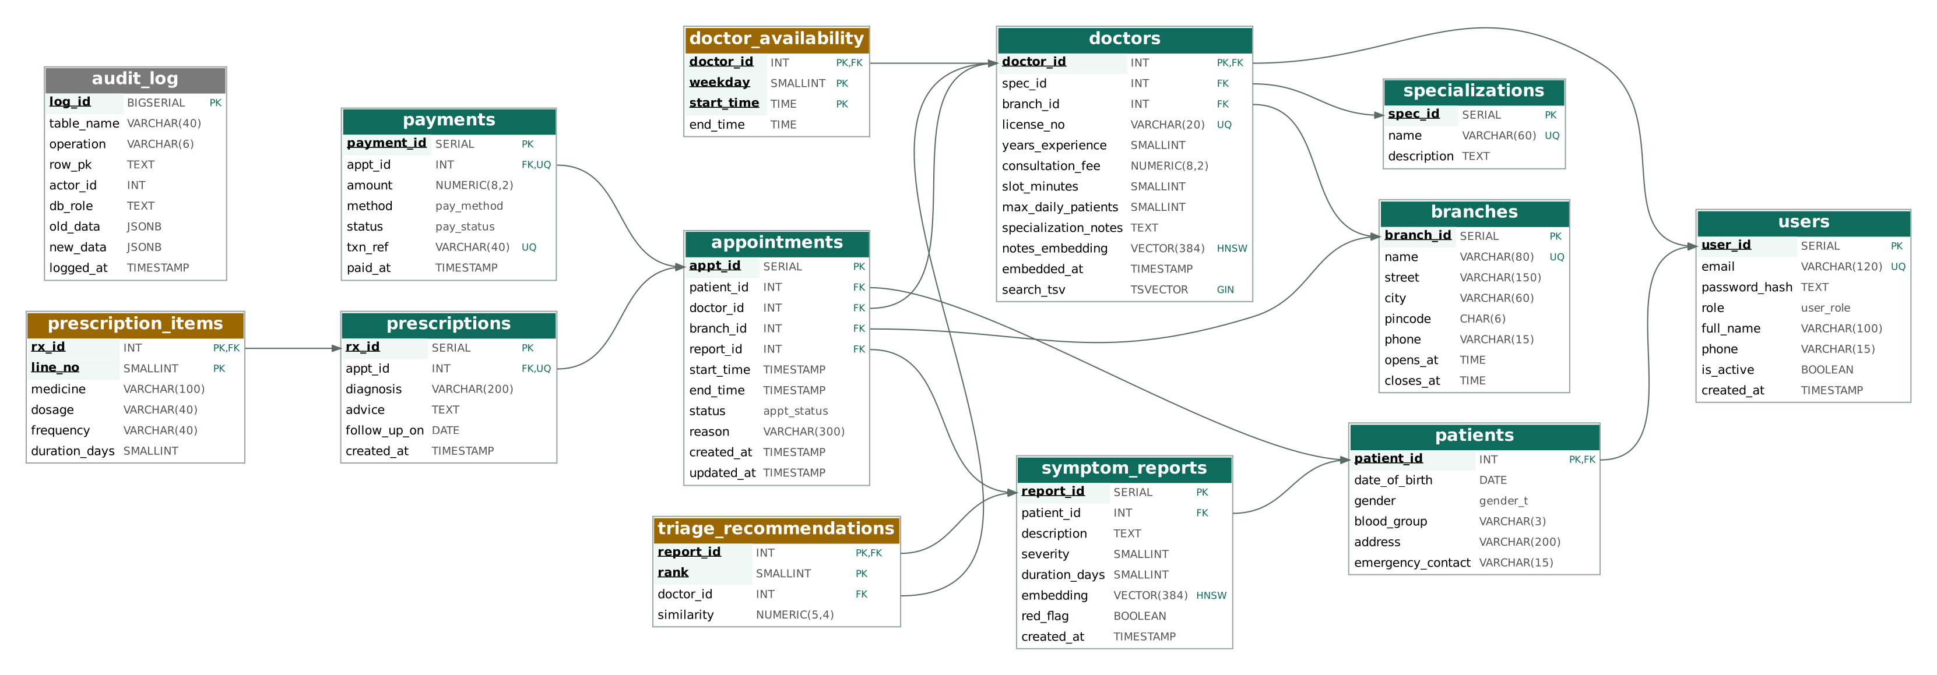
Figure 4.1 – Relational schema with primary keys (underlined), foreign keys (arrows) and special indexes (HNSW, GIN). Orange = weak-entity relations.

c) Data Dictionary — Key Constraints
Table | Integrity constraints
users | PK user_id; UNIQUE lower(email) (expression index); CHECK email regex; CHECK password_hash is bcrypt ($2a/$2b/$2y$, 60 chars); CHECK full_name length ≥ 2; CHECK phone regex; role ENUM
patients | PK/FK patient_id → users ON DELETE CASCADE; CHECK date_of_birth between 1900-01-01 and today; CHECK blood_group IN (8 values); gender ENUM
doctors | PK/FK doctor_id → users; FK spec_id, branch_id ON DELETE RESTRICT; UNIQUE license_no + CHECK ‘KMC-#####’ (added with ALTER TABLE); CHECK fee > 0, experience 0–60, slot ∈ {10,15,20,30,45,60}, capacity 1–60, notes length ≥ 40
doctor_availability | PK (doctor_id, weekday, start_time); CHECK weekday 0–6, end > start; EXCLUDE gist (doctor_id =, weekday =, time range &&) — no overlapping shifts
symptom_reports | FK patient_id; CHECK description 10–2000 chars, severity 1–10, duration 0–3650; embedding NOT NULL
triage_recommendations | PK (report_id, rank); UNIQUE (report_id, doctor_id); CHECK rank 1–3, similarity −1..1
appointments | FKs patient (RESTRICT), doctor (RESTRICT), branch (RESTRICT), report (SET NULL); CHECK end > start and ≤ 2 h; EXCLUDE gist (doctor_id =, tsrange(start,end) &&) WHERE status IN (booked, completed); status ENUM; validation trigger
payments | UNIQUE FK appt_id (1:1) ON DELETE CASCADE; UNIQUE txn_ref; CHECK amount > 0; trigger amount = doctor fee; method/status ENUMs
prescriptions / items | UNIQUE FK appt_id; trigger: not for cancelled/no-show, only treating doctor; items PK (rx_id, line_no), CHECK duration 1–365

5. SQL DDL Statements
The complete DDL is split into four scripts executed in order by npm run db:setup. It demonstrates CREATE (extensions, types, tables, indexes, views, functions, triggers, roles, policies), ALTER (adding a generated column and a CHECK constraint to doctors; ALTER DATABASE/ROLE; ALTER TABLE … ENABLE ROW LEVEL SECURITY) and DROP (clean-slate DROP … IF EXISTS … CASCADE). The full execution log (851 lines, 0 errors) is in docs/logs/ddl_log.txt.

5.1 db/01_schema.sql — tables, keys, constraints, indexes
-- =====================================================================
-- AI Symptom-to-Specialist Clinic Triage System
-- 01_schema.sql — DDL: extensions, tables, keys, constraints, indexes
-- Target: PostgreSQL 16 + pgvector 0.6+ (run as the database owner)
-- =====================================================================

-- ---------- Clean slate (DROP) ----------
DROP MATERIALIZED VIEW IF EXISTS mv_specialization_demand CASCADE;
DROP TABLE IF EXISTS audit_log, prescription_items, prescriptions, payments,
appointments, triage_recommendations, symptom_reports,
doctor_availability, doctors, specializations,
patients, users, branches CASCADE;
DROP TYPE IF EXISTS user_role, appt_status, pay_method, pay_status, gender_t CASCADE;
DROP EXTENSION IF EXISTS vector CASCADE;
DROP EXTENSION IF EXISTS btree_gist CASCADE;

-- ---------- Extensions ----------
CREATE EXTENSION IF NOT EXISTS vector; -- pgvector: VECTOR type + HNSW index
CREATE EXTENSION IF NOT EXISTS btree_gist; -- lets EXCLUDE constraints mix "=" and "&&"

-- ---------- Enumerated domains ----------
CREATE TYPE user_role AS ENUM ('patient', 'doctor', 'admin');
CREATE TYPE appt_status AS ENUM ('booked', 'completed', 'cancelled', 'no_show');
CREATE TYPE pay_method AS ENUM ('upi', 'card', 'cash', 'insurance');
CREATE TYPE pay_status AS ENUM ('paid', 'refunded', 'failed');
CREATE TYPE gender_t AS ENUM ('male', 'female', 'other');

-- ---------- Clinic branches ----------
CREATE TABLE branches (
branch_id SERIAL PRIMARY KEY,
name VARCHAR(80) NOT NULL UNIQUE,
street VARCHAR(150) NOT NULL,
city VARCHAR(60) NOT NULL DEFAULT 'Bengaluru',
pincode CHAR(6) NOT NULL CHECK (pincode ~ '^[1-9][0-9]{5}$'),
phone VARCHAR(15) NOT NULL CHECK (phone ~ '^\+?[0-9]{10,13}$'),
opens_at TIME NOT NULL DEFAULT '08:00',
closes_at TIME NOT NULL DEFAULT '20:00',
CONSTRAINT chk_branch_hours CHECK (closes_at > opens_at)
);

-- ---------- Users (authentication super-entity) ----------
CREATE TABLE users (
user_id SERIAL PRIMARY KEY,
email VARCHAR(120) NOT NULL,
password_hash TEXT NOT NULL, -- bcrypt hash, never plain text
role user_role NOT NULL,
full_name VARCHAR(100) NOT NULL CHECK (length(trim(full_name)) >= 2),
phone VARCHAR(15) CHECK (phone ~ '^\+?[0-9]{10,13}$'),
is_active BOOLEAN NOT NULL DEFAULT TRUE,
created_at TIMESTAMP NOT NULL DEFAULT now(),
CONSTRAINT chk_email_format CHECK (email ~* '^[A-Z0-9._%+-]+@[A-Z0-9.-]+\.[A-Z]{2,}$'),
CONSTRAINT chk_bcrypt_hash CHECK (password_hash ~ '^\$2[aby]\$\d{2}\$.{53}$')
);
-- case-insensitive uniqueness of e-mail (expression index)
CREATE UNIQUE INDEX ux_users_email_lower ON users (lower(email));

-- ---------- Patients (ISA users) ----------
CREATE TABLE patients (
patient_id INT PRIMARY KEY REFERENCES users(user_id) ON DELETE CASCADE,
date_of_birth DATE NOT NULL CHECK (date_of_birth BETWEEN DATE '1900-01-01' AND CURRENT_DATE),
gender gender_t NOT NULL,
blood_group VARCHAR(3) CHECK (blood_group IN ('A+','A-','B+','B-','AB+','AB-','O+','O-')),
address VARCHAR(200),
emergency_contact VARCHAR(15) CHECK (emergency_contact ~ '^\+?[0-9]{10,13}$')
);

-- ---------- Specializations ----------
CREATE TABLE specializations (
spec_id SERIAL PRIMARY KEY,
name VARCHAR(60) NOT NULL UNIQUE,
description TEXT NOT NULL
);

-- ---------- Doctors (ISA users) ----------
CREATE TABLE doctors (
doctor_id INT PRIMARY KEY REFERENCES users(user_id) ON DELETE CASCADE,
spec_id INT NOT NULL REFERENCES specializations(spec_id) ON DELETE RESTRICT,
branch_id INT NOT NULL REFERENCES branches(branch_id) ON DELETE RESTRICT,
license_no VARCHAR(20) NOT NULL UNIQUE,
years_experience SMALLINT NOT NULL CHECK (years_experience BETWEEN 0 AND 60),
consultation_fee NUMERIC(8,2) NOT NULL CHECK (consultation_fee > 0),
slot_minutes SMALLINT NOT NULL DEFAULT 20 CHECK (slot_minutes IN (10,15,20,30,45,60)),
max_daily_patients SMALLINT NOT NULL DEFAULT 16 CHECK (max_daily_patients BETWEEN 1 AND 60),
specialization_notes TEXT NOT NULL CHECK (length(specialization_notes) >= 40),
notes_embedding VECTOR(384), -- all-MiniLM-L6-v2 sentence embedding
embedded_at TIMESTAMP
);
-- keyword (full-text) search column, used to contrast with semantic search
ALTER TABLE doctors
ADD COLUMN search_tsv tsvector
GENERATED ALWAYS AS (to_tsvector('english', specialization_notes)) STORED;
ALTER TABLE doctors
ADD CONSTRAINT chk_license_format CHECK (license_no ~ '^KMC-[0-9]{5}$');

-- ---------- Weekly availability (weak entity of doctor) ----------
CREATE TABLE doctor_availability (
doctor_id INT NOT NULL REFERENCES doctors(doctor_id) ON DELETE CASCADE,
weekday SMALLINT NOT NULL CHECK (weekday BETWEEN 0 AND 6), -- 0 = Sunday
start_time TIME NOT NULL,
end_time TIME NOT NULL,
PRIMARY KEY (doctor_id, weekday, start_time),
CONSTRAINT chk_avail_range CHECK (end_time > start_time),
-- a doctor's shifts on one weekday must not overlap
CONSTRAINT ex_avail_no_overlap EXCLUDE USING gist (
doctor_id WITH =, weekday WITH =,
tsrange(DATE '2000-01-01' + start_time, DATE '2000-01-01' + end_time) WITH &&)
);

-- ---------- Symptom reports (free text + embedding) ----------
CREATE TABLE symptom_reports (
report_id SERIAL PRIMARY KEY,
patient_id INT NOT NULL REFERENCES patients(patient_id) ON DELETE CASCADE,
description TEXT NOT NULL CHECK (length(trim(description)) BETWEEN 10 AND 2000),
severity SMALLINT NOT NULL CHECK (severity BETWEEN 1 AND 10),
duration_days SMALLINT NOT NULL CHECK (duration_days BETWEEN 0 AND 3650),
embedding VECTOR(384) NOT NULL,
red_flag BOOLEAN NOT NULL DEFAULT FALSE,
created_at TIMESTAMP NOT NULL DEFAULT now()
);

-- ---------- Triage recommendations (weak entity of symptom_report) ----------
CREATE TABLE triage_recommendations (
report_id INT NOT NULL REFERENCES symptom_reports(report_id) ON DELETE CASCADE,
rank SMALLINT NOT NULL CHECK (rank BETWEEN 1 AND 3),
doctor_id INT NOT NULL REFERENCES doctors(doctor_id) ON DELETE CASCADE,
similarity NUMERIC(5,4) NOT NULL CHECK (similarity BETWEEN -1 AND 1),
PRIMARY KEY (report_id, rank),
UNIQUE (report_id, doctor_id)
);

-- ---------- Appointments ----------
CREATE TABLE appointments (
appt_id SERIAL PRIMARY KEY,
patient_id INT NOT NULL REFERENCES patients(patient_id) ON DELETE RESTRICT,
doctor_id INT NOT NULL REFERENCES doctors(doctor_id) ON DELETE RESTRICT,
branch_id INT NOT NULL REFERENCES branches(branch_id) ON DELETE RESTRICT,
report_id INT REFERENCES symptom_reports(report_id) ON DELETE SET NULL,
start_time TIMESTAMP NOT NULL,
end_time TIMESTAMP NOT NULL,
status appt_status NOT NULL DEFAULT 'booked',
reason VARCHAR(300),
created_at TIMESTAMP NOT NULL DEFAULT now(),
updated_at TIMESTAMP NOT NULL DEFAULT now(),
CONSTRAINT chk_appt_range CHECK (end_time > start_time
AND end_time - start_time <= INTERVAL '2 hours'),
-- race-proof backstop: a doctor can never hold two live, overlapping appointments
CONSTRAINT ex_doctor_no_double_booking EXCLUDE USING gist (
doctor_id WITH =, tsrange(start_time, end_time) WITH &&)
WHERE (status IN ('booked', 'completed'))
);

-- ---------- Payments (1:1 with appointment) ----------
CREATE TABLE payments (
payment_id SERIAL PRIMARY KEY,
appt_id INT NOT NULL UNIQUE REFERENCES appointments(appt_id) ON DELETE CASCADE,
amount NUMERIC(8,2) NOT NULL CHECK (amount > 0),
method pay_method NOT NULL,
status pay_status NOT NULL DEFAULT 'paid',
txn_ref VARCHAR(40) NOT NULL UNIQUE,
paid_at TIMESTAMP NOT NULL DEFAULT now()
);

-- ---------- Prescriptions (1:1 with a completed appointment) ----------
CREATE TABLE prescriptions (
rx_id SERIAL PRIMARY KEY,
appt_id INT NOT NULL UNIQUE REFERENCES appointments(appt_id) ON DELETE CASCADE,
diagnosis VARCHAR(200) NOT NULL,
advice TEXT,
follow_up_on DATE,
created_at TIMESTAMP NOT NULL DEFAULT now()
);

-- ---------- Prescription line items (weak entity of prescription) ----------
CREATE TABLE prescription_items (
rx_id INT NOT NULL REFERENCES prescriptions(rx_id) ON DELETE CASCADE,
line_no SMALLINT NOT NULL CHECK (line_no > 0),
medicine VARCHAR(100) NOT NULL,
dosage VARCHAR(40) NOT NULL,
frequency VARCHAR(40) NOT NULL,
duration_days SMALLINT NOT NULL CHECK (duration_days BETWEEN 1 AND 365),
PRIMARY KEY (rx_id, line_no)
);

-- ---------- Audit trail (written only by triggers) ----------
CREATE TABLE audit_log (
log_id BIGSERIAL PRIMARY KEY,
table_name VARCHAR(40) NOT NULL,
operation VARCHAR(6) NOT NULL CHECK (operation IN ('INSERT','UPDATE','DELETE')),
row_pk TEXT NOT NULL,
actor_id INT,
db_role TEXT NOT NULL DEFAULT current_user,
old_data JSONB,
new_data JSONB,
logged_at TIMESTAMP NOT NULL DEFAULT now()
);

-- ---------- Secondary indexes ----------
CREATE INDEX ix_appt_doctor_time ON appointments (doctor_id, start_time);
CREATE INDEX ix_appt_patient_time ON appointments (patient_id, start_time DESC);
CREATE INDEX ix_appt_live ON appointments (start_time) WHERE status = 'booked'; -- partial
CREATE INDEX ix_doctors_spec ON doctors (spec_id);
CREATE INDEX ix_doctors_branch ON doctors (branch_id);
CREATE INDEX ix_doctors_fts ON doctors USING gin (search_tsv); -- full-text
CREATE INDEX ix_reports_patient ON symptom_reports (patient_id, created_at DESC);
CREATE INDEX ix_audit_table_time ON audit_log (table_name, logged_at DESC);
-- Vector ANN indexes (HNSW, cosine distance operator <=>)
CREATE INDEX ix_doctors_notes_hnsw ON doctors
USING hnsw (notes_embedding vector_cosine_ops) WITH (m = 16, ef_construction = 64);
CREATE INDEX ix_reports_emb_hnsw ON symptom_reports
USING hnsw (embedding vector_cosine_ops) WITH (m = 16, ef_construction = 64);

COMMENT ON COLUMN doctors.notes_embedding IS '384-d all-MiniLM-L6-v2 embedding of specialization + specialization_notes (L2-normalised)';
COMMENT ON COLUMN symptom_reports.embedding IS '384-d all-MiniLM-L6-v2 embedding of the patient''s free-text symptom description';

5.2 db/02_functions_triggers.sql — triggers, functions, procedure
-- =====================================================================
-- 02_functions_triggers.sql — stored functions, procedures and triggers
-- =====================================================================

-- ---------- Session helpers (set by the API on every transaction) ----------
-- The API runs: SET LOCAL ROLE clinic_<role>; SELECT set_config('app.user_id', '<id>', true);
CREATE OR REPLACE FUNCTION app_uid() RETURNS INT
LANGUAGE sql STABLE AS $$
SELECT NULLIF(current_setting('app.user_id', true), '')::INT
$$;

-- =====================================================================
-- TRIGGER 1: validate every appointment insert/update
-- * blocks double-booking of a doctor's slot (friendly message;
-- the EXCLUDE constraint is the race-proof backstop)
-- * blocks a patient being in two places at once
-- * slot must sit inside the doctor's weekly availability
-- * no booking in the past, doctor must be active,
-- doctor's daily capacity (max_daily_patients) is enforced
-- * branch is always derived from the doctor (consistency)
-- =====================================================================
CREATE OR REPLACE FUNCTION trg_fn_validate_appointment() RETURNS TRIGGER
LANGUAGE plpgsql SECURITY DEFINER SET search_path = public AS $$
DECLARE
v_doc doctors%ROWTYPE;
v_active BOOLEAN;
v_clash INT;
v_day_count INT;
BEGIN
-- patients may only cancel; doctors may only complete / mark no-show
IF TG_OP = 'UPDATE' AND NEW.status <> OLD.status THEN
IF current_setting('app.role', true) = 'patient' AND NEW.status <> 'cancelled' THEN
RAISE EXCEPTION 'Patients can only cancel appointments.' USING ERRCODE = 'insufficient_privilege';
END IF;
IF current_setting('app.role', true) = 'doctor' AND NEW.status NOT IN ('completed','no_show') THEN
RAISE EXCEPTION 'Doctors can only complete or mark no-show.' USING ERRCODE = 'insufficient_privilege';
END IF;
IF OLD.status = 'completed' AND NEW.status = 'cancelled' THEN
RAISE EXCEPTION 'A completed appointment cannot be cancelled.' USING ERRCODE = 'check_violation';
END IF;
IF NEW.status = 'cancelled' AND OLD.start_time < now() THEN
RAISE EXCEPTION 'Past appointments cannot be cancelled.' USING ERRCODE = 'check_violation';
END IF;
END IF;

-- only re-validate when timing/doctor changes or a cancelled appt is revived
IF TG_OP = 'UPDATE'
AND NEW.start_time = OLD.start_time AND NEW.end_time = OLD.end_time
AND NEW.doctor_id = OLD.doctor_id
AND NOT (OLD.status IN ('cancelled','no_show') AND NEW.status = 'booked') THEN
NEW.updated_at := now();
RETURN NEW;
END IF;

IF NEW.status NOT IN ('booked') AND TG_OP = 'INSERT' THEN
-- historical rows (seed/import) may be inserted as completed; skip "past" check only
NULL;
ELSIF NEW.start_time < now() THEN
RAISE EXCEPTION 'Cannot book a slot in the past (%).', NEW.start_time
USING ERRCODE = 'check_violation';
END IF;

SELECT * INTO v_doc FROM doctors WHERE doctor_id = NEW.doctor_id;
SELECT is_active INTO v_active FROM users WHERE user_id = NEW.doctor_id;
IF NOT FOUND OR NOT v_active THEN
RAISE EXCEPTION 'Doctor % is not accepting appointments.', NEW.doctor_id
USING ERRCODE = 'check_violation';
END IF;
NEW.branch_id := v_doc.branch_id;

-- inside weekly availability?
IF NOT EXISTS (
SELECT 1 FROM doctor_availability a
WHERE a.doctor_id = NEW.doctor_id
AND a.weekday = EXTRACT(DOW FROM NEW.start_time)
AND NEW.start_time::time >= a.start_time
AND NEW.end_time::time <= a.end_time
AND NEW.start_time::date = NEW.end_time::date) THEN
RAISE EXCEPTION 'Slot % – % is outside the doctor''s working hours.',
NEW.start_time, NEW.end_time::time USING ERRCODE = 'check_violation';
END IF;

-- doctor double-booking
SELECT appt_id INTO v_clash FROM appointments
WHERE doctor_id = NEW.doctor_id
AND status IN ('booked','completed')
AND appt_id <> COALESCE(NEW.appt_id, -1)
AND tsrange(start_time, end_time) && tsrange(NEW.start_time, NEW.end_time)
LIMIT 1;
IF FOUND THEN
RAISE EXCEPTION 'Double booking blocked: the doctor already has appointment #% in this slot.', v_clash
USING ERRCODE = 'exclusion_violation';
END IF;

-- patient double-booking (any doctor)
SELECT appt_id INTO v_clash FROM appointments
WHERE patient_id = NEW.patient_id
AND status = 'booked'
AND appt_id <> COALESCE(NEW.appt_id, -1)
AND tsrange(start_time, end_time) && tsrange(NEW.start_time, NEW.end_time)
LIMIT 1;
IF FOUND THEN
RAISE EXCEPTION 'You already have appointment #% at this time.', v_clash
USING ERRCODE = 'exclusion_violation';
END IF;

-- daily capacity
SELECT count(*) INTO v_day_count FROM appointments
WHERE doctor_id = NEW.doctor_id
AND start_time::date = NEW.start_time::date
AND status IN ('booked','completed')
AND appt_id <> COALESCE(NEW.appt_id, -1);
IF v_day_count >= v_doc.max_daily_patients THEN
RAISE EXCEPTION 'Doctor is fully booked on % (% / % patients).',
NEW.start_time::date, v_day_count, v_doc.max_daily_patients
USING ERRCODE = 'check_violation';
END IF;

NEW.updated_at := now();
RETURN NEW;
END $$;

CREATE TRIGGER trg_validate_appointment
BEFORE INSERT OR UPDATE ON appointments
FOR EACH ROW EXECUTE FUNCTION trg_fn_validate_appointment();

-- =====================================================================
-- TRIGGER 2: payment amount must equal the doctor's consultation fee
-- =====================================================================
CREATE OR REPLACE FUNCTION trg_fn_payment_amount() RETURNS TRIGGER
LANGUAGE plpgsql SECURITY DEFINER SET search_path = public AS $$
DECLARE v_fee NUMERIC(8,2);
BEGIN
SELECT d.consultation_fee INTO v_fee
FROM appointments a JOIN doctors d USING (doctor_id)
WHERE a.appt_id = NEW.appt_id;
IF NEW.amount IS NULL THEN
NEW.amount := v_fee;
ELSIF NEW.amount <> v_fee THEN
RAISE EXCEPTION 'Payment amount % does not match consultation fee %.', NEW.amount, v_fee
USING ERRCODE = 'check_violation';
END IF;
RETURN NEW;
END $$;

CREATE TRIGGER trg_payment_amount
BEFORE INSERT ON payments
FOR EACH ROW EXECUTE FUNCTION trg_fn_payment_amount();

-- =====================================================================
-- TRIGGER 3: cancelling an appointment automatically refunds its payment
-- =====================================================================
CREATE OR REPLACE FUNCTION trg_fn_refund_on_cancel() RETURNS TRIGGER
LANGUAGE plpgsql SECURITY DEFINER SET search_path = public AS $$
BEGIN
IF NEW.status = 'cancelled' AND OLD.status <> 'cancelled' THEN
UPDATE payments SET status = 'refunded'
WHERE appt_id = NEW.appt_id AND status = 'paid';
END IF;
RETURN NEW;
END $$;

CREATE TRIGGER trg_refund_on_cancel
AFTER UPDATE OF status ON appointments
FOR EACH ROW EXECUTE FUNCTION trg_fn_refund_on_cancel();

-- =====================================================================
-- TRIGGER 4: prescriptions only for the treating doctor's non-cancelled appt
-- =====================================================================
CREATE OR REPLACE FUNCTION trg_fn_check_prescription() RETURNS TRIGGER
LANGUAGE plpgsql SECURITY DEFINER SET search_path = public AS $$
DECLARE v_status appt_status; v_doc INT;
BEGIN
SELECT status, doctor_id INTO v_status, v_doc FROM appointments WHERE appt_id = NEW.appt_id;
IF v_status IN ('cancelled','no_show') THEN
RAISE EXCEPTION 'Cannot prescribe for a % appointment.', v_status USING ERRCODE = 'check_violation';
END IF;
IF app_uid() IS NOT NULL
AND current_setting('app.role', true) = 'doctor'
AND app_uid() <> v_doc THEN
RAISE EXCEPTION 'Only the treating doctor can write this prescription.' USING ERRCODE = 'insufficient_privilege';
END IF;
RETURN NEW;
END $$;

CREATE TRIGGER trg_check_prescription
BEFORE INSERT ON prescriptions
FOR EACH ROW EXECUTE FUNCTION trg_fn_check_prescription();

-- =====================================================================
-- TRIGGER 5: generic audit trail (row images as JSONB)
-- =====================================================================
CREATE OR REPLACE FUNCTION trg_fn_audit() RETURNS TRIGGER
LANGUAGE plpgsql SECURITY DEFINER SET search_path = public AS $$
DECLARE v_pk TEXT;
BEGIN
-- primary-key column name is passed as the trigger argument
v_pk := COALESCE(to_jsonb(NEW), to_jsonb(OLD)) ->> TG_ARGV[0];
INSERT INTO audit_log(table_name, operation, row_pk, actor_id, db_role, old_data, new_data)
VALUES (TG_TABLE_NAME, TG_OP, v_pk, app_uid(), COALESCE(NULLIF(current_setting('app.role', true), ''), session_user::text),
CASE WHEN TG_OP <> 'INSERT' THEN to_jsonb(OLD) - 'notes_embedding' - 'search_tsv' END,
CASE WHEN TG_OP <> 'DELETE' THEN to_jsonb(NEW) - 'notes_embedding' - 'search_tsv' END);
RETURN COALESCE(NEW, OLD);
END $$;

CREATE TRIGGER trg_audit_appointments AFTER INSERT OR UPDATE OR DELETE ON appointments
FOR EACH ROW EXECUTE FUNCTION trg_fn_audit('appt_id');
CREATE TRIGGER trg_audit_doctors AFTER UPDATE OR DELETE ON doctors
FOR EACH ROW EXECUTE FUNCTION trg_fn_audit('doctor_id');
CREATE TRIGGER trg_audit_prescriptions AFTER INSERT OR UPDATE OR DELETE ON prescriptions
FOR EACH ROW EXECUTE FUNCTION trg_fn_audit('rx_id');
CREATE TRIGGER trg_audit_payments AFTER INSERT OR UPDATE ON payments
FOR EACH ROW EXECUTE FUNCTION trg_fn_audit('payment_id');

-- =====================================================================
-- FUNCTION: doctor's daily load (stored function returning a row)
-- =====================================================================
CREATE OR REPLACE FUNCTION fn_doctor_daily_load(p_doctor INT, p_day DATE)
RETURNS TABLE (doctor_id INT, day DATE, total_appts INT, booked INT, completed INT,
cancelled INT, booked_minutes INT, capacity INT, available_minutes INT,
load_pct NUMERIC, revenue NUMERIC)
LANGUAGE sql STABLE SECURITY DEFINER SET search_path = public AS $$
WITH appts AS (
SELECT a.status, a.start_time, a.end_time, p.amount, p.status AS pay_status
FROM appointments a
LEFT JOIN payments p ON p.appt_id = a.appt_id
WHERE a.doctor_id = p_doctor AND a.start_time::date = p_day
), avail AS (
SELECT COALESCE(SUM(EXTRACT(EPOCH FROM (end_time - start_time)) / 60), 0)::INT AS mins
FROM doctor_availability
WHERE doctor_id = p_doctor AND weekday = EXTRACT(DOW FROM p_day)
)
SELECT p_doctor, p_day,
COUNT(*)::INT,
COUNT(*) FILTER (WHERE status = 'booked')::INT,
COUNT(*) FILTER (WHERE status = 'completed')::INT,
COUNT(*) FILTER (WHERE status = 'cancelled')::INT,
COALESCE(SUM(EXTRACT(EPOCH FROM (end_time - start_time)) / 60)
FILTER (WHERE status IN ('booked','completed')), 0)::INT,
(SELECT max_daily_patients FROM doctors WHERE doctors.doctor_id = p_doctor)::INT,
(SELECT mins FROM avail),
ROUND(100.0 * COUNT(*) FILTER (WHERE status IN ('booked','completed'))
/ NULLIF((SELECT max_daily_patients FROM doctors WHERE doctors.doctor_id = p_doctor), 0), 1),
COALESCE(SUM(amount) FILTER (WHERE pay_status = 'paid'), 0)
FROM appts
$$;

-- =====================================================================
-- FUNCTION: free slots for a doctor on a day (RECURSIVE CTE)
-- =====================================================================
CREATE OR REPLACE FUNCTION fn_available_slots(p_doctor INT, p_day DATE)
RETURNS TABLE (slot_start TIMESTAMP, slot_end TIMESTAMP)
LANGUAGE sql STABLE SECURITY DEFINER SET search_path = public AS $$
WITH RECURSIVE
shifts AS (
SELECT p_day + a.start_time AS s, p_day + a.end_time AS e, d.slot_minutes
FROM doctor_availability a JOIN doctors d USING (doctor_id)
WHERE a.doctor_id = p_doctor AND a.weekday = EXTRACT(DOW FROM p_day)
),
slots(slot_start, slot_end, shift_end, step) AS (
SELECT s, s + make_interval(mins => slot_minutes), e, slot_minutes FROM shifts
UNION ALL
SELECT slot_end, slot_end + make_interval(mins => step), shift_end, step
FROM slots WHERE slot_end + make_interval(mins => step) <= shift_end
)
SELECT s.slot_start, s.slot_end
FROM slots s
WHERE s.slot_start > now()
AND NOT EXISTS (SELECT 1 FROM appointments a
WHERE a.doctor_id = p_doctor
AND a.status IN ('booked','completed')
AND tsrange(a.start_time, a.end_time) && tsrange(s.slot_start, s.slot_end))
ORDER BY s.slot_start
$$;

-- =====================================================================
-- FUNCTION: vector similarity search — top-k doctors for a symptom embedding
-- cosine similarity = 1 - (embedding <=> query)
-- re-rank: similarity, lightly penalised by tomorrow's load so an
-- overloaded specialist doesn't always win ties
-- =====================================================================
CREATE OR REPLACE FUNCTION fn_recommend_doctors(p_query VECTOR(384), p_k INT DEFAULT 3,
p_branch INT DEFAULT NULL)
RETURNS TABLE (doctor_id INT, full_name VARCHAR, specialization VARCHAR, branch VARCHAR,
consultation_fee NUMERIC, years_experience SMALLINT,
similarity NUMERIC, load_pct NUMERIC, score NUMERIC)
LANGUAGE sql STABLE SECURITY DEFINER SET search_path = public AS $$
WITH candidates AS ( -- ANN step uses the HNSW index (ORDER BY <=> LIMIT)
SELECT d.doctor_id, 1 - (d.notes_embedding <=> p_query) AS sim
FROM doctors d
JOIN users u ON u.user_id = d.doctor_id AND u.is_active
WHERE d.notes_embedding IS NOT NULL
AND (p_branch IS NULL OR d.branch_id = p_branch)
ORDER BY d.notes_embedding <=> p_query
LIMIT 20
)
SELECT c.doctor_id, u.full_name, s.name, b.name, d.consultation_fee, d.years_experience,
ROUND(c.sim::NUMERIC, 4),
COALESCE(l.load_pct, 0),
ROUND((c.sim - 0.02 * COALESCE(l.load_pct, 0) / 100.0)::NUMERIC, 4) AS score
FROM candidates c
JOIN doctors d ON d.doctor_id = c.doctor_id
JOIN users u ON u.user_id = d.doctor_id
JOIN specializations s ON s.spec_id = d.spec_id
JOIN branches b ON b.branch_id = d.branch_id
LEFT JOIN LATERAL fn_doctor_daily_load(d.doctor_id, CURRENT_DATE + 1) l ON TRUE
ORDER BY score DESC
LIMIT p_k
$$;

-- =====================================================================
-- PROCEDURE: complete an appointment and write its prescription atomically
-- items JSON: [{"medicine":"..","dosage":"..","frequency":"..","duration_days":5}, ...]
-- =====================================================================
CREATE OR REPLACE PROCEDURE sp_complete_appointment(p_appt INT, p_diagnosis TEXT,
p_advice TEXT, p_follow_up DATE,
p_items JSONB)
LANGUAGE plpgsql AS $$
DECLARE v_rx INT; v_status appt_status;
BEGIN
SELECT status INTO v_status FROM appointments WHERE appt_id = p_appt FOR UPDATE;
IF NOT FOUND THEN
RAISE EXCEPTION 'Appointment % not found or not yours.', p_appt USING ERRCODE = 'no_data_found';
END IF;
IF v_status <> 'booked' THEN
RAISE EXCEPTION 'Appointment % is already %.', p_appt, v_status USING ERRCODE = 'check_violation';
END IF;

INSERT INTO prescriptions(appt_id, diagnosis, advice, follow_up_on)
VALUES (p_appt, p_diagnosis, p_advice, p_follow_up)
RETURNING rx_id INTO v_rx;

INSERT INTO prescription_items(rx_id, line_no, medicine, dosage, frequency, duration_days)
SELECT v_rx, ord::SMALLINT, it->>'medicine', it->>'dosage', it->>'frequency',
(it->>'duration_days')::SMALLINT
FROM jsonb_array_elements(COALESCE(p_items, '[]'::jsonb)) WITH ORDINALITY AS t(it, ord);

UPDATE appointments SET status = 'completed' WHERE appt_id = p_appt;
END $$;

-- =====================================================================
-- FUNCTIONS used before a user is authenticated (SECURITY DEFINER so the
-- bare application role needs no table privileges at all)
-- =====================================================================
CREATE OR REPLACE FUNCTION fn_auth_lookup(p_email TEXT)
RETURNS TABLE (user_id INT, password_hash TEXT, role user_role, full_name VARCHAR, is_active BOOLEAN)
LANGUAGE sql STABLE SECURITY DEFINER SET search_path = public AS $$
SELECT user_id, password_hash, role, full_name, is_active
FROM users WHERE lower(email) = lower(p_email)
$$;

CREATE OR REPLACE FUNCTION fn_register_patient(p_email TEXT, p_hash TEXT, p_name TEXT, p_phone TEXT,
p_dob DATE, p_gender gender_t, p_blood TEXT)
RETURNS INT
LANGUAGE plpgsql SECURITY DEFINER SET search_path = public AS $$
DECLARE v_id INT;
BEGIN
INSERT INTO users(email, password_hash, role, full_name, phone)
VALUES (p_email, p_hash, 'patient', p_name, NULLIF(p_phone, ''))
RETURNING user_id INTO v_id;
INSERT INTO patients(patient_id, date_of_birth, gender, blood_group)
VALUES (v_id, p_dob, p_gender, NULLIF(p_blood, ''));
RETURN v_id;
END $$;

-- =====================================================================
-- FUNCTION: privacy-preserving "similar past cases" — nearest neighbours over
-- ALL patients' symptom embeddings, but only aggregated specialisations
-- (never other patients' text) are returned.
-- =====================================================================
CREATE OR REPLACE FUNCTION fn_similar_case_specialties(p_query VECTOR(384), p_k INT DEFAULT 10)
RETURNS TABLE (specialization VARCHAR, cases INT, avg_similarity NUMERIC)
LANGUAGE sql STABLE SECURITY DEFINER SET search_path = public AS $$
WITH nn AS (
SELECT sr.report_id, 1 - (sr.embedding <=> p_query) AS sim
FROM symptom_reports sr
ORDER BY sr.embedding <=> p_query
LIMIT p_k
)
SELECT s.name, COUNT(*)::INT, ROUND(AVG(nn.sim)::NUMERIC, 4)
FROM nn
JOIN appointments a ON a.report_id = nn.report_id AND a.status = 'completed'
JOIN doctors d ON d.doctor_id = a.doctor_id
JOIN specializations s ON s.spec_id = d.spec_id
WHERE nn.sim > 0.35
GROUP BY s.name
ORDER BY COUNT(*) DESC, AVG(nn.sim) DESC
$$;

5.3 db/03_views.sql — views and materialized view
-- =====================================================================
-- 03_views.sql — views (security_invoker so row-level security still applies)
-- =====================================================================

-- Doctor's daily schedule: one row per appointment with patient + payment info
CREATE OR REPLACE VIEW v_doctor_daily_schedule WITH (security_invoker = true) AS
SELECT a.appt_id,
a.doctor_id,
du.full_name AS doctor_name,
a.start_time::date AS day,
a.start_time, a.end_time,
a.status,
a.reason,
a.patient_id,
pu.full_name AS patient_name,
date_part('year', age(p.date_of_birth))::INT AS patient_age,
p.gender AS patient_gender,
sr.description AS symptoms,
sr.severity,
sr.red_flag,
pay.status AS payment_status,
b.name AS branch
FROM appointments a
JOIN users du ON du.user_id = a.doctor_id
JOIN patients p ON p.patient_id = a.patient_id
JOIN users pu ON pu.user_id = a.patient_id
JOIN branches b ON b.branch_id = a.branch_id
LEFT JOIN symptom_reports sr ON sr.report_id = a.report_id
LEFT JOIN payments pay ON pay.appt_id = a.appt_id;

-- Patient's appointment history with doctor, specialization, payment, prescription
CREATE OR REPLACE VIEW v_patient_appointment_history WITH (security_invoker = true) AS
SELECT a.appt_id, a.patient_id, a.start_time, a.end_time, a.status, a.reason,
du.full_name AS doctor_name,
s.name AS specialization,
b.name AS branch,
pay.amount, pay.method, pay.status AS payment_status, pay.txn_ref,
rx.rx_id, rx.diagnosis, rx.advice, rx.follow_up_on
FROM appointments a
JOIN doctors d ON d.doctor_id = a.doctor_id
JOIN users du ON du.user_id = d.doctor_id
JOIN specializations s ON s.spec_id = d.spec_id
JOIN branches b ON b.branch_id = a.branch_id
LEFT JOIN payments pay ON pay.appt_id = a.appt_id
LEFT JOIN prescriptions rx ON rx.appt_id = a.appt_id;

-- Public doctor directory (no sensitive columns)
CREATE OR REPLACE VIEW v_doctor_directory AS
SELECT d.doctor_id, u.full_name, s.name AS specialization, b.name AS branch,
d.years_experience, d.consultation_fee, d.slot_minutes, d.specialization_notes,
u.is_active
FROM doctors d
JOIN users u ON u.user_id = d.doctor_id
JOIN specializations s ON s.spec_id = d.spec_id
JOIN branches b ON b.branch_id = d.branch_id;

-- Branch revenue by month (admin analytics: JOIN + GROUP BY + aggregates)
CREATE OR REPLACE VIEW v_branch_revenue_summary WITH (security_invoker = true) AS
SELECT b.branch_id, b.name AS branch,
date_trunc('month', a.start_time)::date AS month,
COUNT(a.appt_id) AS appointments,
COUNT(*) FILTER (WHERE a.status = 'completed') AS completed,
COUNT(*) FILTER (WHERE a.status = 'cancelled') AS cancelled,
COALESCE(SUM(p.amount) FILTER (WHERE p.status = 'paid'), 0) AS revenue
FROM branches b
JOIN appointments a ON a.branch_id = b.branch_id
LEFT JOIN payments p ON p.appt_id = a.appt_id
GROUP BY b.branch_id, b.name, date_trunc('month', a.start_time);

-- Materialized view: which specialisations the AI triage routes patients to
CREATE MATERIALIZED VIEW mv_specialization_demand AS
SELECT s.spec_id, s.name AS specialization,
COUNT(tr.report_id) AS top1_recommendations,
ROUND(AVG(tr.similarity), 4) AS avg_similarity,
COUNT(DISTINCT sr.patient_id) AS distinct_patients
FROM specializations s
LEFT JOIN doctors d ON d.spec_id = s.spec_id
LEFT JOIN triage_recommendations tr ON tr.doctor_id = d.doctor_id AND tr.rank = 1
LEFT JOIN symptom_reports sr ON sr.report_id = tr.report_id
GROUP BY s.spec_id, s.name;
CREATE UNIQUE INDEX ux_mv_spec_demand ON mv_specialization_demand (spec_id);

CREATE OR REPLACE FUNCTION fn_refresh_demand() RETURNS VOID
LANGUAGE sql SECURITY DEFINER SET search_path = public AS $$
REFRESH MATERIALIZED VIEW CONCURRENTLY mv_specialization_demand
$$;

5.4 db/04_security.sql — roles, GRANTs and Row-Level Security (excerpt)
-- =====================================================================
-- 04_security.sql — database-level role-based access control
-- * three NOLOGIN group roles mirror the application roles
-- * the web app logs in as clinic_app (NOINHERIT) and, inside every
-- transaction, does SET LOCAL ROLE clinic_patient|clinic_doctor|clinic_admin
-- and set_config('app.user_id', ...) so GRANTs + RLS decide what it may see
-- * clinic_app's password is set by scripts/setup-db.mjs from an env var
-- =====================================================================

DO $$
BEGIN
IF NOT EXISTS (SELECT 1 FROM pg_roles WHERE rolname = 'clinic_patient') THEN CREATE ROLE clinic_patient NOLOGIN; END IF;
IF NOT EXISTS (SELECT 1 FROM pg_roles WHERE rolname = 'clinic_doctor') THEN CREATE ROLE clinic_doctor NOLOGIN; END IF;
IF NOT EXISTS (SELECT 1 FROM pg_roles WHERE rolname = 'clinic_admin') THEN CREATE ROLE clinic_admin NOLOGIN; END IF;
IF NOT EXISTS (SELECT 1 FROM pg_roles WHERE rolname = 'clinic_app') THEN CREATE ROLE clinic_app LOGIN NOINHERIT; END IF;
END $$;
GRANT clinic_patient, clinic_doctor, clinic_admin TO clinic_app;

-- start from zero privileges
REVOKE ALL ON ALL TABLES IN SCHEMA public FROM PUBLIC, clinic_app, clinic_patient, clinic_doctor, clinic_admin;
-- revoke default EXECUTE on *our* routines only (extension functions such as
-- pgvector's operators/casts must stay callable)
DO $$
DECLARE r RECORD;
BEGIN
FOR r IN SELECT p.oid::regprocedure AS sig, p.prokind
FROM pg_proc p JOIN pg_namespace n ON n.oid = p.pronamespace
WHERE n.nspname = 'public'
AND NOT EXISTS (SELECT 1 FROM pg_depend d WHERE d.objid = p.oid AND d.deptype = 'e')
LOOP
EXECUTE format('REVOKE ALL ON %s %s FROM PUBLIC',
CASE r.prokind WHEN 'p' THEN 'PROCEDURE' ELSE 'FUNCTION' END, r.sig);
END LOOP;
END $$;
GRANT USAGE ON SCHEMA public TO clinic_app, clinic_patient, clinic_doctor, clinic_admin;

-- unauthenticated app role: only the two login/registration functions
GRANT EXECUTE ON FUNCTION fn_auth_lookup(TEXT) TO clinic_app;
GRANT EXECUTE ON FUNCTION fn_register_patient(TEXT, TEXT, TEXT, TEXT, DATE, gender_t, TEXT) TO clinic_app;
GRANT EXECUTE ON FUNCTION app_uid() TO clinic_patient, clinic_doctor, clinic_admin;

-- ---------------- reference data: everyone reads ----------------
GRANT SELECT ON branches, specializations, doctor_availability TO clinic_patient, clinic_doctor, clinic_admin;
GRANT SELECT (doctor_id, spec_id, branch_id, years_experience, consultation_fee, slot_minutes,
max_daily_patients, specialization_notes, search_tsv)
ON doctors TO clinic_patient, clinic_doctor;
GRANT SELECT ON v_doctor_directory TO clinic_patient, clinic_doctor, clinic_admin;
GRANT SELECT (user_id, full_name, role, is_active) ON users TO clinic_patient, clinic_doctor;
GRANT SELECT (email, phone) ON users TO clinic_patient, clinic_doctor;

-- ---------------- patient ----------------
GRANT SELECT, UPDATE (address, emergency_contact, blood_group) ON patients TO clinic_patient;
GRANT SELECT, INSERT ON symptom_reports, triage_recommendations TO clinic_patient;
GRANT SELECT, INSERT, UPDATE (status, reason) ON appointments TO clinic_patient;
GRANT SELECT, INSERT ON payments TO clinic_patient;
GRANT SELECT ON prescriptions, prescription_items TO clinic_patient;
GRANT SELECT ON v_patient_appointment_history TO clinic_patient;
GRANT USAGE ON SEQUENCE symptom_reports_report_id_seq, appointments_appt_id_seq,
payments_payment_id_seq TO clinic_patient;
GRANT EXECUTE ON FUNCTION fn_recommend_doctors(VECTOR, INT, INT),
…
USING (doctor_id = app_uid()) WITH CHECK (doctor_id = app_uid());
CREATE POLICY users_visible ON users FOR SELECT TO clinic_patient, clinic_doctor
USING ( user_id = app_uid()
OR role = 'doctor'
OR EXISTS (SELECT 1 FROM appointments a
CREATE POLICY pat_self ON patients TO clinic_patient
USING (patient_id = app_uid()) WITH CHECK (patient_id = app_uid());
CREATE POLICY appt_patient ON appointments TO clinic_patient
USING (patient_id = app_uid()) WITH CHECK (patient_id = app_uid());
CREATE POLICY appt_doctor ON appointments FOR SELECT TO clinic_doctor
USING (doctor_id = app_uid());
CREATE POLICY appt_doctor_upd ON appointments FOR UPDATE TO clinic_doctor
USING (doctor_id = app_uid()) WITH CHECK (doctor_id = app_uid());
USING (patient_id = app_uid()) WITH CHECK (patient_id = app_uid());

6. SQL DML Statements
db/05_dml_queries.sql shows the DML used by the application (INSERT, UPDATE, DELETE with RETURNING inside a rolled-back transaction) and the analytical queries behind the dashboards: multi-table JOIN, GROUP BY + HAVING with aggregate FILTER clauses, a correlated subquery, NOT EXISTS / IN nested subqueries, a CTE with window functions, the recursive-CTE slot generator, a LATERAL call of a stored function, views, the stored procedure and the double-booking trigger firing. Below is the psql execution log (statements echoed, results printed).
Border style is 2.
Null display is "∅".
BEGIN;
BEGIN
INSERT INTO branches(name, street, pincode, phone, opens_at, closes_at)
VALUES ('HSR Layout Clinic', '27th Main, Sector 2, HSR Layout', '560102', '+918041234504', '08:30', '20:30')
RETURNING branch_id, name;
+-----------+-------------------+
| branch_id | name |
+-----------+-------------------+
| 5 | HSR Layout Clinic |
+-----------+-------------------+
(1 row)

INSERT 0 1
UPDATE doctors SET consultation_fee = consultation_fee * 1.10
WHERE spec_id = (SELECT spec_id FROM specializations WHERE name = 'Dermatology')
RETURNING doctor_id, consultation_fee;
+-----------+------------------+
| doctor_id | consultation_fee |
+-----------+------------------+
| 6 | 770.00 |
| 7 | 715.00 |
+-----------+------------------+
(2 rows)

UPDATE 2
UPDATE appointments SET status = 'cancelled'
WHERE appt_id = (SELECT min(appt_id) FROM appointments WHERE status = 'booked')
RETURNING appt_id, status;
+---------+-----------+
| appt_id | status |
+---------+-----------+
| 11 | cancelled |
+---------+-----------+
(1 row)

UPDATE 1
SELECT appt_id, status FROM payments
WHERE appt_id = (SELECT min(appt_id) FROM appointments WHERE status = 'cancelled' AND start_time > now());
+---------+----------+
| appt_id | status |
+---------+----------+
| 11 | refunded |
+---------+----------+
(1 row)

DELETE FROM branches WHERE name = 'HSR Layout Clinic' RETURNING branch_id;
+-----------+
| branch_id |
+-----------+
| 5 |
+-----------+
(1 row)

DELETE 1
ROLLBACK;
ROLLBACK
SELECT a.appt_id, a.start_time, pu.full_name AS patient, du.full_name AS doctor, s.name AS specialization,
b.name AS branch, p.amount, p.status AS payment
FROM appointments a
JOIN users pu ON pu.user_id = a.patient_id
JOIN users du ON du.user_id = a.doctor_id
JOIN doctors d ON d.doctor_id = a.doctor_id
JOIN specializations s ON s.spec_id = d.spec_id
JOIN branches b ON b.branch_id = a.branch_id
LEFT JOIN payments p ON p.appt_id = a.appt_id
WHERE a.status = 'booked'
ORDER BY a.start_time;
+---------+---------------------+----------------+--------------------+----------------+--------------------+---------+---------+
| appt_id | start_time | patient | doctor | specialization | branch | amount | payment |
+---------+---------------------+----------------+--------------------+----------------+--------------------+---------+---------+
| 18 | 2026-11-03 09:40:00 | Arnav Reddy | Dr. Vikram Shetty | Cardiology | Koramangala Clinic | 1200.00 | paid |
| 15 | 2026-11-03 12:00:00 | Imran Ali | Dr. Harish Gowda | Urology | Whitefield Clinic | 900.00 | paid |
| 11 | 2026-11-03 14:00:00 | Deepa Srinivas | Dr. Pooja Malhotra | Gynecology | Jayanagar Clinic | 900.00 | paid |
| 13 | 2026-11-04 10:00:00 | Arnav Reddy | Dr. Rohan Kulkarni | Dermatology | Whitefield Clinic | 650.00 | paid |
| 16 | 2026-11-04 14:30:00 | Neha Agarwal | Dr. Shalini Murthy | Pediatrics | Koramangala Clinic | 600.00 | paid |
| 12 | 2026-11-04 15:00:00 | Manoj Kumar | Dr. Fatima Sheikh | Pulmonology | Whitefield Clinic | 900.00 | paid |
| 14 | 2026-11-05 11:00:00 | Sara Thomas | Dr. Suresh Pillai | Ophthalmology | Jayanagar Clinic | 800.00 | paid |
+---------+---------------------+----------------+--------------------+----------------+--------------------+---------+---------+
(7 rows)

SELECT b.name AS branch, count(a.appt_id) AS appts,
sum(p.amount) FILTER (WHERE p.status = 'paid') AS revenue,
round(avg(p.amount), 2) AS avg_ticket
FROM branches b
JOIN appointments a ON a.branch_id = b.branch_id
JOIN payments p ON p.appt_id = a.appt_id
GROUP BY b.name
HAVING sum(p.amount) FILTER (WHERE p.status = 'paid') > 4000
ORDER BY revenue DESC;
+--------------------+-------+---------+------------+
| branch | appts | revenue | avg_ticket |
+--------------------+-------+---------+------------+
| Koramangala Clinic | 7 | 5800.00 | 900.00 |
| Jayanagar Clinic | 6 | 5350.00 | 891.67 |
+--------------------+-------+---------+------------+
(2 rows)

SELECT u.full_name, s.name AS specialization, d.consultation_fee
FROM doctors d JOIN users u ON u.user_id = d.doctor_id JOIN specializations s USING (spec_id)
WHERE d.consultation_fee > (SELECT avg(d2.consultation_fee) FROM doctors d2 WHERE d2.spec_id = d.spec_id)
ORDER BY s.name;
+---------------------+------------------+------------------+
| full_name | specialization | consultation_fee |
+---------------------+------------------+------------------+
| Dr. Vikram Shetty | Cardiology | 1200.00 |
| Dr. Priya Nair | Dermatology | 700.00 |
| Dr. Naveen Hegde | ENT | 700.00 |
| Dr. Sanjay Gupta | Gastroenterology | 1000.00 |
| Dr. Ananya Rao | General Medicine | 500.00 |
| Dr. Arjun Bhat | Neurology | 1200.00 |
| Dr. Rahul Deshpande | Orthopedics | 800.00 |
| Dr. Aditya Verma | Psychiatry | 1000.00 |
+---------------------+------------------+------------------+
(8 rows)

SELECT u.full_name, s.name AS specialization, b.name AS branch
FROM doctors d JOIN users u ON u.user_id = d.doctor_id
JOIN specializations s USING (spec_id) JOIN branches b USING (branch_id)
WHERE NOT EXISTS (SELECT 1 FROM appointments a WHERE a.doctor_id = d.doctor_id)
AND d.branch_id IN (SELECT branch_id FROM appointments WHERE status = 'booked')
ORDER BY b.name, u.full_name;
+--------------------+------------------+--------------------+
| full_name | specialization | branch |
+--------------------+------------------+--------------------+
| Dr. Meera Iyer | Cardiology | Jayanagar Clinic |
| Dr. Divya Krishnan | ENT | Koramangala Clinic |
| Dr. Kavya Reddy | Neurology | Koramangala Clinic |
| Dr. Karthik Menon | General Medicine | Whitefield Clinic |
| Dr. Lakshmi Prasad | Gastroenterology | Whitefield Clinic |
| Dr. Nisha Kapoor | Psychiatry | Whitefield Clinic |
+--------------------+------------------+--------------------+
(6 rows)

WITH visits AS (
SELECT u.full_name, a.start_time::date AS day, s.name AS specialization,
row_number() OVER (PARTITION BY a.patient_id ORDER BY a.start_time) AS visit_no,
count(*) OVER (PARTITION BY a.patient_id) AS total_visits
FROM appointments a JOIN users u ON u.user_id = a.patient_id
JOIN doctors d ON d.doctor_id = a.doctor_id JOIN specializations s USING (spec_id)
WHERE a.status <> 'cancelled')
SELECT * FROM visits WHERE total_visits > 1 ORDER BY full_name, visit_no;
+----------------+------------+------------------+----------+--------------+
| full_name | day | specialization | visit_no | total_visits |
+----------------+------------+------------------+----------+--------------+
| Arnav Reddy | 2026-10-28 | ENT | 1 | 3 |
| Arnav Reddy | 2026-11-03 | Cardiology | 2 | 3 |
| Arnav Reddy | 2026-11-04 | Dermatology | 3 | 3 |
| Deepa Srinivas | 2026-10-17 | Neurology | 1 | 2 |
| Deepa Srinivas | 2026-11-03 | Gynecology | 2 | 2 |
| Imran Ali | 2026-10-24 | Psychiatry | 1 | 2 |
| Imran Ali | 2026-11-03 | Urology | 2 | 2 |
| Manoj Kumar | 2026-10-21 | Cardiology | 1 | 2 |
| Manoj Kumar | 2026-11-04 | Pulmonology | 2 | 2 |
| Neha Agarwal | 2026-10-26 | Endocrinology | 1 | 2 |
| Neha Agarwal | 2026-11-04 | Pediatrics | 2 | 2 |
| Rahul Sharma | 2026-10-15 | Gastroenterology | 1 | 2 |
| Rahul Sharma | 2026-11-03 | Orthopedics | 2 | 2 |
| Sara Thomas | 2026-10-23 | Orthopedics | 1 | 2 |
| Sara Thomas | 2026-11-05 | Ophthalmology | 2 | 2 |
+----------------+------------+------------------+----------+--------------+
(15 rows)

SELECT * FROM fn_available_slots((SELECT user_id FROM users WHERE email = 'vikram.shetty@demo.clinic'),
CURRENT_DATE + CASE WHEN extract(dow FROM CURRENT_DATE + 1) = 0 THEN 2 ELSE 1 END)
LIMIT 6;
+---------------------+---------------------+
| slot_start | slot_end |
+---------------------+---------------------+
| 2026-11-03 09:00:00 | 2026-11-03 09:20:00 |
| 2026-11-03 09:20:00 | 2026-11-03 09:40:00 |
| 2026-11-03 10:00:00 | 2026-11-03 10:20:00 |
| 2026-11-03 10:20:00 | 2026-11-03 10:40:00 |
| 2026-11-03 10:40:00 | 2026-11-03 11:00:00 |
| 2026-11-03 11:00:00 | 2026-11-03 11:20:00 |
+---------------------+---------------------+
(6 rows)

SELECT u.full_name, l.*
FROM doctors d JOIN users u ON u.user_id = d.doctor_id
CROSS JOIN LATERAL fn_doctor_daily_load(d.doctor_id, CURRENT_DATE + 1) l
WHERE l.total_appts > 0;
+---------------------+-----------+------------+-------------+--------+-----------+-----------+----------------+----------+-------------------+----------+---------+
| full_name | doctor_id | day | total_appts | booked | completed | cancelled | booked_minutes | capacity | available_minutes | load_pct | revenue |
+---------------------+-----------+------------+-------------+--------+-----------+-----------+----------------+----------+-------------------+----------+---------+
| Dr. Vikram Shetty | 4 | 2026-11-03 | 1 | 1 | 0 | 0 | 20 | 16 | 480 | 6.3 | 1200.00 |
| Dr. Rahul Deshpande | 12 | 2026-11-03 | 1 | 0 | 1 | 0 | 20 | 16 | 480 | 6.3 | 800.00 |
| Dr. Pooja Malhotra | 21 | 2026-11-03 | 1 | 1 | 0 | 0 | 20 | 16 | 480 | 6.3 | 900.00 |
| Dr. Harish Gowda | 22 | 2026-11-03 | 1 | 1 | 0 | 0 | 20 | 16 | 480 | 6.3 | 900.00 |
+---------------------+-----------+------------+-------------+--------+-----------+-----------+----------------+----------+-------------------+----------+---------+
(4 rows)

SELECT appt_id, doctor_name, start_time, patient_name, patient_age, status, payment_status
FROM v_doctor_daily_schedule WHERE day = CURRENT_DATE + 1 ORDER BY doctor_name, start_time;
+---------+---------------------+---------------------+----------------+-------------+-----------+----------------+
| appt_id | doctor_name | start_time | patient_name | patient_age | status | payment_status |
+---------+---------------------+---------------------+----------------+-------------+-----------+----------------+
| 15 | Dr. Harish Gowda | 2026-11-03 12:00:00 | Imran Ali | 30 | booked | paid |
| 11 | Dr. Pooja Malhotra | 2026-11-03 14:00:00 | Deepa Srinivas | 48 | booked | paid |
| 10 | Dr. Rahul Deshpande | 2026-11-03 14:30:00 | Rahul Sharma | 41 | completed | paid |
| 18 | Dr. Vikram Shetty | 2026-11-03 09:40:00 | Arnav Reddy | 21 | booked | paid |
+---------+---------------------+---------------------+----------------+-------------+-----------+----------------+
(4 rows)

SELECT * FROM v_branch_revenue_summary ORDER BY month DESC, branch;
+-----------+--------------------+------------+--------------+-----------+-----------+---------+
| branch_id | branch | month | appointments | completed | cancelled | revenue |
+-----------+--------------------+------------+--------------+-----------+-----------+---------+
| 2 | Jayanagar Clinic | 2026-11-01 | 2 | 0 | 0 | 1700.00 |
| 1 | Koramangala Clinic | 2026-11-01 | 3 | 1 | 0 | 2600.00 |
| 3 | Whitefield Clinic | 2026-11-01 | 3 | 0 | 0 | 2450.00 |
| 2 | Jayanagar Clinic | 2026-10-01 | 4 | 4 | 0 | 3650.00 |
| 1 | Koramangala Clinic | 2026-10-01 | 4 | 3 | 1 | 3200.00 |
| 3 | Whitefield Clinic | 2026-10-01 | 1 | 1 | 0 | 700.00 |
+-----------+--------------------+------------+--------------+-----------+-----------+---------+
(6 rows)

BEGIN;
BEGIN
SELECT appt_id, status FROM appointments WHERE status = 'booked' ORDER BY appt_id LIMIT 1
CALL sp_complete_appointment(11, 'Viral pharyngitis', 'Warm saline gargles', CURRENT_DATE + 7,
'[{"medicine":"Paracetamol 650 mg","dosage":"1 tab","frequency":"Thrice daily","duration_days":3}]');
CALL
SELECT a.appt_id, a.status, r.diagnosis, i.medicine
FROM appointments a JOIN prescriptions r USING (appt_id) JOIN prescription_items i USING (rx_id)
WHERE a.appt_id = 11;
+---------+-----------+-------------------+--------------------+
| appt_id | status | diagnosis | medicine |
+---------+-----------+-------------------+--------------------+
| 11 | completed | Viral pharyngitis | Paracetamol 650 mg |
+---------+-----------+-------------------+--------------------+
(1 row)

ROLLBACK;
ROLLBACK
BEGIN;
BEGIN
INSERT INTO appointments(patient_id, doctor_id, branch_id, start_time, end_time)
SELECT (SELECT user_id FROM users WHERE email = 'sara@demo.clinic'), a.doctor_id, a.branch_id, a.start_time, a.end_time
FROM appointments a WHERE a.status = 'booked' ORDER BY a.appt_id LIMIT 1;
psql:db/05_dml_queries.sql:106: ERROR: Double booking blocked: the doctor already has appointment #11 in this slot.
CONTEXT: PL/pgSQL function trg_fn_validate_appointment() line 69 at RAISE
ROLLBACK;
ROLLBACK

7. NoSQL / Vector Database Commands
pgvector commands covering create (VECTOR columns and HNSW indexes — in §5.1), insert (seed script and the triage API insert embeddings as '[v1,…,v384]'::vector), read (k-NN search with the cosine operator <=>, function-wrapped search with metadata filter, similar-case aggregation), update (re-embedding a doctor after their notes change), delete, and the query plan proving the HNSW index is used. Log of db/06_vector_commands.sql:
Border style is 2.
SELECT table_name, column_name, udt_name FROM information_schema.columns WHERE udt_name = 'vector';
+-----------------+-----------------+----------+
| table_name | column_name | udt_name |
+-----------------+-----------------+----------+
| symptom_reports | embedding | vector |
| doctors | notes_embedding | vector |
+-----------------+-----------------+----------+
(2 rows)

SELECT indexname, indexdef FROM pg_indexes WHERE indexdef ILIKE '%hnsw%';
+-----------------------+-----------------------------------------------------------------------------------------------------------------------------------------+
| indexname | indexdef |
+-----------------------+-----------------------------------------------------------------------------------------------------------------------------------------+
| ix_doctors_notes_hnsw | CREATE INDEX ix_doctors_notes_hnsw ON public.doctors USING hnsw (notes_embedding vector_cosine_ops) WITH (m='16', ef_construction='64') |
| ix_reports_emb_hnsw | CREATE INDEX ix_reports_emb_hnsw ON public.symptom_reports USING hnsw (embedding vector_cosine_ops) WITH (m='16', ef_construction='64') |
+-----------------------+-----------------------------------------------------------------------------------------------------------------------------------------+
(2 rows)

SELECT u.full_name, vector_dims(d.notes_embedding) AS dims, round(vector_norm(d.notes_embedding)::numeric, 4) AS l2_norm
FROM doctors d JOIN users u ON u.user_id = d.doctor_id LIMIT 3;
+-------------------+------+---------+
| full_name | dims | l2_norm |
+-------------------+------+---------+
| Dr. Ananya Rao | 384 | 1.0000 |
| Dr. Karthik Menon | 384 | 1.0000 |
| Dr. Vikram Shetty | 384 | 1.0000 |
+-------------------+------+---------+
(3 rows)

SELECT sr.report_id, left(sr.description, 60) AS symptoms FROM symptom_reports sr WHERE sr.report_id = 3;
+-----------+--------------------------------------------------------------+
| report_id | symptoms |
+-----------+--------------------------------------------------------------+
| 3 | Pounding headache on one side with nausea and sensitivity to |
+-----------+--------------------------------------------------------------+
(1 row)

SELECT u.full_name, s.name AS specialization,
round((1 - (d.notes_embedding <=> q.embedding))::numeric, 4) AS cosine_similarity
FROM doctors d
JOIN users u ON u.user_id = d.doctor_id
JOIN specializations s ON s.spec_id = d.spec_id,
(SELECT embedding FROM symptom_reports WHERE report_id = 3) q
ORDER BY d.notes_embedding <=> q.embedding
LIMIT 3;
+------------------+------------------+-------------------+
| full_name | specialization | cosine_similarity |
+------------------+------------------+-------------------+
| Dr. Kavya Reddy | Neurology | 0.5796 |
| Dr. Arjun Bhat | Neurology | 0.5517 |
| Dr. Sanjay Gupta | Gastroenterology | 0.2836 |
+------------------+------------------+-------------------+
(3 rows)

SELECT * FROM fn_recommend_doctors((SELECT embedding FROM symptom_reports WHERE report_id = 6), 3, NULL);
+-----------+-------------------+----------------+--------------------+------------------+------------------+------------+----------+--------+
| doctor_id | full_name | specialization | branch | consultation_fee | years_experience | similarity | load_pct | score |
+-----------+-------------------+----------------+--------------------+------------------+------------------+------------+----------+--------+
| 4 | Dr. Vikram Shetty | Cardiology | Koramangala Clinic | 1200.00 | 18 | 0.4682 | 6.3 | 0.4669 |
| 5 | Dr. Meera Iyer | Cardiology | Jayanagar Clinic | 1100.00 | 14 | 0.4572 | 0.0 | 0.4572 |
| 11 | Dr. Kavya Reddy | Neurology | Koramangala Clinic | 1000.00 | 8 | 0.4275 | 0.0 | 0.4275 |
+-----------+-------------------+----------------+--------------------+------------------+------------------+------------+----------+--------+
(3 rows)

SELECT doctor_id, full_name, specialization, branch, similarity
FROM fn_recommend_doctors((SELECT embedding FROM symptom_reports WHERE report_id = 6), 3,
(SELECT branch_id FROM branches WHERE name = 'Whitefield Clinic'));
+-----------+--------------------+------------------+-------------------+------------+
| doctor_id | full_name | specialization | branch | similarity |
+-----------+--------------------+------------------+-------------------+------------+
| 19 | Dr. Nisha Kapoor | Psychiatry | Whitefield Clinic | 0.3698 |
| 17 | Dr. Fatima Sheikh | Pulmonology | Whitefield Clinic | 0.3684 |
| 9 | Dr. Lakshmi Prasad | Gastroenterology | Whitefield Clinic | 0.2888 |
+-----------+--------------------+------------------+-------------------+------------+
(3 rows)

SELECT * FROM fn_similar_case_specialties((SELECT embedding FROM symptom_reports WHERE report_id = 1), 10);
+----------------+-------+----------------+
| specialization | cases | avg_similarity |
+----------------+-------+----------------+
| Dermatology | 1 | 1.0000 |
+----------------+-------+----------------+
(1 row)

SET enable_seqscan = off;
SET
EXPLAIN (COSTS OFF)
SELECT doctor_id FROM doctors
ORDER BY notes_embedding <=> (SELECT embedding FROM symptom_reports WHERE report_id = 1) LIMIT 3;
+------------------------------------------------------------------+
| QUERY PLAN |
+------------------------------------------------------------------+
| Limit |
| InitPlan 1 (returns $0) |
| -> Index Scan using symptom_reports_pkey on symptom_reports |
| Index Cond: (report_id = 1) |
| -> Index Scan using ix_doctors_notes_hnsw on doctors |
| Order By: (notes_embedding <=> $0) |
+------------------------------------------------------------------+
(6 rows)

RESET enable_seqscan;
RESET
BEGIN;
BEGIN
UPDATE doctors SET notes_embedding = (SELECT embedding FROM symptom_reports WHERE report_id = 1), embedded_at = now()
WHERE doctor_id = (SELECT user_id FROM users WHERE email = 'priya.nair@demo.clinic')
RETURNING doctor_id, vector_dims(notes_embedding), embedded_at;
+-----------+-------------+----------------------------+
| doctor_id | vector_dims | embedded_at |
+-----------+-------------+----------------------------+
| 6 | 384 | 2026-11-02 18:44:34.538633 |
+-----------+-------------+----------------------------+
(1 row)

UPDATE 1
DELETE FROM symptom_reports WHERE report_id = 16 RETURNING report_id;
+-----------+
| report_id |
+-----------+
| 16 |
+-----------+
(1 row)

DELETE 1
ROLLBACK;
ROLLBACK
SELECT count(*) AS fts_hits FROM doctors
WHERE search_tsv @@ plainto_tsquery('english', 'itchy red patches on my elbows that flake off');
+----------+
| fts_hits |
+----------+
| 0 |
+----------+
(1 row)

Insert path used by the application (app/api/triage/route.js)
const [vec] = await embed(b.description); // 384-d, mean-pooled, L2-normalised
const v = toPgVector(vec); // '[0.0072,-0.0065,...]'
INSERT INTO symptom_reports(patient_id, description, severity, duration_days, embedding, red_flag)
VALUES (app_uid(), $1, $2, $3, $4::vector, $5) RETURNING report_id;
SELECT * FROM fn_recommend_doctors($1::vector, 3, $2); -- top-3 doctors
INSERT INTO triage_recommendations(report_id, rank, doctor_id, similarity) VALUES ($1,$2,$3,$4);

8. Results

a) Resulting Tables’ Screenshots
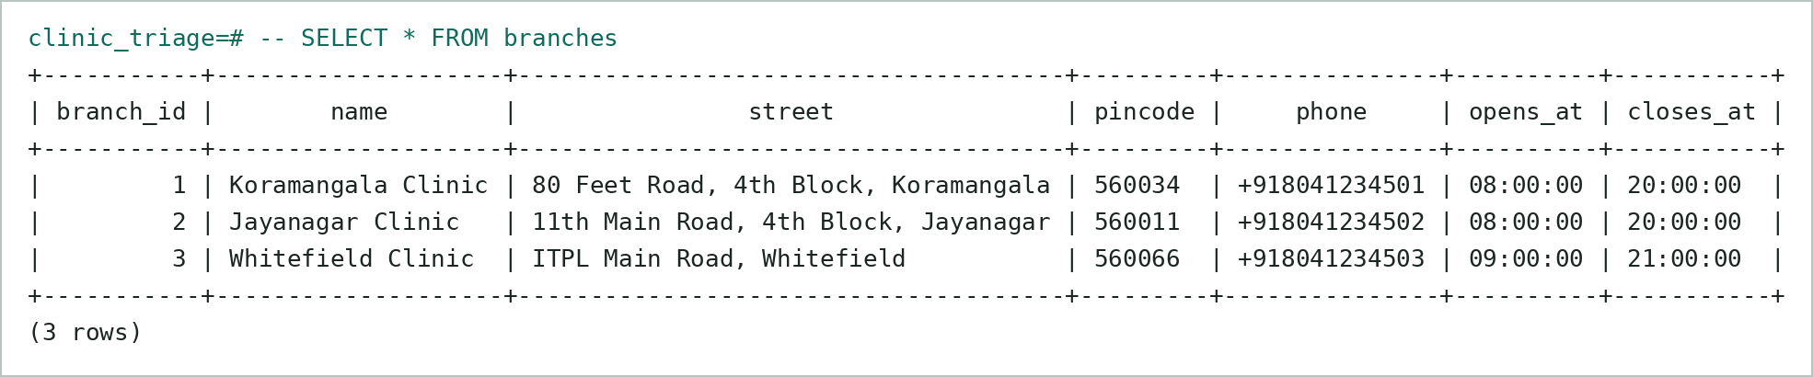
Table: branches
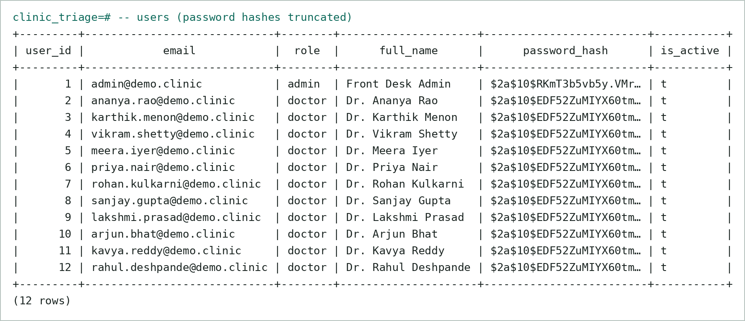
Table: users — passwords stored only as bcrypt hashes
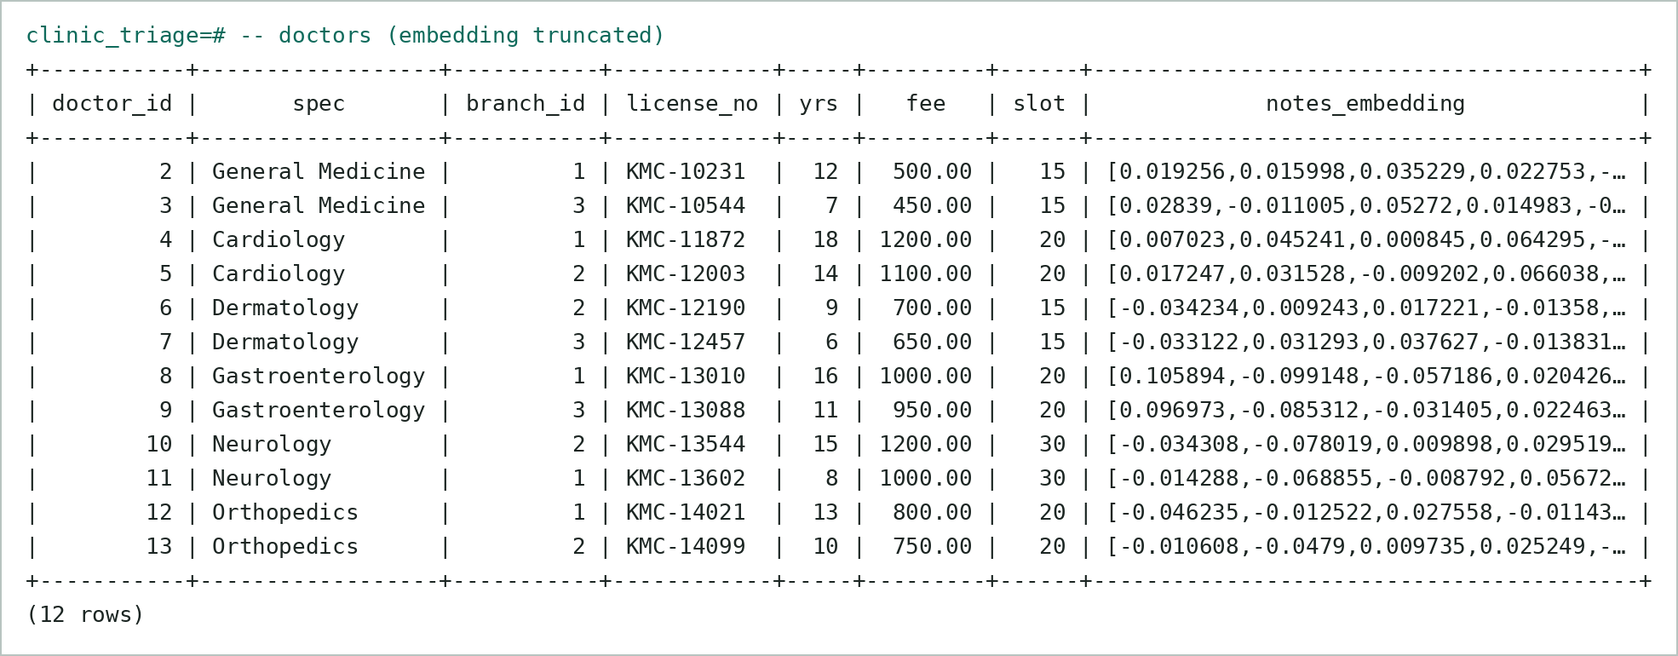
Table: doctors — with 384-d notes_embedding
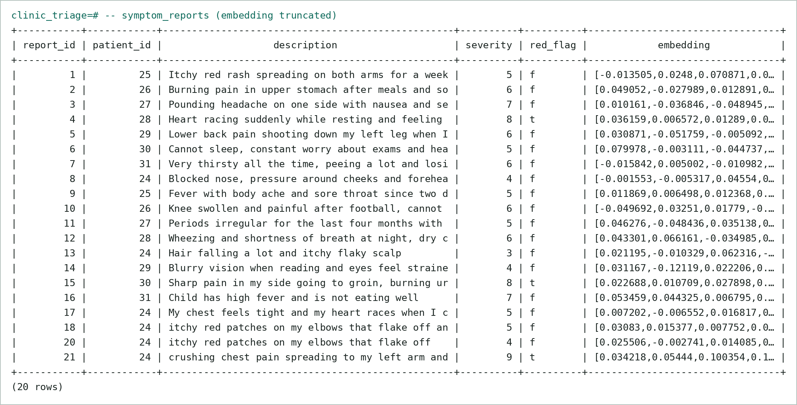
Table: symptom_reports — free text + embedding; red_flag set for urgent text
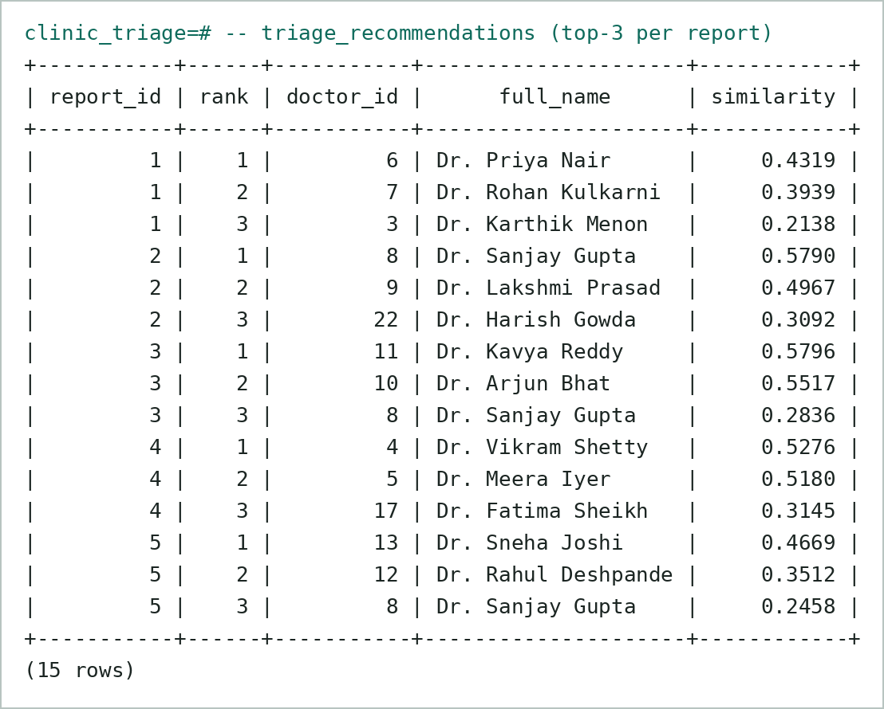
Table: triage_recommendations — top-3 per report with cosine similarity
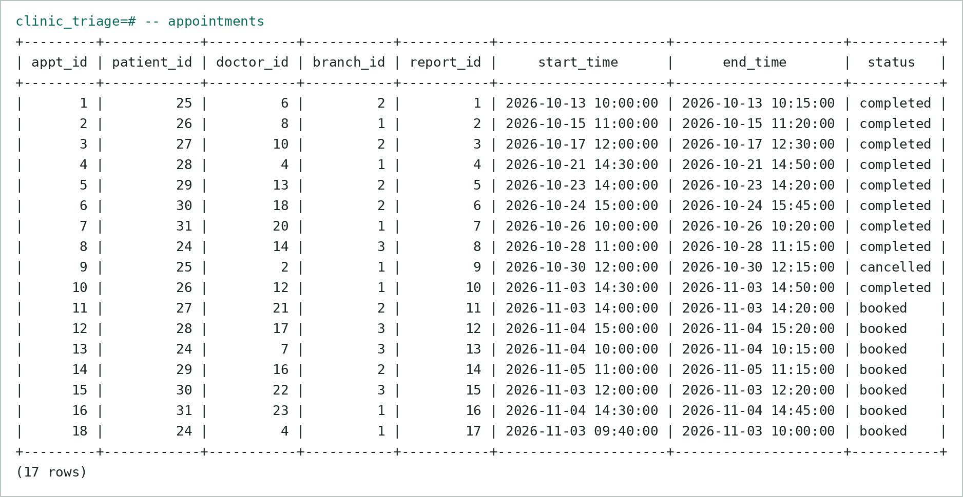
Table: appointments
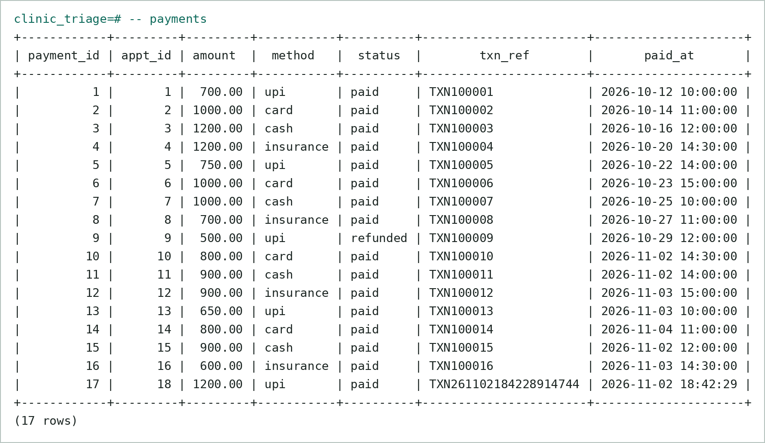
Table: payments — cancelled appointment auto-refunded by trigger
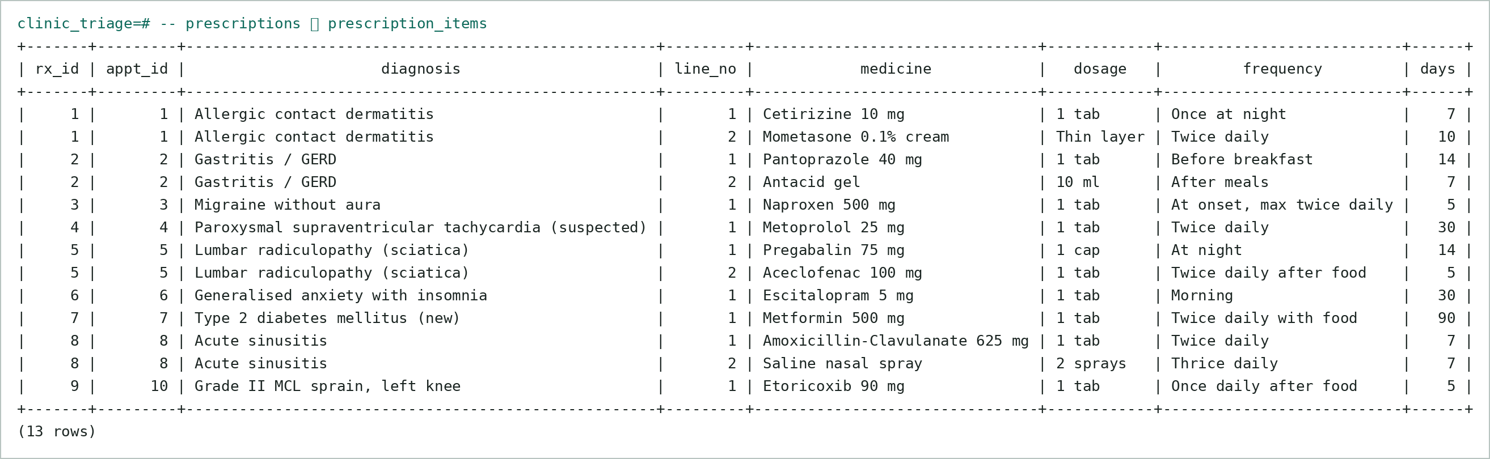
Table: prescriptions ⋈ prescription_items (incl. one written through the UI)
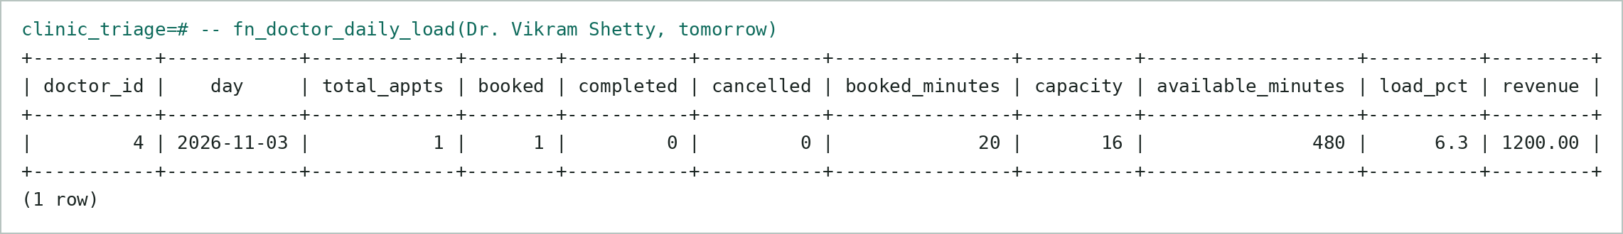
Table: fn_doctor_daily_load() output
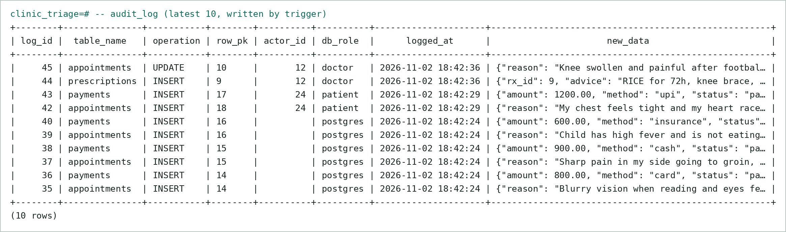
Table: audit_log — rows written by trigger

b) Testing Results
npm run test:db runs 35 automated integration tests against the live database (as the low-privilege application role, switching to each user role) and the running HTTP API. Every database test runs inside a transaction that is rolled back. Result: 35 / 35 passed.
# | Test case | Expected | Actual | Result
T01 | CHECK: invalid e-mail rejected | error: "chk_email_format" | new row for relation "users" violates check constraint "chk_email_format" | PASS
T02 | CHECK: plain-text password rejected (must be bcrypt) | error: "chk_bcrypt_hash" | new row for relation "users" violates check constraint "chk_bcrypt_hash" | PASS
T03 | UNIQUE: duplicate e-mail (case-insensitive) | error: "ux_users_email_lower" | duplicate key value violates unique constraint "ux_users_email_lower" | PASS
T04 | CHECK: severity outside 1..10 | error: "violates check" | new row for relation "symptom_reports" violates check constraint "symptom_reports_severity | PASS
T05 | Trigger/FK: appointment with non-existent doctor | error: "not accepting" | Doctor 9999 is not accepting appointments. | PASS
T06 | FK RESTRICT: delete doctor with appointments | error: "foreign key" | update or delete on table "doctors" violates foreign key constraint "appointments_doctor_i | PASS
T07 | Trigger: valid booking accepted | success | appointment created | PASS
T08 | Trigger: double-booking same doctor slot blocked | error: "double booking" | Double booking blocked: the doctor already has appointment #23 in this slot. | PASS
T09 | Trigger: patient cannot be in two appointments at once | error: "already have appointment" | You already have appointment #25 at this time. | PASS
T10 | Trigger: slot outside working hours | error: "outside the doctor" | Slot 2026-11-09 13:10:00 – 13:25:00 is outside the doctor's working hours. | PASS
T11 | Trigger: booking in the past | error: "past" | Cannot book a slot in the past (2026-11-01 10:00:00). | PASS
T12 | EXCLUDE constraint backstop (trigger disabled) | error: "ex_doctor_no_double_booking" | conflicting key value violates exclusion constraint "ex_doctor_no_double_booking" | PASS
T13 | Trigger: payment amount must equal fee | error: "does not match" | Payment amount 1.00 does not match consultation fee 500.00. | PASS
T14 | Trigger: cancel => payment auto-refunded | success | payment status = refunded | PASS
T15 | Trigger: patient cannot mark own appointment completed | error: "only cancel" | Patients can only cancel appointments. | PASS
T16 | Transaction: failed payment rolls back the appointment | success | appt #34 not persisted; slot still free | PASS
T17 | Procedure: sp_complete_appointment writes Rx + items + status | success | status=completed, items=1 | PASS
T18 | Procedure: another doctor cannot complete it (RLS) | error: "not found or not yours" | Appointment 11 not found or not yours. | PASS
T19 | Function: fn_doctor_daily_load | success | {"total_appts":0,"capacity":16,"load_pct":"0.0"} | PASS
T20 | Recursive CTE: fn_available_slots returns free slots | success | slots=32 | PASS
T21 | Vector: HNSW index used for ORDER BY <=> | success | Index Scan using ix_doctors_notes_hnsw | PASS
T22 | Vector: top-3 of seed reports contain the booked specialty | success | 16/17 reports | PASS
T23 | RLS: patient sees only own appointments | success | visible=3, others=0 | PASS
T24 | RLS: doctor cannot read another doctor's schedule | success | rows of other doctors = 0 | PASS
T25 | GRANT: patient cannot read audit_log | error: "permission denied" | permission denied for table audit_log | PASS
T26 | GRANT: patient cannot read password hashes | error: "permission denied" | permission denied for table users | PASS
T27 | GRANT: doctor cannot change consultation fee | error: "permission denied" | permission denied for table doctors | PASS
T28 | Bare app role has no table access | error: "permission denied" | permission denied for table appointments | PASS
T29 | API: wrong password -> 401 | success | HTTP 401 | PASS
T30 | API: unauthenticated triage -> 401 | success | HTTP 401 | PASS
T31 | API: patient calling admin stats -> 403 | success | HTTP 403 | PASS
T32 | Middleware: doctor opening /admin is redirected | success | 307 -> /doctor | PASS
T33 | API: triage validation (too short) | success | HTTP 400 | PASS
T34 | API: lay-language triage -> Dermatology top-1 | success | Dr. Priya Nair (Dermatology) sim=0.4386; keyword hits=0 | PASS
T35 | API: red-flag text detected | success | red_flag=true, top-1=Cardiology | PASS

c) Triage Quality
For the 16 seeded symptom reports (written in lay language), the specialty that the patient was actually booked with appeared in the AI’s top-3 for 15/16 reports, and at rank 1 for 15/16. The single miss (“cannot sleep, constant worry about exams and heart pounding”) ranked Cardiology first because of the phrase “heart pounding” — an inherently ambiguous case where Psychiatry was still surfaced by the similar-cases panel. Full-text keyword search returned no doctor for most of the same sentences, confirming the need for the vector store.

9. Next.js Project Tree Structure
clinic-triage/
├── app/
│ ├── admin/
│ │ ├── appointments/
│ │ │ └── page.js
│ │ ├── audit/
│ │ │ └── page.js
│ │ ├── doctors/
│ │ │ └── page.js
│ │ ├── layout.js
│ │ └── page.js
│ ├── api/
│ │ ├── admin/
│ │ │ ├── audit/
│ │ │ │ └── route.js
│ │ │ ├── branches/
│ │ │ │ ├── [id]/
│ │ │ │ │ └── route.js
│ │ │ │ └── route.js
│ │ │ ├── demand/
│ │ │ │ └── route.js
│ │ │ ├── doctors/
│ │ │ │ ├── [id]/
│ │ │ │ │ └── route.js
│ │ │ │ └── route.js
│ │ │ └── stats/
│ │ │ └── route.js
│ │ ├── appointments/
│ │ │ ├── [id]/
│ │ │ │ └── route.js
│ │ │ └── route.js
│ │ ├── auth/
│ │ │ ├── login/
│ │ │ │ └── route.js
│ │ │ ├── logout/
│ │ │ │ └── route.js
│ │ │ ├── me/
│ │ │ │ └── route.js
│ │ │ └── register/
│ │ │ └── route.js
│ │ ├── branches/
│ │ │ └── route.js
│ │ ├── doctor/
│ │ │ ├── complete/
│ │ │ │ └── route.js
│ │ │ ├── profile/
│ │ │ │ └── route.js
│ │ │ └── schedule/
│ │ │ └── route.js
│ │ ├── doctors/
│ │ │ └── [id]/
│ │ │ └── slots/
│ │ │ └── route.js
│ │ └── triage/
│ │ └── route.js
│ ├── doctor/
│ │ ├── profile/
│ │ │ └── page.js
│ │ ├── layout.js
│ │ └── page.js
│ ├── login/
│ │ └── page.js
│ ├── patient/
│ │ ├── appointments/
│ │ │ └── page.js
│ │ ├── layout.js
│ │ └── page.js
│ ├── register/
│ │ └── page.js
│ ├── globals.css
│ ├── layout.js
│ └── page.js
├── components/
│ └── Shell.js
├── db/
│ ├── 01_schema.sql
│ ├── 02_functions_triggers.sql
│ ├── 03_views.sql
│ ├── 04_security.sql
│ ├── 05_dml_queries.sql
│ └── 06_vector_commands.sql
├── docs/
│ ├── diagrams/
│ │ ├── er.dot
│ │ ├── er_diagram.png
│ │ ├── schema.dot
│ │ └── schema_diagram.png
│ └── project_tree.txt
├── lib/
│ ├── api.mjs
│ ├── auth.mjs
│ ├── client.js
│ ├── db.mjs
│ ├── embed.mjs
│ └── validators.mjs
├── scripts/
│ ├── seed-data.mjs
│ ├── setup-db.mjs
│ └── test-db.mjs
├── .env.example
├── .gitignore
├── README.md
├── jsconfig.json
├── middleware.js
├── next.config.mjs
├── package-lock.json
└── package.json

10. Sample Screenshots of Application Code and Demo

a) Application code
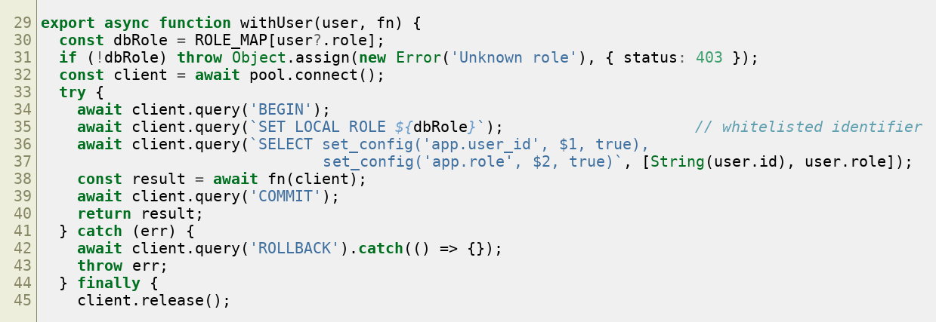
lib/db.mjs — every request runs in a transaction as its database role (RLS context)
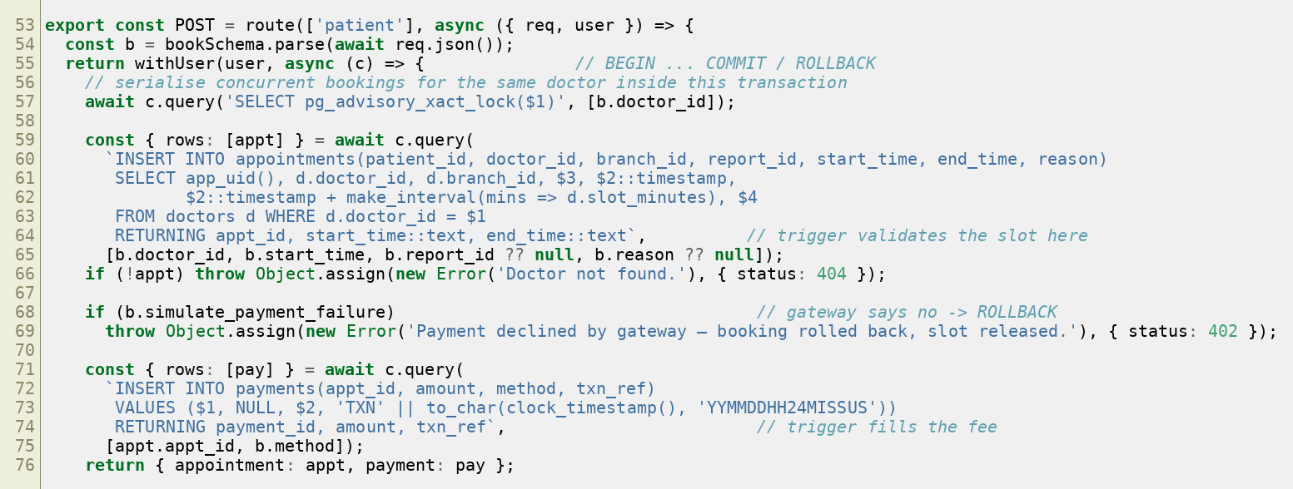
app/api/appointments/route.js — booking + payment as one transaction
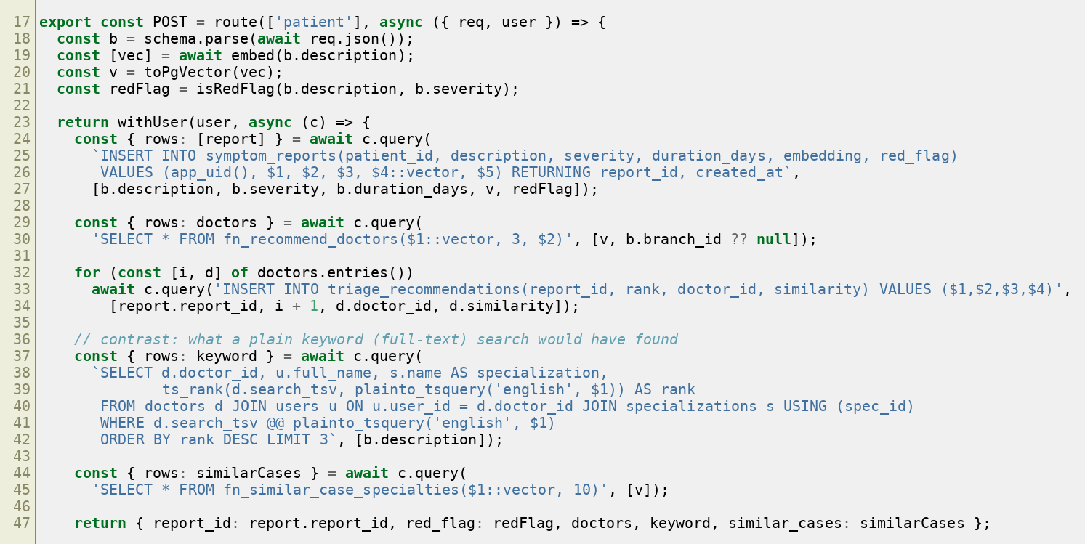
app/api/triage/route.js — embed → store → vector search → recommendations
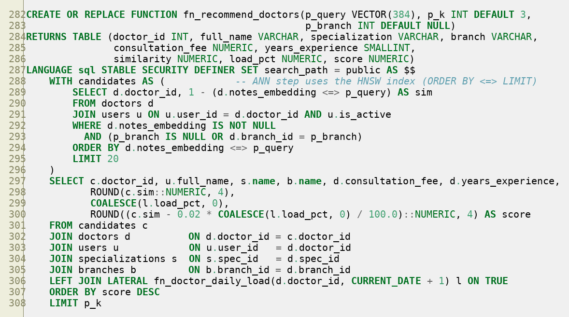
fn_recommend_doctors — pgvector cosine k-NN + load-aware re-rank
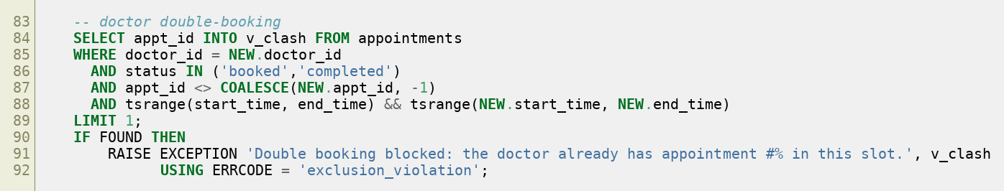
trg_fn_validate_appointment — double-booking checks

b) Demo
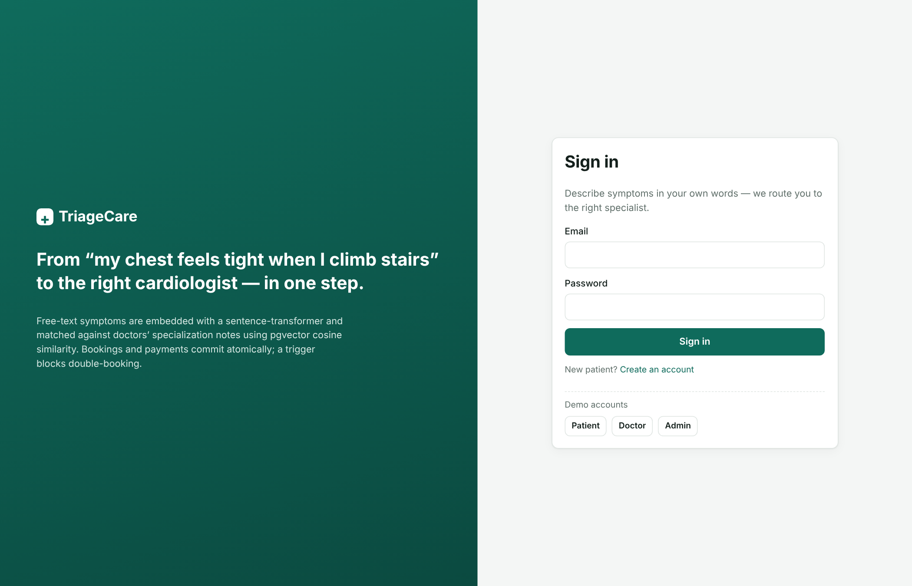
Screenshot – Login page with demo-account quick fill
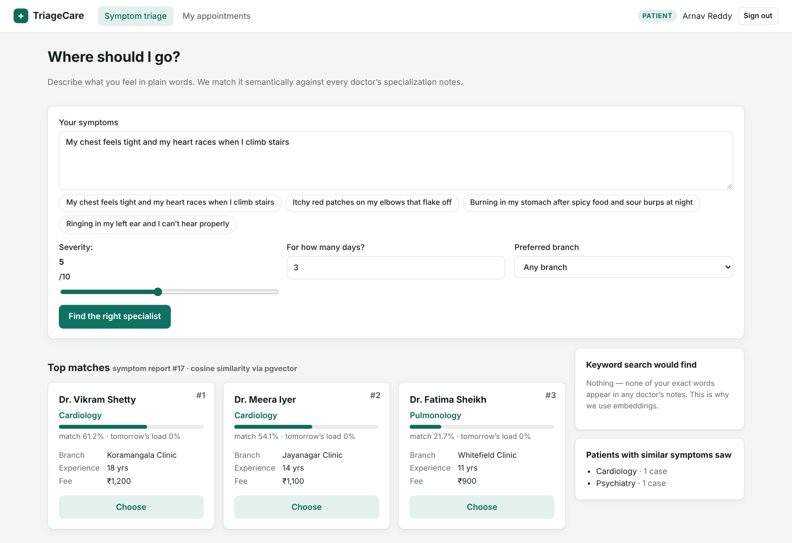
Screenshot – Patient: free-text symptoms → top-3 doctors (two cardiologists); keyword search finds nothing
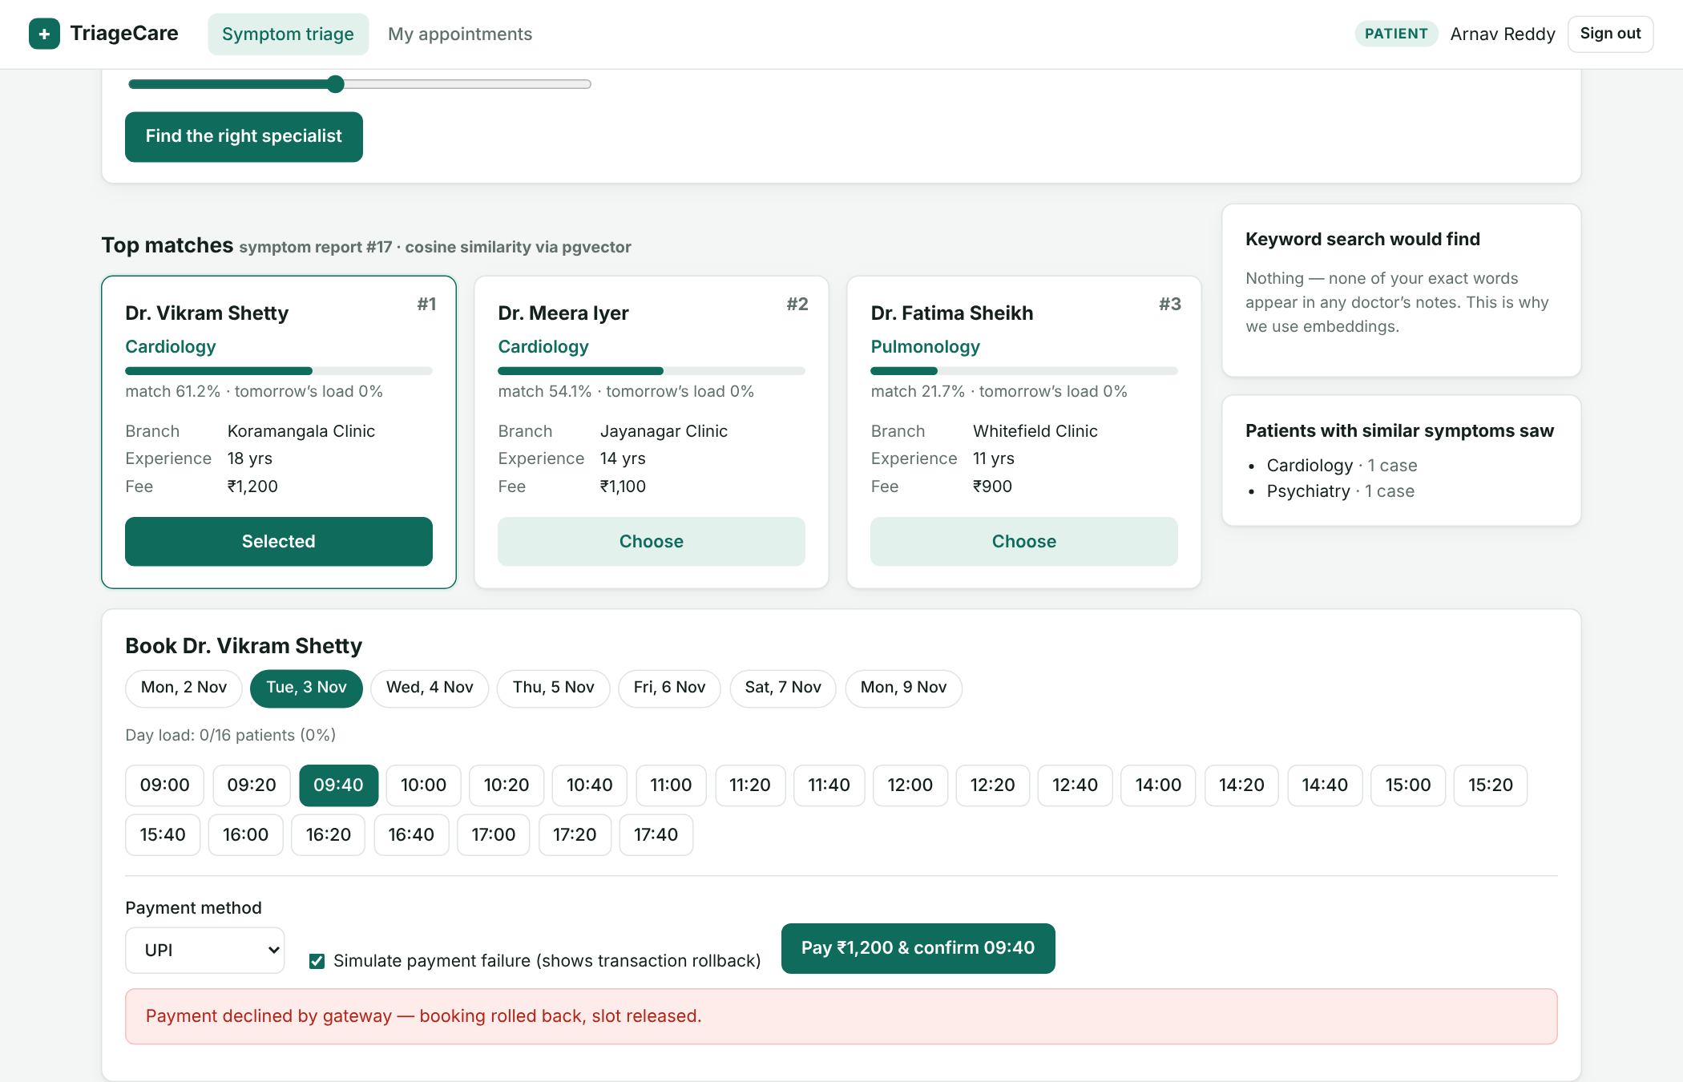
Screenshot – Simulated payment failure → transaction rolled back, slot released
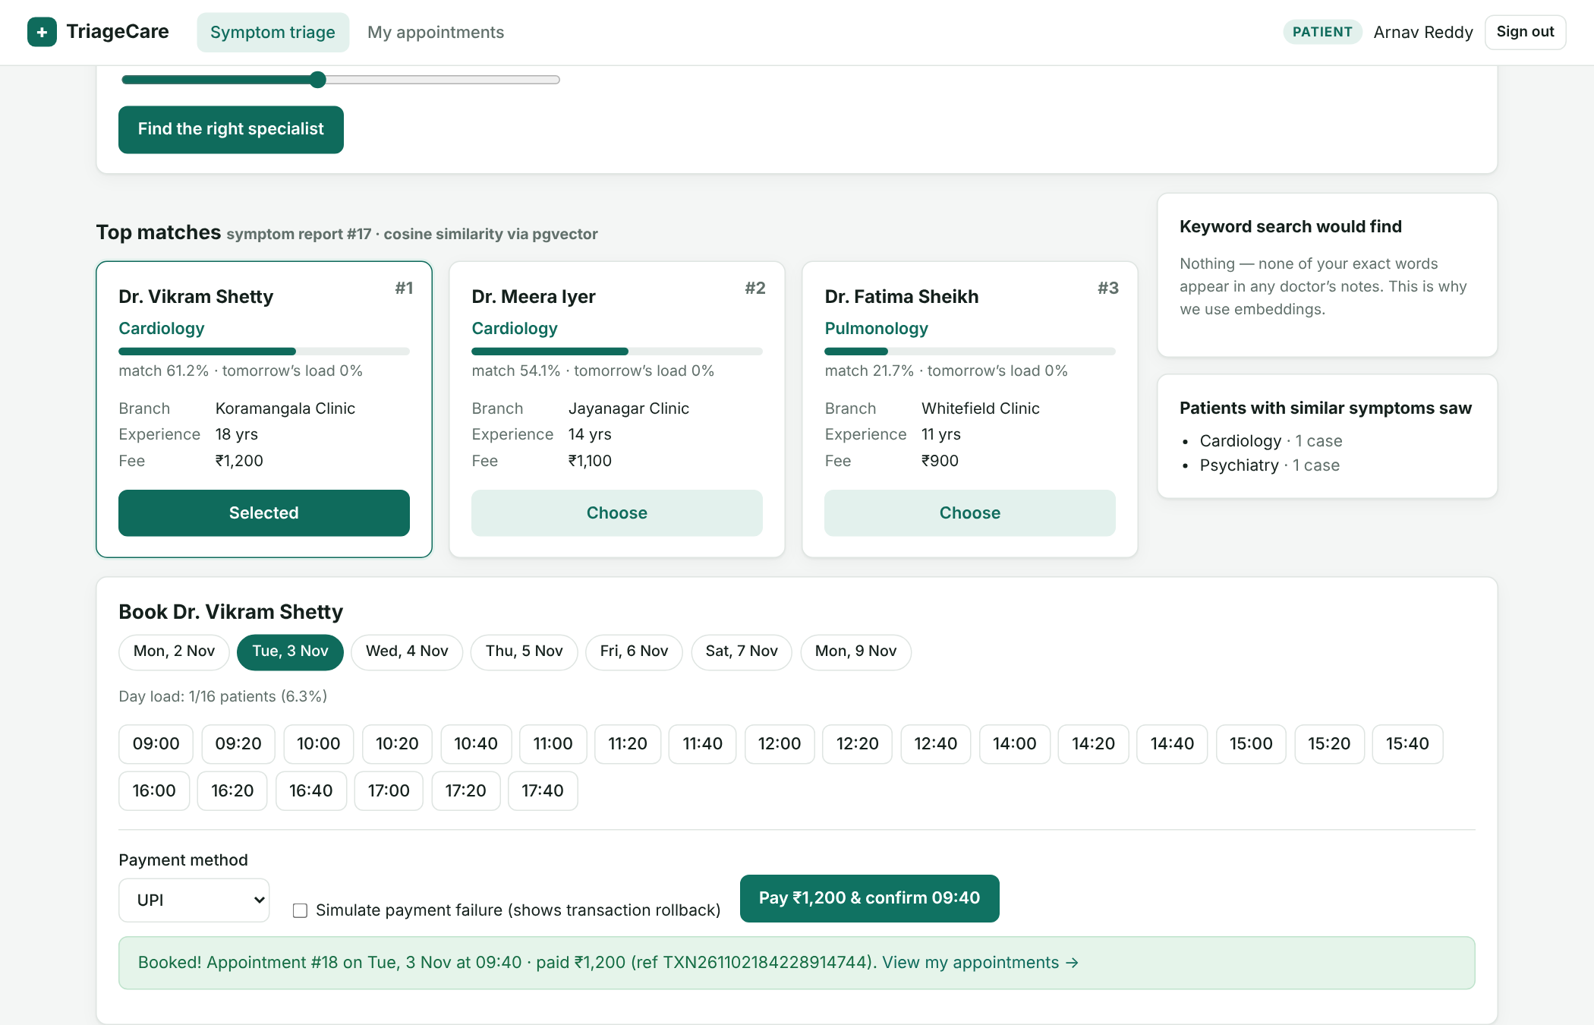
Screenshot – Successful booking: appointment + payment committed together
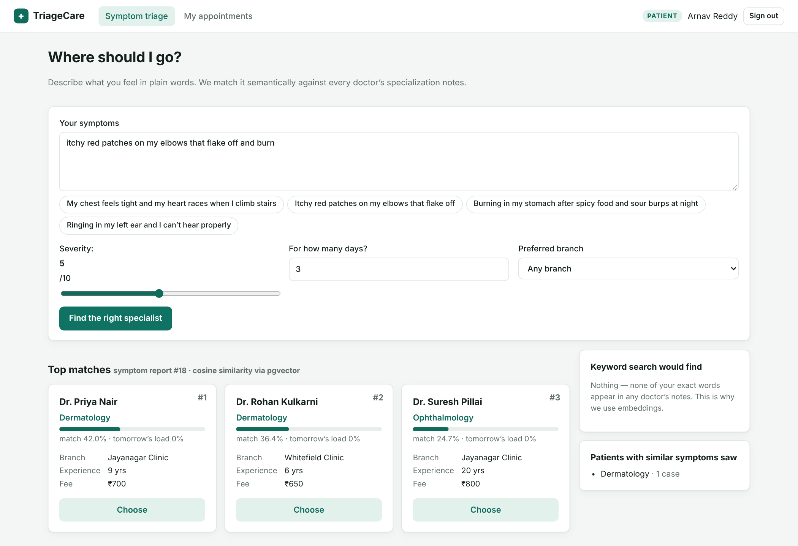
Screenshot – Lay description of a skin problem routed to dermatologists
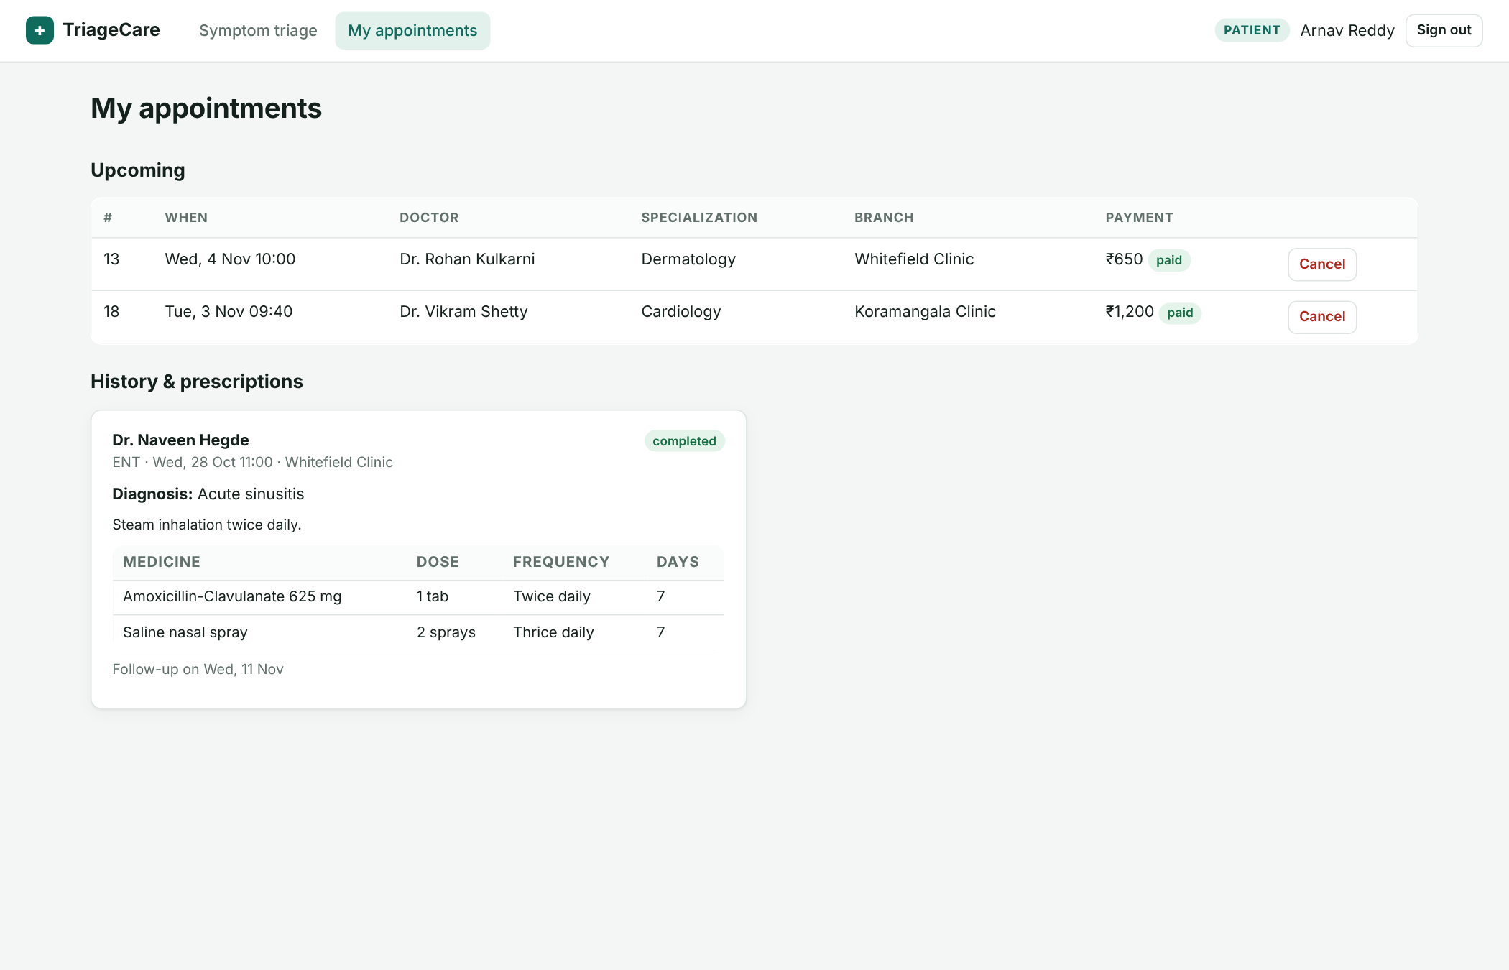
Screenshot – Patient: upcoming appointments (cancel) and history with prescriptions
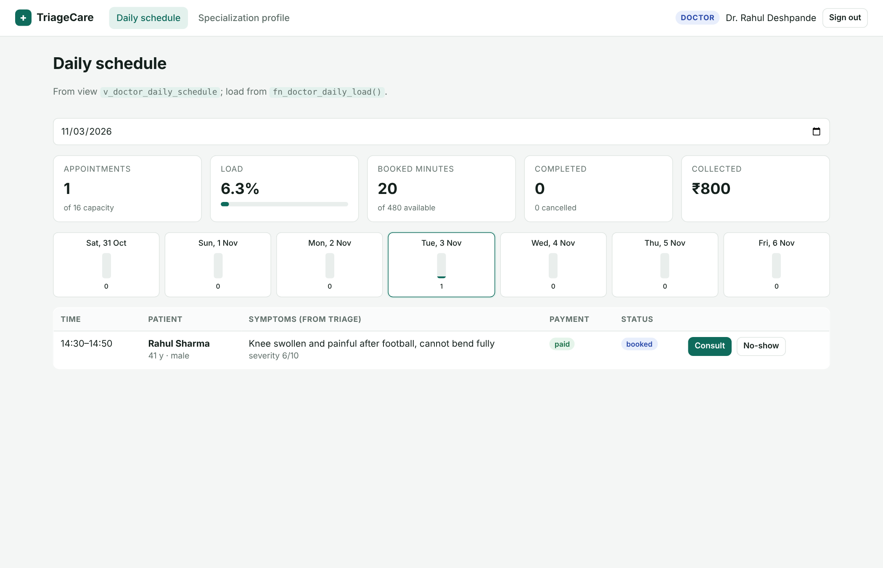
Screenshot – Doctor: daily schedule from v_doctor_daily_schedule + load from fn_doctor_daily_load
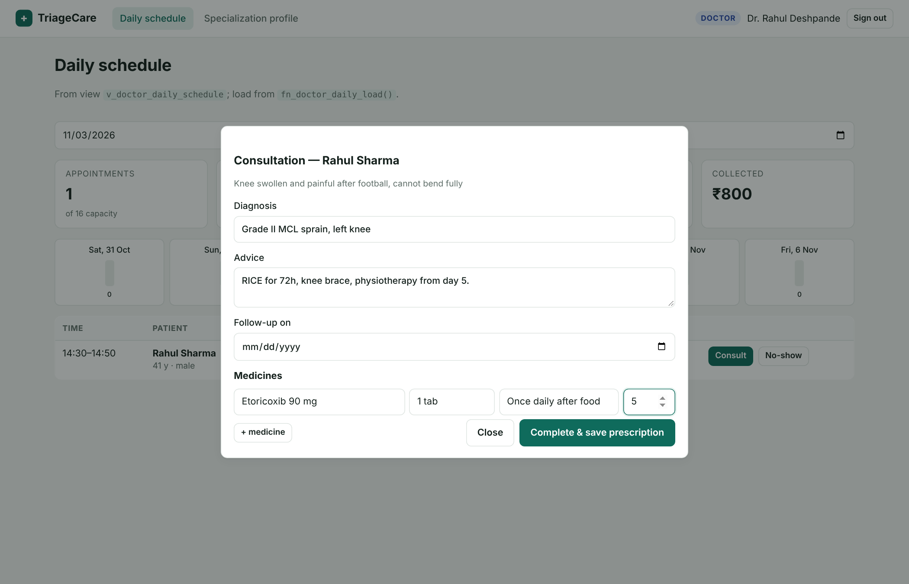
Screenshot – Doctor: consultation and prescription form
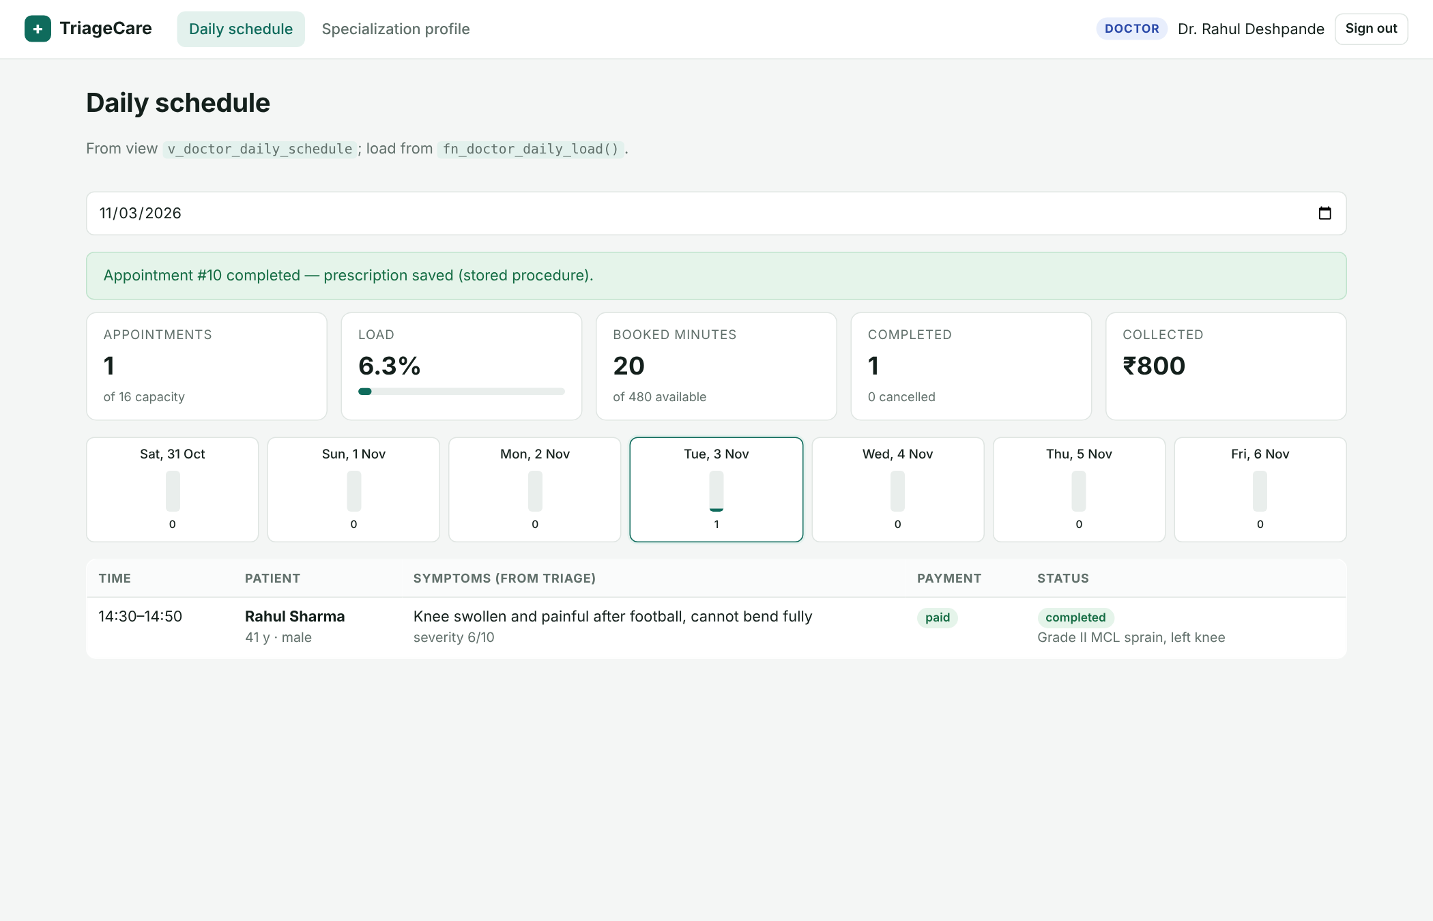
Screenshot – After sp_complete_appointment: status completed, diagnosis shown
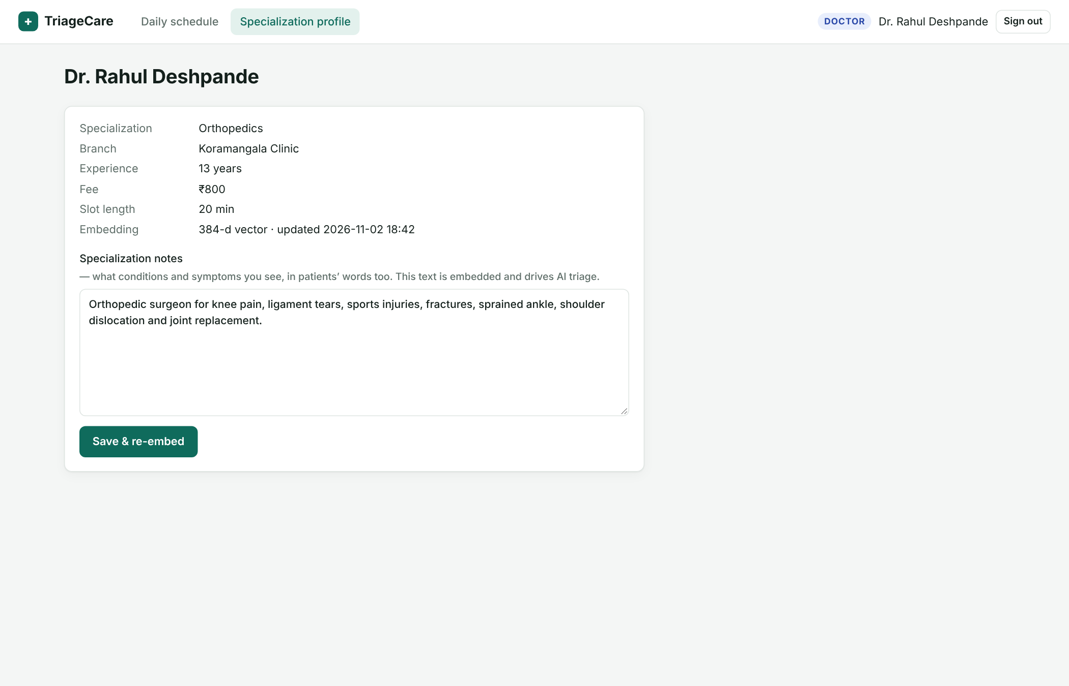
Screenshot – Doctor: editing specialisation notes re-computes the embedding
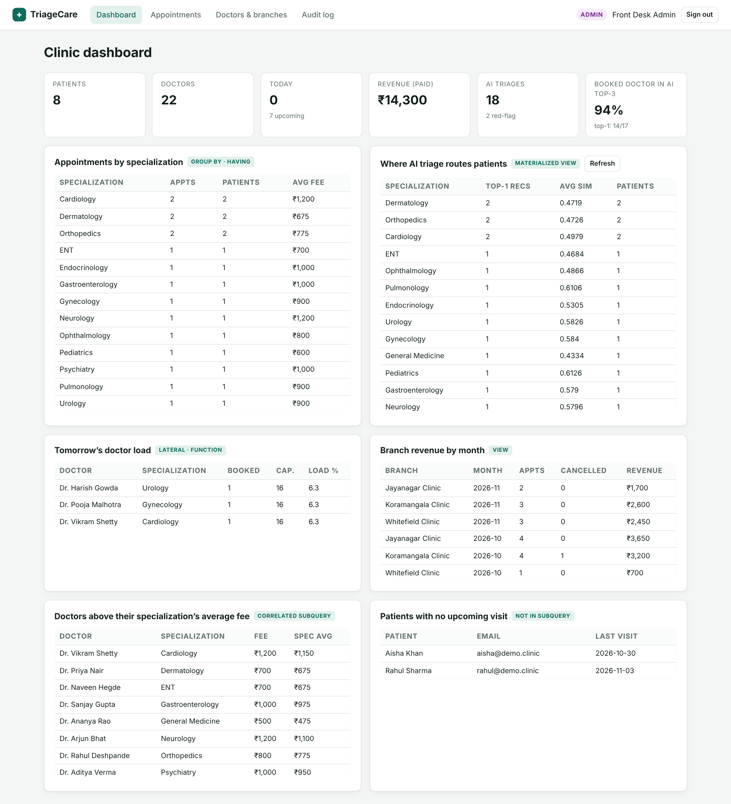
Screenshot – Admin dashboard: GROUP BY/HAVING, materialized view, LATERAL function, view, correlated and nested subqueries
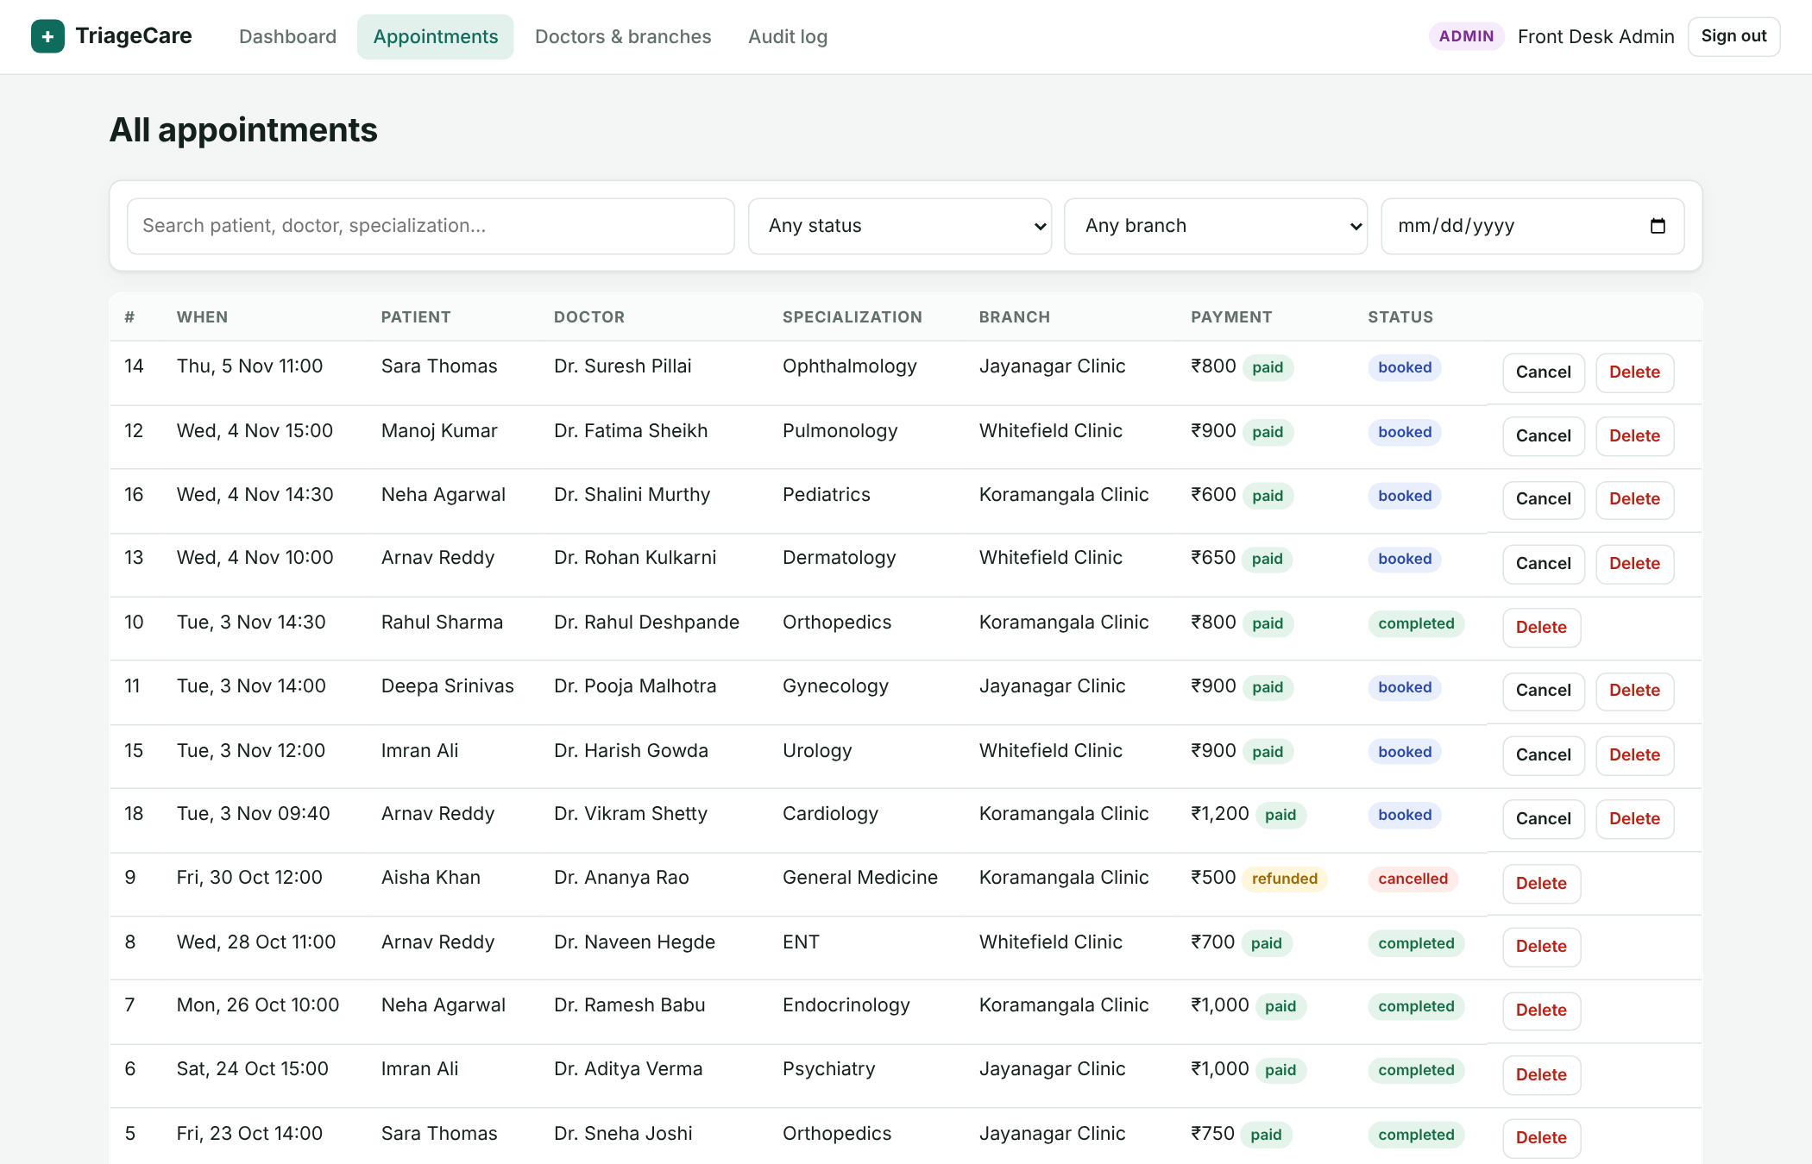
Screenshot – Admin: appointment search and filters
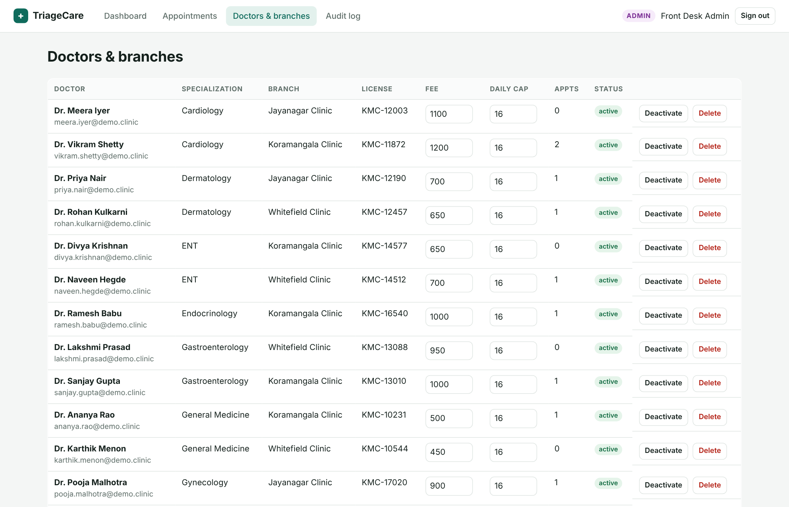
Screenshot – Admin: doctors and branches management
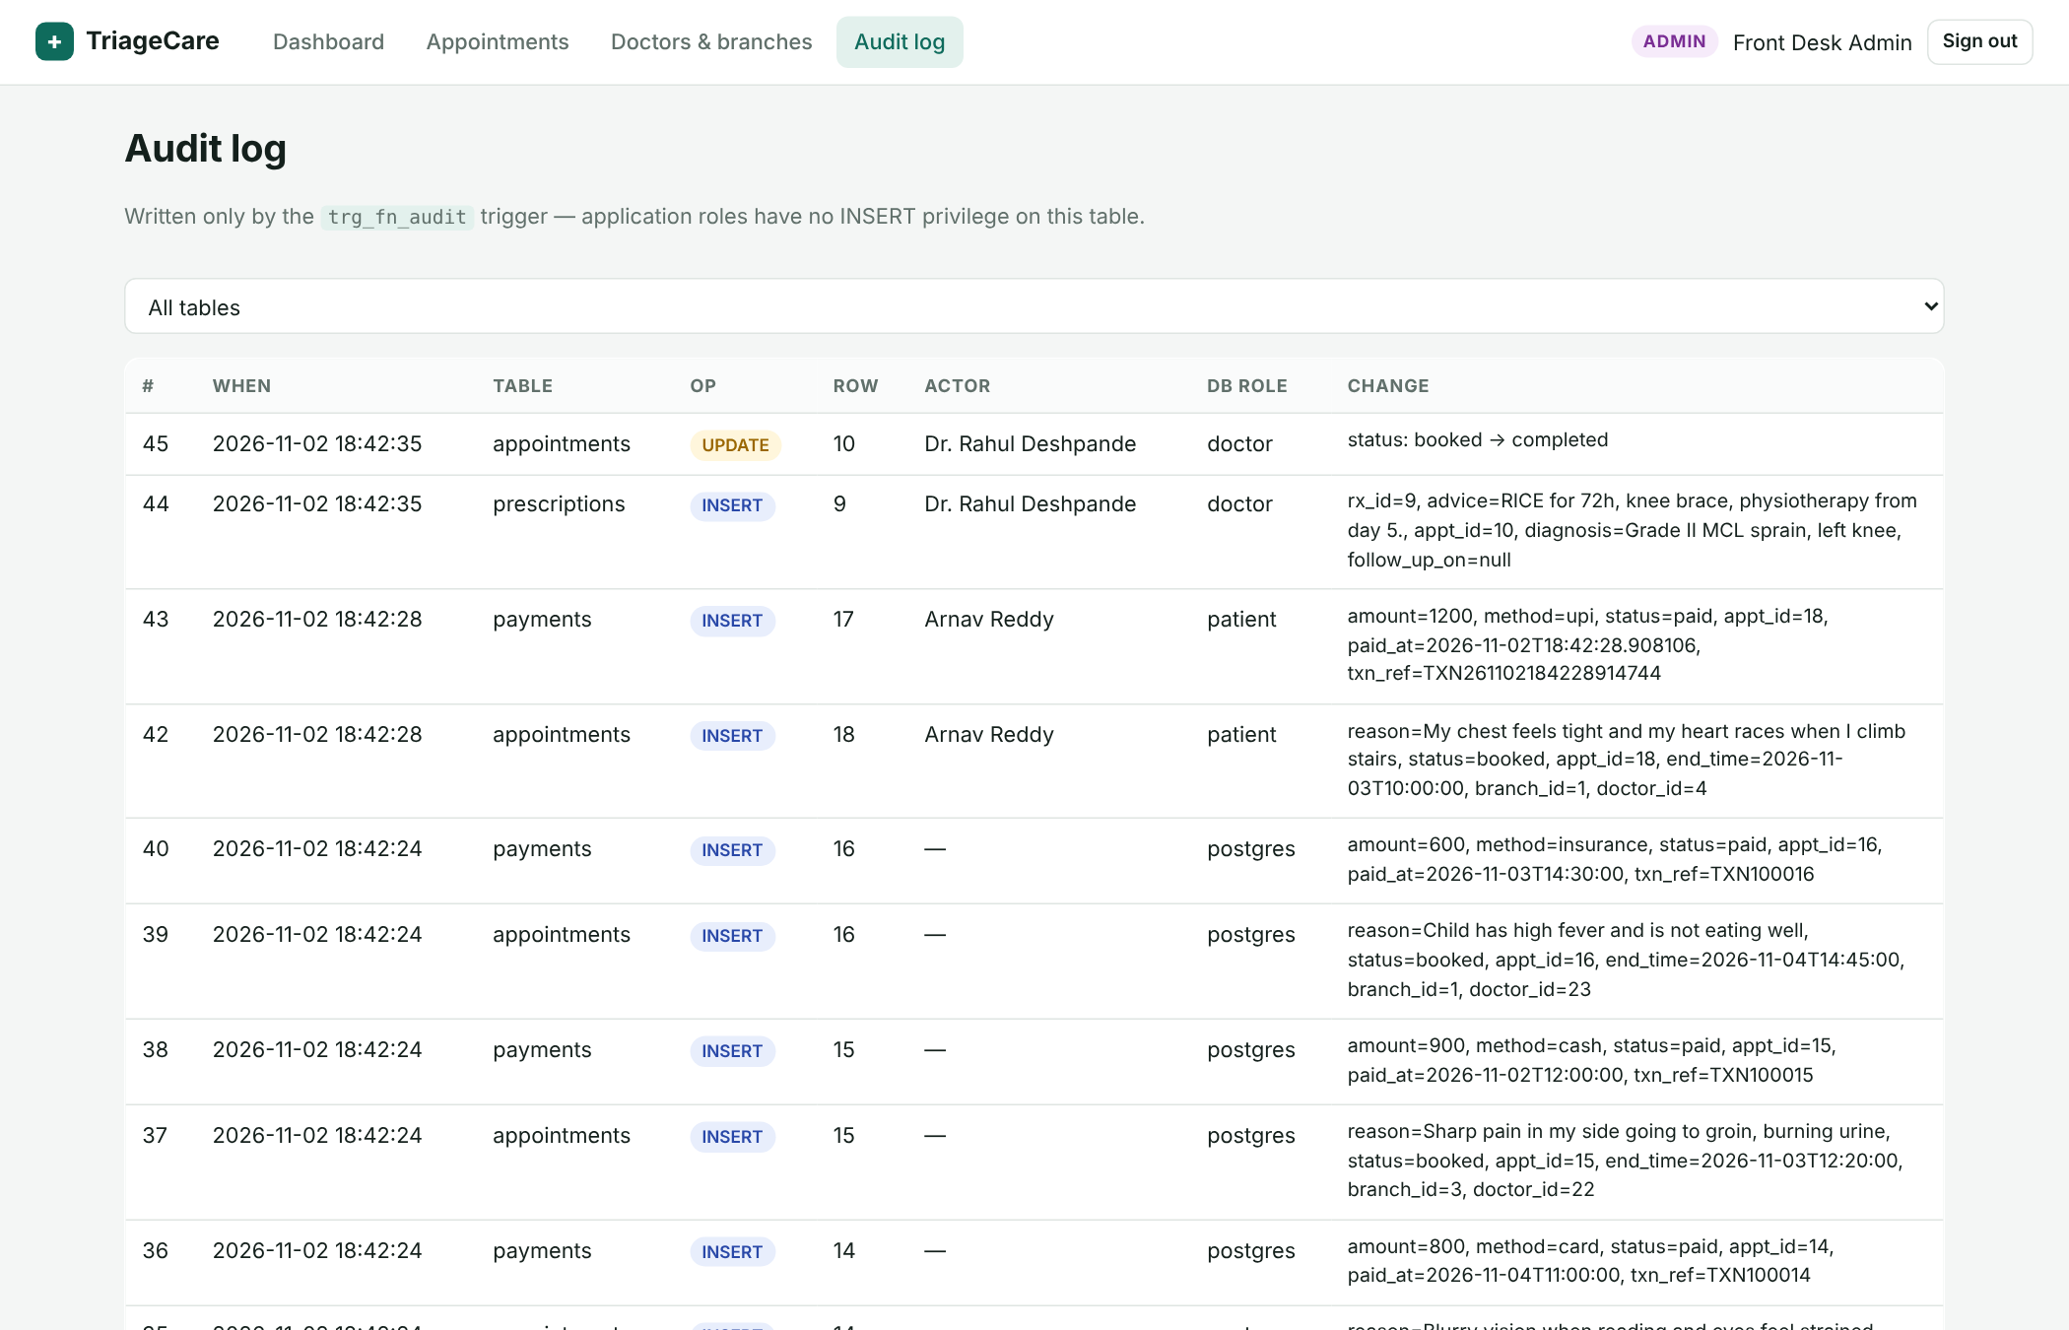
Screenshot – Admin: audit log written by triggers
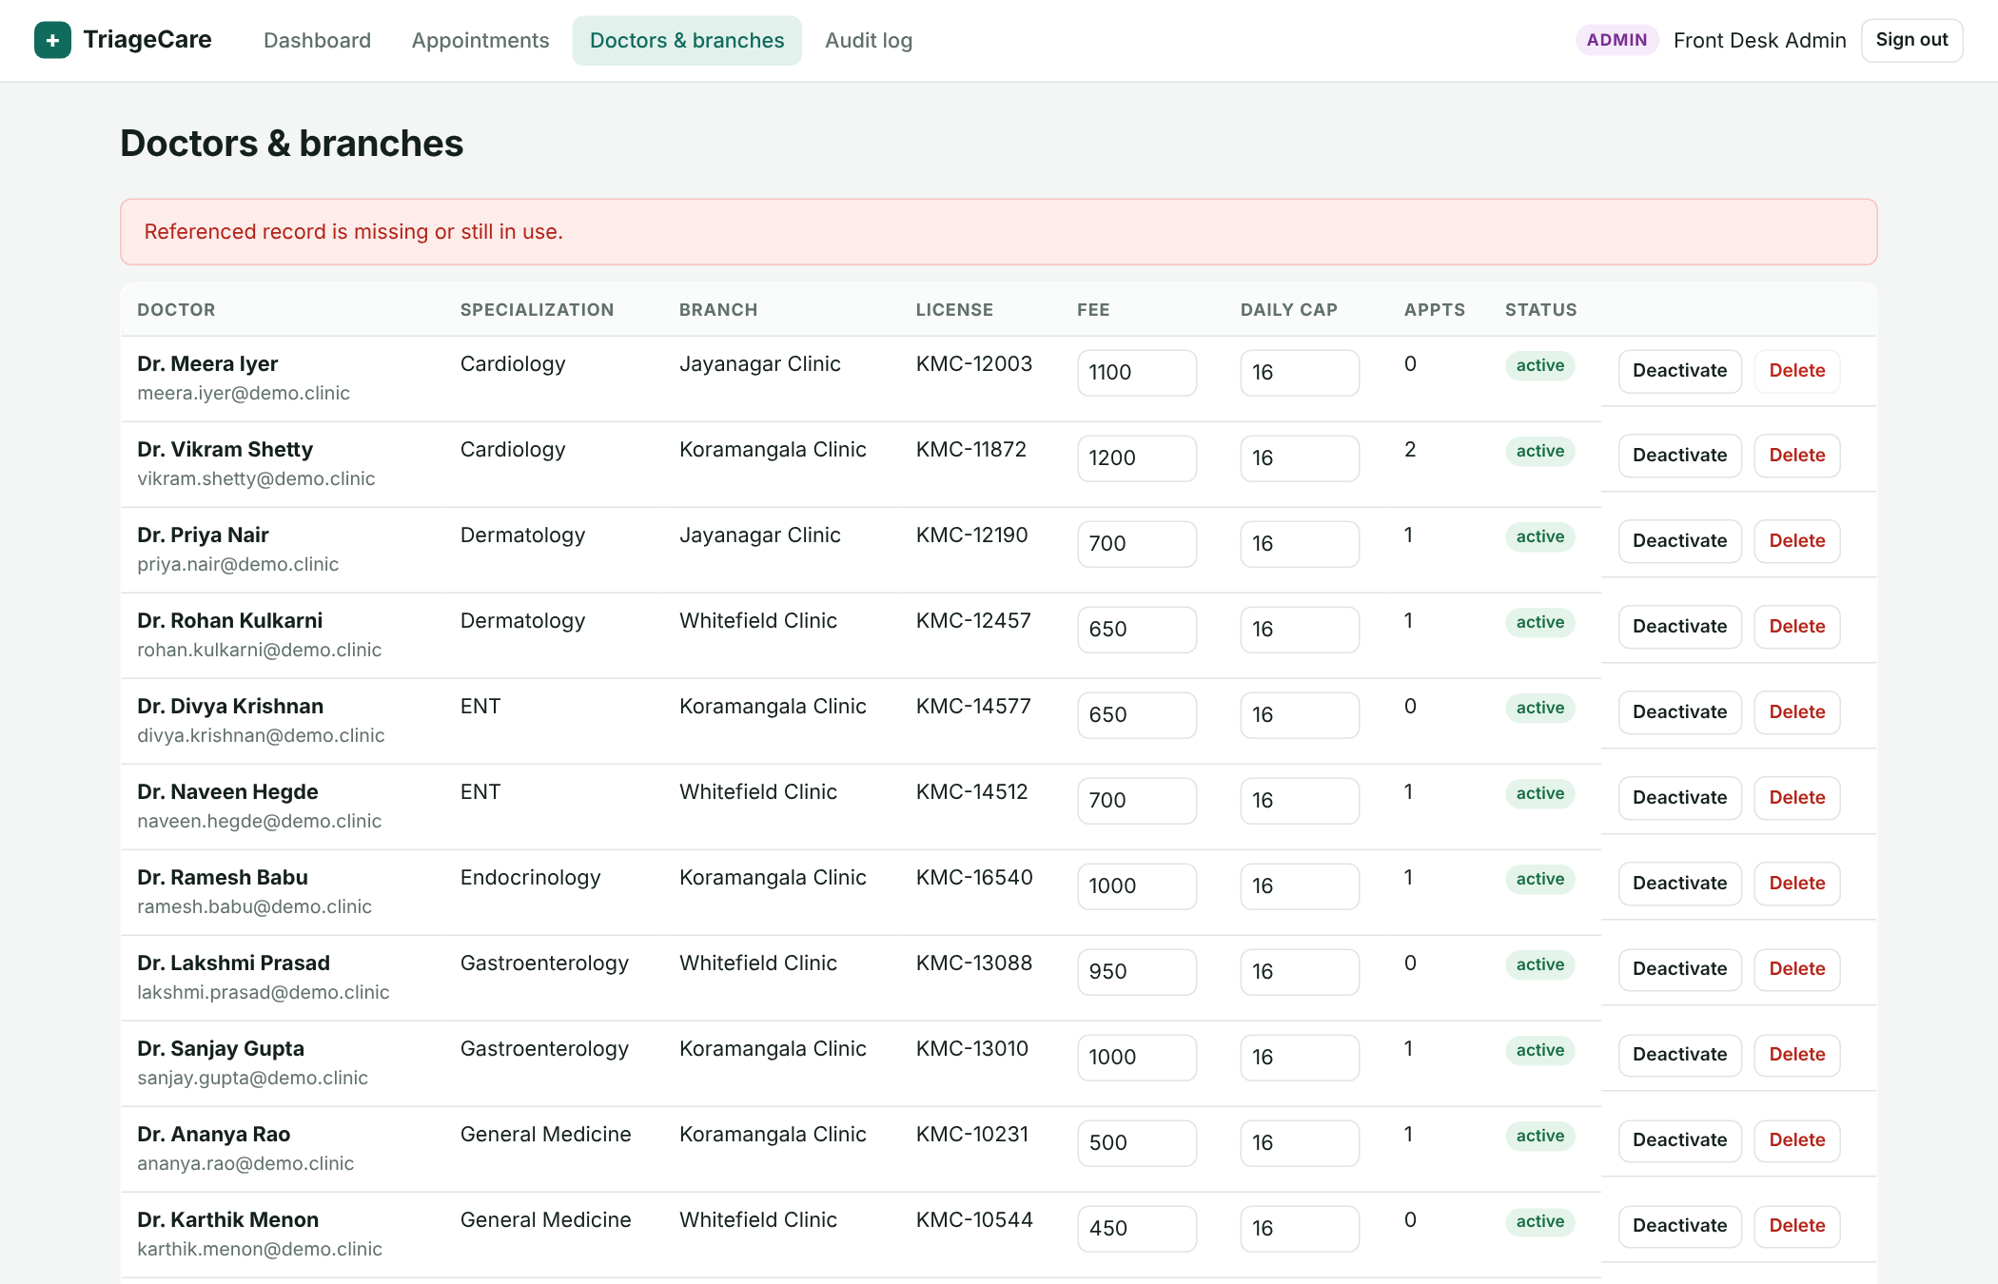
Screenshot – Deleting a doctor who has appointments is blocked by ON DELETE RESTRICT

11. Conclusion and Future Enhancements
TriageCare shows that the choice of database paradigms can follow directly from the shape of the data: strongly structured, integrity-critical clinic data is relational, while open-vocabulary symptom text is best handled as embeddings. Keeping both in PostgreSQL with pgvector lets the core feature — symptom-to-specialist matching — run as a single SQL function that joins vector similarity with relational filters and doctor load, and lets the resulting booking be protected by the same transactions, triggers and constraints as the rest of the system. Business rules (no double booking, working hours, capacity, fee consistency, refunds, prescription ownership) and access control (roles, GRANTs, RLS) are enforced inside the database, so they hold even if the application layer is bypassed.
Future enhancements:
- Hybrid retrieval: combine BM25 full-text rank and vector similarity (reciprocal-rank fusion) and fine-tune on clinic triage history.
- Multilingual embeddings so patients can describe symptoms in Kannada or Hindi.
- Real payment-gateway integration with idempotent webhooks; SMS/e-mail reminders.
- Waiting-list and automatic rebooking when a slot is cancelled; doctor leave calendar.
- Table partitioning of appointments/audit_log by month and read replicas for analytics.

12. Evaluation Rubrics – Completion Status
# | Criteria | Distribution | Status
1 | Database Design | ER diagram , relational schema with keys, relationships, and constraints | Completed (§3, §4)
2 | Database Creation | SQL database implementation - DDL with constraints , NoSQL/Vector database creation , Technology justification | Completed (§2e, §5, §7)
3 | SQL Operations and Queries | DML operations , Nested/correlated/Recursive SQL queries, Join SQL queries | Completed (§6)
4 | Advanced Database Concepts | Advanced database concepts (Procedure/function, trigger, CTE) , NoSQL/Vector feature RUD | Completed (§5, §7)
5 | Web Application and Database Integration | Next.js interface , Backend/API and database integration | Completed (§9, §10)
6 | Authentication and Authorization | Authentication implementation (front end and backend) and minimum two roles and role-based access control in database | Completed (§2, §5.4, §8b)
7 | Documentation, Git/GitHub, Demonstration, Testing, and Originality | Documentation, Git/GitHub , Originality and individual contribution | Completed (§8b, README, Git)

Individual Contribution
Member | SRN | Contribution
Vasu | PES1UG24AM918 | Database: ER model, relational schema and DDL (tables, keys, CHECK/EXCLUDE constraints, indexes), appointment-validation/payment/refund triggers, booking + payment transaction, pgvector embeddings, HNSW indexes and fn_recommend_doctors. Application: embedding pipeline, patient triage and booking pages with their API routes, seed data.
Name 2 | SRN 2 | Database: views and materialized view, fn_doctor_daily_load, recursive-CTE slot function, sp_complete_appointment, audit trigger, roles/GRANTs and Row-Level Security, analytical queries. Application: authentication (bcrypt, JWT, middleware), doctor and admin pages with their API routes, automated test suite, report and README.

