BAG HEAVEN



A

Human Computer Interface Course Project Report

in partial fulfilment of the degree

**Bachelor of Technology**

in

**Computer Science & Engineering**

**CH.VASU** 2303A51618

G.ADITHYA 2303A51596  
P.RAKESH 2303A51742

Under the guidance of

FAIZA IRAM

Assistant professor

**Submitted to**

**School of Computer Science and Artificial Intelligence**





**DEPARTMENT OF COMPUTER SCIENCE & ENGINEERING**

**CERTIFICATE**

This is to certify that the **Human Computer Interface** Report entitled **“TREND CART”** is a record of bonafide work carried out by the student CH.VASU,G.ADITHYA,P.RAKESHbearing Roll No(s) .2303A51618, 2303A51596,2303A51742 during the academic year 2024-25 in partial fulfillment of the award of the degree of ***Bachelor of Technology* in School of** **Computer Science & Artificial Intelligence** by the SR University, Ananthasagar, Hanamkonda.

**Head of the Department**

**Mrs.Faiza Iram Dr. M.Sheshikala**

Asst.Professor Dept of CSE, Assoc.Prof & HOD(CSE),

SR University, SR University,

Ananthasagar, Warangal. Ananthasagar, Warangal.

**ACKNOWLEDGMENT**

We owe an enormous debt of gratitude to our project guide Mrs.Faiza Iram, Assistant Professor as well as Head of the CSE Department Dr. M. Sheshikala, Associate Professor for guiding us from the beginning through the end of the Project with their intellectual advises and insightful suggestions. We truly value their consistent feedback on our progress, which was always constructive and encouraging and ultimately drove us to the right direction.

We wish to take this opportunity to express our sincere gratitude and deep sense of respect to our beloved Vice Chancellor, Prof. Deepak Garg, for his continuous support and guidance to complete this project in the institute.

Finally, we express our thanks to all the teaching and non-teaching staff of the department for their suggestions and timely support.

**CONTENTS**

**TOPIC PAGE NO**

**Abstract 5**

**Objective 6**

**Elements used in the project 7-8**

**Screens 8-11**

**Implementation 11-14**

**Result Design 14-16**

**Conclusion 17**

**ABSTRACT**

Crispy crafts is an e-commerce website designed using HTML, CSS, and JavaScript to provide a seamless shopping experience for fashion enthusiasts. Featuring responsive designs, it offers a wide variety of fashion designs, and sportswear, kidswear, etc. The website emphasizes intuitive navigation, user-friendly functionality, and visually appealing design. TREND CART demonstrates the effective integration of core web technologies to deliver a scalable, accessible, and engaging E-COMMERCE platform.

**OBJECTIVES**

1)To develop a user-friendly e-commerce platform for showcasing and selling a variety of fashion trends.

2)To implement a responsive design ensuring accessibility across desktops, tablets, and smartphones.

3)To provide intuitive navigation for seamless product browsing and selection.

4)To utilize HTML, CSS, and JavaScript for a visually appealing and interactive interface.

5)To create a scalable, efficient, and modern website meeting the needs of both users and business owners.

**Elements Used in the Project**

**Document Structure**

<html>: The root element of an HTML document.

<head>: Contains metadata about the HTML document, such as title, links, and scripts.

<title>: Specifies the title of the webpage, displayed in the browser tab.

<body>: Contains the main content of the HTML document.

**Text Content**

<h1> to <h6>: Headings, with <h1> being the largest and <h6> the smallest.

<p>: Defines a paragraph.

<br>: Inserts a line break.

<hr>: Inserts a horizontal line for thematic breaks.

**Links and Media**

<a>: Defines a hyperlink.

<img>: Embeds an image.

**Forms**

<button>: Defines a clickable button.

<label>: Labels an input element.

<select>: Creates a drop-down list.

<option>: Defines options in a drop-down list.

**Semantics**

<header>: Represents the header section of a document.

<footer>: Represents the footer section of a document.

<nav>: Defines navigation links.

<section>: Groups related content.

**Scripts**

<script>: Embeds or links a JavaScript file.

<link>: Links an external resource (e.g., CSS files).

<style>: Embeds internal CSS styles.

**CSS Tags**

CSS is used for styling the HTML elements.

**Selectors**

*: Universal selector (selects all elements).

element: Selects all <element> tags.

.classname: Selects all elements with a specific class.

#idname: Selects a specific element with an ID.

**Properties**

**Text**

color: Changes text color.

font-size: Sets the size of the text.

text-align: Aligns text (e.g., left, center, right).

font-family: Sets the font.

line-height: Adjusts the space between lines.

**Box Model**

margin: Sets the space outside an element.

padding: Sets the space inside an element.

border: Adds a border around an element.

**Background**

background-color: Sets the background color.

background-image: Adds a background image.

**Positioning**

position: Specifies the position of an element (e.g., static, relative, absolute, fixed).

top, right, bottom, left: Positions an element relative to its container.

**Display**

display: Sets the display behavior (e.g., block, inline, flex, grid).

visibility: Toggles visibility (visible, hidden).

**Flexbox**

display: flex;: Enables flex layout.

justify-content: Aligns items horizontally.

align-items: Aligns items vertically.

**SCREEN**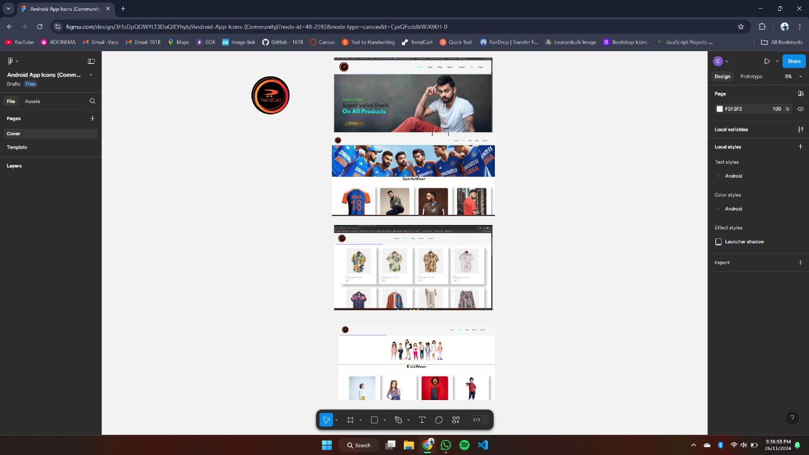

**CODE**

<!DOCTYPE html>

<html lang="en">

<head>

<meta charset="UTF-8">

<meta http-equiv="X-UA-Compatible" content="IE=edge">

<meta name="viewport" content="width=device-width, initial-scale=1.0">

<title>TrendCart</title>

<link rel="stylesheet" href="https://cdn.jsdelivr.net/npm/bootstrap-icons@1.11.3/font/bootstrap-icons.css" integrity="sha384-tViUnnbYAV00FLIhhi3v/dWt3Jxw4gZQcNoSCxCIFNJVCx7/D55/wXsrNIRANwdD" crossorigin="anonymous">

<link rel="icon" type="image/x-icon" href="img\WebLogo.png">

<link rel="stylesheet" href="style.css">

</head>

<body id="body">

<section id="header">

<a href="#"><img src="img\WebLogo.png" class="logo" alt="logo"></a>

<div>

<ul id="navbar">

<li><a class="active" href="index.html">Home</a></li>

<li><a href="shop.html">Shop</a></li>

<li><a href="blog.html">Blog</a></li>

<li><a href="about.html">About</a></li>

<li><a href="contact.html">Contact</a></li>

<li><a id="lg-bag" href="cart.html"><i class="bi bi-bag"></i></a></li>

<li><a href="login.html">Login</a></li>

<!-- <a href="#" id="close"><i class="f"></i></a> -->

</ul>

</div>

</section>

<section id="hero">

<h4>Trade in Offers</h4>

<h2>Super value Deals</h2>

<h1>On All Products</h1>

<p>Save more with coupons & up to 70% OFF</p>

<button onclick="window.location.href='shop.html';" >Shop Now</button>

</section>

<section id="feature" class="section-p1">

<div class="feature-box">

<img src="img/features/f1.png" alt="f1.png">

<h6>Free Shipping</h6>

</div>

<div class="feature-box">

<img src="img/features/f2.png" alt="f2.png">

<h6>Online Order</h6>

</div>

<div class="feature-box">

<img src="img/features/f3.png" alt="f3.png">

<h6>Save Money</h6>

</div>

<div class="feature-box">

<img src="img/features/f4.png" alt="f4.png">

<h6>Promotions</h6>

</div>

<div class="feature-box">

<img src="img/features/f5.png" alt="f5.png">

<h6>Happy Sell</h6>

</div>

<div class="feature-box">

<img src="img/features/f6.png" alt="f6.png">

<h6>24/7 Support</h6>

</div>

</section>

<section id="product1" class="section-p1" >

<h2>Featured Products</h2>

<p>Summer Collection New Modern Design</p>

<div class="pro-container">

<div class="pro">

<img src="img/products/f1.jpg" alt="product f">

<div class="des">

<span>Adidas</span>

<h5>Cartoon Astronut T- shirts</h5>

<div class="star">

<i class="fa fa-star"></i>

<i class="fa fa-star"></i>

<i class="fa fa-star"></i>

<i class="fa fa-star"></i>

<i class="fa fa-star"></i>

</div>

<h4>$50</h4>

</div>

<a href="#"><i class="bi bi-cart cart"></i></a>

</div>

<div class="pro">

<img src="img/products/f2.jpg" alt="product f">

<div class="des">

<span>Adidas</span>

<h5>Cartoon Astronut T- shirts</h5>

<div class="star">

<i class="fa fa-star"></i>

<i class="fa fa-star"></i>

<i class="fa fa-star"></i>

<i class="fa fa-star"></i>

<i class="fa fa-star"></i>

</div>

<h4>$50</h4>

</div>

<a href="#"><i class="bi bi-cart cart"></i></a>

</div>

<div class="pro">

<img src="img/products/f3.jpg" alt="product f">

<div class="des">

<span>Adidas</span>

<h5>Cartoon Astronut T- shirts</h5>

<div class="star">

<i class="fa fa-star"></i>

<i class="fa fa-star"></i>

<i class="fa fa-star"></i>

<i class="fa fa-star"></i>

<i class="fa fa-star"></i>

</div>

<h4>$50</h4>

</div>

<a href="#"><i class="bi bi-cart cart"></i></a>

</div>

<div class="pro">

<img src="img/products/f4.jpg" alt="product f">

<div class="des">

<span>Adidas</span>

<div class="pro">

<img src="img/products/f7.jpg" alt="product f">

<div class="des">

<span>Adidas</span>

<h5>Cartoon Astronut T- shirts</h5>

<div class="star">

<i class="fa fa-star"></i>

<i class="fa fa-star"></i>

<i class="fa fa-star"></i>

<i class="fa fa-star"></i>

<i class="fa fa-star"></i>

</div>

<h4>$50</h4>

</div>

<a href="#"><i class="bi bi-cart cart"></i></a>

</div>

<div class="pro">

<img src="img/products/f8.jpg" alt="product f">

<div class="des">

<span>Adidas</span>

<h5>Cartoon Astronut T- shirts</h5>

<div class="star">

<i class="fa fa-star"></i>

<i class="fa fa-star"></i>

<i class="fa fa-star"></i>

<i class="fa fa-star"></i>

<i class="fa fa-star"></i>

</div>

<h4>$50</h4>

</div>

<a href="#"><i class="bi bi-cart cart"></i></a>

</div>

</div>

</section>

<section id="banner" class="section-m1">

<h4>Repair Services</h4>

<h2>Up to <span>70% Off</span> T-Shirts & Accessories</h2>

<button class="normal">Explore More</button>

</section>

<section id="product1" class="section-p1" >

<h2>New Arrivals</h2>

<p>Summer Collection New Modern Design</p>

<div class="pro-container">

<div class="pro">

<img src="img/products/n1.jpg" alt="product f">

<div class="des">

<span>Adidas</span>

<h5>Cartoon Astronut T- shirts</h5>

<div class="star">

<i class="fa fa-star"></i>

<i class="fa fa-star"></i>

<i class="fa fa-star"></i>

<i class="fa fa-star"></i>

<i class="fa fa-star"></i>

</div>

<h4>$50</h4>

</div>

<a href="#"><i class="bi bi-cart cart"></i></a>

</div>

<div class="pro">

<img src="img/products/n2.jpg" alt="product f">

<div class="des">

<span>Adidas</span>

<h5>Cartoon Astronut T- shirts</h5>

<div class="star">

<i class="fa fa-star"></i>

<i class="fa fa-star"></i>

<i class="fa fa-star"></i>

<i class="fa fa-star"></i>

<i class="fa fa-star"></i>

</div>

<h4>$50</h4>

</div>

<a href="#"><i class="bi bi-cart cart"></i></a>

</div>

<div class="pro">

<img src="img/products/n3.jpg" alt="product f">

<div class="des">

<span>Adidas</span>

<h5>Cartoon Astronut T- shirts</h5>

<div class="star">

<i class="fa fa-star"></i>

<i class="fa fa-star"></i>

<i class="fa fa-star"></i>

<i class="fa fa-star"></i>

<i class="fa fa-star"></i>

<i class="fa fa-star"></i>

<i class="fa fa-star"></i>

<i class="fa fa-star"></i>

<i class="fa fa-star"></i>

</div>

<h4>$50</h4>

</div>

<a href="#"><i class="bi bi-cart cart"></i></a>

</div>

<div class="pro">

<img src="img/products/n7.jpg" alt="product f">

<div class="des">

<span>Adidas</span>

<h5>Cartoon Astronut T- shirts</h5>

<div class="star">

<i class="fa fa-star"></i>

<i class="fa fa-star"></i>

<i class="fa fa-star"></i>

<i class="fa fa-star"></i>

<i class="fa fa-star"></i>

</div>

<h4>$50</h4>

</div>

<a href="#"><i class="bi bi-cart cart"></i></a>

</div>

</div>

</section>

<section id="sm-banner" class="section-p1" >

<div class="banner-box">

<h4>Crazy Deals</h4>

<h2>Buy 1 Get 1 Free</h2>

<span>The Best Classic dress is an Sale at Now</span>

<button class="white">Learn More</button>

</div>

<div class="banner-box box2">

<h4>Crazy Deals</h4>

<h2>Buy 1 Get 1 Free</h2>

<span class="t-span">The Best Classic dress is an Sale at Now</span>

<button class="white">Learn More</button>

</div>

</section>

<section id="banner3">

<div class="banner-box">

<h2>Seasonal Sale </h2>

<span>Winter Collection - 60% OFF</span>

<button class="white">Learn More</button>

</div>

</section>

<section id="newsletter" class="section-p1" >

<div class="newstext">

<h4>Sign Up For News Letter</h4>

<p>get E-mail Updates about our <br> latest shop <span>Special Offers</span> and best offers .</p>

</div>

<div class="form">

<input type="text" placeholder="Your Email Address">

<button class="normal">SignUp</button>

</div>

</section>

<footer class="section-p1">

<div class="col">

<img class="logo" src="img/WebLogo.png" alt="logo">

<h4>Contact</h4>

<p><strong>Address : </strong> Hyderabad , Telangana, India</p>

<p><strong>Phone : </strong> +91 1234567890</p>

<p><strong>Email : </strong> <a href="#">info@shop.com</a></p>

<div class="follow">

<h4>Follow Us</h4>

<div class="icon">

<i class="bi bi-facebook"></i>

<i class="bi bi-instagram"></i>

<i class="bi bi-threads"></i>

<i class="bi bi-whatsapp"></i>

</div>

</div>

</div>

<div class="col">

<h4>About</h4>

<a href="#">About US</a>

<a href="#">Delivery Information</a>

<a href="#">Privacy policy</a>

<a href="#">Terms & Conditions</a>

<a href="#">Contact Us</a>

</div>

<div class="col">

<h4>My Account</h4>

<a href="#">Sign In</a>

<a href="#">View Cart</a>

<a href="#">My Whitelist</a>

<a href="#">Track my Order</a>

<a href="#">Help</a>

</div>

<div class="col install">

<h4>Install App</h4>

<p>Download Our App for iOS and Android to get Exclusive Offers and Discounts</p>

<div class="row">

<img src="img/pay/app.jpg" alt="appstore">

<img src="img/pay/play.jpg" alt="googleplay">

</div>

<p>Secured Payment GateWays</p>

<img src="img/pay/pay.png" alt="pay">

</div>

</footer>

<footer class="foot">

<div class="copyright">

<strong><p>&copy;Designed by Vasu </p></strong>

<strong><p>&copy; 2024 Shop. All Rights Reserved</p></strong>

</div>

</footer>

<script src="script.js"></script>

</body>

</html>

**RESULT SCREENS**

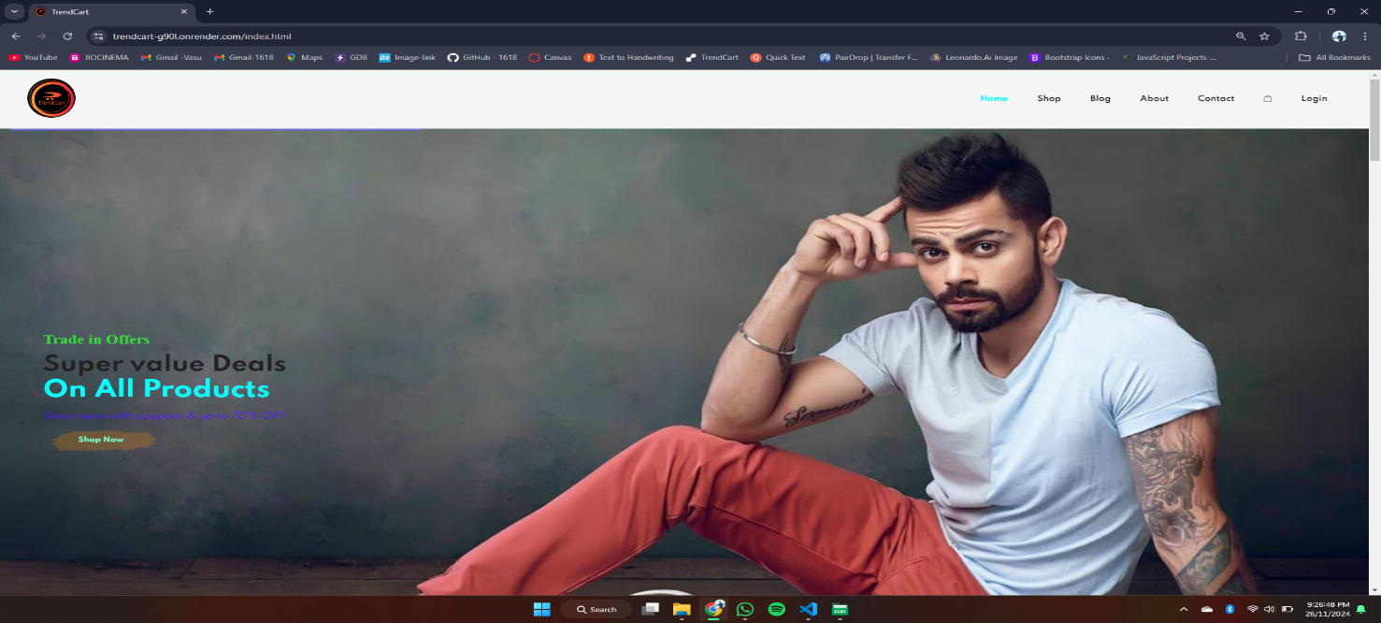

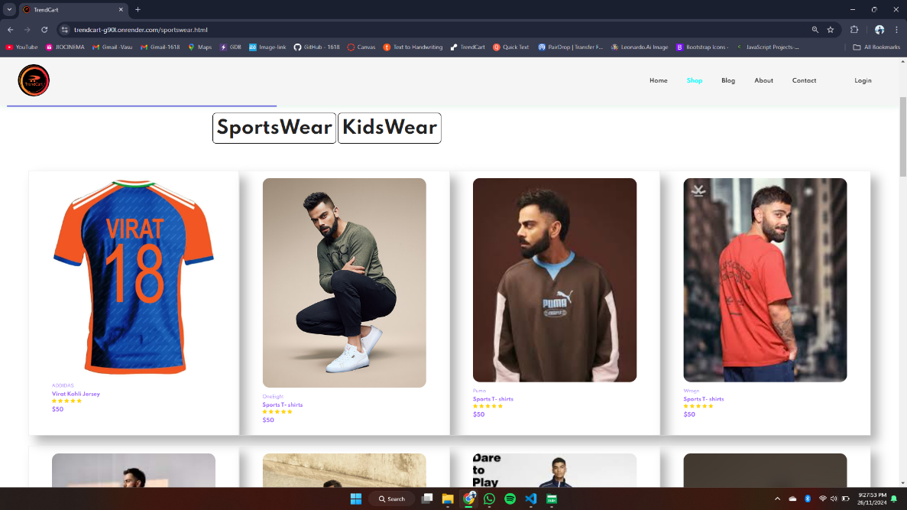

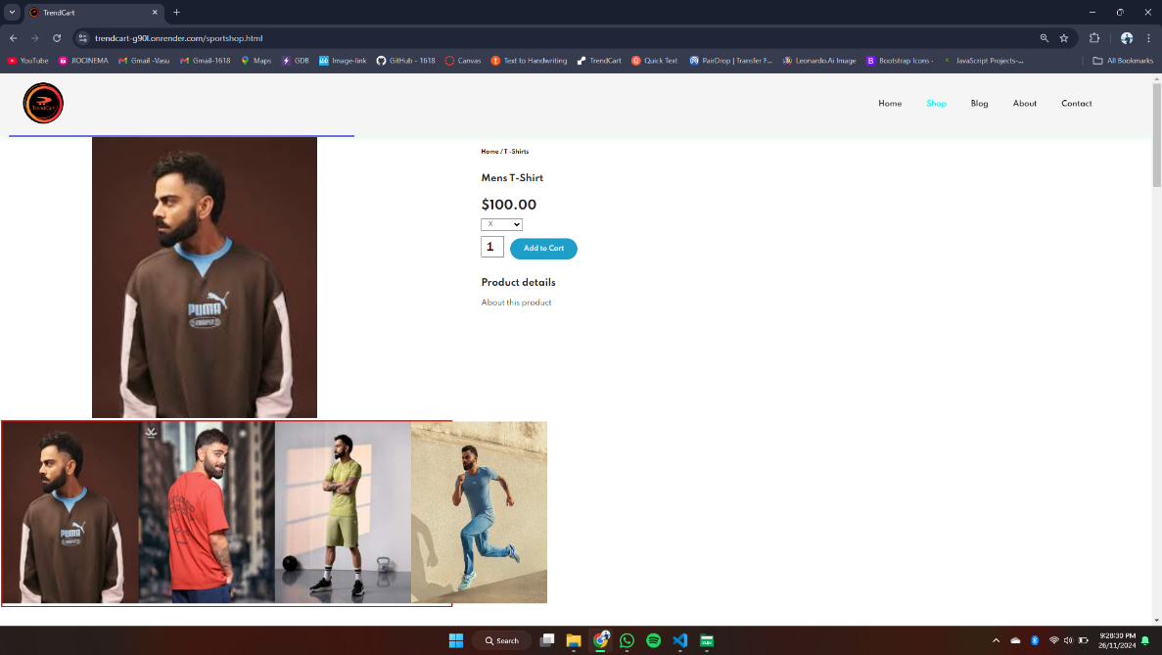

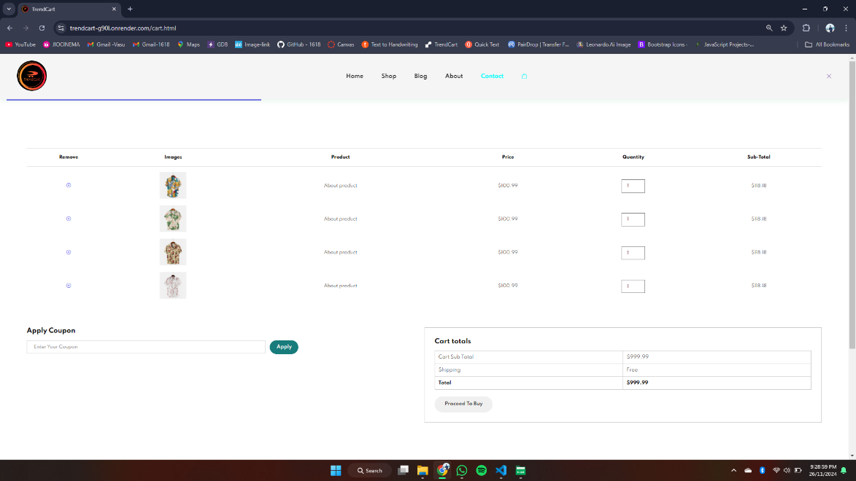

**CONCLUSION**

In conclusion, our website "TREND CART" successfully combines HTML, CSS, and JavaScript to create an engaging and user-friendly E-COMMERCE experience. The clean layout, responsive design, and interactive features ensure seamless navigation and an enjoyable browsing experience for customers, offering them easy access to a wide variety of FASHION TRENDS.