1. **COMMERCE DATABASE MANAGEMENT SYSTEM**

**IN**

**COMPUTER SCIENCE AND ENGINEERING**

**By**

**Balagam Vasu(221801340010)**

***Under the esteemed Guidance of***

1. **Lalu Prasad**

**Assistant Professor**



**CENTURION UNIVERSTIY OF TECHNOLOGY AND MANAGEMENT**

# (VIZIANAGARAM) (2022-2023)

**CENTURION UNIVERSITY OF TECHNOLOGY AND MANAGEMENT**

**VIZIANAGARAM**

**DEPARTMENT OF COMPUTER SCIENCE AND ENGINEERING**



**BONAFIDE CERTIFICATE**

This is to certify that the project work entitled “E-**COMMERCE DATABASE MANAGEMENT SYSTEM”** is a fulfillment of project work done by B.Vasu(22180140010)for the award of degree of **BACHELOR OF TECHNOLOGY** in **COMPUTER SCIENCE AND ENGINEERING, CENTURIONUNIVERSITY OF TECHNOLOGY** during the academic year 2022-2023.

**INTERNAL GUIDE HEAD OF THE DEPARTMENT**

**J. Lalu Prasad Dr. P. Subrat Kumar Parida**

**Assistant Professor Associate. Professor & HOD**

**Dept. of CSE Dept. of CSE**

**EXTERNAL EXAMINER**

## ACKNOWLEDGEMENT

It is with at most pleasure and excitement we submit our project partial fulfillment of the requirement for the award of Bachelor of Technology.

The project is a result to the cumulative efforts, support, guidance, encouragement and inspiration from many of those for whom we have to give our truthful honor and express gratitude through bringing out this project at the outset as per our knowledge.

We convey special thanks to our project Guided by **J. Lalu Prasad** who has guided us and encouraged us to enhance our knowledge with present working of this project to bring out enriching the quality of project.

I express my appreciativeness to **Dr. Subrat Kumar Parida (Associate. Prof.) and Head of the Department,** who facilitated us to providing the friendly environment which helped to enhance my skills in present project.

I would also like to extend my gratitude to **Dr. P. SUNNY DAYAL, Dean-School of Engineering and Technology, Centurion University of Technology and Management** who has helped us to attain all the requirements of the project.

I convey my sincere thanks to **Dr. Pallavi, Registrar of Centurion University of Technology and Management** who provided us with an opportunity to take on project work in well-equipped laboratories of Computer Science Department in our college.

At the outset, we thank to **Sri. Dr. Prashant Mohanthy**, beloved **Vice Chancellor of Centurion University of Technology and Management** who is the backbone by providing for completion of this project, Thank you sir.

**DECLARATION**

I hereby declare that the project entitled **“E-COMMERCE DATABASE MANAGEMENT SYSTEM”** submitted to the fulfillment of award the degree of **B.TECH (CSE)** in **CENTURION UNIVERSITY OF TECHNOLOGY AND MANAGEMENT**, **ANDHRA PRADESH.**

**Submitted by,**

B Vasu(221801340010),

## ABSTRACT

E-Commerce Database Management System (EC-DBMS) is a system that is designed to store, process, retrieve and analyze information concerned with the administrative and management of sales activity done by a customer online sitting at home. This project aims at maintaining all the information pertaining to the customers, vendors, products, and their categories, orders, and couriers. It enables vendors to set up online shops, customers to browse through the shops, and a system administrator to approve and reject requests for new shops and maintain lists of shop categories. The system manages the items in the shop and also helps customers purchase them online without having to visit the shop physically. The online shopping system will use the internet as the sole method for selling goods, products, and services to its consumers. The website will show all products in a categorized manner. Customers can browse any product for its price, other details and can order the product by using their registered account. The customer has to pay the order amount at the time of delivery.

In this project we will creating e-commerce database management where the the complete data can be stored in the data base of e-commerce website this project consist of er diagram and relational diagram generation

**KEYWORDS**- ER MODEL, RELATIONAL DIAGRAM,E-COMMERECE WEBSITE,DATA BASE

**CONTENTS**

|  |  |
| --- | --- |
| **S.No** | **Topic Name** |
| 1 | INTRODUCTION |
| 2 | SYSTEM ANALYSIS |
| 3 | SYSTEM DESIGN |
| 4 | IMPLEMENTATION |
| 5 | CODE |
| 6 | OUTPUT |
| 7 | CONCLUSION |
| 8 | BIBILIOGRAPHY |

1. **INTRODUCTION**

The system that handles every aspect of a E-commerce website proper management is known as a E-commerce database management system. The management of information relating to the various products, customers, billing, seller etc., is one of these aspects. An effective way to manage information about is E-commerce website provided by this system.

The E-commerce Management System will primarily provide a platform to purchase, sell, distribution of items, product or service through the internet and on some other network. It will provide an option to a customer for the comparison of product with another seller, while a shop is available only at day time the e-commerce is available 24 hours of a day and seven days of the week. The E-commerce Management System will be a huge marketplace as most of the business are going to implement based on the internet. This system will provide the detailed description of the products to users so that they can compare to the different product and will by the one which is more suitable to them.

## SYSTEM ANALYSIS

### Existing System

* + - A E-commerce website is a type of retail establishment that offers mostly food. A grocer sells food in large quantities.
    - Maintaining the files system is not advisable, considering the vast amount of data being accumulated on daily basis.
    - Its also hard to maintain the data physically and it is accessible to everyone and there is no security for confidential data and during any emergency situations like fire accidents etc. data will be lost.
    - And maintaining the file system is very expensive, it will be very hard to update the values on daily basis, and considering the human errors there might be a faulty value, which can effect the balance sheet.

### Proposed System

* + - Any manager committed to the success of his shop must comprehend the essential principles involved in managing a successful E-commerce website
    - It takes more than just maintaining enough of each item on hand to manage the inventory of a small E-commerce website
    - Barcode label printing
    - Today one cannot afford to rely on the fallible human beings really wants to stand against today’s merciless competition where it is impossible not to make a human error and the file system, it’s outdated to rationalize your mistake.
    - Fast checkout time
    - Multiple payments accepted
    - POS
    - So, to keep pace with time, to bring about the best result without malfunctioning and greater efficiency so to replace the unending heaps of flies with a much- sophisticated hard disk of the computer.

### System Requirements

* + 1. **Hardware Requirements**
       - Memory Required (Roughly 600kb for both python file and excel file)
       - Processor (Pentium Gold)
       - RAM (2gb)

### Software Requirements

* + - * Operating system :- Windows Xp
      * Database:- Sql Community server, Oracle, Xaamp
      * MySQL Workbench

## SYSTEM DESGIN

**Entity:** An entity is an object that are represented in the database. Example Rani, Rajani, etc. An entity is represented or defined by set of attributes.

Types of Entities:

1. Strong Entity Types
2. Weak Entity Types
3. Recursive Entity Types
4. Composite Entity Types or Associative Entity Types
5. Super Type and Subtype Entities

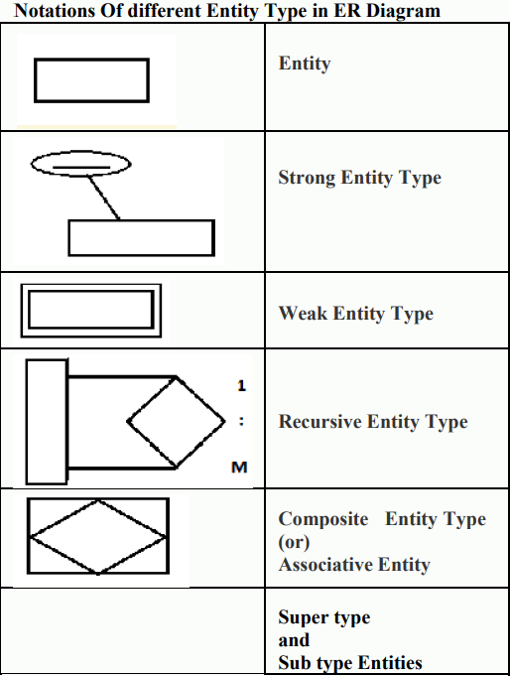

**Attributes:** are the properties used to describe an entity. For example, a STUDENT entity may have a Name, Roll number, Class, Marks etc. where STUDENT is the entity. Here name, roll number, class, marks are the attributes.

**Required Attributes:** A REQUIRED ATTRIBUTE is an attribute that must have a value i.e., it cannot be left empty. In the STUDENT table stnum, stname are represented in boldface that means that the data entry will be required.

**Optional Attributes**: An OPTIONAL ATTRIBUTE is an attribute that does not require a value, therefore it can be left blank. In the STUDENT table the attributes ph.no, email id are optional attributes. Domains: Attributes have a domain. A domain is the set of possible values for a given attribute. The domain for a gender attribute consists of only two possibilities: M or F. Similarly the basic salary attribute of an EMPLOYEE can have the domain between 4000 and 15000. Identifiers (Primary Keys): The ERM uses identifiers i.e., one or more attributes that uniquely identify each row in a entity. In the relational model, such identifiers are mapped to primary keys in tables.

**Composite Attributes:** Attributes are classified as simple or composite. A composite attribute is an attribute that can be further subdivided to yield additional attributes. For example, the attribute ADDRESS can be subdivided into street, city, state and zip code. Simple attribute: A simple attribute is an attribute that cannot be subdivided. For example age, marital status.

**Single-Valued Attributes:** A single-valued attribute is an attribute that can have only a single value. For example, the attribute STUDNAME can have only a single value. A single valued attribute is not necessarily a simple attribute.

**Multivalued Attributes:** Multivalued attributes are attributes that can have many values. For example, a person may have several college degrees. Similarly, a car’s color may be subdivided into many colors (that is, colors for the top, body and trim). In the Chen ERM, the multivalued attributes are shown by a double line connecting the attribute to the entity.

**Stored Attribute**: An attribute, which cannot be derived from other attribute, is known as stored attribute. For example, Birthdate of employee.

**Derived Attributes:** Attributes derived from other stored attribute. For example age from Date of Birth and Today’s date. A derived attribute is an attribute whose value is calculated from other attributes. For example the attributed STUD_TOTAL is a derived attributed, because its value can be calculated by using the other attributes like MARKS1, MARKS2, MARKS i.e. STUD_TOTAL= MARKS1+ MARKS2+ MARKS3.

# 4. IMPLEMENTATION

You can download the MySQL community server from this location. Once the installer has been downloaded, double-click the setup file to start the installation process. On the Choosing a Setup Type page, you can see four installation options.

1. Developer default: If you want to create a development machine, you can use this option. It installs the components which are required for application development, e.g., MySQL Server, MySQL Shell, MySQL connectors, MySQL
2. Server Only: If you want to create a standalone database server with specific components, you can use this option
3. Full: If you want to install MySQL Server with its all components, then you can use this option
4. Custom: If your requirements are limited to the few components, you can use this option We are going to install MySQL Server with all components; hence, choose “Full” and click on Next.

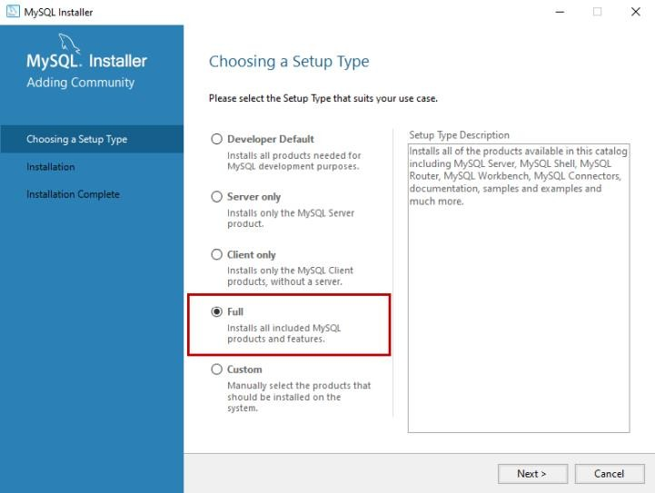

Before installation begins, the installer checks all the prerequisites that are required to install all the components of the MySQL database server. If any software prerequisites are missing, then you can see the details of failing requirements on the “Check Requirements” screen. It shows the name of the product, required component/software, and its status. As you can see, to install the MySQL database server for visual studio, we must install visual studio 2015 or above. Similarly, to install Python connector, we must install python on the work station. Click on Next.

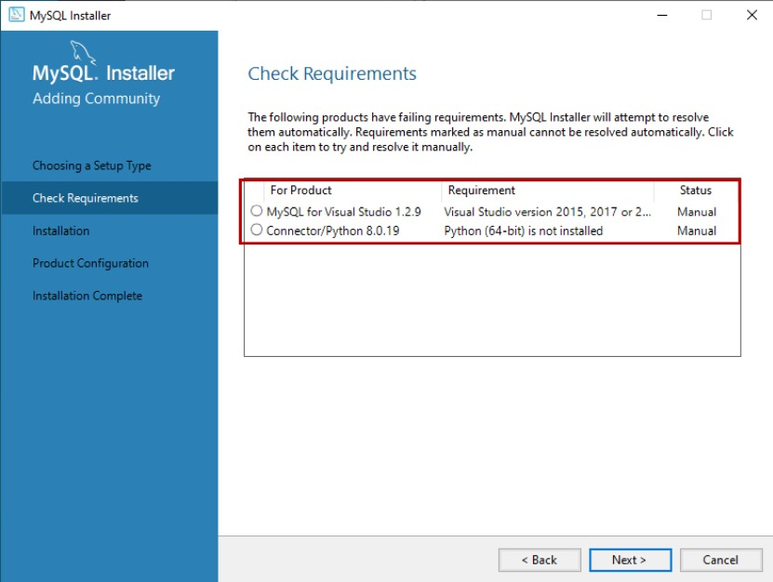

An installer gives us a warning. We can continue our installation without installing the visual studio and python. Click on Yes.

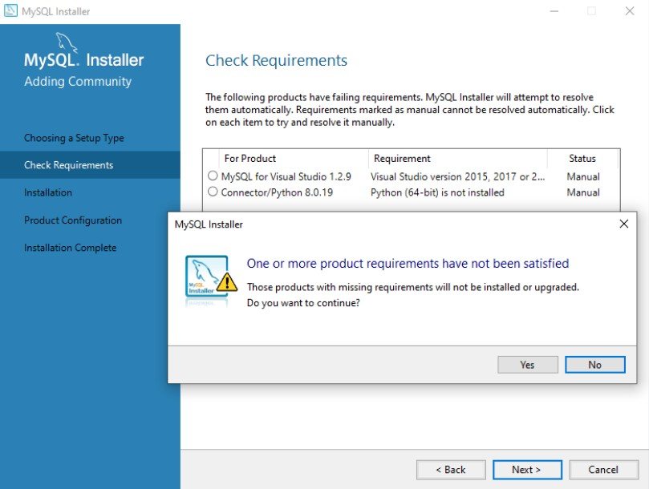

On the Installation screen, you can see the list of the MySQL products/software that are going to be installed on my workstation. Review the list and click on Execute.

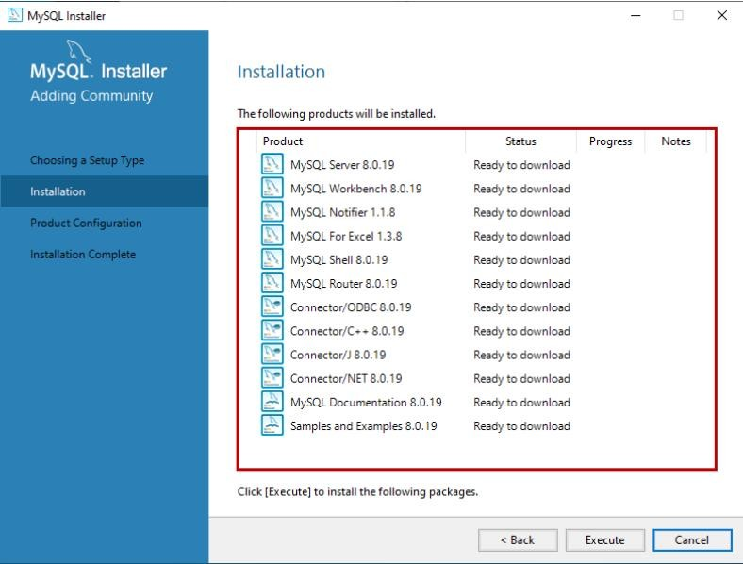

The installer downloads all the products/software. After that, it installs all the products.

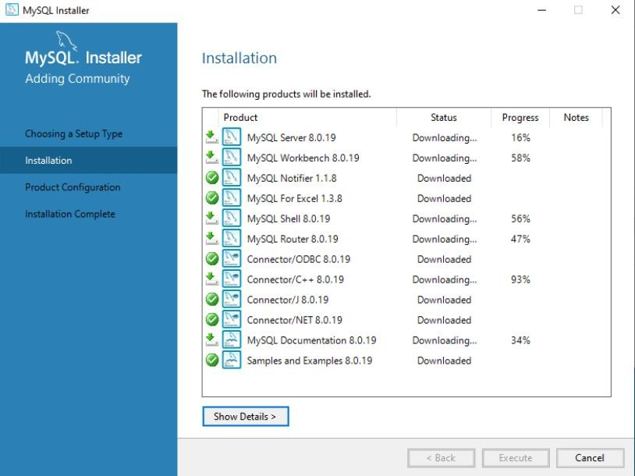

Wait for a few mins. Once the installation process completes, we are ready to configure the MySQL database server and other components. Click on Next.

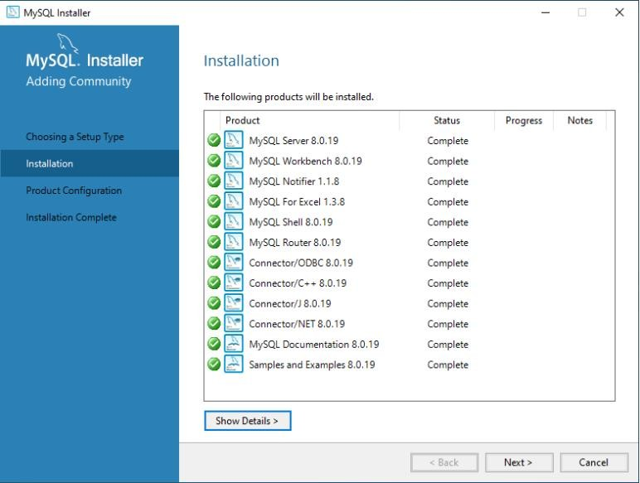

On the Product configuration screen, you can see the list of the products that need to be configured. First, let us configure the MySQL Server. Click on Next.

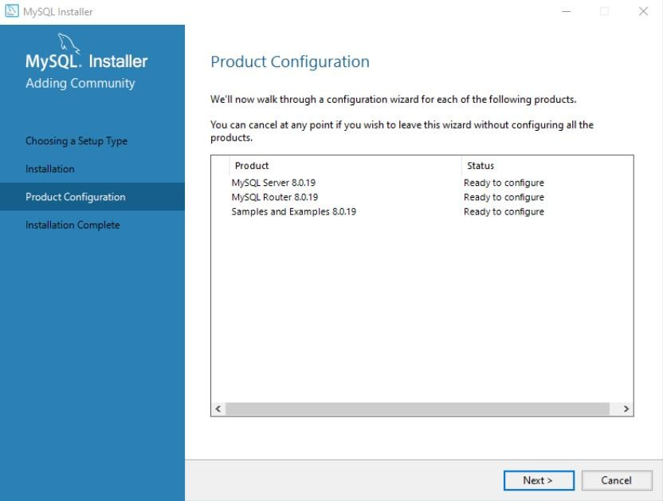

On the High availability screen, we can choose to install the InnoDB cluster or Standalone MySQL Server. InnoDB cluster is the High availability solution of MySQL. It uses group replication. I will explain more about it in my future series of articles. We are going to perform a standalone installation of MySQL Server hence choose “Standalone MySQL Server

/ Classic MySQL Replication”.

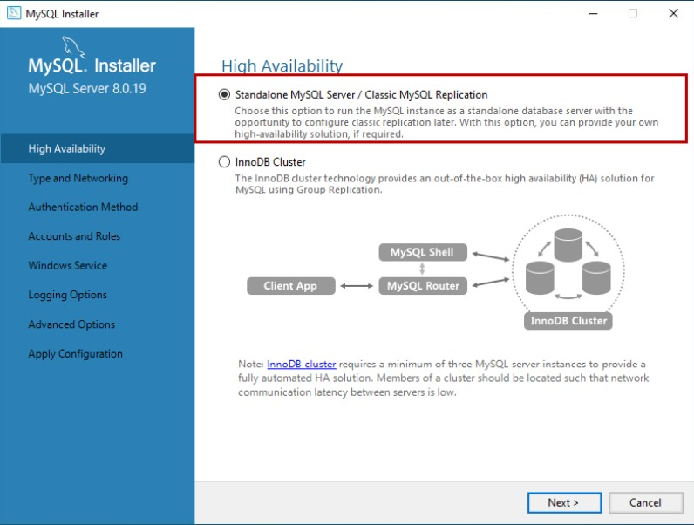

On Type and Networking screen, we can configure the following:

The type of MySQL configuration.

The type of MySQL configuration is a predefined set of configuration parameter that determines how much resources should be allocated to the MySQL Services. You have three configuration options:

1. Development Computer: This configuration uses a minimal amount of the resources to MySQL Service
2. Server Computer: This configuration uses a minimal amount of resources. This option is suitable when we are installing database servers and web servers on the same machine. The configuration allocates an average amount of resources to MySQL Service
3. Dedicated Computer: This option is used when we have created a dedicated MySQL Server. The configuration allocates a high amount of resources to MySQL Service

We would configure the server with minimal resources hence select “Development computer” from the Config Type drop-down box

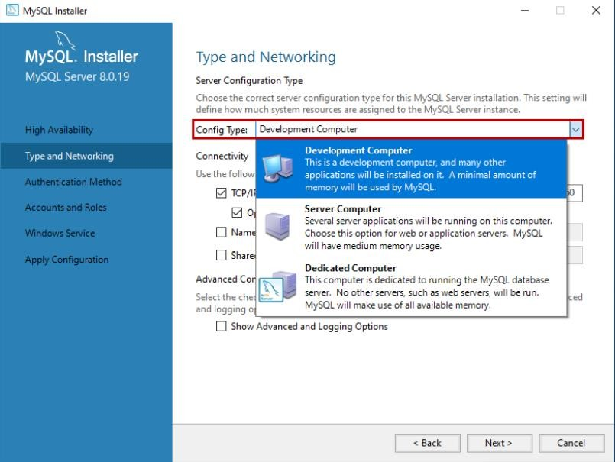

#### Network Connectivity

In this section, we can control how clients can connect to MySQL databases. We can use TCP/IP protocol or Named Pipe or Shared Memory. If you want to configure Named Pipe

/ Shared Memory, we must provide the Pipe Name and Memory Name. You can also specify the default port to connect to the database server. You can also choose to allow the port number specified in Port textbox in the firewall. See the following image:

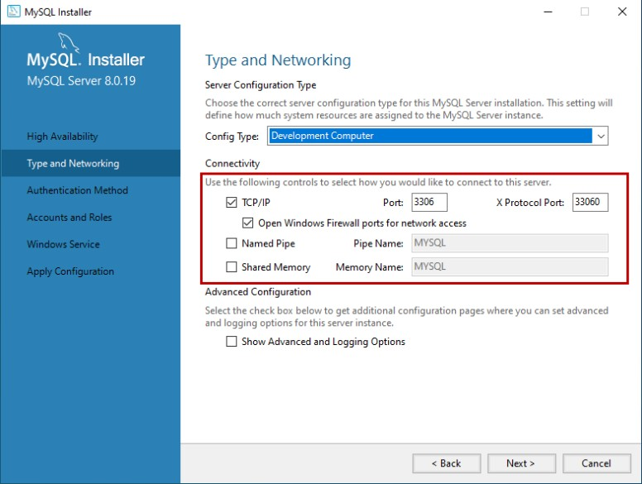

In MySQL 8.0 version, we can use SHA256 based strong passwords. On the Authentication Method screen, choose the option to use the Legacy authentication method or Strong password for authentication. Note: If you are using Strong Password Encryption for Authentication, then make sure that all the connectors must be updated to the latest version. We are going to use Strong password Encryption for Authentication.

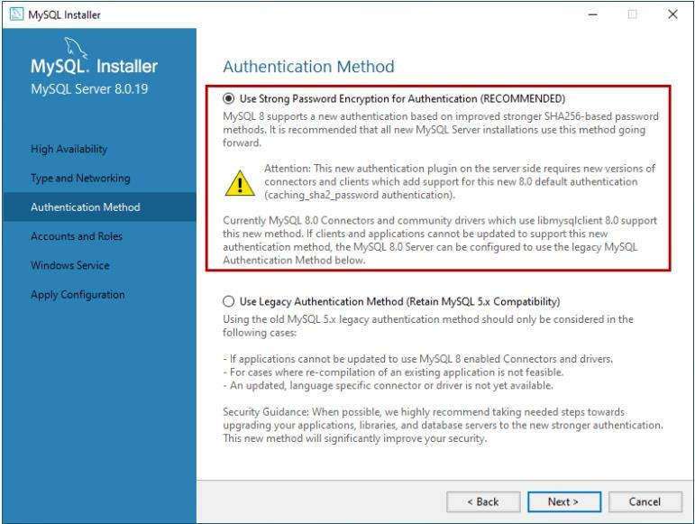

On Accounts and Roles screen, you can specify the MySQL root account password.

MySQL Root account is a default sys admin account, and it must be disabled.

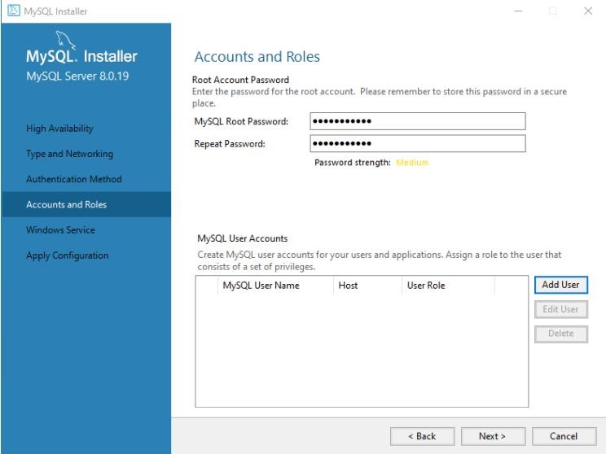

You can also create other users to do that click on Add user. On MySQL User account dialog box, provide a username, hostname, Role of the User, type of authentication, and password. Once the user is created, click on Next. See the following image:

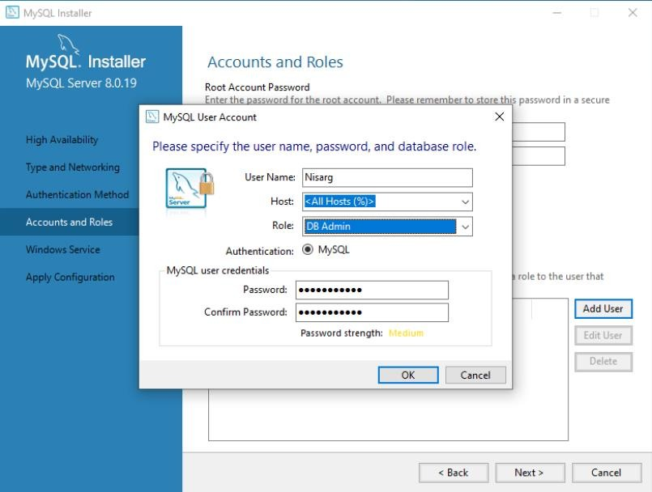

On the Windows Service screen, you can configure the MySQL server to run as a windows service. You can provide the desired name and configure it to auto-start the service when the system reboots. Moreover, you can provide the credentials under which the MySQL Service will run. You can choose the standard system account or provide a specific user. See the following image:

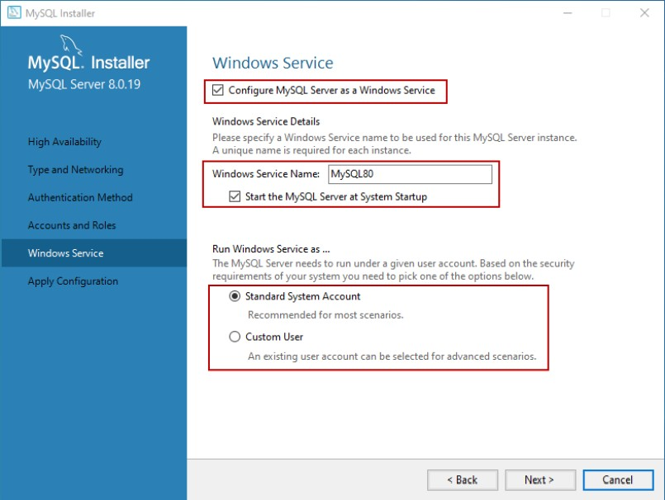

On the Apply Configuration screen, you can see the list of confirmation steps. Once all the configuration settings are verified, click on Execute.

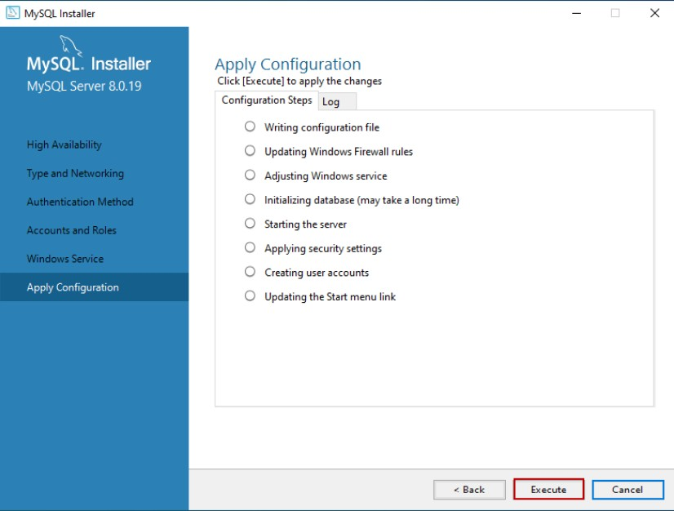

The MySQL installation process starts. You can view the installation process in the “Log” tab. Once installation completes successfully, click on “Finish” to close the installer.

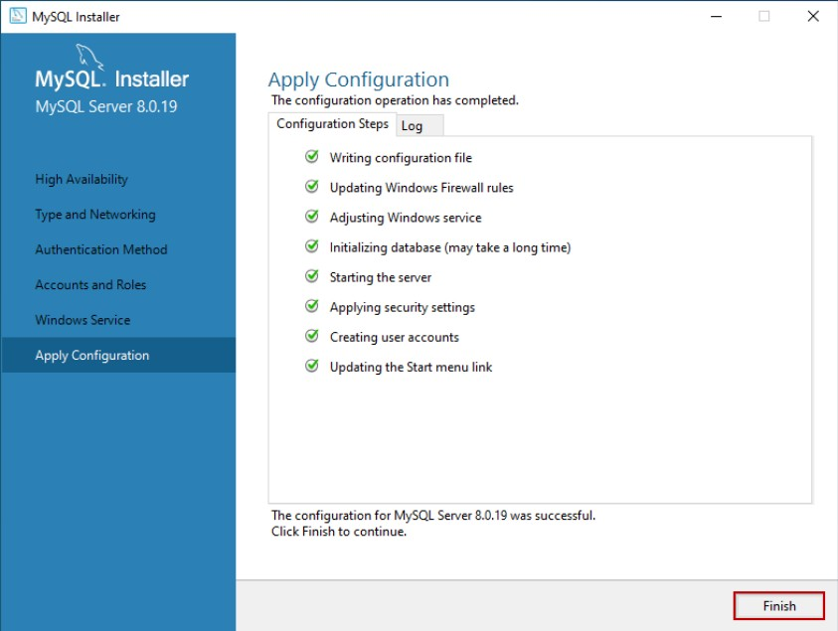

#### Install the sample database

If you have chosen to install all the components of MySQL Server (Full Setup Type), MySQL installer moves to Sample and Example screen. On this screen, provide username and password of the user that has root/sysadmin privileges and click on Check. If the connection establishes successfully, click on next. See the following image:

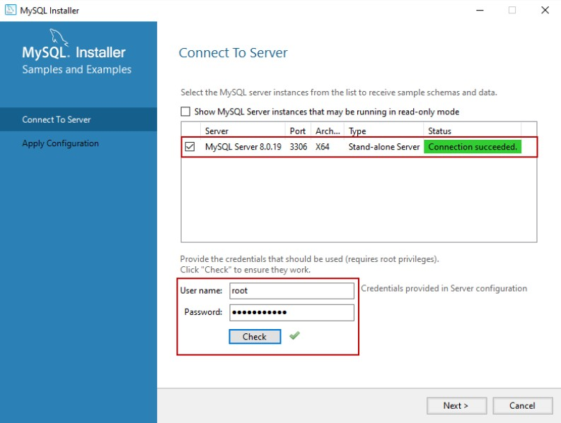

On the Apply Configuration Screen, click on Execute to start the installation of the Sample database. See the following:

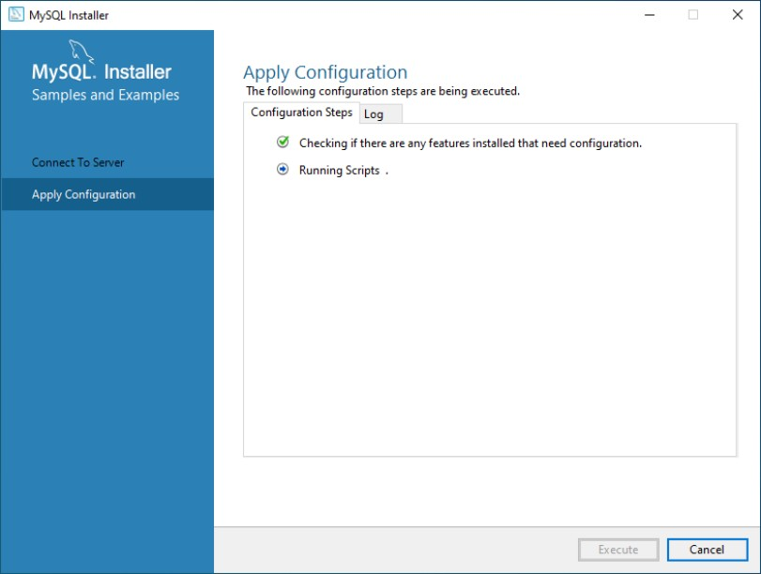

Once the sample database has been installed, click on the Finish button.

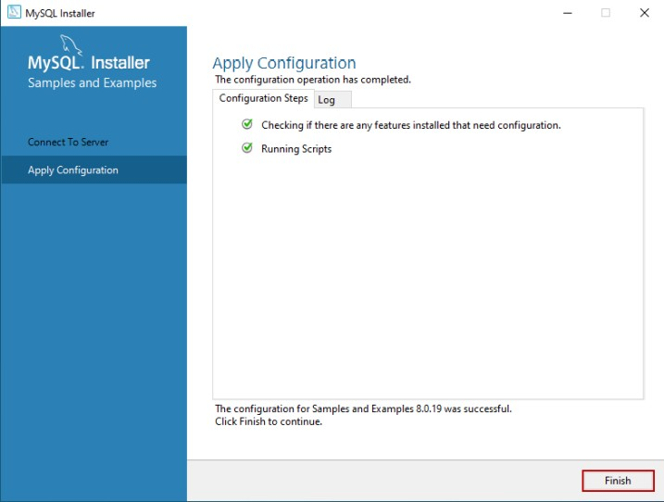

The installer continues to the Product Configuration screen. On this screen, you can see that the installation of the MySQL Server 8.0.19 and Sample and Example

8.0.19 has been completed successfully. See the following image:

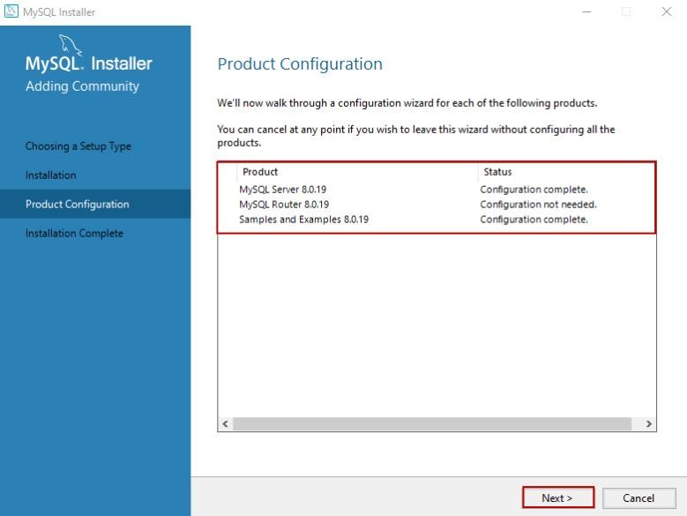

Once the installation completes, you can copy the installation logs on the clipboard to review it later. Moreover, if you want to start exploring MySQL straight away, then you can select “Start MySQL workbench after Setup” and “Start MySQL Shell after Setup” and click on Finish. See the following image:

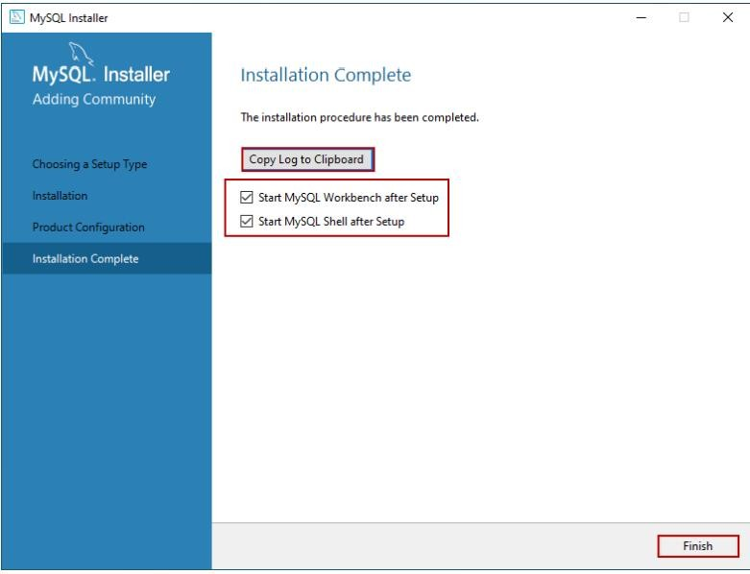

#### Connect to MySQL Server

Once the installation completes, let us connect to the server and execute the first MySQL Query. Open MySQL workbench. Just like SQL Server management studio, MySQL workbench is the development tool which is used to querying the database and create database objects. On MySQL workbench welcome screen, you can see the list of MySQL connections. We have not configured multiple connections; hence you can see “Local instance MySQL80.” Click on it to open the new query editor window.

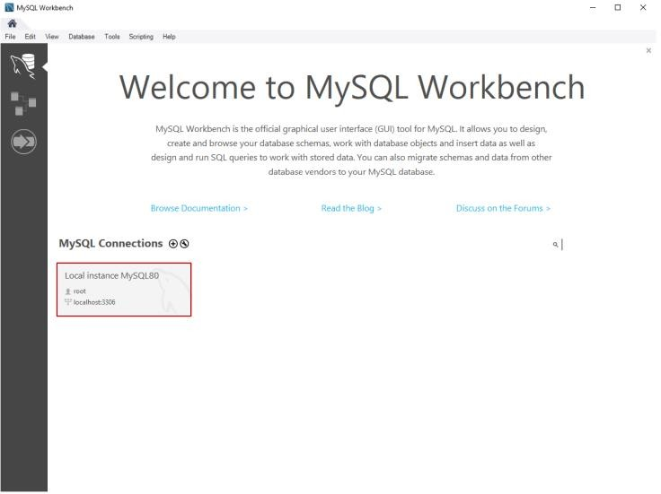

When you click on the connection, you must enter the credentials to connect the database server. Enter the password and click on OK.

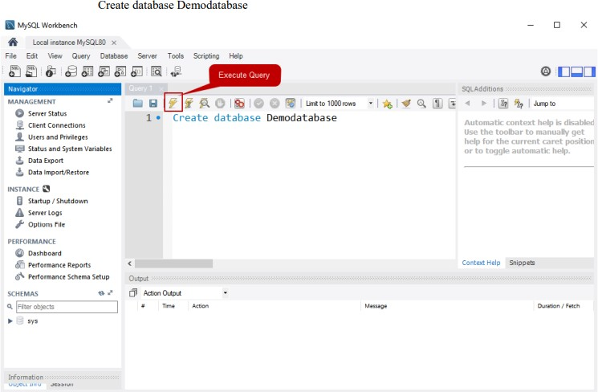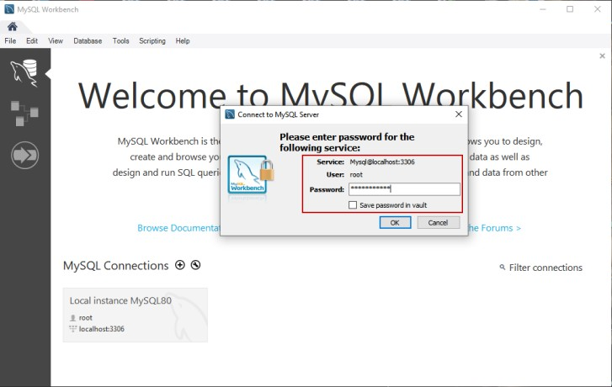

First, let’s create a simple database on MySQL Server. Write the following query in the query editor window and click on execute. See the following image:

Once the query executes successfully, you can see the new database in the “SCHEMAS” pan. See the following image:

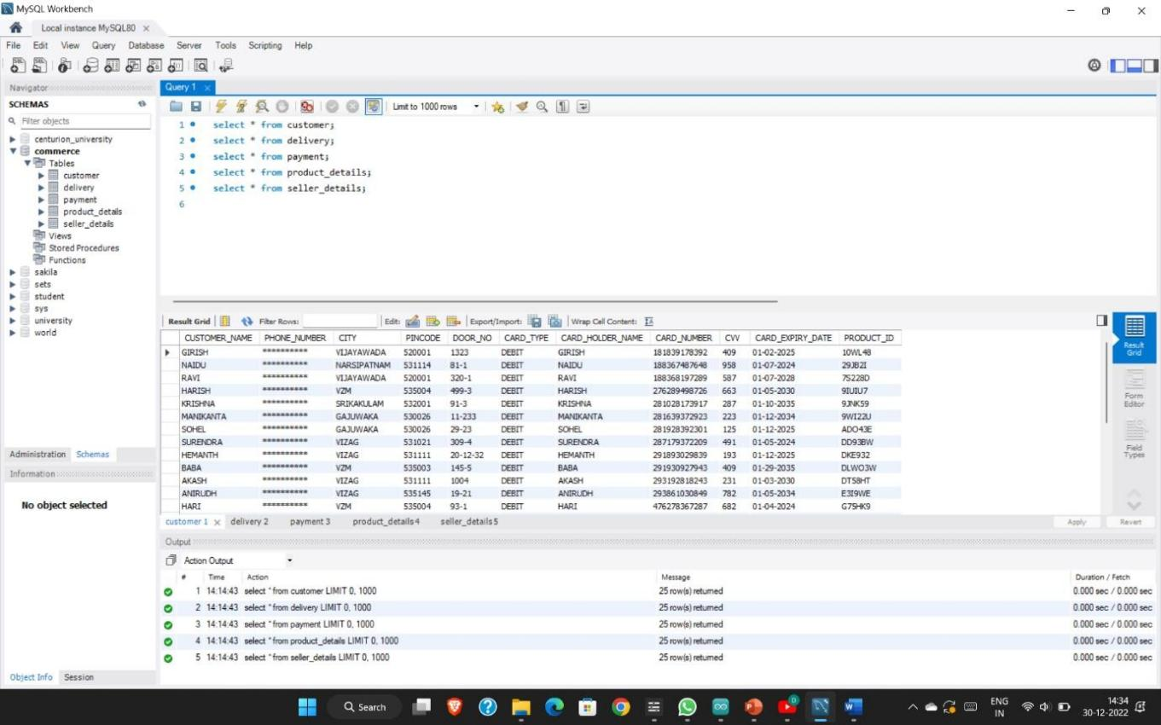

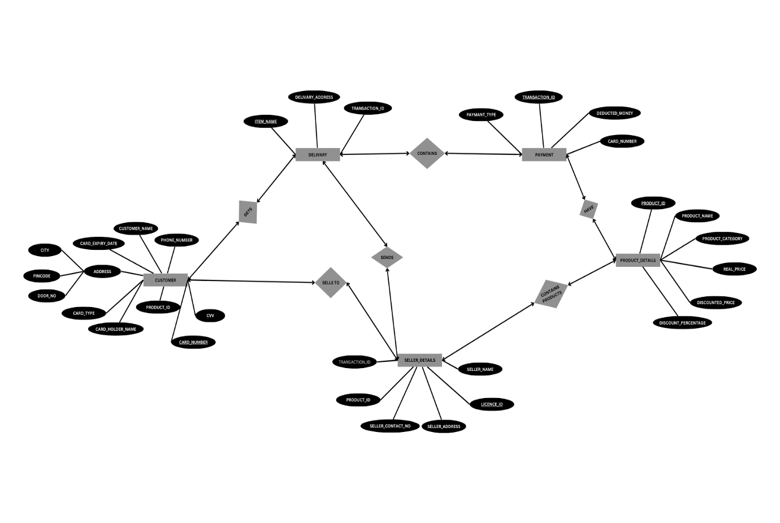

**5. CODE**

CREATE TABLE PRODUCT(PRODUCT_ID VARCHAR(10),PRODUCT_NAME VARCHAR(20),PRODUCT_TYPE VARCHAR(20),REAL_PRICE VARCHAR(10),DISCOUNTED_PRICE VARCHAR(10));

Query OK, 0 rows affected (0.01 sec)

mysql> SELECT * FROM PRODUCT;

Empty set (0.00 sec)

mysql> DESCRIBE PRODUCT;

+ -+ + + + + +

| Field | Type | Null | Key | Default | Extra |

+ -+ + + + + +

| PRODUCT_ID | varchar(10) | YES | | NULL | |

| PRODUCT_NAME | varchar(20) | YES | | NULL | |

| PRODUCT_TYPE | varchar(20) | YES | | NULL | |

| REAL_PRICE | varchar(10) | YES | | NULL | |

| DISCOUNTED_PRICE | varchar(10) | YES | | NULL | |

+ -+ + + + + + 5 rows in set (0.00 sec)

mysql> CREATE TABLE CUSTOMER(NAME CHAR(20),PHONE_NUMBER VARCHAR(11),VILLAGE_NAME CHAR(20),STREET CHAR(20),CITY CHAR(20),PINCODE VARCHAR(10),DOOR_NO VARCHAR(10),CARD_TYPE CHAR(10),CARD_HOLDER_NAME CHAR(20),CARD_NUMBER INT(15) PRIMARY KEY,CVV INT(4),CARD_EXPIRY_DATE VARCHAR(15));

Query OK, 0 rows affected, 2 warnings (0.02 sec)

mysql> SHOW TABLES;

+ +

| Tables_in_commerce |

+ +

| customer |

| product |

+ +

2 rows in set (0.00 sec)

mysql> DESCRIBE CUSTOMER;

+ -+ + + + + +

| Field | Type | Null | Key | Default | Extra |

+ -+ + + + + +

| NAME | char(20) | YES | | NULL | |

| PHONE_NUMBER | varchar(11) | YES | | NULL | |

| VILLAGE_NAME | char(20) | YES | | NULL | |

| STREET | char(20) | YES | | NULL | |

| CITY | char(20) | YES | | NULL | |

| PINCODE | varchar(10) | YES | | NULL | |

| DOOR_NO | varchar(10) | YES | | NULL | |

| CARD_TYPE | char(10) | YES | | NULL | |

| CARD_HOLDER_NAME | char(20) | YES | | NULL | |

| CARD_NUMBER | int | NO | PRI | NULL | |

| CVV | int | YES | | NULL | |

| CARD_EXPIRY_DATE | varchar(15) | YES | | NULL | |

+ -+ + + + + + 12 rows in set (0.00 sec)

Mysql>INSERT INTO CUSTOMER(CUSTOMER_NAME,PHONE_NUMBER,CITY,PINCODE,DOOR_NO,CARD_TYPE,CARD_HOLDER_NAME,CARD_ NUMBER,CVV,CARD_EXPIRY_DATE)

-> VALUES('BABA','**********','VZM',535003,'145-5','DEBIT','SONALI',291930927943,409,'09-29-2035'),

-> ('LAXMAN','**********','NARSIPATNAM',531114,'10-102','DEBIT','LAXMAN',822719928123,362,'02-15-2026'),

-> ('RISHI','**********','VIZAG',531021,'123-34','DEBIT','RISHI',486293782032,543,'01-24-2028'),

-> ('MANIKANTA','**********','GAJUWAKA',530026,'11-233','DEBIT','MANIKANTA',28163937292,223,'11-12-2034');

Query OK, 4 rows affected (0.01 sec) Records: 4 Duplicates: 0 Warnings: 0

mysql>INSERT INTO PRODUCT(PRODUCT_ID,PRODUCT_NAME,PRODUCT_CATEGORY,REAL_PRICE,DISCOUNTED_PRICE,DISCOUNT_PERCEN TAGE) VALUES('WO94JS','REALME BAND 2','ELECTRONICS',3499,1847,47);

Query OK, 1 row affected (0.01 sec)

mysql> INSERT INTO PRODUCT(PRODUCT_ID,PRODUCT_NAME,PRODUCT_CATEGORY,REAL_PRICE,DISCOUNTED_PRICE,DISCOUNT_PERCEN TAGE) VALUES('9JNK59','MATRESS','HOME',9999,7439,25);

Query OK, 1 row affected (0.01 sec)

mysql> UPDATE PRODUCT SET PRODUCT_CATEGORY='SPORTS' WHERE PRODUCT_NAME='FOOT BALL';

Query OK, 1 row affected (0.00 sec)

Rows matched: 1 Changed: 1 Warnings: 0

mysql> UPDATE PRODUCT SET PRODUCT_CATEGORY='APPLIANCES' WHERE PRODUCT_NAME='ONEPLUS TV';

Query OK, 1 row affected (0.00 sec)

Rows matched: 1 Changed: 1 Warnings: 0

mysql> INSERT INTO PRODUCT(PRODUCT_ID,PRODUCT_NAME,PRODUCT_CATEGORY,REAL_PRICE,DISCOUNTED_PRICE,DISCOUNT_PERCEN TAGE) VALUES('K3PSD3','WASHING MACHINE','APPLIANCES',21400,14990,29);

Query OK, 1 row affected (0.01 sec)

mysql> INSERT INTO PRODUCT(PRODUCT_ID,PRODUCT_NAME,PRODUCT_CATEGORY,REAL_PRICE,DISCOUNTED_PRICE,DISCOUNT_PERCEN TAGE) VALUES('9IUIU7','REFIGERATOR','APPLIANCES',34050,24990,26);

Query OK, 1 row affected (0.00 sec)

mysql> INSERT INTO PRODUCT(PRODUCT_ID,PRODUCT_NAME,PRODUCT_CATEGORY,REAL_PRICE,DISCOUNTED_PRICE,DISCOUNT_PERCEN TAGE) VALUES('DLWO3W','AIR CONDITIONERS','APPLIANCES',53900,31990,40);

Query OK, 1 row affected (0.00 sec)

mysql> INSERT INTO PRODUCT(PRODUCT_ID,PRODUCT_NAME,PRODUCT_CATEGORY,REAL_PRICE,DISCOUNTED_PRICE,DISCOUNT_PERCEN TAGE) VALUES('10WL48','SUITCASE','FASHION',7140,2049,71);

Query OK, 1 row affected (0.00 sec)

mysql> INSERT INTO PRODUCT(PRODUCT_ID,PRODUCT_NAME,PRODUCT_CATEGORY,REAL_PRICE,DISCOUNTED_PRICE,DISCOUNT_PERCEN TAGE) VALUES('SWW35V','CAMERA','ELECTRONICS',169995,159995,5);

Query OK, 1 row affected (0.00 sec)

**OUTPUT**

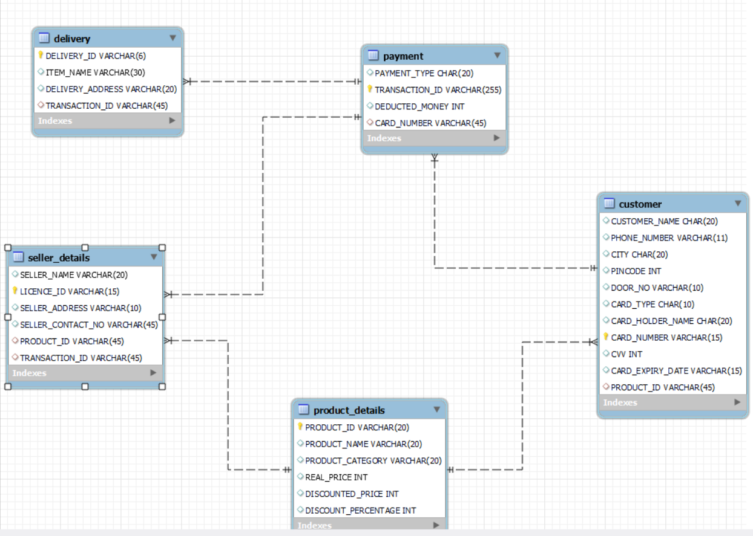

## CONCLUSION

The goal of a grocery store management system is to improve the efficiency of such grocery stores by taking the necessary steps to halt the growing problem with all manual grocery store operations. This project has successfully developed the software or system that can be used to assist all grocery stores that are still run manually. All varieties of grocery stores can use the software. The software is very efficient and precise and has a large memory for storing all the items in the grocery store as well as keeping records. Businesses urgently need effective management as business opportunities grow like never before. One of these crucial areas is keeping a methodical approach to managing sizable databases, particularly in the retail sector. A crucial tool for the continued expansion of business organizations is the DBMS. It provides a straightforward, effective, and dependable method for managing, storing, and accessing data.

## BIBLIOGRAPHY

### Sites Referred

1. <https://dev.mysql.com/downloads/installer/>
2. <https://www.w3schools.com/MySQL/default.asp>
3. <https://www.hostinger.in/tutorials/what-is-mysql>
4. https:/[/www](http://www.canva.com/graphs/er-diagrams/).[canva.com/graphs/er-diagrams/](http://www.canva.com/graphs/er-diagrams/)

### Books Referred

* 1. Learning MySQL (Seyed M.M/Hugh E. Williams)
  2. DATABASE SYSTEMS (Carlos Carol/ Steven Morris)