S­­enior Design

Final Design Report

Driver 2.0

Vasu Bhog

ChaoYang Zhu

Chunjie Pan

Table of Contents

Project Description 3

User Stories and Design Diagrams 6

1. Design 1
2. Design 2
3. Design 3
4. Description

Project Tasks and Timeline 9

1. Task List
2. Timeline
3. Effort Matrix

PowerPoint Presentation 12

Self-Assessment Essays 16

Professional Biographies 20

Budget 25

1. Expected Expenses
2. Donated Items
3. Summary of Billable Hours

Appendix 30

# Project Description

## Team Members

* Vasu Bhog - [bhogvu@mail.uc.edu](mailto:bhogvu@mail.uc.edu)
* ChaoYang Zhu - [zhucy@mail.uc.edu](mailto:zhucy@mail.uc.edu)
* Chunjie Pan - [pance@mail.uc.edu](mailto:pance@mail.uc.edu)

## Faculty Advisor

* Dr. Wen-Ben Jone - [jonewb@ucmail.uc.edu](mailto:jonewb@ucmail.uc.edu)

## Background Description

Billions of people still drive on the road and have barely any assistance from smart devices to help them while driving. There is a continuous increase in crashes over the years, and there are more and more drivers that are getting on the road. Our project will aim at creating a simple interface-based application that will use computer vision and machine learning to detect dangerous situations and objects on the road. This will decrease the probability of crashes and injury, as well as increase the awareness of the driver.

## Problem Statement

There have been millions of distracted drivers and car crashes over the years. Car crashes are continuously increasing, and the issue is with drivers that are not aware or distracted. We need to find a solution that everyday drivers can utilize instead of buying a completely new vehicle.

### Statistics

* Average of 6 million car accidents in the U.S. every year
* More than 1.5 million people in the US are injured every year in car accidents

The table below shows the crashes from 2008 - 2017. The increase in drivers and vehicle purchases illustrate the inadequate technology in vehicles.

|  |  |  |  |  |
| --- | --- | --- | --- | --- |
| Year | Fatal | Injury | Property damage only | Total crashes |
| 2008 | 34,172 | 1,630,000 | 4,146,000 | 5,811,000 |
| 2009 | 30,862 | 1,517,000 | 3,957,000 | 5,505,000 |
| 2010 | 30,296 | 1,542,000 | 3,847,000 | 5,419,000 |
| 2011 | 29,757 | 1,530,000 | 3,778,000 | 5,338,000 |
| 2012 | 31,006 | 1,634,000 | 3,950,000 | 5,615,000 |
| 2013 | 30,057 | 1,591,000 | 4,066,000 | 5,687,000 |
| 2014 | 30,056 | 1,648,000 | 4,387,000 | 6,064,000 |
| 2015 | 32,539 | 1,715,000 | 4,548,000 | 6,296,000 |
| 2016 | 34,748 | 2,116,000 | 4,670,000 | 6,821,000 |
| 2017 | 34,247 | 1,889,000 | 4,530,000 | 6,452,000 |

[Credit for Statistics](https://www.iii.org/fact-statistic/facts-statistics-highway-safety)

## Inadequacy of Current Solutions

There is no device that currently out there that detects objects, tired drivers, and road signs for drivers. There are currently only advanced cars that cost an additional hundreds of thousands of dollars that have sensors and cameras built in the vehicle. Not everyone can afford expensive vehicles, therefore a device that can detect and notify dangerous objects and distractions on the road will reduce the likelihood of a crash along with increasing the safety.

## Background Skills and Interest

**Background Skills**: We have experience in full-stack web development, computer vision, and deep learning.

**Interest**: We are interested in adding to our skill sets and are looking forward to learning more about applications using Computer Vision.

## Approach, Goals and Expectations

**Primary Goals**

* Create/Utilize devices such as Raspberry PI
* Utilize camera feed data to detect objects, drivers swaying, and road signs to enhance the drivers' safety
* Create an interface to help drivers in all conditions

# User Stories and Design Diagrams

## User Stories

* As a driver I want to be able to utilize the device to enable smart detection of dangerous road objects and conditions.
* As a passenger, I want to be able to help navigate and aid the driver using the device and ensuring that that the driver is aware.
* As a device owner, I will be able to utilize the advanced modeling that detects driver swaying and fatigue, as well as road sign detection.

## Design Diagrams

**Diagram 1:**

**Diagram 2:**

**Diagram 3:**

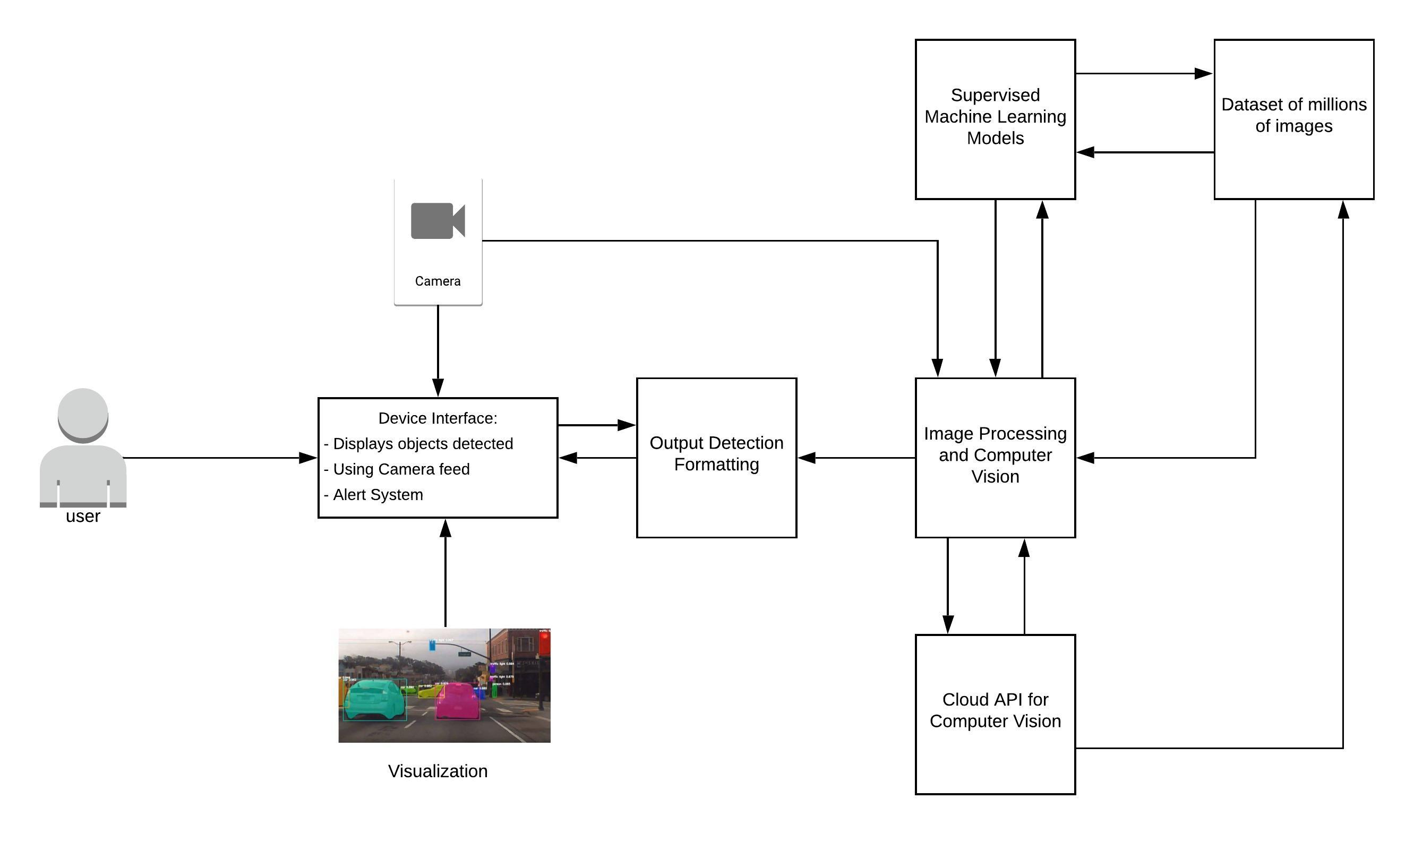

## Design Description

**Diagram 1:**

* High-Level Design of the Input Layer, Computer Layer, and Output Layer.
* Able to illustrate the overall system design that will take place.
* Includes the amount of data, computation through ML models and output to the interface.

**Diagram 2:**

* A more concrete diagram illustrating from the user perspective.
* Illustrates the computer layer further.
* We will feed live feed road data into our image processing program that will be able to detect and use the ML models to output warnings to the user.

**Diagram 3:**

* An in-depth look at the internal system of the ML models and Computer Vision.
* The diagram will illustrate what the user should get back to the interface based on the computer layer.
* The diagram illustrates the different components of the machine learning model that will be used to first learn and then process the live feed data back to the user.

# Test Plan and Results

# User Manual

# PowerPoint Presentation



Driver 2.0



Team Info

* Team Member:
  + Vasu Bhog - [bhogvu@mail.uc.edu](mailto:bhogvu@mail.uc.edu)
  + ChaoYang Zhu - [zhucy@mail.uc.edu](mailto:zhucy@mail.uc.edu)
  + Chunjie Pan - [pance@mail.uc.edu](mailto:pance@mail.uc.edu)
* Project Advisor:
  + Frank Zhou - [zhoxu@ucmail.uc.edu](mailto:zhoxu@ucmail.uc.edu)

1 2



Problem

There have been millions of car crashes over the years due to distracted drivers and dangerous objects. Car crashes are continuously increasing and the issue is with drivers that are not aware or distracted. We need to find a solution that everyday drivers can utilize instead of buying a completely new vehicle.



Solution

A device that can detect and notify drivers about dangerous objects and distractions on the road in order to reduce the likelihood of a crash along with increasing safety.

3 4



Project Abstract

Billions of people still drive on the road and have barely any assistance from smart devices to help them while driving. There is a continuous increase in crashes over the years, and there are more and more drivers that are getting on the road. Our project will aim at creating a simple interface based device that will use computer vision and machine learning to detect dangerous situations and objects on the road. This will decrease the probability of crashes and injury, as well as increase the awareness of the driver.



Goals statements

* Create/Utilize devices such as Raspberry PI to process driving data
* Utilize camera feed data to detect objects, drivers swaying, and road signs to enhance the driver's safety
* Create an interface to help drivers in all types of conditions

5 6



User Stories

* As a driver, I want to be able to utilize the device to enable smart detection of dangerous road objects and conditions.
* As a passenger, I want to be able to help navigate and aid the driver using the device and ensuring that that the driver is aware.
* As a device owner, I will be able to utilize the advanced modeling that detects driver swaying and fatigue, as well as road sign detection.

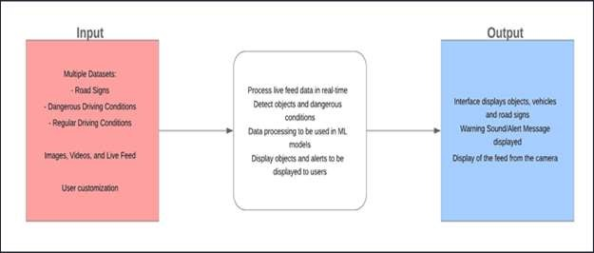

Design Diagram

7 8

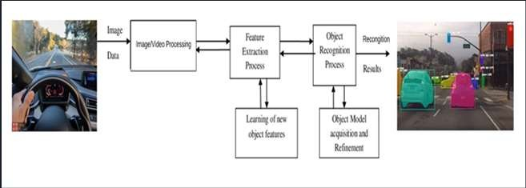

Design Diagram 2

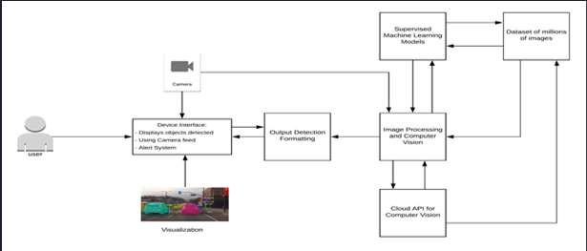

In Depth Design Diagram

9 10



Project Constraints

Economic Concerns

* Our solution will cost us money as we need to purchase parts to create the device. In order the users end cost would be low, we will utilize inexpensive devices. We are not limited to any organization or facility as we will be using open source frameworks.

Social Concerns

* Safety is of the utmost importance when it comes to driving therefore ensuring our project will be able to positively impact the safety of driving is our main focus.
* Our machine will help drivers use ML and Computer Vision to attain a higher level of safety through alerting the driver of oncoming danger.



Current state of project

1. Discussed with Professor Frank about our project and got feedback from additional professors.
2. Researched the object detection and Raspberry Pi.
3. Learning OpenCV and it utilization with different programming languages.
4. Practicing object detection using Python and Java.

11 12



Expected Accomplishments for the end of this term

* Understand OpenCV and practice object detection using Python/Java and Raspberry PI.
* Research how to train a machine learning model to detect road objects and dangerous conditions.
* Research methods to detect multiple objects in image, video, and live feed to improve the model and device.

|  |  |  |
| --- | --- | --- |
| **Dates** | **Milestones** | **Tasks** |
| Dec 02 2019  -  Dec 27 2019 | Create a program that detects objects in driving video data | 1,2,3,4,5 |
| Dec 30 2019  -  Jan 10 2020 | Connect the program to the camera to read live feed data | 6,7 |
| Jan 13 2020  -  Jan 24 2020 | Setup the program to be used with Raspberry Pi | 8,9 |
| Jan 27 2020  -  Feb 14 2020 | Create an alert interface and program that triggers when objects are detected | 10,11 |
| Feb 17 2020  -  Mar 20 2020 | Implement more desired features | 12 |

13 14



Timeline for the Project



Timeline and Milestone 1

* Milestone 1:
  + Create a program that detects speed limit in a video/live feed
* Task:

1. Understand OpenCV and practice object detection using Python or web application
2. Research how to train a machine learning model to detect road objects
3. Research methods to detect multiple objects in image, video, and live feed
4. Write the neural network code to be used to learn and recognize dangerous car conditions
5. Train the neural network with training and validation sets of dangerous objects



Timeline and Milestone 2

* Milestone 2:
  + Connect the program to the camera to read live feed data
* Task:

1. Set up a camera to be connected to live feed driving data
2. Write a program to detect objects as they move in the camera

15 16



Timeline and Milestone 3

* Milestone 3:
  + Setup the program with Raspberry Pi
* Task:

1. Connect Camera with Raspberry Pi
2. Get the full system to run on Raspberry Pi in a “live” environment



Timeline and Milestone 4

* Milestone 4:
  + Create an alert interface/program that triggers when object detected
* Task:

1. Write code to notify the user of the alerted object through Raspberry Pi and interface screen
2. Create an alert interface/program when an object is detected

17 18



Timeline and Milestone 5

* MileStone 5:
  + Implement more desired features
* Task:

12. Detect road swaying and dangerous driving through lane detection



Division of Work

Vasu:

* OpenCV detection and setup
* ML models
* Utilizing setup/models for final system Chunjie:
* Rasperberry PI
* Camera live feed/Interface
* Connecting interface with final system ChaoYang:
* Research for multiple object detection
* Enhancing neural network
* Connecting results to final system

19 20

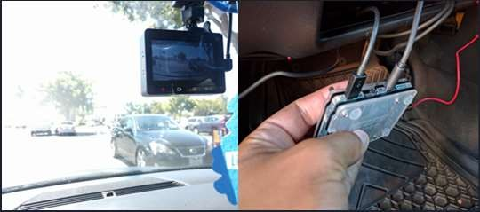

Expected Demo at Expo

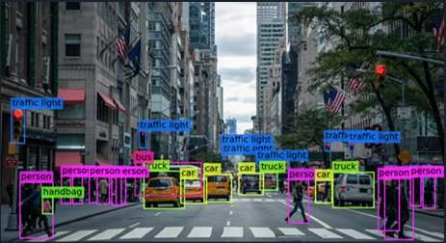

Expected Demo at Expo

21 22



Credits

Follow our progress on our

Github Repo: https://github.com/VasuBhog/Senior-Project

Images used from: Google images

2

# Expo Poster

# Self-Assessment Essays

## Vasu Bhog

Our project aims to answer the millions of crashes that still occur today due to distractions and dangerous objects while driving. As of today, there is research and companies that utilize cameras and sensors on vehicles to detect collisions and dangers. We will use computer vision to detect objects, road signs, and machine learning to analyze dangerous driving patterns. We will utilize our technical knowledge to develop an application and device that will be used to monitor driving conditions in any vehicle. We plan to use a small device such as a Raspberry PI and camera attachment to give us live camera feed data of the vehicle. Once we retrieve the data, we then will process it and illustrate to the user obstacles, road signs, and warnings that may occur.

Throughout my college career, I have learned a diverse set of technical and professional knowledge. I was able to learn specifically about computer vision and machine learning through courses I took abroad in France. I was able to get practical experience through a project that required the use of creating an application to detect objects using Java and OpenCV. I was able to understand the curriculum due to my previous technical knowledge and use of programming languages through Software Engineering courses. There have been many fundamental courses that allowed me to learn more about my interests today. I was able to develop many professional skills that allowed me to get the France opportunity as well.

My co-op and internship experiences intertwine with my degree in which I have a diverse set of technical and professional skills. I have worked on many different projects and roles ranging from data analyst to full-stack developer during my previous internships. I like to challenge myself and find projects that expand my technical knowledge and professional skills. I have been able to develop these skills through my co-op experiences at Microsoft, Fifth Third Bank and the research internship in France called UrbanLoop. I enjoyed learning from incredibly smart people and their perspectives on how to bring my knowledge to be used in an industry manner. I believe that all my internship experiences will benefit me greatly in successfully leading and developing our project.

I am extremely interested in this project as it deals with a revolutionary technology that can impact millions to billions of people worldwide. Computer vision and machine learning can solve many problems in today’s fields of healthcare, transportation, and many others. I believe technology today should not be limited for only people who can afford it. The vehicle aid assistance that we plan to develop would be available to anyone to use in their conventional vehicles. It will allow drivers to rest assured that there are a detection and awareness in their smart device. I believe it is important for us to learn about these technologies along with the data that is available for us to utilize and create highly efficient models.

Our approach to solving this will be based on a learning structure and verification. We will begin with validating and processing images and videos of objects, road signs, and dangerous conditions on the roadway to aid the driver. Detection and validation will allow us to create reliable models for which we can use in our AI-enabled device. We will then utilize the raspberry PI and camera system to capture live feed. Once verification and system design are suitable for vehicles then we can test our product. I believe if we are able to satisfiable detect dangerous objects and distractions that could cause a crash, this would justify our project and success.

## ChaoYang Zhu

There are millions of car accidents in the U.S. every year and cause millions of people injured every year. I believe, accidents occur mainly because of human behaves and the limitation of human’s ability to react and process all the information in a short amount of time. As technology rapidly grows, we invent the self-driving vehicle and other technology to help the driver. However, not everyone can afford to can a smart vehicle. For our project, we will be focusing on computer vision and deep learning to create a project to help process information for the driver with an external camera and Raspberry Pi and show them on an interface. The goal is to break the limitation for the older vehicle to have a smart assisting drive system.

As mentioned in the first paragraph, the project involves computer vision and deep learning. For computer vision, we will be focusing on graphic processing. For this reason, all our team members are currently taking Computer Graphic I and self-studying with this knowledge, we want to use this project as a learning experience as well. For deep learning, every member has taken deep learning or machine learning previous, we use those experience to help develop the program and improve our skill in deep learning as well. For the interface for the system, I have taken User Interface I previously and created a web application as the final assignment for Python course. All that knowledge will help us solve the problem we might face and complete the project.

For my pass four co-op experiences, I have involved in diverse roles. Roles include application developer and research assistant. During co-op at Innomark Communications, I was an application developer in the IT department. My primary works were web app development for both front-end and back-end. The job involved using interface design and system (back-end) structure design. My last co-op was at Cincinnati Children’s Hospital Medical Center as a biomedical developer, my goal at CCHMC was to create a program to analyze the collected data from the participant. The data was collected with Tobii Eye Tracker, which requires me to understand the row data’s mean with the graphic shown to the participant. This will help me to understand the data/graphs captured with the camera and reformat them into the form that drive’s need and desire.

As someone who does not like to drive, I always want to have as much assistance as possible from our technology. One of the common problems while driving is not seeing the road sign on the side or other objects such as the vehicle or small animals. Our first step will be road sign detection for images and videos processing, then we will try live feed for detecting road sign. After we complete the basic functionality, we will start to create a user interface for live feedback. This will complete the minimal requirement for our project. Then we can start adding more futures we want, such as the vehicle or small animal detection.

Our goal is to complete the minimal requirement for the project that can be in use for a live test on the vehicle. To accomplish this, we need to be able to detect the road sign while it is changing size (as we get closer to it) in the video. Our team will sit down in a meeting to complete this task. Since I have a lot of experience in interface design and web application development, I will be doing more for programming the interface for the user. I believe we will be able to complete the basic functionally for the project by mid next semester and start to implement more future for the rest of the semester. Base on the problem we might face while programming the futures, I believe we will be able to complete the prototype that can be in use for testing.

## Chunjie Pan

The project aims to harness the power of computer vision and machine learning to detect dangerous and object on the road. The end project will utilize camera feed data, utilize Raspberry PI as platform and use Amazon Web Services to process image. Nowadays, the number of vehicles on road is increasing every day and there is a continuous increase in crashes over the years. However, there are barely any smart devices installed in vehicle to help driver recognized the dangerous on the road. For most people, they must buy a completely new vehicle to obtain smart assistant. The project will help people get smart assistant by installing a low-cost and small size device in their current vehicles.

As a Computer Science major, the curriculum at UC has played an important role in gaining the necessary expertise to develop the project. Data Structures (CS 2028) helped me understand concepts such as Object-Oriented Programming. Linear Algebra (MATH2076) helped me understand vector and matrix operations which are very important in machine learning and computer vision. Software Engineering (EECE 3093) introduced me to concepts such as agile methodology. Design & Analysis of Algorithms (CS 4071) and Machine Learning (CS 6037) improved my programming through concepts such as complexity and using neural networks in the machine learning.

I have gained a lot of software development experience through four co-op rotations. During my first co-op rotation, I worked in the UC College of Engineering and Applied Science as a research assistant. I gained the skill to design and implement a digital circuit simulator and displayed excellent team work skill and communication skill. For my second rotation, I worked at Siemens Innovation Center. I was a web application developer and created a web application from scratch with teammates. I have gained hands-on development experience of software. I also learned how to use the database and connect database to software efficiently. For my third rotation, I worked at the Institute of Automation, Chinese Academy of Sciences. I was an embedded software developer. I completed a PDF reader application alone and it was used in a printer system. I was also brought on as the development lead for the programmable motion control software project. I designed a set of programming language and interrupter functions. During this co-op, I gained embedded software developer experience and better understanding on the Linux system. During my last co-op, I worked at UC as a research assistant, I learned new technology that might be used in the project.

I have always been interested in computer vision, cloud computing and machine learning. I really like this project because it will not only provide a cost-effective drive assistant option for drivers but also decrease the probability if crashed and injury as well as increase the awareness of the driver. Of cause, I was also seeking a project that would also help improve my career options by giving me experience valuable to employers.

This project will be divided into three main parts: getting data from camera and sending the data to Amazon Web Service; using machine learning to recognize objects in each image; detecting dangerous from that information. As a team, we will work through all this task together. For my part, the focus will be on embedded development and machine learning. I will evaluate my contributions by measuring the accuracy and feedback received by teammate and advisors. The expected result of the project will be a small device with interface that can detect dangerous situations and objects on the road. I will know that I have done a good job if the device performance is well above baseline of our expectation.

# Budget

## Expected Expenses

|  |  |
| --- | --- |
| Item | Price |
| Raspberry Pi | $149.00 |
| Raspberry Pi Interface | $79.95 |
| ML model Accelerator | $95.00 |
| Total | $323.95 |

## Donations

|  |  |  |
| --- | --- | --- |
| Item | Donor | Price |
| GoPro Camera | Vasu Bhog | $300 |

## Billable Hours

### Vasu Bhog

|  |  |  |
| --- | --- | --- |
| Date | Hours | Activity |
| 8/28/2019 | 2 | Met with other teammates to discuss different project ideas and then ended up on a Computer Vision project |
| 8/30/2019 | 1.5 | Assignment 1 Due Biography |
| 9/04/2019 | 3 | Met with teammates to discuss the finalize project idea and begin working on project abstract and description |
| 9/05/2019 | 1.5 | Met with Dr. Wen Ben to discuss our project and see his recommendations and suggestions |
| 9/06/2019 | 2 | Researched our project further in the aspects of hardware and software to understand if this project is feasible |
| 9/08/2019 | 2 | Assignment 2 Due Project Description with teammates |
| 9/15/2019 | 1.5 | Assignment 3 Due Self-Assessment |
| 9/20/2019 | 3 | I helped Pan research equipment for the project, like raspberry pi, camera, and intel accelerator |
| 9/22/2019 | 4 | I focused on creating the User Stories and Design Diagrams for our project that was for Assignment 4 |
| 10/09/2019 | 2 | I helped assign certain tasks associated to our Task Lists Assignment 5 |
| 10/13/2019 | 4 | Did more research into which camera would work best for our project and found that we could use a camera I already have |
| 10/15/2019 | 2 | Worked on Assignment 6 Milestones, Timelines, and Effort Matrix with the team |
| 10/26/2019 | 8 | I worked on researching OpenCV and looking at previous Java programs I created to relearn important image processing techniques |
| 11/12/2019 | 4 | Worked on Assignment 8 Presentation and recorded the presentation (editing, and recording) that would be presented in front of class |
| 12/05/2019 | 4 | Worked on updating our Github and creating a Github Wiki to illustrate our final report |
| 12/10/2019 | 4 | Worked on Assignment 9 Final Report |
| Total Hours | 48.5 |  |

### Chunjie Pan

|  |  |  |
| --- | --- | --- |
| Date | Hours | Activity |
| 8/28/2019 | 2 | Met with other teammates to discuss different project ideas |
| 8/30/2019 | 1.5 | Assignment 1 Due Biography |
| 9/04/2019 | 3 | Met with teammates to discuss our project ideas |
| 9/05/2019 | 1 | Met with Dr. Wen Ben to discuss our project |
| 9/06/2019 | 2 | Researched on project topic (hardware and software) to find out the level of difficulty of our project. If it is way too hard, we will change our project |
| 9/08/2019 | 2 | Assignment 2 Due Project Description |
| 9/15/2019 | 1.5 | Assignment 3 Due Self-Assessment |
| 9/20/2019 | 5 | Researched equipment for the project, like raspberry pi, camera, and intel accelerator |
| 9/22/2019 | 1.5 | Assignment 4 Due User Stories and Design Diagrams |
| 10/09/2019 | 2 | Assignment 5 Due Task Lists |
| 10/13/2019 | 3 | Did more research into which camera would work best for our project |
| 10/15/2019 | 2 | Assignment 6 Due Milestone, Timeline, and Effort Matrix |
| 10/26/2019 | 6 | researched OpenCV |
| 10/27/2019 | 7 | Did more research into OpenCV and wrote a small OpenCV project |
| 10/28/2019 | 3 | Added more features into my small project |
| 11/12/2019 | 2 | Assignment 8 Due Presentation |
| 12/10/2019 | 4 | Assignment 9 Due final report |
| Total Hours | 46.5 |  |

### ChaoYang Zhu

|  |  |  |
| --- | --- | --- |
| Date | Hours | Activity |
| 8/28/2019 | 2 | Met with teammates to discuss different project ideas and decided to go with Computer Vision project |
| 8/30/2019 | 1.5 | Assignment 1 Due Biography |
| 9/04/2019 | 3 | Met with teammates to collect every member's project ideas |
| 9/05/2019 | 1 | Met with Dr. Wen-Ben to present our idea and get feedback |
| 9/06/2019 | 2.5 | Researched on project topic (hardware and software) to find out the level of difficulty of our project. If it exceeds the difficulty we can handle, we will change our project |
| 9/08/2019 | 2 | Assignment 2 Due Project Description |
| 9/15/2019 | 1.5 | Assignment 3 Due Self-Assessment |
| 9/20/2019 | 3 | Helped Pan to research equipment for the project, like raspberry pi, camera, and intel accelerator |
| 9/22/2019 | 2 | Assignment 4 Due User Stories and Design Diagrams |
| 10/09/2019 | 2 | Assignment 5 Due Task Lists |
| 10/13/2019 | 3.5 | Helped on research the best camera that fit the project |
| 10/15/2019 | 2 | Assignment 6 Due Milestones, Timelines, and Effort Matrix |
| 10/26/2019 | 8 | Researched on OpenCV with team |
| 11/12/2019 | 5 | Assignment 8 Due Presentation and uploaded presentation |
| 12/05/2019 | 5 | Worked on updating our Github and creating a Github Wiki to illustrate our final report |
| 12/10/2019 | 3 | Assignment 9 Due Final Report |
| Total Hours | 47 |  |

## Total Team Billable Hours

|  |  |  |
| --- | --- | --- |
| Team Member | Hours | Amount due at $75/hr. |
| Vasu Bhog | 48.5 | $3,637.50 |
| Chunjie Pan | 46.5 | $3,487.50 |
| ChaoYang Zhu | 47 | $3,525.00 |

# Appendix

Code Repository: <https://github.com/VasuBhog/Senior-Project>

OpenCV: <https://www.learnopencv.com/>

Previous OpenCV Projects: <https://github.com/VasuBhog/Twizy-Project>