**Aim:** To predict maintenance requirement of vehicle in advance before it breakdown.

**Background:** Maintenance is a challenging task. System availability and minimize repair resource consumption with maintaining the quality of product is one of the biggest challenge in automotive industry.

Predictive maintenance involves collecting and evaluating data from vehicle to increase efficiency and optimize maintenance processes. It helps in monitoring condition of components and more precisely predict about need of maintenance work.

**Types of maintenance:**

1. Reactive
2. Proactive
   1. Preventive
   2. Predictive

Below picture explain about advantage of Predictive Maintenance over other types.

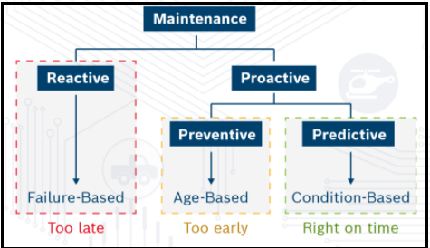

(Image Courtesy: Bosch White Paper-Prognosis for Connected Cars)

**Advantage**:

1. Lower maintenance costs by predicting maintenance activity before component failure
2. Save huge resources by reducing the need to purchase new parts before it fail
3. Reduce out-of-service time by determining when maintenance must be completed in order to minimize system failure risk
4. Helps manufacturers to increase customer satisfaction
5. Reduction in vehicle maintenance cost for end users and warranty cost optimization for the OEMs
6. Reduction in fuel cost and thus reduced vehicle emissions contributing to a cleaner environment.

**How Predictive Diagnosis Works**:

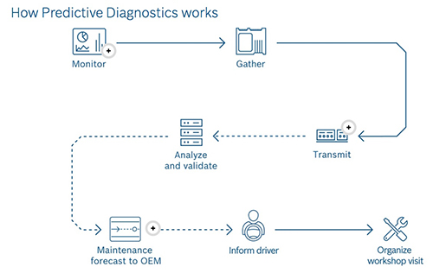

(Image Courtesy: Google Image)

**Approach for further proceeding:**

Approach 1: Use data from sensors

Approach 2: Use historical maintenance and Geographic Information System (GIS) data

Dataset:

1. **Turbofan Engine Degradation Simulation Data Set**

<https://ti.arc.nasa.gov/tech/dash/groups/pcoe/prognostic-data-repository/>

Reference:

1. <https://www.infoq.com/articles/machine-learning-techniques-predictive-maintenance/>
2. <https://github.com/roshanmadhushanka/PythonML/>