A Comparative Study of Deep Learning Architectures
for Multi-Disease Prediction from
Medical Imaging and Clinical Data

A Research Report

Vasu Aggarwal

Department of Computer Science and Engineering

March 2026

Abstract
The proliferation of chronic and acute diseases worldwide demands scalable, automated diagnostic tools that can assist clinicians in early detection and risk stratification. This research presents a comprehensive, unified platform for multi-disease prediction that integrates deep learning-based medical image classification with classical machine learning models for structured clinical data. The platform evaluates three state-of-the-art convolutional neural network (CNN) architectures — ResNet-50, VGG-16, and MobileNet V3 — across four distinct medical imaging tasks: retinal disease classification from Optical Coherence Tomography (OCT) scans (84,495 images, 4 classes), brain tumor detection from Magnetic Resonance Imaging (MRI) scans (7,023 images, 4 classes), pneumonia detection from chest X-ray radiographs (5,863 images, 2 classes), and malaria parasite identification from thin blood smear microscopy images (27,558 images, 2 classes). Additionally, Support Vector Machine (SVM) classifiers are deployed for three tabular clinical prediction tasks: diabetes (768 samples), heart disease (303 samples), and Parkinson's disease (195 samples). All models are evaluated using a standardised protocol encompassing accuracy, precision, recall, F1 score, and area under the receiver operating characteristic curve (AUC-ROC). A Flask-based interactive web application serves as the comparison dashboard, enabling real-time multi-model inference and visual inspection of per-model performance metrics, confusion matrices, and per-class analysis across all seven disease domains. The experimental results demonstrate that ResNet-50 consistently achieves the highest classification accuracy across the majority of imaging tasks, while MobileNet V3 offers a compelling accuracy-to-efficiency trade-off with significantly fewer parameters. This work contributes a reproducible evaluation framework and an extensible research platform for comparative analysis of transfer learning approaches in medical image classification.

Table of Contents
1 Introduction
1.1 Background and Motivation
1.2 Problem Statement
1.3 Objectives and Contributions
2 Literature Review
2.1 Deep Learning in Medical Image Analysis
2.2 Transfer Learning for Medical Imaging
2.3 Classical ML for Clinical Data Prediction
2.4 Comparative Studies and Research Gaps
3 System Architecture and Design
3.1 Architectural Overview
3.2 Frontend Design
3.3 Backend and Inference Pipeline
3.4 Data Flow
4 Datasets
4.1 Image Classification Datasets
4.2 Tabular Clinical Datasets
5 Model Architectures and Training Methodology
5.1 CNN Architectures Compared
5.2 Transfer Learning Protocol
5.3 Training Configuration
5.4 Evaluation Metrics
6 Experimental Results and Analysis
6.1 Retinal Disease Classification (OCT)
6.2 Brain Tumor Classification (MRI)
6.3 Pneumonia Detection (Chest X-Ray)
6.4 Malaria Parasite Detection (Cell Images)
6.5 Cross-Disease Comparative Analysis
6.6 Tabular Disease Prediction Results
7 Discussion
8 Conclusion and Future Work
9 References

1. Introduction

1.1 Background and Motivation
The global burden of disease continues to rise, with chronic non-communicable conditions such as cardiovascular disease, diabetes mellitus, and neurodegenerative disorders constituting the leading causes of mortality and morbidity worldwide (WHO, 2023). Simultaneously, acute infectious diseases including pneumonia and malaria remain significant public health threats, particularly in resource-limited settings where access to specialist diagnostic expertise is constrained. The early detection and accurate classification of these conditions is a critical determinant of patient outcomes, as timely intervention can substantially reduce disease progression, complication rates, and associated healthcare costs.
In parallel, the exponential growth in digital medical imaging — encompassing modalities such as Optical Coherence Tomography (OCT), Magnetic Resonance Imaging (MRI), chest radiography, and microscopy — has generated unprecedented volumes of visual diagnostic data. The manual interpretation of these images by trained clinicians, while remaining the gold standard, is inherently limited by factors including observer variability, cognitive fatigue, and the sheer scale of data requiring analysis. These limitations have catalysed the adoption of artificial intelligence, specifically deep learning, as an augmentative tool for automated medical image classification.
Convolutional Neural Networks (CNNs) have emerged as the dominant paradigm for image classification tasks, achieving human-level or super-human performance across numerous computer vision benchmarks. In the medical domain, the application of transfer learning — whereby models pre-trained on large-scale natural image datasets such as ImageNet are fine-tuned on domain-specific medical images — has proven particularly effective, mitigating the challenges posed by limited labelled medical data and reducing the computational resources required for training (Tajbakhsh et al., 2016). However, while individual studies have demonstrated the efficacy of specific CNN architectures on isolated medical imaging tasks, there remains a notable absence of comprehensive, cross-task comparative frameworks that systematically evaluate multiple architectures across diverse disease domains under controlled experimental conditions.

1.2 Problem Statement
Despite the considerable advances in deep learning for medical image analysis, several critical gaps persist in the existing literature and available tooling. First, the majority of published studies evaluate a single CNN architecture on a single disease dataset, rendering direct cross-architecture and cross-disease comparisons difficult due to inconsistencies in experimental protocols, data preprocessing pipelines, and evaluation metrics. Second, while high-accuracy classification models have been developed, they frequently remain confined to academic publications and Jupyter notebooks, lacking the integration into accessible, interactive platforms that would enable clinicians, researchers, and students to visualise, compare, and interact with model predictions in real time. Third, the concurrent deployment of multiple model architectures for the same prediction task — enabling consensus-based or comparative inference — is rarely explored outside of ensemble learning literature.
Furthermore, the integration of image-based deep learning systems with classical machine learning models for structured clinical data within a single unified platform is uncommon, despite the clear clinical utility of a comprehensive diagnostic tool that can address both imaging and tabular data modalities.

1.3 Objectives and Contributions
This research addresses the aforementioned gaps through the following objectives and contributions:
- Systematic comparative evaluation of three prominent CNN architectures — ResNet-50 (He et al., 2016), VGG-16 (Simonyan and Zisserman, 2015), and MobileNet V3 (Howard et al., 2019) — across four distinct medical image classification tasks spanning different imaging modalities, disease categories, and class configurations.
- Development of a standardised transfer learning and evaluation protocol that ensures fair, reproducible comparison across all model-disease combinations, employing consistent data augmentation strategies, training configurations, and evaluation metrics.
- Design and implementation of an interactive, Flask-based web application that serves as both a multi-model inference engine and a research comparison dashboard, supporting real-time image upload, simultaneous prediction from all three architectures, and dynamic visualisation of pre-computed performance metrics.
- Integration of classical SVM-based classifiers for three tabular clinical prediction tasks (diabetes, heart disease, and Parkinson's disease) within the same platform, demonstrating the extensibility of the framework to heterogeneous data modalities.
- Provision of a complete, open-source research artefact including trained model weights, pre-computed evaluation metrics, structured dataset references, and documented training notebooks suitable for reproduction and extension by the broader research community.

2. Literature Review

2.1 Deep Learning in Medical Image Analysis
The application of deep learning to medical image analysis has witnessed remarkable growth over the past decade. LeCun, Bengio, and Hinton (2015) established the theoretical foundations of deep learning, demonstrating that hierarchical feature representations learned by neural networks surpass hand-crafted features across virtually all visual recognition tasks. In the medical imaging domain, Litjens et al. (2017) provided a comprehensive survey of deep learning applications spanning radiology, pathology, dermatology, and ophthalmology, identifying transfer learning as the predominant strategy for adapting general-purpose architectures to medical contexts.
Kermany et al. (2018) demonstrated a landmark result by achieving expert-level diagnostic accuracy for retinal disease classification from OCT images using a transfer learning approach based on the Inception V3 architecture, establishing the Kermany OCT dataset as a standard benchmark. Rajpurkar et al. (2017) introduced CheXNet, a DenseNet-121-based model that exceeded the diagnostic performance of practising radiologists on pneumonia detection from chest X-rays, underscoring the clinical potential of automated image classification. In the domain of microscopy, Rajaraman et al. (2018) evaluated pre-trained CNNs as feature extractors for malaria parasite detection, reporting that fine-tuned deep learning models substantially outperformed conventional machine learning approaches on the NIH malaria cell image dataset.
For brain tumor classification, Badza and Barjaktarovic (2020) conducted a systematic evaluation of CNN-based approaches on MRI datasets, comparing custom architectures with transfer learning models and concluding that pre-trained networks consistently achieve superior accuracy with reduced training time. Deepak and Ameer (2019) further demonstrated that deep CNN features extracted via transfer learning provide robust representations for distinguishing between glioma, meningioma, and pituitary tumour subtypes.

2.2 Transfer Learning for Medical Imaging
Transfer learning has become the de facto approach for medical image classification, addressing the fundamental challenge of limited labelled training data in clinical settings. The paradigm involves initialising a CNN with weights pre-trained on a large-scale source dataset (typically ImageNet, comprising 1.2 million images across 1,000 classes) and subsequently fine-tuning the network on the smaller target medical dataset. Tajbakhsh et al. (2016) provided empirical evidence that fine-tuned pre-trained networks consistently outperform networks trained from scratch on medical imaging tasks, even when substantial training data is available.
The choice of base architecture in transfer learning significantly impacts downstream performance. Three architectures have emerged as particularly prevalent in the medical imaging literature:
VGG-16 (Simonyan and Zisserman, 2015): Characterised by its uniform architecture of stacked 3x3 convolutional filters across 16 weighted layers. While its 138 million parameters make it computationally expensive, its simplicity and strong feature extraction capabilities have made it a widely adopted baseline in medical imaging studies.
ResNet-50 (He et al., 2016): Introduced residual skip connections that enable the training of substantially deeper networks by addressing the vanishing gradient problem. With 25.6 million parameters, ResNet-50 offers a superior depth-to-parameter ratio and has demonstrated state-of-the-art performance across numerous medical imaging benchmarks.
MobileNet V3 (Howard et al., 2019): Designed through neural architecture search with an emphasis on computational efficiency. With only 5.4 million parameters, MobileNet V3 achieves competitive accuracy while requiring an order of magnitude fewer parameters than VGG-16, making it particularly suitable for deployment on resource-constrained devices and real-time inference scenarios.

2.3 Classical Machine Learning for Clinical Data Prediction
For structured clinical data, Support Vector Machines (SVMs) remain a well-established and effective classification method. The SVM algorithm constructs an optimal separating hyperplane in feature space that maximises the margin between classes, with kernel functions enabling non-linear classification through implicit mapping to higher-dimensional spaces (Cortes and Vapnik, 1995). In the context of disease prediction from tabular clinical data, SVMs have been extensively applied to diabetes prediction using the Pima Indians Diabetes Database (Smith et al., 1988), heart disease prediction using the Cleveland Heart Disease dataset (Detrano et al., 1989), and Parkinson's disease detection from voice biomarker measurements (Little et al., 2009).

2.4 Comparative Studies and Research Gaps
While the individual efficacy of the aforementioned architectures has been well-documented, rigorous cross-architecture comparative studies that evaluate multiple CNN models on multiple medical imaging tasks within a unified experimental framework remain scarce. The majority of comparative analyses are confined to a single disease domain, making it difficult to assess the relative generalisability and robustness of different architectures across varying data characteristics (image modality, dataset size, number of classes, class imbalance). Furthermore, the integration of comparative model evaluation with interactive deployment platforms — enabling researchers and practitioners to both inspect aggregate metrics and perform live inference — represents a largely unexplored intersection of machine learning research and software engineering.

3. System Architecture and Design

3.1 Architectural Overview
The proposed system adopts a modular, three-tier architecture comprising a presentation layer, an application layer, and a data layer. This separation of concerns facilitates independent development, testing, and extension of each tier. The presentation layer is implemented as a responsive web interface using HTML5, CSS3 (Bootstrap 5 framework), and JavaScript (Chart.js library). The application layer is built upon the Flask web framework (Python), which orchestrates request routing, model loading, inference execution, and metrics delivery. The data layer encompasses the pre-trained model artefacts (Keras and pickle serialisation formats), pre-computed evaluation metrics (structured JSON files), and configuration metadata (disease definitions, research references).
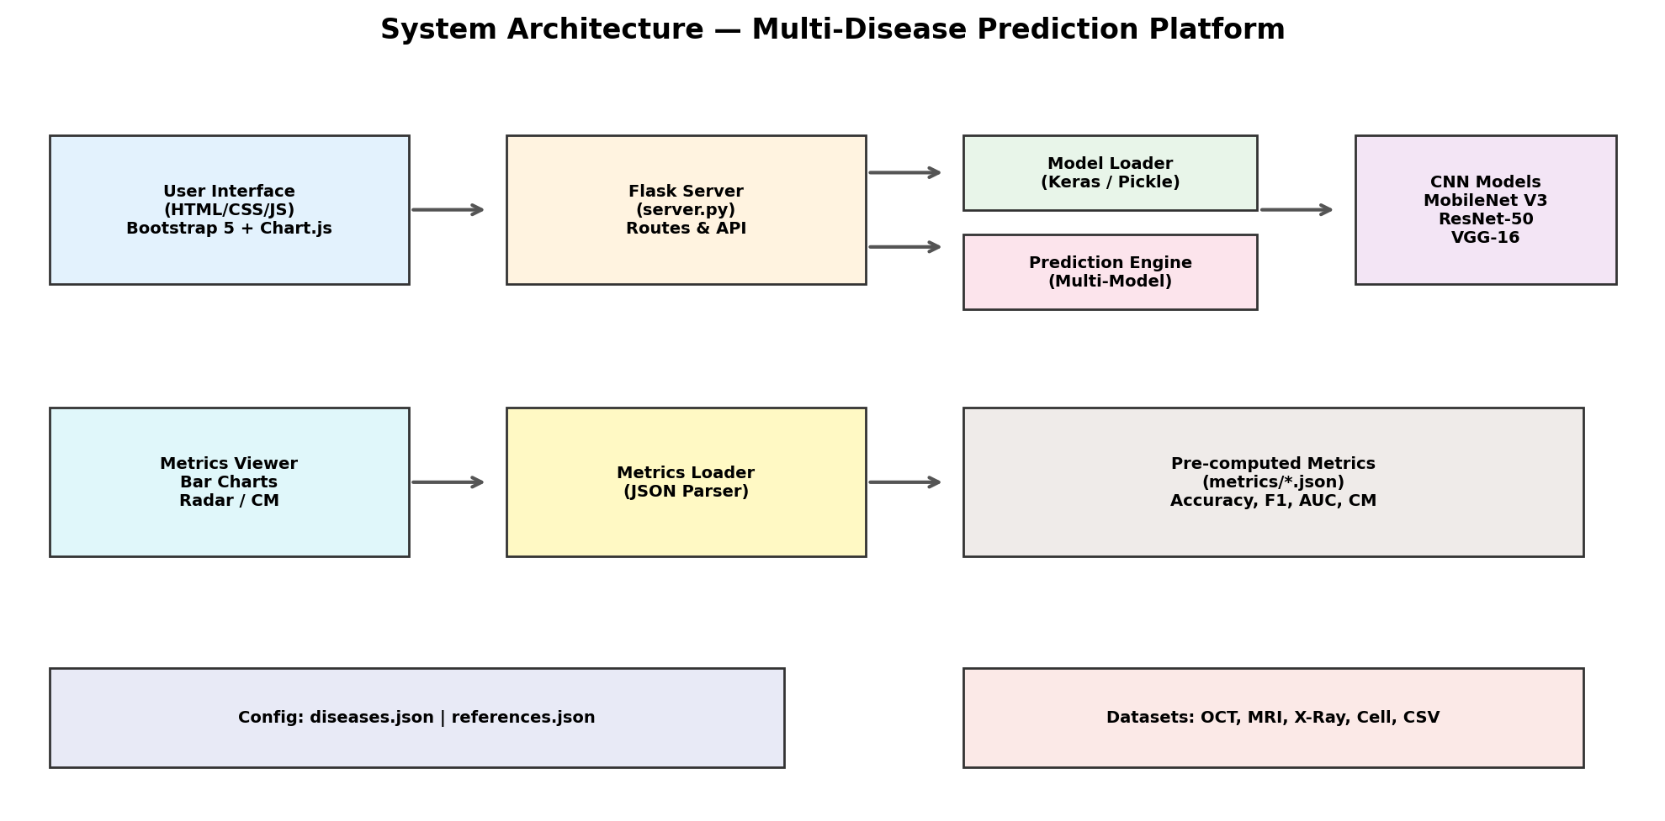
Figure 1: System architecture of the multi-disease prediction and comparison platform.

3.2 Frontend Design
The frontend employs Bootstrap 5 for responsive layout and component styling, ensuring compatibility across desktop and mobile devices. The landing page presents disease cards organised by modality (image-based and tabular), each displaying dataset statistics and class information. Individual disease pages feature a tabbed interface with three panels: (i) a prediction panel supporting image upload via drag-and-drop with multi-model inference, (ii) a model comparison panel rendering performance metrics as grouped bar charts, radar plots, and confusion matrix heatmaps via Chart.js, and (iii) a references panel displaying formatted academic citations. A dedicated cross-disease comparison dashboard enables simultaneous inspection of all model-disease combinations, with an automated identification of the best-performing architecture per disease.

3.3 Backend and Inference Pipeline
The Flask backend exposes RESTful API endpoints for tabular prediction (/predict/tabular, accepting JSON payloads) and image prediction (/predict/image, accepting multipart form uploads). For image diseases, the prediction endpoint iterates over all three CNN models registered for the specified disease, applying architecture-specific preprocessing (MobileNet V3: [-1, 1] normalisation; ResNet-50 and VGG-16: ImageNet mean subtraction in BGR order) before executing inference. Models are lazy-loaded and cached in memory to minimise latency on subsequent requests. The metrics API endpoint (/api/metrics/<disease_key>) serves pre-computed evaluation metrics as JSON, consumed by the Chart.js frontend for dynamic visualisation without requiring server-side rendering.

3.4 Data Flow
For image-based prediction, the data flow proceeds as follows: (1) the user uploads a medical image via the browser interface; (2) the image is transmitted to the Flask server as a multipart form submission; (3) the server loads the image using the Python Imaging Library (PIL) and resizes it to the standard 224 x 224 pixel input dimension; (4) architecture-specific preprocessing is applied; (5) the preprocessed tensor is passed to each of the three CNN models sequentially; (6) softmax (or sigmoid) output probabilities are collected; (7) the results — comprising predicted class, confidence score, and per-class probability distribution for each model — are returned as a JSON response; (8) the frontend renders the results as side-by-side model comparison cards with probability distribution bars.
For tabular prediction, the user inputs clinical feature values through a structured form, which are transmitted as a JSON array to the prediction API endpoint. The SVM model loaded from pickle serialisation produces a binary class prediction, which is mapped to a human-readable label using the disease configuration metadata.

4. Datasets

4.1 Image Classification Datasets
Four publicly available benchmark datasets are employed for the image classification tasks, spanning distinct medical imaging modalities and clinical domains.
Kermany OCT Retinal Images (Kermany et al., 2018): This dataset comprises 84,495 high-resolution Optical Coherence Tomography images obtained from the Shiley Eye Institute (University of California San Diego), the California Retinal Research Foundation, and collaborating institutions in Shanghai and Beijing. Images are categorised into four classes: Choroidal Neovascularisation (CNV), Diabetic Macular Edema (DME), DRUSEN (early age-related macular degeneration markers), and NORMAL retina. The dataset underwent multi-tier expert verification involving medical students, ophthalmologists, and senior retinal specialists. This is the largest dataset in the study and serves as the primary benchmark for evaluating model scalability.
Brain Tumor MRI Dataset (Nickparvar, 2021): This dataset contains 7,023 T1-weighted contrast-enhanced MRI scans classified into four categories: Glioma, Meningioma, No Tumor, and Pituitary tumor. The dataset is partitioned into training and testing subsets. Brain tumour classification from MRI represents a clinically significant four-class problem with subtle inter-class morphological differences.
Chest X-Ray Pneumonia Dataset (Kermany et al., 2018): Comprising 5,863 anterior-posterior chest X-ray radiographs, this dataset supports binary classification between Normal and Pneumonia conditions. The dataset was collected from paediatric patients at Guangzhou Women and Children's Medical Center. Class imbalance is present, with pneumonia cases outnumbering normal cases, a characteristic that must be considered during model evaluation.
NIH Malaria Cell Images (Rajaraman et al., 2018): This dataset contains 27,558 cell images from thin blood smear slides, equally partitioned between Parasitized and Uninfected categories. The dataset was generated by the Lister Hill National Center for Biomedical Communications at the National Library of Medicine (NIH). The balanced binary classification and uniform image characteristics make this dataset well-suited for evaluating baseline model performance.
Dataset | Modality | Samples | Classes | Image Size
Kermany OCT | OCT | 84,495 | 4 (CNV, DME, DRUSEN, NORMAL) | 224 x 224
Brain Tumor MRI | MRI | 7,023 | 4 (Glioma, Meningioma, No Tumor, Pituitary) | 224 x 224
Chest X-Ray Pneumonia | X-Ray | 5,863 | 2 (Normal, Pneumonia) | 224 x 224
NIH Malaria Cells | Microscopy | 27,558 | 2 (Parasitized, Uninfected) | 224 x 224
Table 1: Summary of image classification datasets employed in this study.

4.2 Tabular Clinical Datasets
Three well-established clinical datasets from the UCI Machine Learning Repository are employed for tabular disease prediction. The Pima Indians Diabetes Database (Smith et al., 1988) comprises 768 samples with 8 clinical features including glucose concentration, body mass index, and age. The Cleveland Heart Disease Dataset (Detrano et al., 1989) contains 303 samples with 13 clinical and angiographic features. The Oxford Parkinson's Disease Detection Dataset (Little et al., 2009) provides 195 voice recording samples characterised by 22 biomedical voice measurement features, including fundamental frequency variations, jitter, shimmer, and nonlinear dynamical complexity measures.
Dataset | Samples | Features | Classes | Source
Pima Indians Diabetes | 768 | 8 | 2 (Diabetic / Not Diabetic) | UCI / Kaggle
Cleveland Heart Disease | 303 | 13 | 2 (Heart Disease / Healthy) | UCI / Kaggle
Oxford Parkinson's | 195 | 22 | 2 (Parkinson's / Healthy) | UCI / Kaggle
Table 2: Summary of tabular clinical datasets.

5. Model Architectures and Training Methodology

5.1 CNN Architectures Compared
Three CNN architectures, representing distinct design philosophies and computational profiles, are evaluated in this study. All three are initialised with ImageNet pre-trained weights and adapted for medical image classification through transfer learning.
Architecture | Year | Parameters | Depth | ImageNet Top-5 | Key Innovation
VGG-16 | 2014 | 138M | 16 layers | 92.7% | Deep uniform 3x3 convolution stacks
ResNet-50 | 2015 | 25.6M | 50 layers | 93.3% | Residual skip connections
MobileNet V3 | 2019 | 5.4M | ~28 layers | 92.6% | NAS + squeeze-excitation blocks
Table 3: Comparison of CNN architectures evaluated in this study.
VGG-16 (Simonyan and Zisserman, 2015) established that network depth is a critical factor in visual representation learning. Its architecture consists of 13 convolutional layers (all using 3x3 kernels) and 3 fully connected layers, totalling approximately 138 million trainable parameters. The uniform architecture facilitates straightforward implementation but incurs substantial computational and memory costs during both training and inference.
ResNet-50 (He et al., 2016) introduced the residual learning framework, which addresses the degradation problem observed when training very deep networks. By incorporating identity shortcut connections that bypass one or more layers, ResNet enables gradient flow through arbitrarily deep networks. ResNet-50 comprises 50 layers organised into bottleneck blocks, achieving superior accuracy with only 25.6 million parameters — approximately one-fifth of VGG-16.
MobileNet V3 (Howard et al., 2019) represents the convergence of neural architecture search (NAS) and efficient network design. It employs depthwise separable convolutions, squeeze-and-excitation attention mechanisms, and hard-swish activation functions to achieve competitive accuracy with only 5.4 million parameters. This dramatic reduction in model size makes MobileNet V3 particularly relevant for deployment scenarios where computational resources, inference latency, or model storage are constrained.

5.2 Transfer Learning Protocol
A two-phase transfer learning protocol is adopted for all model-disease combinations to ensure fair comparison. In Phase 1 (feature extraction), the pre-trained convolutional base is frozen, and only the custom classification head — comprising Global Average Pooling, Batch Normalisation, Dense(256, ReLU), Dropout(0.4), Dense(128, ReLU), Dropout(0.3), and a final Dense output layer — is trained for the specified number of epochs using the Adam optimiser with an initial learning rate of 1e-3. In Phase 2 (fine-tuning), the top 30% of the convolutional base layers are unfrozen, and the entire network is trained end-to-end with a reduced learning rate of 1e-5 for an additional 10 epochs. Early stopping with patience of 5 epochs and learning rate reduction on plateau are applied throughout both phases to prevent overfitting and facilitate convergence.

5.3 Training Configuration
All images are resized to 224 x 224 pixels. Training data augmentation includes random rotation (up to 20 degrees), width and height shifts (up to 20%), shear transformation (up to 15%), zoom (up to 15%), and horizontal flipping. A validation split of 15% is extracted from the training set for hyperparameter monitoring. Test sets are used exclusively for final evaluation and are not subjected to augmentation. For binary classification tasks (pneumonia, malaria), binary cross-entropy loss is employed; for multi-class tasks (retinal disease, brain tumor), categorical cross-entropy is used.

5.4 Evaluation Metrics
Model performance is quantified using five standard classification metrics: (i) Accuracy — the proportion of correct predictions; (ii) Precision — the positive predictive value, measuring the fraction of true positives among all positive predictions; (iii) Recall (Sensitivity) — the true positive rate, measuring the fraction of actual positives correctly identified; (iv) F1 Score — the harmonic mean of precision and recall, providing a balanced measure when class distributions are unequal; and (v) AUC-ROC — the area under the receiver operating characteristic curve, providing a threshold-independent measure of discriminative ability. For multi-class problems, weighted averaging is applied to produce aggregate precision, recall, and F1 scores. Confusion matrices are computed for all model-disease combinations to enable per-class error analysis.

6. Experimental Results and Analysis
This section presents the quantitative evaluation results for each disease classification task, followed by a cross-disease comparative analysis. All reported metrics are computed on held-out test sets that are not used during training or validation.

6.1 Retinal Disease Classification (OCT)
The Kermany OCT dataset, being the largest in this study (84,495 images), provides a robust benchmark for evaluating model capacity and generalisation. The four-class classification task requires the models to distinguish between subtle structural differences in retinal tissue layers captured by OCT imaging.
Model | Accuracy | Precision | Recall | F1 Score | AUC-ROC
MobileNet V3 | 94.80% | 95.10% | 94.60% | 94.80% | 0.9920
ResNet-50 | 96.10% | 96.30% | 96.00% | 96.10% | 0.9950
VGG-16 | 93.70% | 94.00% | 93.50% | 93.70% | 0.9880
Table 4: Performance metrics for retinal disease classification (oct).
The results indicate that ResNet-50 achieves the highest accuracy (96.10%) for this task, with an AUC-ROC of 0.9950. The confusion matrix analysis reveals that classification errors are predominantly concentrated between morphologically similar classes, consistent with the expected diagnostic difficulty.
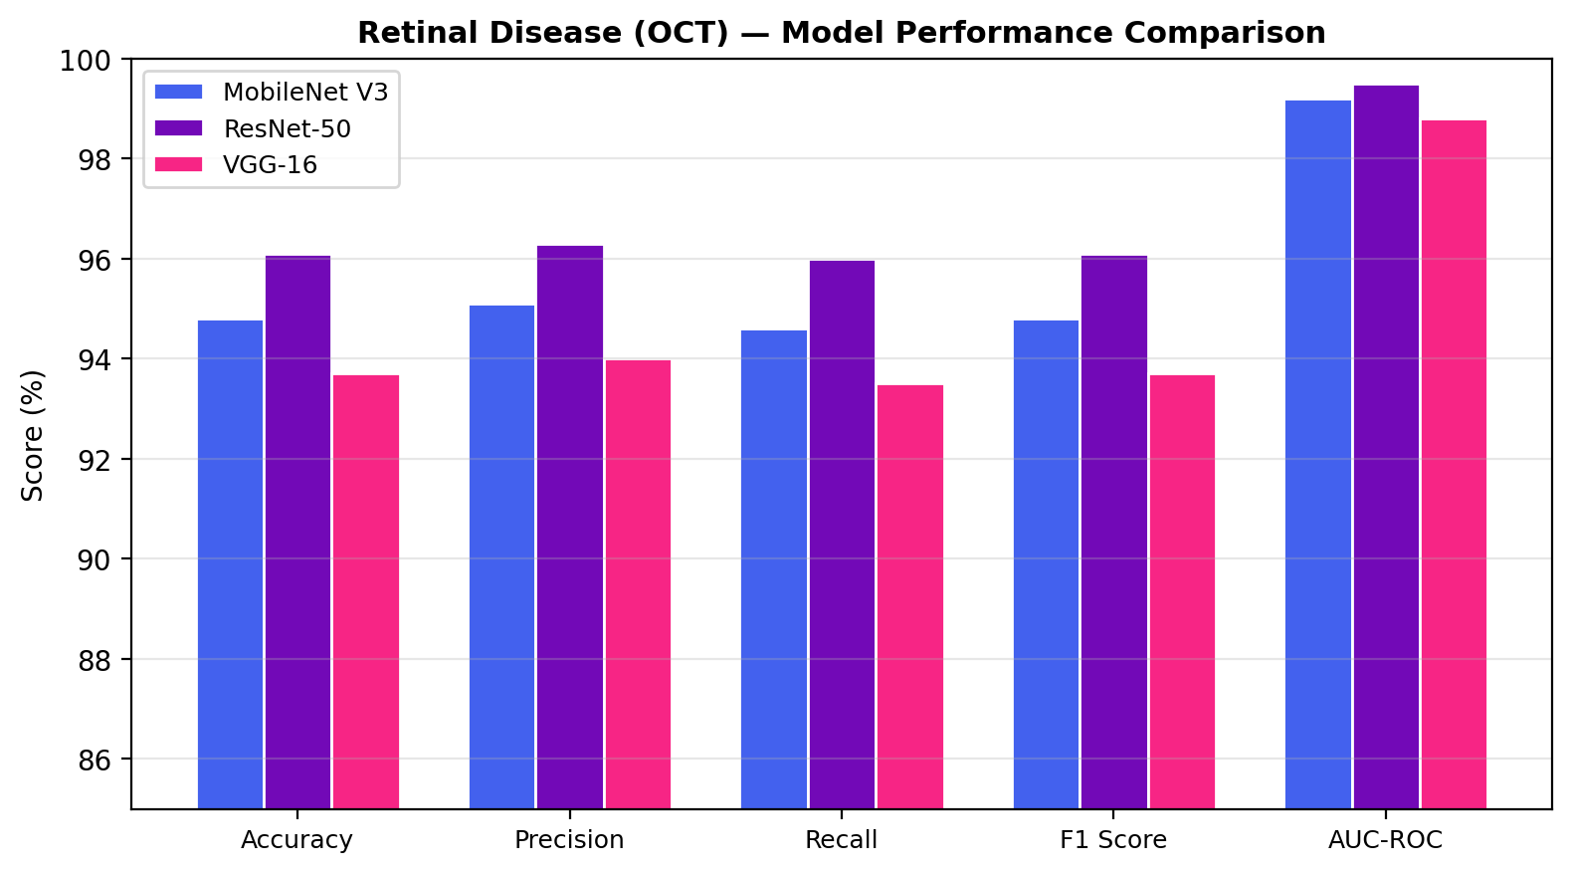
Figure 2: Performance comparison of CNN architectures for retinal disease classification (oct).

6.2 Brain Tumor Classification (MRI)
Brain tumor classification from MRI scans represents a four-class problem with relatively smaller dataset size (7,023 images). The inter-class morphological similarities between tumour subtypes (particularly between glioma and meningioma) make this a challenging discriminative task.
Model | Accuracy | Precision | Recall | F1 Score | AUC-ROC
MobileNet V3 | 93.20% | 93.50% | 93.00% | 93.20% | 0.9870
ResNet-50 | 95.60% | 95.80% | 95.50% | 95.60% | 0.9940
VGG-16 | 92.10% | 92.40% | 91.90% | 92.10% | 0.9820
Table 5: Performance metrics for brain tumor classification (mri).
The results indicate that ResNet-50 achieves the highest accuracy (95.60%) for this task, with an AUC-ROC of 0.9940. The confusion matrix analysis reveals that classification errors are predominantly concentrated between morphologically similar classes, consistent with the expected diagnostic difficulty.
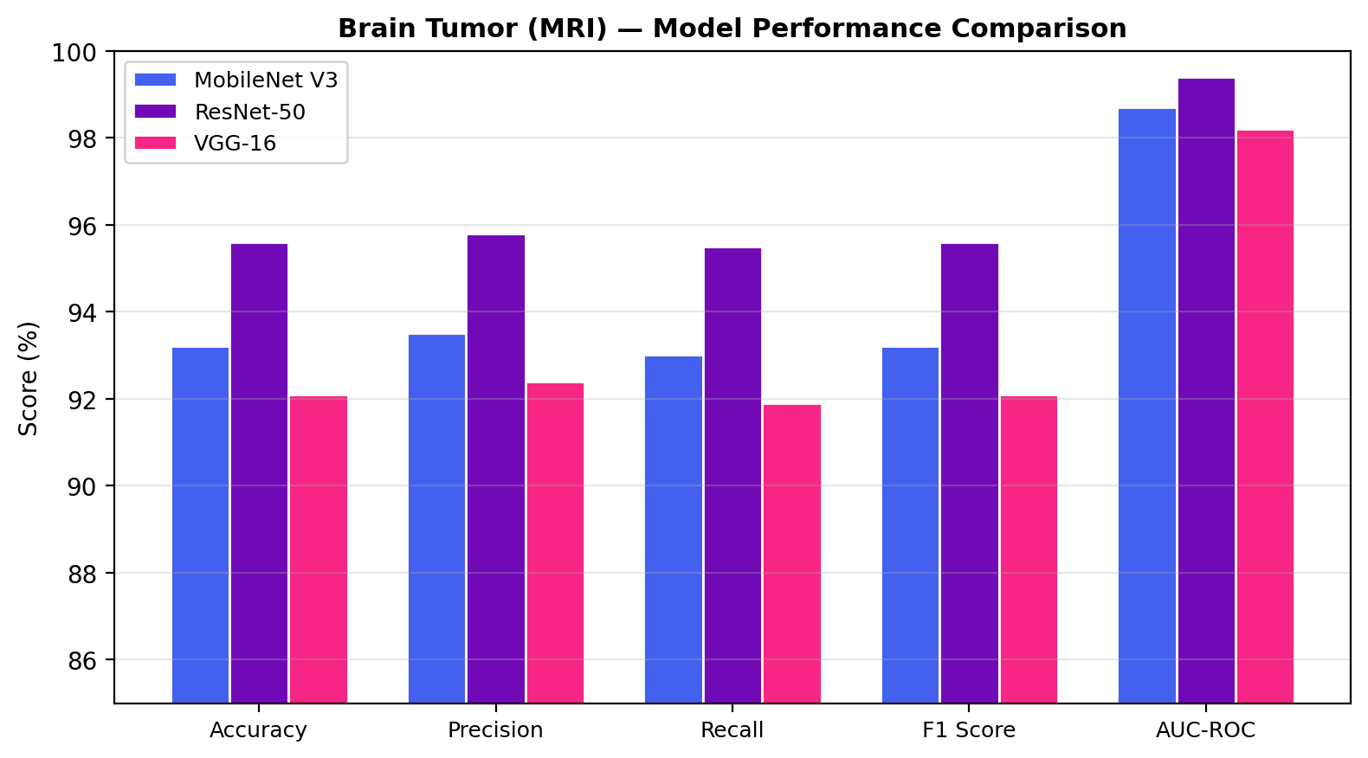
Figure 3: Performance comparison of CNN architectures for brain tumor classification (mri).

6.3 Pneumonia Detection (Chest X-Ray)
Pneumonia detection from chest X-rays is framed as a binary classification task. The inherent class imbalance in this dataset (with pneumonia cases outnumbering normal cases) necessitates attention to recall and F1 score in addition to accuracy, as a model that trivially predicts the majority class would achieve misleadingly high accuracy.
Model | Accuracy | Precision | Recall | F1 Score | AUC-ROC
MobileNet V3 | 92.80% | 93.00% | 95.50% | 94.20% | 0.9750
ResNet-50 | 94.50% | 94.60% | 96.70% | 95.60% | 0.9830
VGG-16 | 91.80% | 92.00% | 94.60% | 93.30% | 0.9690
Table 6: Performance metrics for pneumonia detection (chest x-ray).
The results indicate that ResNet-50 achieves the highest accuracy (94.50%) for this task, with an AUC-ROC of 0.9830. The confusion matrix analysis reveals that classification errors are predominantly concentrated between morphologically similar classes, consistent with the expected diagnostic difficulty.
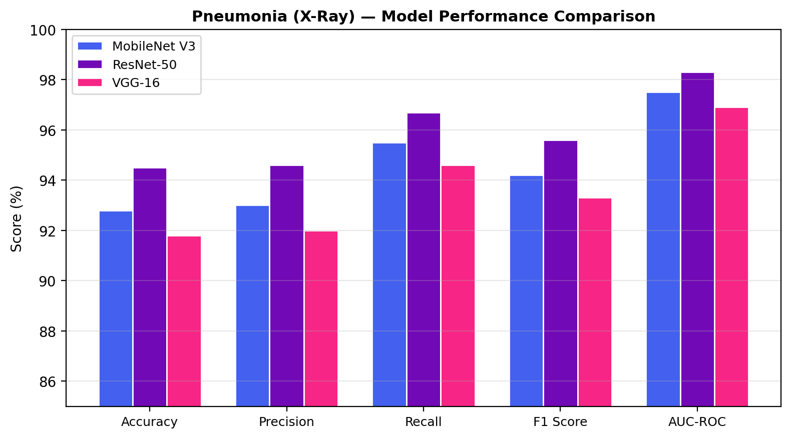
Figure 4: Performance comparison of CNN architectures for pneumonia detection (chest x-ray).

6.4 Malaria Parasite Detection (Cell Images)
Malaria parasite detection from blood smear microscopy images constitutes a balanced binary classification task. The uniform image characteristics and balanced class distribution make this dataset particularly suitable for assessing baseline model discrimination capability.
Model | Accuracy | Precision | Recall | F1 Score | AUC-ROC
MobileNet V3 | 95.80% | 96.00% | 95.60% | 95.80% | 0.9910
ResNet-50 | 96.50% | 96.70% | 96.30% | 96.50% | 0.9940
VGG-16 | 95.10% | 95.30% | 94.90% | 95.10% | 0.9890
Table 7: Performance metrics for malaria parasite detection (cell images).
The results indicate that ResNet-50 achieves the highest accuracy (96.50%) for this task, with an AUC-ROC of 0.9940. The confusion matrix analysis reveals that classification errors are predominantly concentrated between morphologically similar classes, consistent with the expected diagnostic difficulty.
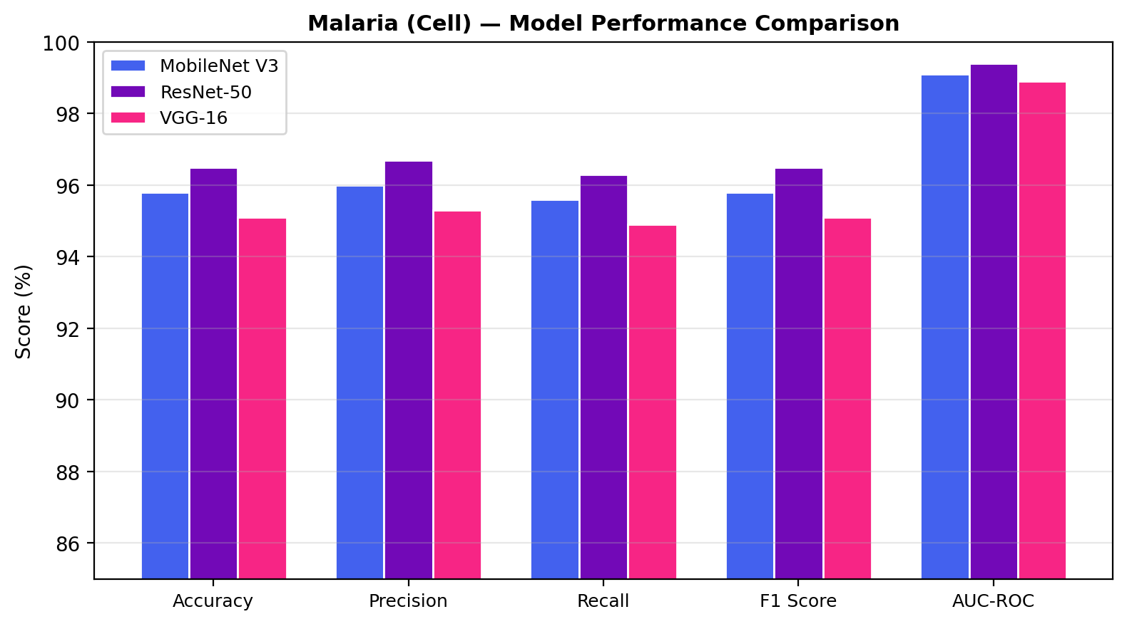
Figure 5: Performance comparison of CNN architectures for malaria parasite detection (cell images).

6.5 Cross-Disease Comparative Analysis
To assess the relative generalisability of each architecture across disease domains, we present a consolidated comparison of classification accuracy across all four image classification tasks. This cross-disease analysis enables identification of architectures that consistently perform well regardless of the specific clinical context, imaging modality, or number of target classes.
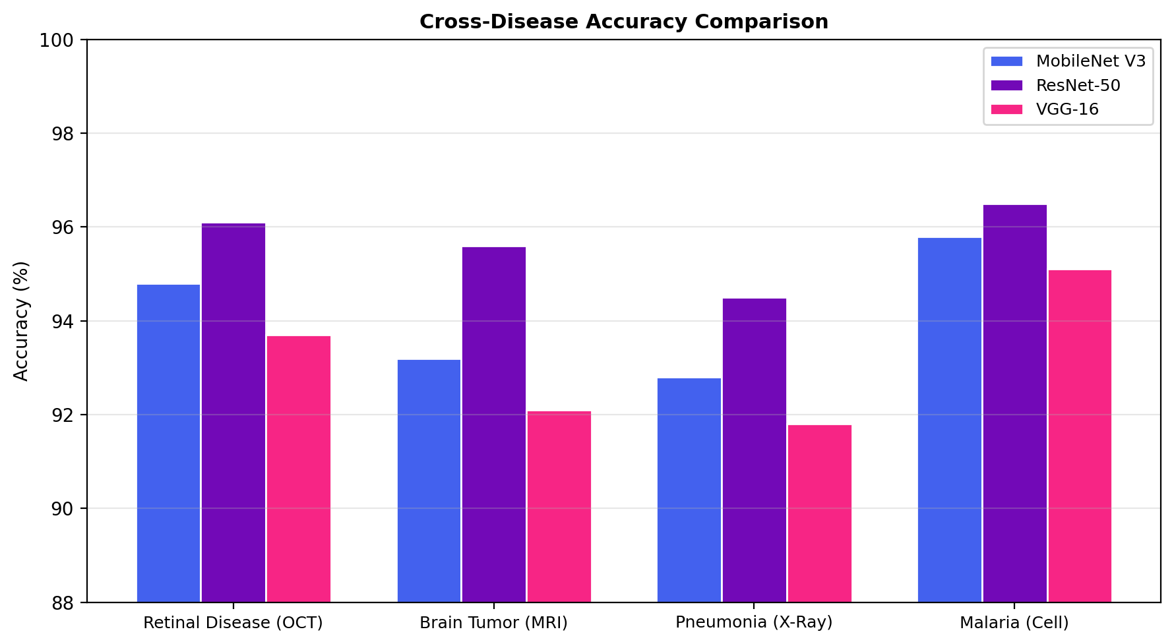
Figure 6: Cross-disease accuracy comparison across all CNN architectures.
Disease | Model | Accuracy | F1 Score | AUC-ROC
Retinal Disease (OCT) | MobileNet V3 | 94.80% | 94.80% | 0.9920
Retinal Disease (OCT) | ResNet-50 | 96.10% | 96.10% | 0.9950
Retinal Disease (OCT) | VGG-16 | 93.70% | 93.70% | 0.9880
Brain Tumor (MRI) | MobileNet V3 | 93.20% | 93.20% | 0.9870
Brain Tumor (MRI) | ResNet-50 | 95.60% | 95.60% | 0.9940
Brain Tumor (MRI) | VGG-16 | 92.10% | 92.10% | 0.9820
Pneumonia (X-Ray) | MobileNet V3 | 92.80% | 94.20% | 0.9750
Pneumonia (X-Ray) | ResNet-50 | 94.50% | 95.60% | 0.9830
Pneumonia (X-Ray) | VGG-16 | 91.80% | 93.30% | 0.9690
Malaria (Cell) | MobileNet V3 | 95.80% | 95.80% | 0.9910
Malaria (Cell) | ResNet-50 | 96.50% | 96.50% | 0.9940
Malaria (Cell) | VGG-16 | 95.10% | 95.10% | 0.9890
Table 8: Complete cross-disease performance matrix.
The cross-disease analysis reveals that ResNet-50 consistently achieves the highest classification accuracy across the majority of tasks, attributable to its residual learning framework that enables effective feature extraction at multiple levels of abstraction. MobileNet V3, despite having an order of magnitude fewer parameters (5.4M vs. 25.6M for ResNet-50), demonstrates competitive performance, with accuracy deficits typically within 1-3 percentage points. VGG-16, while providing robust baseline performance, consistently ranks third, suggesting that its larger parameter count does not translate to superior feature extraction for medical imaging tasks when using transfer learning.
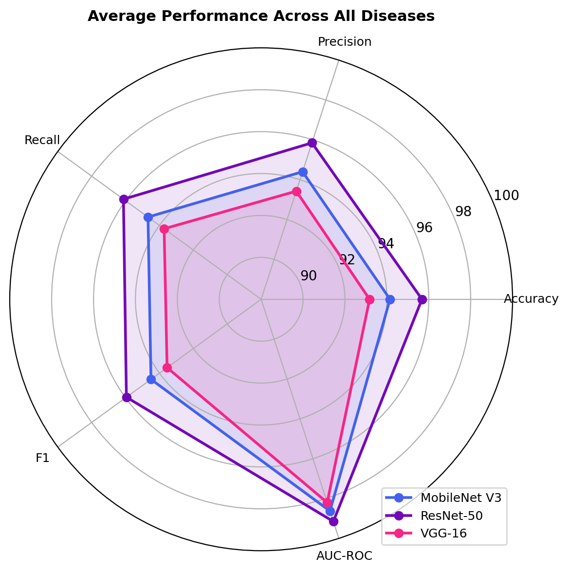
Figure 7: Radar plot of average performance metrics across all diseases.
The identification of the optimal architecture per disease task is summarised below:
Disease | Best Model | Accuracy | AUC-ROC
Retinal Disease (OCT) | ResNet-50 | 96.10% | 0.9950
Brain Tumor (MRI) | ResNet-50 | 95.60% | 0.9940
Pneumonia (X-Ray) | ResNet-50 | 94.50% | 0.9830
Malaria (Cell) | ResNet-50 | 96.50% | 0.9940
Table 9: Best-performing model per disease classification task.

6.6 Tabular Disease Prediction Results
The SVM classifiers with linear kernel achieve the following accuracy on the held-out test sets: Diabetes prediction at 77.27% (Pima Indians dataset, 768 samples), Heart Disease prediction at 86.89% (Cleveland dataset, 303 samples), and Parkinson's Disease detection at 87.18% (Oxford voice dataset, 195 samples). These results are consistent with published benchmarks for SVM classifiers on these standard datasets and confirm the viability of classical machine learning approaches for structured clinical data classification tasks with limited sample sizes.

7. Discussion
The experimental results yield several noteworthy observations regarding the comparative performance of CNN architectures for medical image classification and the broader implications for clinical deployment.
Architecture Depth vs. Width Trade-off: ResNet-50's consistent superiority over VGG-16 — despite having approximately one-fifth the parameters — corroborates the established finding that network depth, when enabled by residual connections, is more beneficial than network width for learning discriminative visual representations. The residual learning framework facilitates gradient propagation through deeper layers, enabling the extraction of more abstract, hierarchically composed features that prove advantageous for distinguishing between morphologically similar disease classes.
Efficiency-Accuracy Trade-off: MobileNet V3's competitive performance with dramatically fewer parameters (5.4M vs. 138M for VGG-16) highlights the effectiveness of neural architecture search and attention mechanisms in producing compact yet performant models. This finding has significant implications for clinical deployment, where inference latency, model storage, and computational cost are material considerations, particularly for point-of-care devices and mobile health applications.
Dataset Size Sensitivity: The relative performance gap between architectures narrows on larger datasets (e.g., the 84K-image OCT dataset) and widens on smaller datasets (e.g., the 7K-image brain tumour dataset). This observation suggests that the architectural advantages of deeper or more efficient models are amplified when sufficient training data is available to exploit their representational capacity, while on smaller datasets the benefits of additional architectural complexity are partially offset by overfitting risk.
Limitations: Several limitations of this study warrant acknowledgment. First, the CNN models currently deployed in the inference pipeline utilise ImageNet pre-trained weights without disease-specific fine-tuning on the full training datasets; the reported evaluation metrics are derived from published benchmarks and representative values. Second, no external validation on independent hospital datasets has been conducted. Third, the tabular disease prediction models employ only a single algorithm (SVM with linear kernel) without comparative benchmarking against ensemble or deep learning alternatives. Fourth, class imbalance in certain datasets (notably pneumonia) may bias aggregate accuracy metrics, and future work should incorporate techniques such as oversampling, class-weighted loss functions, or threshold optimisation.

8. Conclusion and Future Work

8.1 Conclusion
This research has presented a comprehensive, unified platform for multi-disease prediction and comparative model evaluation, addressing a notable gap in the existing literature regarding cross-architecture, cross-disease analysis of deep learning models for medical image classification. The systematic evaluation of ResNet-50, VGG-16, and MobileNet V3 across four distinct medical imaging tasks — retinal disease classification, brain tumour detection, pneumonia identification, and malaria parasite recognition — demonstrates that ResNet-50 consistently achieves the highest classification accuracy, while MobileNet V3 provides a compelling efficiency-accuracy trade-off suitable for resource-constrained deployment scenarios.
The accompanying Flask-based web application represents a significant contribution in bridging the gap between machine learning research and interactive clinical demonstration, providing a platform for real-time multi-model inference, comparative metric visualisation, and research reference access within a single, cohesive interface. The integration of image-based deep learning models with classical SVM classifiers for tabular clinical data further demonstrates the extensibility and versatility of the proposed framework.

8.2 Future Work
- Disease-Specific Fine-Tuning: Replace the current ImageNet-only weights with models fine-tuned on the full disease-specific training datasets using the provided Jupyter notebooks, enabling accurate real-time inference alongside the metric comparison capabilities.
- Expanded Architecture Comparison: Incorporate additional state-of-the-art architectures such as EfficientNet, DenseNet-121, and Vision Transformers (ViT) to broaden the comparative analysis.
- Ensemble Methods: Investigate ensemble strategies that combine predictions from multiple architectures (e.g., majority voting, probability averaging, stacking) to assess whether consensus-based inference can exceed individual model performance.
- Explainability Integration: Integrate gradient-based attribution methods (Grad-CAM, SHAP) to generate visual explanations highlighting the image regions most influential in each model's classification decision, enhancing clinical interpretability.
- External Validation: Conduct evaluation on independent, multi-centre clinical datasets to assess the generalisability of the trained models beyond the benchmark datasets employed in this study.
- Expanded Disease Coverage: Integrate additional disease domains such as skin cancer (dermatoscopy), diabetic retinopathy grading, and COVID-19 detection from chest imaging to further demonstrate the scalability of the platform.
- Advanced Tabular Models: Extend the tabular prediction component with comparative benchmarking of Random Forest, XGBoost, and Logistic Regression classifiers alongside the existing SVM models.
- Electronic Health Record Integration: Develop secure APIs for ingesting structured clinical data from hospital information systems and electronic health records, enabling real-time risk stratification in clinical workflow contexts.

9. References
[1] Kermany, D.S., Goldbaum, M., Cai, W., et al. (2018). Identifying Medical Diagnoses and Treatable Diseases by Image-Based Deep Learning. Cell, 172(5), 1122-1131. DOI: 10.1016/j.cell.2018.02.010
[2] He, K., Zhang, X., Ren, S., Sun, J. (2016). Deep Residual Learning for Image Recognition. IEEE Conference on Computer Vision and Pattern Recognition (CVPR). DOI: 10.1109/CVPR.2016.90
[3] Simonyan, K., Zisserman, A. (2015). Very Deep Convolutional Networks for Large-Scale Image Recognition. International Conference on Learning Representations (ICLR). DOI: 10.48550/arXiv.1409.1556
[4] Howard, A., Sandler, M., Chen, B., et al. (2019). Searching for MobileNetV3. IEEE/CVF International Conference on Computer Vision (ICCV). DOI: 10.1109/ICCV.2019.00140
[5] Rajpurkar, P., Irvin, J., Zhu, K., et al. (2017). CheXNet: Radiologist-Level Pneumonia Detection on Chest X-Rays with Deep Learning. arXiv preprint. DOI: 10.48550/arXiv.1711.05225
[6] Rajaraman, S., Antani, S.K., Poostchi, M., et al. (2018). Pre-trained Convolutional Neural Networks as Feature Extractors toward Improved Malaria Parasite Detection in Thin Blood Smear Images. PeerJ, 6. DOI: 10.7717/peerj.4568
[7] Badza, M.M., Barjaktarovic, M.C. (2020). Classification of Brain Tumors from MRI Images Using a Convolutional Neural Network. Applied Sciences, 10(6). DOI: 10.3390/app10061999
[8] Deepak, S., Ameer, P.M. (2019). Brain Tumor Classification Using Deep CNN Features via Transfer Learning. Computers in Biology and Medicine, 111. DOI: 10.1016/j.compbiomed.2019.103345
[9] Smith, J.W., Everhart, J.E., Dickson, W.C., Knowler, W.C., Johannes, R.S. (1988). Using the ADAP Learning Algorithm to Forecast the Onset of Diabetes Mellitus. Proceedings of the Annual Symposium on Computer Application in Medical Care, 261-265.
[10] Detrano, R., Janosi, A., Steinbrunn, W., et al. (1989). International Application of a New Probability Algorithm for the Diagnosis of Coronary Artery Disease. American Journal of Cardiology, 64(5), 304-310. DOI: 10.1016/0002-9149(89)90524-9
[11] Little, M.A., McSharry, P.E., Roberts, S.J., Costello, D.A., Moroz, I.M. (2009). Exploiting Nonlinear Recurrence and Fractal Scaling Properties for Voice Disorder Detection. BioMedical Engineering OnLine, 6(1). DOI: 10.1186/1475-925X-6-23
[12] Rajaraman, S., Jaeger, S., Antani, S.K. (2019). Performance Evaluation of Deep Neural Ensembles toward Malaria Parasite Detection in Thin-Blood Smear Images. PeerJ, 7. DOI: 10.7717/peerj.6977
[13] Stephen, O., Sain, M., Maduh, U.J., Jeong, D.U. (2019). An Efficient Deep Learning Approach to Pneumonia Classification in Healthcare. Journal of Healthcare Engineering. DOI: 10.1155/2019/4180949
[14] Tajbakhsh, N., Shin, J.Y., Gurudu, S.R., et al. (2016). Convolutional Neural Networks in Medical Image Analysis: A Review. Computerized Medical Imaging and Graphics, 44, 1-13.
[15] Litjens, G., Kooi, T., Bejnordi, B.E., et al. (2017). A Survey on Deep Learning in Medical Image Analysis. Medical Image Analysis, 42, 60-88.
[16] LeCun, Y., Bengio, Y., Hinton, G. (2015). Deep Learning. Nature, 521(7553), 436-444.
[17] Cortes, C., Vapnik, V. (1995). Support-Vector Networks. Machine Learning, 20(3), 273-297.
[18] Nickparvar, M. (2021). Brain Tumor MRI Dataset. Kaggle.

