### **Report**

### **Information retrieval Assignment_4**

### **Steps 1. Data Preprocessing:**

* Cleaning Text and Summary Columns: Remove any special characters, HTML tags, and punctuation. Tokenize the text and summary into words or subwords.  
  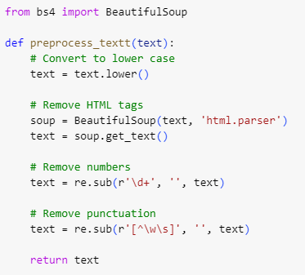

**Output:**

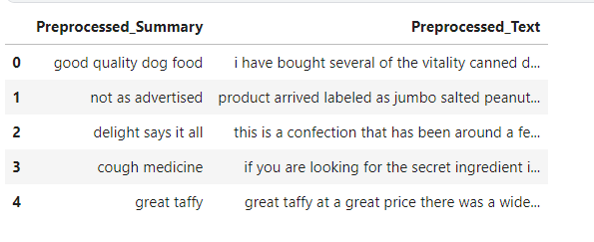

### **Step 2. Model Training:**

* Initializing GPT-2 Tokenizer and Model: Utilize Hugging Face's GPT2Tokenizer and GPT2LMHeadModel.

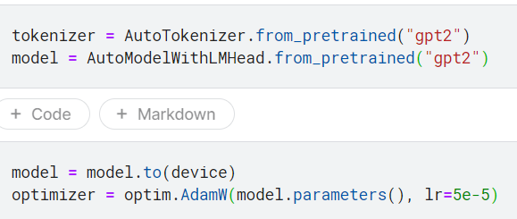

* Data Splitting: Divide the dataset into 75% for training and 25% for testing.
* Custom Dataset Class: Create a custom PyTorch dataset class to prepare the data for training, including tokenization and padding.
* Fine-Tuning GPT-2 Model: Fine-tune the pre-trained GPT-2 model on the review dataset to generate summaries.
* Hyperparameter Tuning: Experiment with different hyperparameters like learning rate, batch size, and number of epochs to optimize the model's performance.
* **Parameter used are (epoch = 6 , learning rate = 5e-5, batch size = 32, sample size = 20000, max length = 180 )**
* **Model is trained on 20K datapoints.**
* **Time to train the model ~1.5 hours.**
* It also has a function to process the query passed and print the output in the given format.

### **Step 3. Evaluation:**

* ROUGE Scores Calculation: After training, compute ROUGE scores on the test set to assess the model's overall performance. Calculate ROUGE scores for every predicted summary versus the actual summary.
* 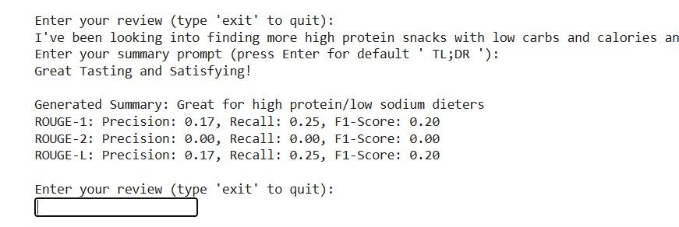
* 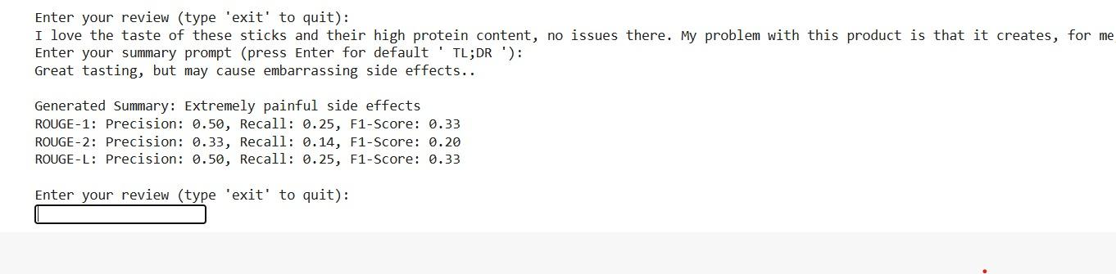

### **Results Analysis:**

* Quantitative Evaluation: Analyze ROUGE scores to understand the model's performance in terms of summarization accuracy.
* Qualitative Evaluation: Examine a sample of generated summaries to gauge the quality and coherence of the generated text.
* Hyperparameter Impact: Discuss the impact of different hyperparameters on the model's performance and convergence.
* Comparison with Baselines: Compare the ROUGE scores achieved by the fine-tuned GPT-2 model with baseline models or approaches to assess the improvement.

### **Conclusion:**

* Summarize the findings from the evaluation, highlighting the strengths and weaknesses of the fine-tuned GPT-2 model for generating summaries from Amazon Fine Food Reviews.
* Discuss potential areas for future improvement or research.