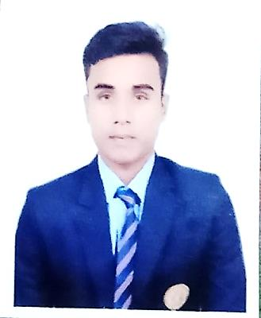

Akhilesh Kumar Chaudhary
Date of birth: 01/07/1999 Nationality: Indian Gender: Male

CONTACT
Shastrinagar, Konnagar,
Hooghly, Pin 712246 West Bengal, India

akhilxyz999@gmail.com

(+91)8790852090

Whatsapp Messenger: 8790852090

ABOUT ME
To secure the opportunity to be a part of in Food and Beverage industry to show my excellence in hospitality sector and aiming to grow along with the development of your organization, Looking forward to discuss my application with you .

15/07/2019 – 22/03/2020 – Hyderabad, India

Former Intern

The Westin mindscape Hyderabad
- I'm a Hotel Management Graduate and I had done my Internship in ALL CORE DEPARTMENTS from The Westin mindscape Hyderabad. During my Internship I have worked in F&B in that speciﬁcally i had worked in BANQUET, RESTAURANT and also IN ROOM DINING.

WORK EXPERIENCE

01/12/2021 – 12/12/2024 – Kolkata, India

GUEST SERVICE ASSOCIATE

J W MARRIOT KOLKATA

- Set the ballrooms or other banquets facility according to all supplies duration of the events.
- BE in Communication with the guest regarding any special need.
- Greet all guest and owner warmly with an appropriate greeting.
- Respond to guest Request in a friendly timely and efficient manner.
- I am very punctual regarding of my work and over the shift.

EDUCATION AND TRAINING
01/07/2018 – 30/06/2021 – Sodhpur, Kolkata, India

Bachelor Administration of Hotel Management

Guru Nanak Institute Of Hotel Management (Kolkata)

I've done my Bachelor's degree from Guru Nanak Institute Of Hotel Management (Kolkata) and my subjects are 1.food Production 2.F&B service 3.Accommodation operation 4. Nutrition 5.accountancy 6.Principles of Food science 7.Management In Tourism 8.Front oﬃce operations 8.HR management 9 Research Methodology 10.facility Planning

Field(s) of study
- hotel management
72% overall

2014 – 2016 – Rishra, Hooghly ,West Bengal, India

10+2

Rishra Swantantra Hindi Vidhyalay under West Bengal Board Of Secondary education
I've done 10+2 from High School in which my subjects are 1.Commerce 2.English 3. Mathmatics 4.Physics 5. Hindi

Field(s) of study
  - pure Commerce 69.4%

10th

Narayangarg High School under Uttar Pradesh Board Of Secondary Education
I've done 10th from Narayangarg High School in which my subjects are 1.Hindi 2.English 3. Mathematics 4.physical Science 5. Life science 6.History 7. Geography

Field(s) of study
  - Education
77.4% |

LANGUAGE SKILLS
MOTHER TONGUE(S): Hindi

OTHER LANGUAGE(S):
English

Listening
C2

Reading
C2

Spoken production C1
Spoken interaction C1

Writing
C2

Hindi

Listening
C2

Reading
A2

Spoken production C2
Spoken interaction C2

Writing
B1

PASSPORT DETAILS
08/04/2019

Passport Number – T5214586
My Passport Expire Will be on 07/04/2029

