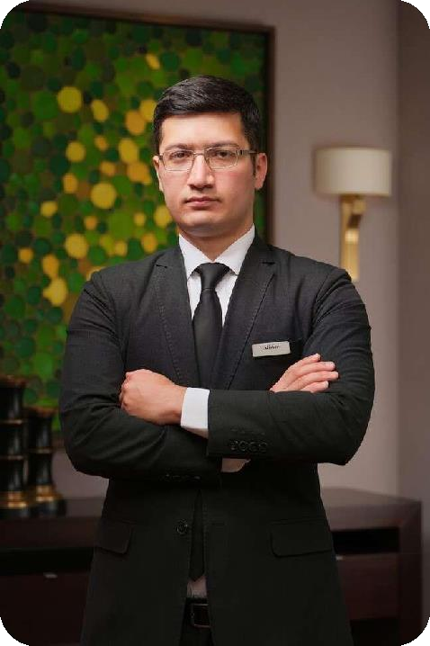Alisher Ergashev

Uzbekistan Tashkent

+998909096779

Experience
19.10.2024 – Present
Director of Food & Beverage Department • Hilton Hotels & Resorts Dushanbe, Dushanbe, Tadjikistan

01.01.2024 – 01.08.2024
Resort General Manager • Burchmulla Mountain Resort Burchmulla Mountain Resort LLC, Tashkent, Uzbekistan

01.08.2023 – 31.12.2023
Hotel General Manager • Burchmulla Mountain Resort Burchmulla Mountain Resort LLC, Tashkent, Uzbekistan
01.12.2020–01.08.2023
General Manager Restaurant & Bar • “Sette" Italian Fine Dining Restaurant & Bar •
Hyatt Regency Tashkent, Uzbekistan

01.03.2022–01.06.2022
General Manager Restaurant & Bar • “Khiva" National and Fusion Cuisine, All Day Dining Restaurant & Bar • Hyatt Regency Tashkent, Uzbekistan
alisher_blend@mail.ru
01.09.2018–01.12.2020
Assistant of Restaurant General Manager • “Sette" Italian Fine Dining Restaurant & Bar • Hyatt Regency Tashkent, Uzbekistan
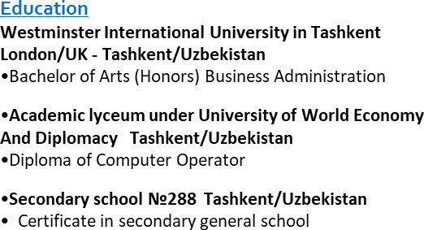

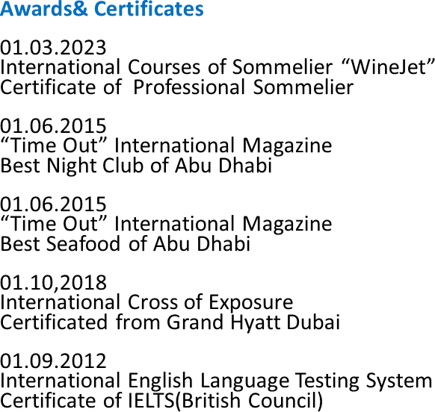
01.09.2016–01.09.2018 (Pre-Opening Team)
Team Leader • “Sette" Italian Fine Dining Restaurant & Bar • Hyatt Regency Tashkent, Uzbekistan

01.12.2015–01.06.2016
Assistant of Restaurant Manager • "Catch" Fine Dining Seafood Restaurant& Bar •
St.Regis Hotel Abu Dhabi, UAE

01.11.2014–01.12.2015 (Pre-Opening Team)
Floor Supervisor • "Catch" Fine Dining Seafood Restaurant& Bar • St.Regis Hotel Abu Dhabi, UAE

01.08.2013–01.04.2014
Administrative Manager • US Travel Uzbekistan

01.05.2012–01.08.2013 (Pre-Opening Team)
Hall Supervisor • “Basilic” Mediterranean Restaurant & Bar • Brassiere Company Tashkent, Uzbekistan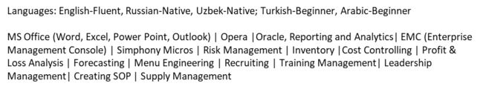
Language & Extracurricular Knowledge



