BIO DATA
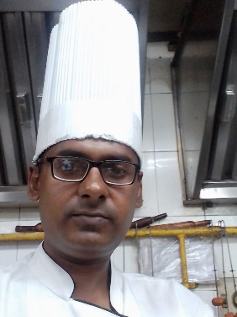
NAME : ARGHYA SUR ROY
FATHER’S NAME : Dipti Kalyan Sur Roy
ADDRESS : G-22, Baghajatin, Kolkata-700086
DATE OF BIRTH : 21/09/1985
CONTACT NO. : 8697473258
NATIONALITY : INDIAN
RELIGION : HINDUISM
MARITAL STATUS : MARRIED
MAIL ID : surroyarghya5@gmail.com

CARRIER OBJECTIVE : To work with a leading organisation and to use
my analytical thinking to the best of my ability
combined with reservation so as to contribute
to the organisations growth and goal as well as
to attain personal goal .

ACADEMIC QUALIFICATION : Passed Madhyamik Exam in 2002 from
W.B.B.S.E
Passed HS exam in 2006 from W.B.C.H.S.E
PROFESSIONAL QUALIFICATION : Diploma in Hotel Management from
London College of Management in
Kolkata from 2005-2008 .
WORKING EXPERIENCE :
- Industrial Training in Hotel Senator in 2007
- Vocational training in ITC Sonar Bangla & Hyatt Regency Kolkata.
- Job training in Hotel Supreme in Goa from Jan 2009 – Dec 2009.
- Working as a commi 3 in Hotel Stadel from Jan 2013 – Nov 2015

Contd………P 2

- Working as a commi in Hotel Hindustan International from Dec 2015 – Apr 2016
- Working as a Commi 2 in Hotel Sonajhuri in Digha from May 2016 – Feb 2019
- Working as a Commi 2 in Hotel Park Prime in Kolkata from June 2022 – Nov 2023

LANGUAGE KNOWN : Bengali, Hindi & English .

I hereby declare that the above informations are correct & truth and to the best of my
knowledge & believe .

Place :
Date : Signature

