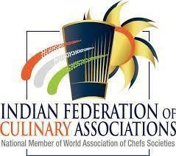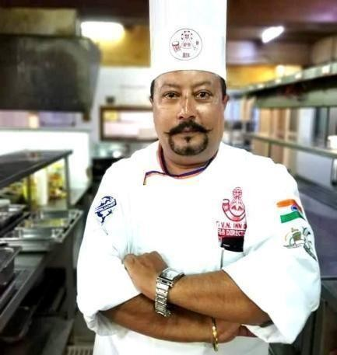

BUDDHADEB CHATTERJEE

Linkedin---https://www.linkedin.com/in/chefbuddha001 Email - Chefchatterjee@gmail.com
Contact no: 8617664504 / 8900500964

A versatile, high-energy professional, targeting senior managerial level assignments in Culinary & Kitchen Management / F&B Management/ Hotel Administration with a reputed organization.

Core Competencies

Food & Beverages Management Kitchen Administration & Operations Staff Training & Development Food Preparation & Presentation
Menu Planning & Pricing Budgeting & Planning

Key Responsibilities

- Heavy Banqueting / Out Door Catering with minimum no of persons 2000 to 5000 including, menu planning ,orientation of Buffet with modern concepts , manpower planning and execution of planning . Facility management was also a part of assignment
- Responsible for Human Resources: benefits, hiring, terminating and orientations. Increased total rooms revenue by 15%, and food & beverage revenue by 25%.
- Analyzed monthly P&L with detailed critique.

- Forecasted daily, weekly and monthly to accomplish budgeted revenues. Directing and coordinating the food & beverage operations for 15000 sq. ft. banquet space and four outlets: Multi Cuisine Specialty Restaurant, Coffee Shop, 24 hrs in room dining.
- Awarded company's cost containment awards. Implemented guest satisfaction program, allowing hotel to improve standards with scores over five.
- Personally and successfully handled all arrangements for high profile guests that earned publicity for the establishment.
- Handled heavy banqueting / outdoor catering with minimum person of 2000 to 5000 including , menu planning, orientation of buffet with modern concepts, manpower planning and execution of planning as well as facility management was also a part of assignments.
- Increased Room and Food & Beverage revenues by 20% over the previous year through the development of new strategies and effective management of programs. Secured new business and expanded the client base by planning and executing dynamic marketing and advertising campaigns with trade papers, local newspapers, Media and the Chamber of Commerce. Maximized revenues by increasing the average daily rate (ADR) through Internet based third-party wholesalers.
- Developed, implemented and sustained aggressive solicitation program focusing on increasing business.
- Analyzed monthly P&L with detailed critique. Forecasted daily, weekly and monthly to accomplish budgeted revenues.
- Developed and completed multi-room renovation project within strict budget and allotted time. Evaluated and re-negotiated all vendor services contracts, resulting in a 15% annual savings while maintaining similar quality and standards.
- Improved employee retention through implementation of departmental training, employee recognition and incentive programs that resulted in a almost static turnover rate of 4.5%.Led full responsibility for the bidding and hiring of all contractors for renovation and PIP.
- Devised and planned all capital expenditures, annual budgets and forecasts; oversaw all volume and profit objectives, P&L, operational strategies and programs. Developed and launched entirely new menus for the restaurant, room service, and catering; developed outside catering menus for multiple local corporate offices.
- Created and established a training program to enhance employee knowledge of best practices, while effectively managing staff and career development objectives. Established significant training programs for each department resulting in increased guest satisfaction.
Organizational Experience
Hotel Name: Double Tree By Hilton(Pre-opening 5star deluxe property with 144
rooms and heavy Banqueting) Location: Varanasi, Uttar Pradesh Designation: Culinary Director
Duration: 05th of Sept 2022 to present

Roles & Responsibilities:

- Direct and oversee all aspects of the hotel’s food and beverage planning and service, with duties to include menu planning and costs, preparation and presentation of food and drinks, and adherence to quality and safety standards.
- Approach all encounters with guests and team members in a friendly, service-oriented manner.
- Supervise food preparation to include methods, portion control and garnishing; ensure attractive presentation of all foods.
- Inspect and taste prepared foods on a daily basis to ensure quality ingredients, good presentations and recipes meet standards.
- Monitor expenses to keep within budgeted guidelines
- Schedule employees at proper staffing levels; watches labor cost daily to ensure efficiency in scheduling
- Requisition food and equipment, giving specifications, quantities and quality descriptions.
- Participate in monthly inventory verification and maintains adequate supplies.
- Respond quickly to guest requests in a friendly manner. Follows up to ensure guest satisfaction.
- Provide a professional image at all times through appearance and dress.
- Follow company policies and procedures and is able to effectively communicate them to subordinates.
- Aggressively recruit staffs for department using company hiring standards (i.e. Behavioral questioning, reference checks, evaluations and team interviews).
- Conduct training classes regarding safety, security, department procedures and service guidelines.
- Develop new menu items and sets pricing, keeping in tune with the market.
- Improve existing practices and services both in the front of the house and the back of the house.
- Ensures Outlets and Kitchen are in compliance with all federal, state and local laws, including OSHA, EEOC, Wage Hour and health laws.
- Follow company policies and procedures and is able to communicate them effectively to subordinates.
- Formulate short term and long term operational and financial plans for the food and beverage department.
- Communicate financial information to the General Manager on a daily basis, including up-to-date budget information and revenue growth programs.
- Prepare the annual hotel budget for food and beverage operations.
- Achieve budgeted revenues, controls cost (which includes labor, food, maintenance, etc.) and maximizes profitability related to the facility operations.
- Ensures proper procedures for handling of financial transactions and credit control.
- Respond quickly to guest requests in a friendly manner. Follows up to ensure guest satisfaction.
- Take an active role in sales and marketing by surveying market to know guest needs, creating special menus for catered events to increase sales and developing innovative ideas to increase average checks, increase covers and increase liquor sales in restaurant.
- Conduct regular food and beverage meetings, providing objective and constructive feedback for the employees. Take time to listen to employees concerns and deal with any challenges in a timely manner.
- Effectively hold training classes for all food and beverage employees to effectively train on safety, proper procedures and service guidelines.
- Maintain constant communication between departments and keeps other departments informed about special programs and events.


Organizational Experience-
Hotel Name: Lemon Grass Group of Hotel and Resort PVT LTD
Location: Durgapur, Designation:
Group Corporate Chef
Duration: 13th of Sept 2021 to 30th July 2022

Roles & Responsibilities:

- Taking care of Six Units including Bakery.
- Responsible for Revenue Budget, Cost Budget, Food Costing, New menu implementation, Training for staffs.
- Interaction with the Guest and Handle all complains and assuring the best quality of food and Services to the Guest.
- Also responsible for huge Banqueting function, proper indenting for every function, Manning with proper Logistic and Brand reputations.
- Monitoring the sales target every month through proper Sales and Marketing platform.
- Ensure implementation of all service and operational standards for maintaining quality and hygiene for streamlining process and generating revenue and ensuring cost saving operations
- Prepare standard recipes and techniques for food preparation and presentation to assure high quality and to ensure minimum costs; exercising portion control for all items served
- Document necessary data for applicable parts of the budget; projecting annual food, labor, other costs and monitored actual financial results and taking corrective action as necessary to meet financial goals
- Established selling prices of food items in the menu
- Bring innovative ideas, molecular fusion & other styles for new dishes and implementing cost control measures
- Recruit & select professionals for maximum productivity and meeting high standards of quality, controls, food and payroll costs for maximum profitability
- Conduct promotional strategies to increase sales volume and achieve maximum customer satisfaction
- Planning, directing, coordinating, forecasting, budgeting and ensuring revenue generation


Organizational Experience-
Hotel Name: Kanha Plam Spring Resort
Location: Hosengabad Road, Bhopal Designation: Chef and Head of Food & Beverage
Duration: October 2019 to August 2021
Roles & Responsibilities:

- Achieved 3% sales growth to budget annually
- Consistently maintained best in company cost of goods to budgeted goals
- Increased hourly employee efficiency and reduced labour costs by 2%, while maintaining quality
- Managed controllable costs to ensure adherence to budget guidelines and expectations
- Accomplished Human Resource objectives by recruiting, selecting, orienting, coaching, and disciplining subordinates. Facilitated vendor relationships for purchasing and cost control capitalizing on the economy of scale. Analyzed sales statistics to properly forecast, schedule and control labour costs.
- Manage overall operations and management of F&B service and production department
- Supervise, trained and lead the productive and efficient team
- Ensure implementation of all service and operational standards for maintaining quality and hygiene for streamlining process and generating revenue and ensuring cost saving operations
- Play a key role in ensuring the profitability of the operations; supervising F&B service and production department
- Analysis daily sales revenue and creating USP for all the F&B outlets
- Monitor quality and quantity of all F&B items served to the guest on day-to-day basis
- Maintain highest service standards for quality of work for smooth F&B operations
- Contribute in setting effective system to check and control daily breakages, misuse of linen, crockery and cutlery to stop and control F&B spoilage
- Prepare standard recipes and techniques for food preparation and presentation to assure high quality and to ensure minimum costs; exercising portion control for all items served
- Established selling prices of food items in the menu
- Document necessary data for applicable parts of the budget; projecting annual food, labor, other costs and monitored actual financial results and taking corrective action as necessary to meet financial goals
- Governing food and beverage staff and management meetings
- Recruit & select professionals for maximum productivity and meeting high standards of quality, controls, food and payroll costs for maximum profitability
- Adhere to establish standards food &service principles to enhance quality of service delivery Maintaining banquet sales division from rejoining period till date


Organizational Experience -
Hotel Name: The Aananda Imperial
Location: Bilaspur, Chhattisgarh
Designation: Food and Beverage Director
Duration: October 2016 to September 2019

Roles & Responsibilities:
- Create plans for menus for an expensive repertoire of menus with portion standardization &supervision of food preparation process
- Administrate all aspects of kitchen management comprising monitoring of food production and aesthetic presentation of food and beverages
- Collaborate with kitchen staff for preparation of meals
- Bring innovative ideas, molecular fusion & other styles for new dishes and implementing cost control measures
- Play a key role in maintaining quality and consistency of food for customer satisfaction
- Work with operating staff for upkeep of kitchen equipment in working order
- Determine strategies for development & expansion in hotels based on current market trends
- Conduct promotional strategies to increase sales volume and achieve maximum customer satisfaction
- Guide subordinate chefs and kitchen chefs for smooth working of operations
- Manage overall operations and management of F&B service and production department
- Supervise, trained and lead the productive and efficient team
- Ensure implementation of all service and operational standards for maintaining quality and hygiene for streamlining process and generating revenue and ensuring cost saving operations
- Play a key role in ensuring the profitability of the operations; supervising F&B service and production department
- Planning, directing, coordinating, forecasting, budgeting and ensuring revenue generation
- Analysis daily sales revenue and creating USP for all the F&B outlets
- Monitor quality and quantity of all F&B items served to the guest on day-to-day basis
- Maintain highest service standards for quality of work for smooth F&B operations
- Contribute in setting effective system to check and control daily breakages, misuse of linen, crockery and cutlery to stop and control F&B spoilage
- Prepare standard recipes and techniques for food preparation and presentation to assure high quality and to ensure minimum costs; exercising portion control for all items served
- Established selling prices of food items in the menu

- Document necessary data for applicable parts of the budget; projecting annual food, labour, other costs and monitored actual financial results and taking corrective action as necessary to meet financial goals
- Governing food and beverage staff and management meetings
- Recruit & select professionals for maximum productivity and meeting high standards of quality, controls, food and payroll costs for maximum profitability
- Adhere to establish standards food &service principles to enhance quality of service delivery maintaining banquet sales division from rejoining period till date.

Organizational Experience -
Hotel Name: Dhensa Boutique Resort & Spa
Location: Phunaka, Bhutan, Designation: Group Head Chef
Duration: May 2016 to September 2016
Roles & Responsibilities:
- Train and monitor the kitchen staff to be highly efficient.
- Examine the freshness of ingredients, conduct food testing and evaluate food presentation.
- Inspect kitchen team strictly adheres to state and BAFRA regulations when it comes to food storage handling and preparation.
- Monitor safety and sanitation codes involving dining utensils, kitchen equipments and overall cleanliness.
- Manage day to day kitchen operation and culinary team.
- Execution of daily food service, quality technique, portion, presentation and food cost control.
- Support management with catering proposal, menu principle and menu innovation.
- Track food cost while managing vendors to provide standard cost efficient products.
- Estimate food consumption and requisite of food purchase.
- Standardize product recipes to ensure consistent quality.
- Assist sales and marketing manager in menu planning and costing for special event catering.
- Collaborate with General Manager on expense tracking for accurate financial projects.
- Implement and maintain culinary excellence standards.
- Make clientele base dietary on daily basis.
- Strictly maintain constant G.S.I. (Guest Satisfaction Index)
- Responsible to set up the brand standard and S.O.P. (standard operating procedure)
- Generate daily operation report and send to head office, Singapore.
- Prepared and submit on the required budgetary information and updates as required.

- Responsible for implementation of global cuisine.
- Need to make everyday new “Table D’hôte” menu as per occupancy and nationality breakup.
- Make a menu of wine and food pairing on daily basis.
- Maintain and take care of Bio garden regularly.

Tripadvisor Review:
https://www.tripadvisor.in/Hotel_Review-g469429-d6408531-Reviews-Dhensa_Boutique_Resort- Punakha_Punakha_District.html#REVIEWS


Organizational Experience -
Hotel Name: The Aananda Imperial
Location: Bilaspur, Chhattisgarh, India
Designation: Food and Beverage Director Duration: October 2014 to May 2016
Roles & Responsibilities:

- Created plans for menus for an expensive repertoire of menus with portion standardization &supervision of food preparation process
- Administrated all aspects of kitchen management comprising monitoring of food production and aesthetic presentation of food and beverages
- Collaborated with kitchen staff for preparation of meals
- Brought innovative ideas, molecular fusion & other styles of new dishes, implementing cost control measures.
- Played a key role in maintaining quality and consistency of food for customer satisfaction
- Worked with operating staff for upkeep of kitchen equipment in working order
- Determined strategies for development & expansion in hotels based on current market trends
- Conducted promotional strategies to increase sales volume and achieve maximum customer satisfaction
- Guided subordinate chefs and kitchen chefs for smooth working of operations
- Managed overall operations and management of F&B service and production department
- Supervised, trained and lead the productive and efficient team
- Ensured implementation of all service and operational standards for maintaining quality and hygiene for streamlining process and generating revenue and ensuring cost saving operations
- Played key role in ensuring the profitability of the operations; supervising F&B service and production department
- Planning, directing, coordinating, forecasting, budgeting and ensuring revenue generation

- Analysis daily sales revenue and creating USP’s for all the F&B outlets
- Monitored quality and quantity of all F&B items served to the guest on day-to-day basis
- Maintained highest service standards for quality of work for smooth F&B operations
- Contributed in setting effective system to check and control daily breakages, misuse of linen, crockery and cutlery to stop and control F&B spoilage
- Prepared standard recipes and techniques for food preparation and presentation to assure high quality and to ensure minimum costs; exercising portion control for all items served
- Established selling prices of food items in the menu
- Documented necessary data for applicable parts of the budget; projecting annual food, labour, other costs and monitored actual financial results and taking corrective action as necessary to meet financial goals
- Governing food and beverage staff and management meetings
- Recruited & selected professionals for maximum productivity and meeting high standards of quality, controls, food and payroll costs for maximum profitability
- Adhered to established standards food &service principles to enhance quality of service delivery. Maintaining banquet sales division from rejoining period till date.

Highlights:
- Attained from Indian Hospitality Congress for outstanding contribution in the year of 2009
- Recognized as ‘Master Chef’ of Indian Cuisine at the Aananda Imperia, Bilaspur
- Merit of achieving sales target of INR 1Crore within 3 months of opening
- Contributed in ranking of hotels No. 1 in Chattisgarh within 6 months of opening
- Streamlined fund resulting in GOP in the year of 2011
- Successfully contributed in major assignments such as new project
- Devised a special cuisine for new year eve in the year of 2012
- Took personal initiatives to improve guest satisfaction level from 25 to 75% in the year 2011
- Recipient of employee of the year for outstanding contribution resulting in create huge corporate segment in the year 2012.
- Got a best Food Award in Bhopal , MP IN 2020
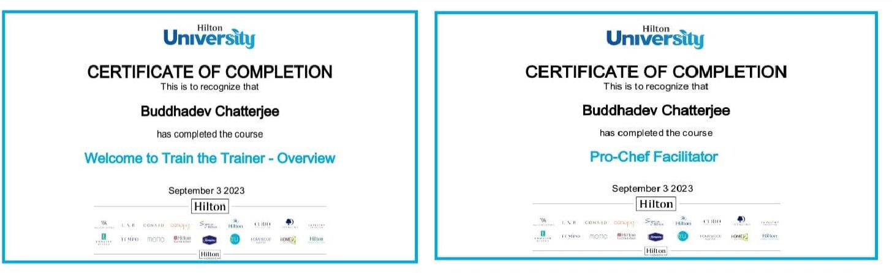

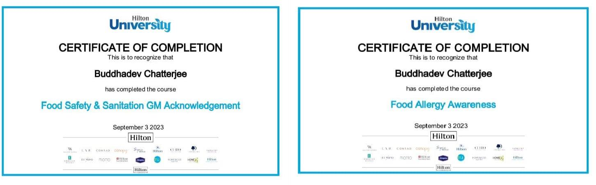
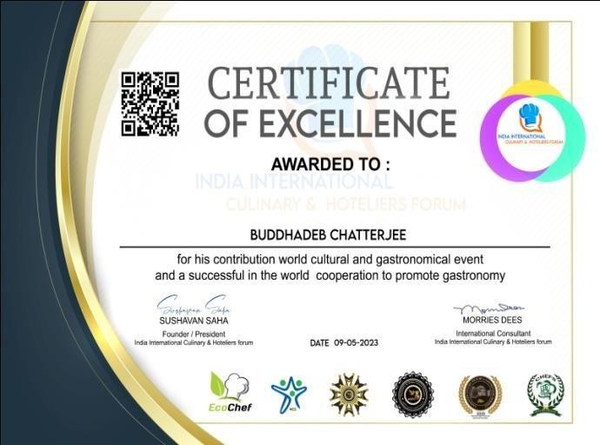
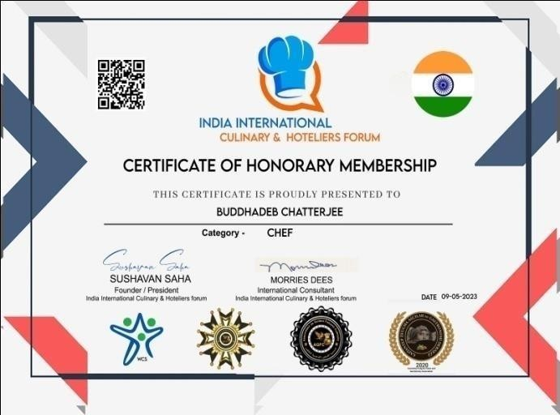

Organizational Experience -
Hotel Name: Rani Indian Bistro
Location:
Boston, United States Of America
Designation: Executive Chef
Duration: August 2012 to October 2014

Roles & Responsibilities:
- Prepared schedules and coordinated with chefs, cooks and other kitchen employees to assure that food preparation is economical, technically correct and within budgeted labour cost goals. Provided approval on requisition of products and other necessary food supplies
- Contributed in maintaining high standards of sanitation, cleanliness and safety measures
- Managed all food production comprising food at restaurant, banquet functions and other outlets
- Created menus, food purchase specifications and recipes

- Determined & monitored food and labour budget for the department to maintain highest professional food quality and sanitation standards



Hotel Name: Indian Awadh Location: Lucknow .U.P. Designation: Corporate Chef Duration: July 2012 to Nov 2012

Roles & Responsibilities:

- Was looking over the entire operations of F&B for 3 hotels as per Standard Operating Procedures.

Hotel Name: Aananda Imperial Location: Bilaspur, Chhattisgarh, India Designation: Executive Chef
Duration: February 2010 to July 2012

Roles & Responsibilities:

- Pre-opening set up with imparting training.
- Menu costing,
- Setting up of the Brand Standards.


Hotel Name: D.S.M.S (Durgapur Society of Management Science) Location: Durgapur ,West Bengal
Designation: Sr.Lecturer
Duration: August 2008 to February 2010

Roles & Responsibilities:
- Imparted knowledge to students by taking practical classes for different cuisines
- Contributed in 100 covers of two Specialty Restaurants under same management
- Acted as:
- In-charge of F&B production for 2500 Capacity Hostel Catering

- Head of research and development programme in the food and beverage production
- Supervised the student grievances cell
- Managed all food related activities at the NIIT, Durgapur

Highlights:
- Launched 3 restaurants for the management named Aananya, Lemongrass and Cruet Set
Hotel Name: The Kebab Factory, Radisson
Location: Chennai, Tamil Nadu, India Designation: MASTER Chef
Duration: January 2008 to August 2008

Roles & Responsibilities:
- Prepare all the kebabs according to the standardized recipes. Managed the outlet comprising costing, training and menu planning

Remaining Organizations -

Hotel Name: Sarovar Group of Hotels Location: Durgapur, West Bengal, India Designation: Executive Sous Chef

Duration: March 2005 to January 2008

Hotel Name: Aditya Group of Hotels Location: Kolkata, West Bengal, India Designation: Executive Sous Chef

Duration: November 2000 to December 2005

Hotel Name: Tident Oberoi Location: Jaipur, Rajasthan, India Designation: Senior Chef de Partie

Duration: June 2000 to October 2000

Hotel Name: Express Group of Hotels Location: Vadodara, Gujrat, India Designation: Kitchen Executive Trainee

Duration: April 1998 to May 2000

Hotel Name: Clarks Hotel Location: Ajmer, Rajasthan, IndiaDesignation: Industrial Trainee

Duration: March 1996 to September 1996

Academics:

- MBA (HM) from – Punjab Technical University.
- BHMCT from – IIAS, AICTE, Kolkata – 1997.
- Bachelor of Commerce – Vidyasagar College – University of Burdwan, Suri, West Bengal – 1993.
- 12th from Benimadhab Institution – West Bengal Council of Higher Secondary Education, Suri, West Bengal – 1991.
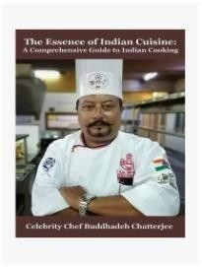
- 10th from Benimadhab Institution – West Bengal Board of Secondary Education, Suri, West Bengal, India – 1989.

Creation

https://amzn.eu/d/7AoYvmC
  - A book writer named “The Essence of Indian Cuisine” that enticing the Indian Culinary and defines the Indian gastronomy
Projects Undertaken

- Herbs Uses as Future Ingredients of Dessert (Research Project)
- Entrepreneurship Development.
- Food And Wine Pairing.
- Gluten Free Food and New American Indian Cuisine (Free from Any Nuts), United States Of America
- Change in Molecular Gastronomy.
- Acted as Head In-charge to train the tribal people under self-help group by Jharkhand government in 2010
- Trained the orphanage people for bakery as a project

Other Professional Achievements

- Food Production Head Examiner for the Rajasthan Deemed University in India in 2008.
- External Examiner of Vinobho Bhave University, Haziribagh for the course of Clinical Nutrition and Dietetics.
- University Station Supervisor in Hotel Management sector for West Bengal University of Technology.
- Active member of Train the Trainer Programme for Jharkhand Tourism Development Corporation.
- Consultant Chef for West Bengal Tourism Development Corporation on their outlet project throughout

- West Bengal (Durgapur, Siliguri, Burdwan, Asansol & Bolpur)

- Member of IFCA-Eastern Region (Indian Federation of Culinary Association under the banner of WACS (World Association of Culinary Society)
- Pride Member of A.C.F – American Culinary Federation since April 2013

Personal Details

Date of Birth : 16.12.1973
Gender : Male
Marital status : Married
Nationality : Indian
Permanent address : Karidhya Dist-Birbhum West Bengal India
Pin : 731126
Religion : Hinduism
Passport Details : Passport no – U2907928 Date of Issue – 12.10.2020 Date of Expir – 11.10.2030

Languages Known:

Sl No | Languages Known | Reading | Writing | Speaking
1 | English | Fluent | Fluent | Fluent
2 | Hindi | Good | Good | Fluent
3 | Bengali | Fluent | Fluent | Fluent
4 | Odia | NA | NA | Fluent
5 | Gujrati | NA | NA | Good
6 | Spanish | NA | NA | Can Understand
7 | Nepali | NA | NA | Fluent

