CURRICULUM VITAE
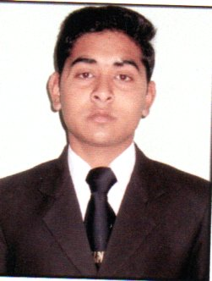

RAHUL DUBEY

Mob: +91-9760795137
EMAIL: rahuldubeyrd9925600@gmail.com

CAREER OBJECTIVE:
- I want to secure a challenging position in an reputable organization to expand my learnings , skills and knowledge while making significant contribution to the success of the organisation.

EDUCATIONAL QUALIFICATION:
- Bachelor's Degree in Hotel Management from Alpine Group of Institute, Premnagar, Dehradun affiliated with Hemwati Nandan Bahuguna Central University, Srinagar, Garhwal.
- Intermediate Passed from CBSE Board in Year 2018.
- High School Passed from CBSE Board in Year 2016.

WORKING EXPERIENCE:
- Currently working as Commii Il Indian Indian Curry section at Holiday Inn Candolim , Goa from 4th December 2024.
- Worked as Commii II in Indian Curry section at Radisson Blu Hotel Ahmedabad, Gujarat w.e.f 01/04/24 to 15/11/24.
- Worked as Commii lll in Indian Curry section at Radisson Blu Hotel Ahmedabad, Gujarat w.e.f 17/10 /2022 to 30/03/24.
- On Job Training from Fairfield by Marriott, Lucknow, UttarPradesh from 09 /03/ 2022 to 31/08/2022 in Culinary section(Indian curry).
- Industrial Training from Radisson Blu Udaipur Palace Resort and Spa from 01/07/2019 to 01/12/2019.

HOBBIES:
- Travelling

SKILLS AND ABILITIES:
- Self Motivated and Honest.
- Dedicated and Decision maker.
- Keen learner

PERSONAL DETAILS :
Name : Rahul Dubey
Father's Name : Mr. SatishDubey
Mother Name : Mrs. Geeta Devi
Date of Birth : 28/11/1999
Languages : Hindi & English
Gender : Male
Address : 110/4 Chander Nagar , Dehradun(UK) 248001
Marital status : Unmarried
Nationality : Indian

DECLARATION:
I hereby declare that the above mentioned particulars are true and correct to the best of my knowledge and belief.

Date ........................
Place ....................... (RAHUL DUBEY)

