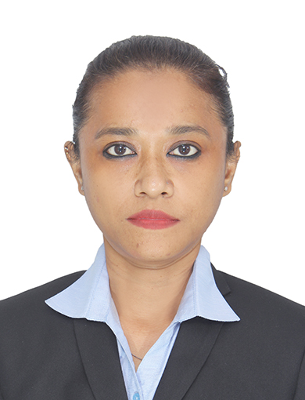

PERSONAL DETAILS:

RESUME

NAME : Dejina Rani Roychowdhury

DATE OF BIRTH : 25th October 1978

PERMANENT ADDRESS : 173/3 Putiary Banerjee Para Road
Haridevpur Kolkata Opp.Milan Sangha Club
Tollygunge Kolkata 82 .West Bengal

CONTACT NO. : +9170020 73592
E-MAIL ADDRESS d_roy_chowdhury@yahoo.com HEIGHT : 157 cms.
NATIONALTY : Indian MARITAL STATUS : MARRIED LANGUAGES KNOWN

 | ENGLISH | HINDI | ASSAMESE | BENGALI
READ | √ | √ | √ | √
WRITE | √ | √ | √ | √
SPEAK | √ | √ | √ | √

QULIFICATIONS:

LEVEL | SCHOOL/COLLEGE | YEAR | RESULT
- Class10th  - Class12th | Peace Cottage School, Dibrugarh  Oil India Higher Secondary School, Duliajan | 1997  1999 | Pass Pass

NAME OF COURSE |  | INSTITUTE |  | YEAR | RESULT
1.Diploma In Aviation 2.Hospitality  3.Travel And Tourism Management 4.Personality Development, Grooming,  First Aid & Swimming |  | Frankfinn Institute of Air Hostess Training, Guwahati, Assam |  | 2004-2005 | Pass
NAME OF COURSE | INSTITUTE |  | YEAR |  |  | RESULT
Diploma in Computer  Office2000& Internet | Institute of Information Technology  & Management, Tinsukia, Assam |  | 2004 |  |  | Pass

WorkExperience:
Worked at The Gateway Hotel Nasik (Tata Enterprise) as a Travel Desk Executive (Indi travel Private Limited) period from 05January 2007 till 31st March 2011.

Job Profile at The Gateway Hotel:
- Responsible for tour reservation.
- Responsible for duty allocation and briefing to the staff.
- Responsible for smooth day to day functioning and supervise the tour reservation, ticketing.
- Responsible for guest preferences.
- Handling guest complaint and make suggestion to the guest
- Responsible as trainer in the department
- Report to the F.O.M and discuss all the information
- Additional responsibility to work at the hotel Front Desk in Reservations Check-in, check-out, greetings, billing, profiling, service centre.
- To give regular feedback to the F.O.M.
- Presently working at EllBEE GANGA VIEW HOTELl Rishikesh from 15 April 2023 as a Front Office Executive.
JOB Profile at ELLBEE Ganga View Hotel
- Overseeing the day to day operations including check in, check-out, hotel reservations, guest queries, maintaining guest records, CForm,coordinate with housekeeping. Handles conceirge desk of hotel.
- Handles guests interaction in person and also email correspondence ,ensures that the guest have a good time and convert their happiness into great reviews.
- Responsible to execute the task which will be inclusive always.
- Reports to the Managing Director of the hotel and discuss all the informations.

PLACE: Rishikesh Signature
DATE: Dejina Rani Roychowdhury

