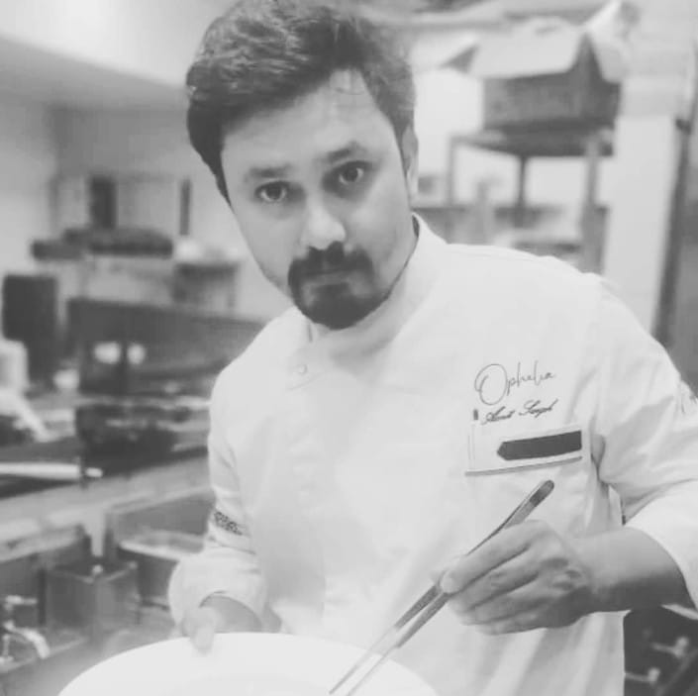 AMIT SINGH
Mobile: +91 9810587644| E - mail: amits9713@gmail.com
Social Media Instagram : amits9713
Chef, gastronomic, continental, Italian, Fusion
HACCP (FOSTAC) CERTIFIED

Offer capabilities in Operations & Process Management in Hospitality sector with methodological approach and ability to utilize experience and skills to impact organisational growth.

Synopsis

- Experience in working with multi-functional teams.
- Presently associated with PULLMAN & NOVOTEL AEROCITY, As a COMPLEX CHEF DE CUISINE.
- A people-oriented approach and can get along well within a new corporate culture.
- Persistent in follow-ups with attention to detail.
- Accepts Challenges and work towards achieving success.

Career Path
__________________________________________________________________________________________
PULLMAN & NOVOTEL AEROCITY MAY 2023 - TILL DATE
(COMPLEX CHEF DE CUISINE)

Responsible for complex hotel production pullman 270 keys & Novotel 400 keys
(Accor flagship largest in south east Asia)
Coffee Shop
In Room Dining (Pullman & Novotel (Both hotels)
Quoin Bar
- Controlling and directing the food preparation process and any other relative activities.
- Constructing menus with new or existing culinary creations ensuring the variety and quality of the servings.
- Approving and “polishing” dishes before they reach the customer.
- Managed food and product ordering by keeping details records and minimize waste, plus work with existing work format.
- Improve waste reduction and manage budgetary concerns.
- Launching new products for company upcoming restaurant all food preparation and presentation, to ensure quality and restraunt standards.

MARRIOTT, JAN 2023- May 2023
THE WESTIN SOHNA GURGAON
New Delhi (Chef de cuisine)
- Supervise the preparation of all food, ensure all food is prepared as per food preparation requirements.
- Ensure meals are produced on time, and sufficient quantities are available for the various areas.
- Delegate duties to kitchen staff as per the menu requirements
- Oversee and monitor the work of kitchen staff to ensure all tasks are done as required
- Give staff feedback on their performance to enable staff development
- Ensure any staffing issues are resolved fairly and quickly
- Pay careful attention to the operating budgets of the department to ensure that costs are controlled to maintain the correct levels of spending

CHEF CONSULTANT
With close to decade of hands-on experience & exposure within the hospitality vertical-have had a very successful & satisfying track record in Italian cuisine till date which only improves with each passing day & also with each hotel & restaurants I have creates depending on various specification &standards demanded by.
During the pandemic time I have started the role of food consultant and got many good results till now in Delhi & NCR.
These are my projects: -
W AT RAJINDRA NAGAR
WHITE OAK AT GHITORNI DELHI
AN AIVORY REGION DELHI
COSY BOX DELHI
RIZQ DEFENCE COLONY
_________________________________________________________________________________

(OPHELIA, NEW DELHI (HEAD CHEF) SEPTEMBER 2019- JAN 2023
THE ASHOK HOTEL
- Controlling and directing the food preparation process and any other relative activities.
- Constructing menus with new or existing culinary creations ensuring the variety and quality of the servings.
- Approving and “polishing” dishes before they reach the customer.
- Managed food and product ordering by keeping details records and minimize waste, plus work with existing work format.
- Improve waste reduction and manage budgetary concerns.
- Launching new products for company upcoming restrauntas all food preparation and presentation, to ensure quality and restraunt standards.

The Imperial, New Delhi
(Kitchen Executive) OCTOBER 2016- AUGUST2019
- Responsibility for the majority of duties and responsibilities of the chef, such as inventory, kitchen staff management and food preparation.
- Assisting in overseeing and directing all aspects of the operation of the kitchen and in providing functional assistance; coordinating activities and functions with other heads in the food and beverage department, especially in the absence of head chef.
- The individual in this role is responsible for food preparation, storing and service delivery to customers in their establishments.

The Leela Palace, New Delhi January 2015 – DEC 2015
FRENCH –ITALIAN
––––––––––––––––––––––––––––––––––––––––––––––––––––––––––––––––––––––––––––––––––––––––––
- Providing my guest high quality standard service.
- Assist guest efficiently, courteously and professionally in all food and beverage related function in order to maintain a high standard of service and hospitality in all time.
- Provide high quality of food service to the guest.

Le Meridian, New Delhi (Commis) July 2011-Dec 2014
–––––––––––––––––––––––––––––––––––––––––––––––––––––––––––––––––––––––––––––––––
- Check the freshness of food and ingredients.
- Supervise and coordinate activities of cooks and other food preparation workers.
- Develop recipes and determine how to present dishes.
- Plan menus and ensure the quality of meals.
- Inspect supplies, equipment, and work areas for cleanliness and functionality

Industrial Training
–––––––––––––––––––––––––––––––––––––––––––––––––––––––––––––––––––––––––––––––––

- Completed Six Months Industrial Training in F & B Production from “LE MERIDIEN New Delhi, CJ International Hotel’s Ltd, Windsor place New Delhi.

Awards & Recognitions

- Participated in various activities at institute level.

PROFESSIONAL QUALIFICATION
- Diploma in Hospitality and Hotel Management from Delhi institute of Hotel Management Lajpat Nagar, New Delhi.

EDUCATION

Qualification | University/Institute/Board |  | Year
Diploma in Hospitality and Hotel Management |  | DIHM | 2010
Senior Secondary Certificate – 12th |  | DC Arya Sr.Sec. School Lodhi Colony (CBSE) | 2007
Higher Secondary Certificate – 10th |  | DC Arya Sr.Sec. School Lodhi Colony (CBSE) | 2005

JOB DISCRIPTION
- Ensure consistent and smooth running of food production.
- Ensure effective stock purchase, its receipt and storage.
- Ensure that working areas are always kept clean.
- Assist other kitchen staff as need arises.
- Perform other administrative tasks as will be communicated by superiors.
- Ensure that required standards are adhered to in the production and preparation of food – in quality, quantity.
- Work towards exceeding customer’s expectation by encouraging and promoting high level of service.
- Ensure all complaints, inquiries, and suggestions by customers are attended to accordingly.
- Give appropriate support or guidance to members of kitchen when need arises.
- Resolve possible disputes within the kitchen and report any unresolved.
- Promote good team spirit regularly.
- Ensure all dishes are prepared according to specification and served at the correct quality, portion size, and temperature.
Assets:-
- Hard working, high confidence level, positive attitude and above all keen to learn.
- Ability to work within teams and as an individual; a self-starter who can work within a framework and with some support.
- Strong programme implementation and management skills including team coordination, supportive supervision and task planning.
Personal Details

FATHERS NAME : LATE. SH. AVTAR SINGH
DOB : 16TH JAN 1990
MARITAL STATUS : MARRIED
LANGUAGE KNOWN : ENGLISH &HINDI
ETHNICITY : INDIAN
STAR SIGN : ARIES

HOBBIES: Cooking food with passion.
“I hereby declare that all the given information above is equitable with my best knowledge”.
Date:
Place: Delhi
Sign. {AMIT SINGH}
Signature ……………….

Date …......................

