Cover letter

I wish to consider my candidature for the post of Corporate Chef. I am articulate, presentable, friendly, energetic, and capable of running a large service staff. My understanding and adeptness to add and provide efficient service to customers with serve your company goals. Moreover, my bilingual skills, life experiences and studies have given me the practical know how, which would be great assets. I am looking forward to expanding my experience and encountering new growth and potential possibilities, which I believe your company, can afford me. I am confident that my education, experience, and dedication to quality service will enable me to succeed. I offer high energy level, strong interpersonal and organizational skills which believe make me a strong candidate for this position. I welcome the opportunity to discuss with you in greater details the position and hope to schedule and interviews with you in the upcoming weeks.

CHANDAN SINGH

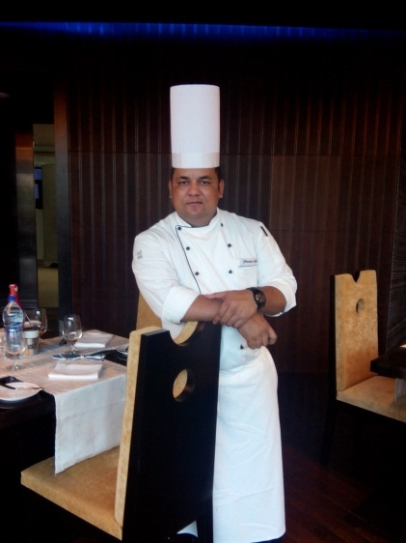
E-mail: chefchandan357@gmail.com

Mobile: 91-7557607177

OBJECTIVE

To continue to build upon my years of experience with an organization that is a benchmark in the hospitality industry. Offer my knowledge, devotion and passion to help achieve our common goals while providing myself with the opportunities to grow and be successful.

SUMMARY
• Proven ability supervising and training new employees.
• Ability to plan a variety of minus from fine dining to contemporary modern culinary set up.
• Efficiently handle inventory control to ensure waste and theft is reduced
• Solid understanding and enforcement of safety procedures
• Ability to plan work schedules and assign duties in accordance to the work schedule.
• Expert in Training Modules across all level staff.
• Assessing competencies and suggesting refresher training.

RESPONSIBILITIES
• Responsible for complete kitchen operations
• Implementing SOPs as per the company polices and standard
• Controlling food cost, hygiene of kitchen service area, store monitoring and HACCP.
• Responsible for standardizes recipe production.
• Managing the daily shift operations of a specific production function facility
• Ensuring that the set of standard procedures and targets are adhered to and are in line with the hygiene and safety standards.
• Responsible for overseeing all daily operation activities in the kitchen
• Supervising staff, maintaining production schedules planning and assigning work and training staff on the job while maintaining established quality & hygiene standards.
• Liaising with seniors to propose menus and develop new work methods to meet customer requirement with utmost adherence to quality and hygiene standards.
• Conducting daily production briefings on all matters relating to daily operational activities and or related activities.
• Appling the quality policy and quality system established in accordance with international standards General Management and operations Food & Beverage Operations
• Preparing and monitoring of food & beverage budgets and maintaining appropriate documentation for sales, cost and inventory Controls for timely indenting of supplies.
• Overseeing all aspects of kitchen Management including menu planning and monitoring.

Management and operations Food & Beverage Operations
• Preparing and monitoring of food & beverage budgets and maintaining appropriate documentation for sales, cost and inventory Controls for timely indenting of supplies.
• Overseeing all aspects of kitchen Management including menu planning and monitoring food production.
• Ensuring compliance with preset quality & hygiene standards as well as aesthetic presentation of food and beverages.
• Managing all aspects of facilities management.
• Handling procurement of necessary equipment for banquets facility and food items for the food & beverage department.
• Inventory planning for raw materials & spares based on business requirements, utilization forecasts. Man management / Training & development
• Imparting appropriate in-house training on service excellence and team work to provide support to the service staff.
• Organizing and conducting practical and theoretical training programs, to enhance skill and motivational levels.
• Screening new joiners and conducting interviews & implementing of the training modules across all levels of staff. • Assessing competencies and suggesting refresher training.

Personal Details

EDUCATION

- 12th Passed from UP Board (1999) India

- B.A (Pass) Graduate from Meerut University (2003) India

- 3-year Apprenticeship from B.T.C. PUSA (New Delhi India)

LANGUAGES

- Hindi, English & Indonesian (Batavi)

DATE OF BIRTH

15th OCT, 1980

MARITAL STATUS

- Married

PASSPORT DETAIL

- Passport No- U3411421
- Expiry date – 28/01/2031

NATIONALITY

- Indian

EMPLOYMENT HISTORY


- Promoted with LP Vilas Hotels (Dehradun) as Director Production since 10th March 2019 to till the date.


- Worked with REGENTA LP VILA BY ROYAL ORCHID (PRE-OPENING, DEHRADUN) as Executive chef since 22nd may 2017 to 09th March to 2019.


- Worked with FORTUNE PARK ORANGE (GURUGRAM) as Executive chef since 16 June 2016 to 20th may 2017.

- Worked with MAYFAIR LAGOON, (BHUBANESWAR) Sous chef and taking care of Nakli Dhaba (Indian Specialty Restaurant) & Banquet (capacity up to 4000 Pax in a day) since 8th July 2013 to 20th May, 2016.

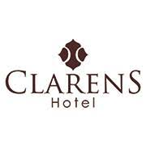
- Worked with CLARENS HOTEL (PRE-OPENING, GURUGRAM) as a Master Chef (Indian cuisine) since 1stoct 2011 to 29th June 2013.


- Worked with AMERICAN CLUB (SINGAPORE) as a Junior Sous Chef since 17th Sep 2008 to 15thsep 2011.
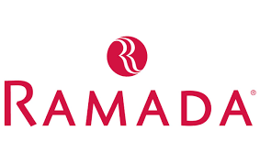
- Worked with RAMADA CARAVELA BEACH RESORT (GOA) as a Chef de Partie since 20th march 2006 to 25 August 2008.


- Worked with WESTIN HOTELS & RESORTS (GURUGRAM) as a Commi I
Since 15th April 2004 to 10 March 2006


- Worked with BADHAAI BANQUET (PRE-OPENING, DELHI) as a Cook Oct. 2002 to March 2004.



- Worked with HOTEL RAJDOOT (DELHI) as a Cook General 14th Sept. 1999 to 20th Sept. 2002.

ACHIEVEMENT

- Chef of the month (09.11.2008) Selected by the Zao-Bao Newspaper in Singapore.

- I have done HYGIENE POLICIES AND PROCEDURES by WSQ (Singapore)

- Famous Blog Writer (Zafar Anjum) has written about my Tandoori Chai on his Blog.

Personal references

S.N | NAME | DESIGNATION | COMPANY
1. | CHEF KHEM RAJ | GROUP EXECUTIVE CHEF | ALLEGEN’S GROUP OF HOTELS
2. | DEBASMITA DEY | SR. MANAGER HR | INFIILOOM INDIA

(CHANDAN SINGH)

Date: -

Place: - New Delhi

