Vishal kumar yadav
(M):+91-9711157758,
E-mail : yadavvishal099@gmail.com

Introduction
I am Vishal Kumar Yadav, presently working as a Executive Chef at The Taj Damdama lake Resort and Spa, Gurgaon which had 90000sq ft Banqueting Space, an opulent Indian Specialty restaurant ZVATRA and iconic SHAMIANA.
. I take care of the entire food production operations with a team of 37 chefs. I believe in team
work and I am focused towards creating a lifetime Dining experience for a guest in terms of food and services.

Applying for: Executive Chef

Career Objective: Looking for a senior management position where I can apply and utilize my culinary & management skills.

Achievement:

Reduced the year end food cost by 4% from Budgeted 27.8% to 23.9% in FY 2023-2024.

Successful Execution of food Promotions

Rajasthani food promotion, Awadhi food promotion and Malabar food promotion

Currently working on new concept FUN FOOD FRIDAY BAZAR

Pre-opening Experiences:

- Fairfield by Marriott, OMR Chennai
- Westin Kolkata, Rajarhat
- Vivanta By Taj, Gurgaon
- Fairfield by Marriott, Dehradun

Key Result Area

- Have been an active member of pre-opening team of as a Management Trainee.
- Have been successful in controlling food cost during busy operations.
- Have maintained the food and hygiene standards as per international standards.
- Have been successful in maintaining quality and taste of food and gained guest appreciations.
- Have been actively involved in maximizing the guest interactions among teammembers.
- Trained and developed associates to command next level in their career.
- Successfully planned and organized food promotions.

Educational Qualification:
- Bachelor of Hospitality and Hotel Administration (BHM) from Institute of Hotel Management Pusa, New Delhi from 2009-2012. With 79.9% scores.

- Pursued Senior Secondary Education from Gyan Sagar public school from Science Streamscoring 87.2%.
- Pursued Secondary Education from Gyan Sagar public school scoring 86.2%.

WORK EXPERIENCE
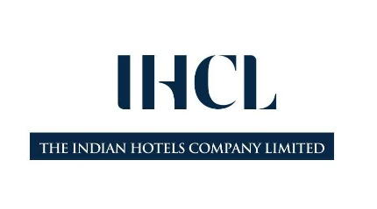

Executive Chef (Luxury segment of IHCL)
The Taj Damdama Lake Resort and Spa, Gurugram
from December,2023 to present

Head Chef
Hyatt Place Gurgaon from Jan,2023- Nov,2023

MARRIOTT INTERNATIONAL (More than 7years)

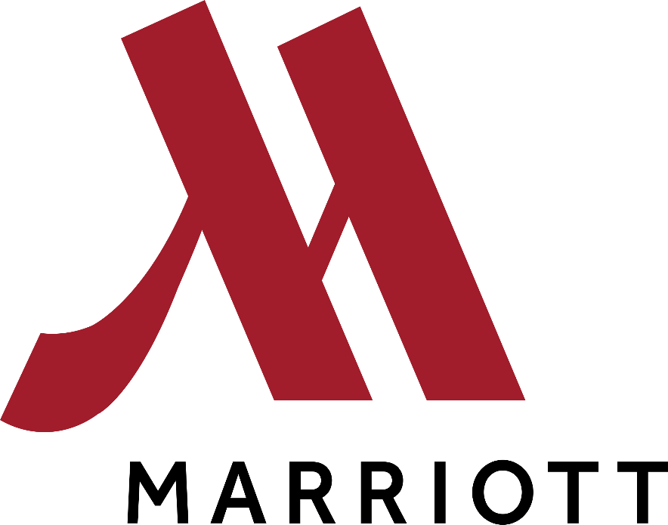
Head Chef (Internal Transfer)
Four Points by Sheraton, Bangalore
from July, 2022 to Nov, 2022

Senior Sous Chef (Internal promotion)
Aloft New Delhi Aerocity
from February, 2022 to July, 2022

Sous chef (Internal Transfer)
Aloft New Delhi Aerocity
from July, 2019 to January, 2022

Senior Sous chef (Internal promotion)
Hotel Le Meridien Jaipur Resort and Spa
From March, 2019 till July,2019 .

Sous chef (Internal promotion)
Hotel Le Meridien Jaipur Resort and Spa
From June, 2016 till Feb,2019.

Jr. Sous chef
Hotel Le Meridien Jaipur Resort and Spa
From August, 2015 to June, 2016.

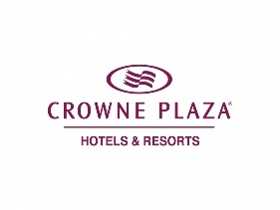

Chef De Partie
Hotel Crowne Plaza Rohini (IHG Group)
From March, 2015 to August, 2015.

INDIAN HOTELS COMPANY LIMITED(Almost 3years)
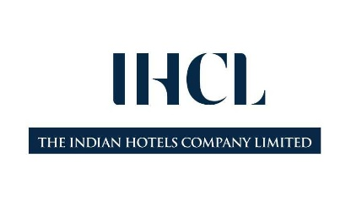

Chef De Partie (Internal Transfer)
Hotel Taj Club house, Chennai
From October, 2014 to March, 2015.

Chef De Partie
Taj City Centre, Gurugram
From July 2014 to September 2015

Hotel Operations Management Trainee
Taj City Centre, Gurugram
From July, 2012 to June, 2014.

Additional Add-on Experiences

Period of Service : One Month Training
Name of the Company : Indian Hotels company Limited (IHCL) Main Course of Activity : Cross Exposure
Outlets : THAI PAVILLION (VBT, Gurgaon)
THE ORIENT EXPRESS (The Taj Palace, New Delhi)

Achievements:

- Achieved twice 100% Compliance in FSSAI AUDIT at The Taj Damdama Resort and Spa
- Achieved 100% Compliance in ISO 22000 AUDIT at HyattPlace, Udyogvihar
- Certified Food Safety manager from Tap Series
- Certified Food Safety Supervisor from FSSAI (2021-2023)
- Awarded as a ‘Trip Advisor Champ of the Year’ 2020 and 2021
- Awarded as “Trip Advisor Champ of the month” for the month of August and September,2019.
- Awarded as “GUEST VOICE CHAMPION” (Marriott guest satisfaction survey) of the year 2018-2019 by the hotel.
- Nominated from the hotel for” VINAY JAYARAJ GUEST VOICE CHAMPION” in 2018.
- Achieved the Highest” GUEST VOICE FOOD QUALITY SCORE’s” in the 2017-2018.
- Awarded as “GUEST VOICE CHAMPION” (Marriott guest satisfaction survey) of the year 2017-2018by the hotel.
- Awarded as “BEST CREATIVE CHAMP” by the hotel
- Achieved year end Food Cost at 25% against the budget of 28%.for the year2016.
- Achieved year end Food Cost at 24% against the budget of 28%.for the year2015.
- Achieved 96% in the Hygiene Audit in Sep-2015, highest in history of Le Meridien Jaipur.
- Have Twice been an active participant to host the Jaipur Literature Festival’s Writers Ball for almost 1500 + guest with Different cuisines

PERSONAL DETAILS :-

Date of Birth : 24th July, 1991
Marital Status : Married
Languages known : English, Hindi, Marwari Nationality : Indian

