SECONDARY EDUCATION (10TH)
Gujarat Secondary Education Board (GSEB), Gujarat
Mr. Akshay Shah
Director, Rushabh Financial services
- +91 84606 61497
- rushhabh.investment@gmail.com
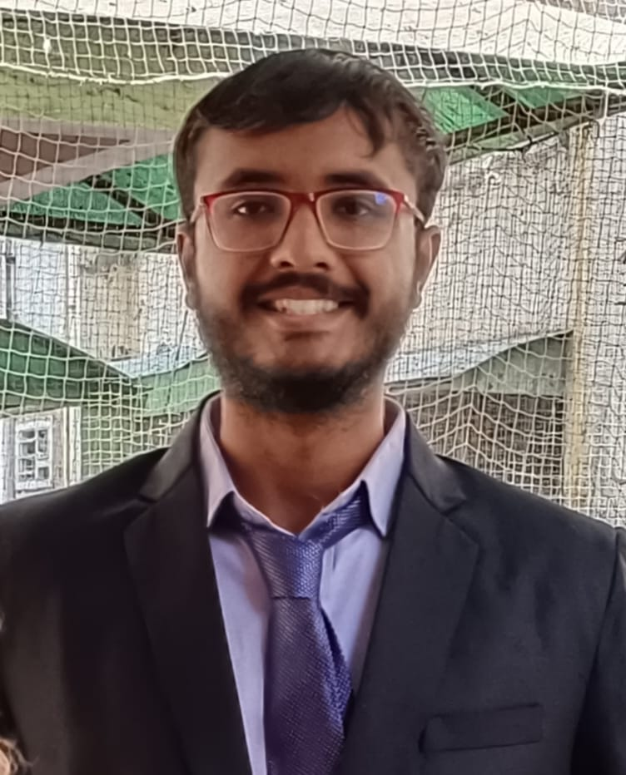
Summer Internship Project: “Study on perception of women investors towards Mutual Funds in Ahmedabad”.
PROJECTS UNDERTAKEN

Tally & MS Office, Time management, Project management, Initiative & Communication, Team Work, Professionalism, Positive attitude

rohanjayswal.mba23@gmail.com
Rohan Jayswal
Management Student in Dual Specialization Finance and Marketing
2020
HIGHER SECONDARY EDUCATION (12TH) Gujarat Higher Secondary Education Board (GHEB), Gujarat
BACHELORS IN BUSINESS ADMINISTRATION(BBA) WITH SPECIALIZATION INTERNATIONAL BUSINESS
Faculty of Business Administration, GLS University, Ahmedabad
2018
REFERENCE

SKILLS
2020 - 2023
8849433188
C-204 Siddhi Chakra Appartment Opp. Visat Petrol Pump Sabarmati Ahmedabad- 380005
(MBA-PURSUING) WITH SPECIALIZATION FINANCE and MARKETING
Faculty of Management, GLS University, Ahmedabad
I aim to secure a full-time role as a Finance and marketing professional within an organization where I can apply my educational background while acquiring valuable experience in a collaborative team setting.
CONTACT
ABOUT ME
2023 - 2025

EDUCATION

